

VistA Blood Establishment Computer Software (VBECS) Version 2.0.0

User Guide

April 2015

Department of Veterans Affairs

Product Development

This page intentionally left blank.

# Revision History

| **Date** | **Revision** | **Description** | **Author** |
| --- | --- | --- | --- |
| 4/22/13 | 1.0 | Modified VistA Blood Establishment Computer Software (VBECS) User Guide for VBECS 1.6.1, Version 1.0 to create the VistA Blood Establishment Computer Software (VBECS) User Guide for VBECS 2.0.0, Version 1.0:   * Global: Replaced "1.6.1" with "2.0.0” * Global: Replaced “January 2013” with “April 2013” in the footer. * Table 1: Updated Level 4 and Level 6 User Roles. * Figure 1: Updated. * Hardware and Infrastructure Architecture section: Changed “Windows 2003” to “Windows 2008”. Added “Windows 7”. * Hardware and Infrastructure Architecture section: Added paragraph about VBECS 2.0.0 being installed in a virtualized environment using vSphere 5 as the virtualization platform. * Hardware and Infrastructure Architecture section: Added paragraph about SQL Server 2012 AlwaysOn. * Creating and Viewing Reports section: Removed last bullet item. DR 4581 * Creating and Viewing Reports section: Added Report Tool Bar section and sub-sections. DR 4581 * Navigation Arrows and Report Pages section: Added new last bullet item that the number of pages may differ between the screen and the printed report. DR 4589 * Blood Availability section: Removed the limitation/restriction that the report may not be viewed outside of VBECS. Also removed from Canned Comments section. * Glossary: Added SQL Server Reporting Services. * Canned Comments, Limitations and Restrictions section and Appendix D: Removed "Comments must not contain an apostrophe." DR 4599 * Maintain Patient Records section, Step 4, Notes: Edited the Transfusion Requirements note. DR 4598 * Table 17, Platelets row: Added E064 and E065. * Table 17, Fresh Frozen Plasma row: Added E066 and E067. * Table 23: Updated 6th row by deleting “serologic problems, such as valid”. | BBM team |
| 9/10/13  9/10/13 | 2.0  (cont. on next page)  2.0  (cont. from previous page) | * Global: Replaced “Version 1.0” with “Version 2.0” in the footer. * Global: Replaced “April 2013” with “September 2013” in the footer. * Customer Support section, paragraph beginning “After local and regional triage”: Revised. * Navigation Arrows and Report Pages: Removed fourth paragraph about report pages not matching the printout. DR 4761 * Report Export section: Added second paragraph/note about a Microsoft Word bug. DR 4821 * Report Export section: Added information that the data output from VBECS is not controlled by the medical device and must be strictly regulated by local facility personnel. DR 4627 * Report Export section: Added information that specific reports cannot be exported to Excel. DR 4607 * Issue Blood Components (Routine): Added second note to Step 2 about error messages. DR 4808 * Issue Blood Components, Step 5: Added a seventh note about whole blood not being allowed for emergency issue. DR 4811 * Invalidate Test Results, Limitations and Restrictions section: Added fourth bullet that a user should not invalidate only part of the TAS. DR 4685 * Patient Testing, General Instructions, Limitations and Restrictions: Added fourth bullet about VBECS not being able to compare test results for a patient when two users are trying to enter test results for the same patient at the same time. DR 4817 * Finalize/Print TRW, Step 3: Added 1,000 character limitation in third bullet. DR 4788 * Exception Report, Limitations and Restrictions: Added second bullet about only the first twenty patient antigens printing on the report when an exception is generated for a unit issued with unsatisfied antigen negative requirements. DR 4820 * Transfusion Complications Report, Step 3: Added second note about report requiring a logged on VistA user to retrieve lab results. DR 4810 * Transfusion Effectiveness Report, Step 4: Added second note about report requiring a logged on VistA user to retrieve lab results. DR 4810 * Processing Orders, Accept Orders: Accept an Order, Limitations and Restrictions: Added first bullet explaining that an order for TAS must be accepted before a component order if the user wants to include the component request to the Inappropriate Transfusion Request Report. Also added second note to Step 6 explaining the same. Remedy 826766 * Appendix O: Added. Removed from VBECS Technical Manual-Security Guide and added to this document. DR 4679 | BBM team  BBM team |
| 11/7/13 | 3.0 | * Global: Replaced “Version 2.0” with “Version 3.0” in the footer. * Global: Replaced “September 2013” with “November 2013” in the footer. * Customer Support section: Revised text in box. * Figure 25: Revised figure caption. * Report Toolbar section: Revised Figure 8 screen capture. DR 4835 * Report Layout section: Added. DR 4835 * Report Search section: Revised. DR 4835 * Table 11, User Entry G: Changed the Unit Status to “Crossmatched”. | BBM team |
| 7/28/14 | 4.0  (cont. on next page)  4.0  (cont. from previous page) | * Global: Replaced “Version 3.0” with “Version 4.0” in the footer. * Global: Replaced “November 2013” with “July 2014” in the footer. * Global: Removed references to Windows XP. * Global: Replaced “Pittsburgh” with “Philadelphia”. * Related Manuals and Materials: Removed *VistA Blood Establishment Computer Software (VBECS) Patch Installation Guide*. * Customer Support, National VA Service Desk Alternate Contacts: Updated Web site and email address. Revised text in Warning box. * Working with Data: Revised 3rd bullet. Added last bullet about column width adjustment. DR 2218 * Report Toolbar: Revised paragraph. * Using VBECS: Removed “(hardware and software)” from second paragraph. Revised and added a hyperlink to the Sharepoint site to fourth paragraph. Revised fourth paragraph since NT&EO is no longer maintained. * Viewing the VBECS Version Number: Added an explanation of how version numbers are incremented and revised Figure 25. DR 4991 * View Recent Orders, Recent Transfusions/Issued Units, and Transfusion Reaction History: Added third note. DR 2218 * Options at a Glance: VBECS and VistA Blood Bank v5.2 section and VistA and VBECS Functions sub-section: Removed, since users are not in VistA or transitioning any longer. * Main Status Bar: Revised the Order Alert paragraph. DR 4963 * Local Facilities, Limitations and Restrictions: Added fifth sub-bullet about maximum character length. DR 4980 * Reagents, Limitations and Restrictions: Added sixth bullet about free text details. DR 2218 * Modify Components: Modify Units, Step 7: Changed “prompts” to “allows” in VBECS action. Step 10: Revised user action. Step 11: Revised user action. Step 12, first note, second sentence: Revised to read “When the user does not verify the label, he must enter a comment and click **Cancel** to exit.” * Maintain Unit Records, Limitations and Restrictions: Added sixth bullet about user changing restricted to patient associated with a split. DR 2218 * Edit Financial Data, Limitations and Restrictions: Added a limitation for access to edit financial data. DR 5012 * Modify Units: Pool Units, Limitations and Restrictions: Removed third bullet. DR 4474 * Issue Blood Components, Additional Information: Added fifth bullet to tell the user to add the date to the BTRF form. Last bullet: Revised. * Issue Blood Components (Routine), Limitations and Restrictions: Revised 6th bullet. Step 5: Revised the seventh note. DR 4854 * Print Unit Caution Tag & Transfusion Record Form, Step 3, Notes: Revised second note. Revised first sentence of third note. INC000000997296 * Figure 98: Revised to reflect the current caution tag print out. DR 4848 * Invalidate Test Results, Limitations and Restrictions: Revised fourth note. * Display Order Alerts: Additional Information: Revised 2nd bullet. DR 4854 * Accept Orders, Accept an Order: Revised first note. DR 4854 * Accept Orders, Pending Order List, Outcome: Revised first bullet and added second bullet. * Accept Orders, Pending Order List, Step 2: Added ninth bullet. DR 4938 * Display Order Alerts: Limitations and Restrictions: Removed second bullet. Additional Information: Added second bullet. DR 4938 * Patient Services, Patient Screen Search, Additional Information: Added second bullet. DR 4989 * Reports: Added a note explaining an error message that is displayed when switching report layouts for large reports. DR 5059 * Post-Transfusion Information, Additional Information, first bullet: Revised to add “BCE COTS interface”. * Reports section: Added a paragraph about report information sorting. * Exception Report, Additional Information: Added third bullet. DR 4883 * Appendix D: Updated to reflect related changes within the document. * Appendix M: Removed. | BBM team |
| 11/5/14 | 5.0 | * Global: Replaced “Version 4.0” with “Version 5.0” in the footer. * Global: Replaced “July 2014” with “November 2014” in the footer. * Global: Removed “Full-Face” from “Full-Face Label Printer. DR 5105 * Introduction: Added Limitations and Restrictions. DR 5105 * Options That Require VistALink, Main Menu: Patients, third bullet: Added “(to include a hospital location)”. DR 5073 * Issue Blood Components, Limitations and Restrictions: Revised third bullet. DR 5073 * Issue Blood Components, Issue Blood Components (Routine), Step 4: Added new fifth note. DR 5073 * Figure 122: Revised. DR 5107 * Transfusion Requirements Report, Limitations and Restrictions: Revised first bullet. DR 5086 * Patient Testing: Record a Transfusion Reaction Workup, Step 11: Revised second note. DR 5100 * Table 27, Throughout VBECS: Removed rows that are duplicated in the newly added Limitations and Restrictions under Freeware Disclaimer. DR 5105 | BBM team |
| 1/7/15 | 6.0 | * Global: Replaced “Version 5.0” with “Version 6.0” in the footer. * Global: Replaced “November 2014” with “January 2015” in the footer. * Transfusion Requirements Report, Additional Information: Added sixth bullet alerting user to check subsequent pages of the report for more information. DR 5125 * Appendix B: Updated tables to be current with VBECS Truth Table Catalog. DR 5110 * Appendix H: Revised to remove actual FAQs and added information on accessing FAQs from the SharePoint site. | BBM team |
| 4/7/15 | 7.0 | * Global: Replaced “Version 6.0” with “Version 7.0” in the footer. * Global: Replaced “January 2015” with “April 2015” in the footer. * Report Export section: Revised first paragraph, added information box, added second paragraph and added Table 3. * Copying an Exported VBECS Report section: Added. * Issue Blood Components (Routing and Emergency) sections: Moved third bullet about selecting the unsatisfactory unit from Step 7 to Step 5. * Accept Orders: Accept and Order, Limitations and Restrictions: Added sixth bullet about a VBECS order on a Cancellation List. Also added this information to Appendix D. | BBM team |

Table of Contents

[Revision History i](#_Toc416166601)

[Introduction 1](#_Toc416166602)

[Freeware Disclaimer 1](#_Toc416166603)

[Related Manuals and Materials 2](#_Toc416166604)

[Orientation 3](#_Toc416166605)

[How This User Guide Is Organized 3](#_Toc416166606)

[Terms 3](#_Toc416166607)

[Background and Basic Knowledge 3](#_Toc416166608)

[Figures and Tables 3](#_Toc416166609)

[Options 3](#_Toc416166610)

[Supplemental Information 4](#_Toc416166611)

[Appendices 4](#_Toc416166612)

[Security 4](#_Toc416166613)

[Application Architecture 6](#_Toc416166614)

[Hardware and Infrastructure Architecture 6](#_Toc416166615)

[Options That Require VistALink 7](#_Toc416166616)

[Customer Support 10](#_Toc416166617)

[Problems? 10](#_Toc416166618)

[Using the Software 10](#_Toc416166619)

[Software Basics 10](#_Toc416166620)

[Commonly Used System Rules 12](#_Toc416166621)

[Date and Time 12](#_Toc416166622)

[Locking and Time-Outs 12](#_Toc416166623)

[Working with Data 12](#_Toc416166624)

[Searching the Database 13](#_Toc416166625)

[Testing 14](#_Toc416166626)

[Creating and Viewing Reports 16](#_Toc416166627)

[Report Toolbar 18](#_Toc416166628)

[Navigation Arrows and Report Pages 18](#_Toc416166629)

[Report Layout 18](#_Toc416166630)

[Report Zoom-in/Zoom-out 19](#_Toc416166631)

[Report Search 19](#_Toc416166632)

[Report Export 20](#_Toc416166633)

[Copying an Exported Report 23](#_Toc416166634)

[Using VBECS 25](#_Toc416166635)

[Using Online Help 26](#_Toc416166636)

[Contents Tab 28](#_Toc416166637)

[Index Tab 29](#_Toc416166638)

[Search Tab 30](#_Toc416166639)

[Glossary Tab 31](#_Toc416166640)

[Viewing the VBECS Version Number 32](#_Toc416166641)

[VistA Records in VBECS 34](#_Toc416166642)

[Accessing the System 35](#_Toc416166643)

[Log Into VBECS and VistA 35](#_Toc416166644)

[Exit VBECS 38](#_Toc416166645)

[Screen Settings 39](#_Toc416166646)

[Screen Display 42](#_Toc416166647)

[Sound 43](#_Toc416166648)

[Volume 45](#_Toc416166649)

[Keyboard Shortcuts for Windows 46](#_Toc416166650)

[Drop-Down Menus 47](#_Toc416166651)

[Tool Tips 47](#_Toc416166652)

[Icons and Buttons 48](#_Toc416166653)

[Toolbars 48](#_Toc416166654)

[Patient Information Toolbar 49](#_Toc416166655)

[Patient Blood Availability 49](#_Toc416166656)

[small_patient_medications Medication Profile 50](#_Toc416166657)

[small_si_tr View Special Instructions and Transfusion Requirements 51](#_Toc416166658)

[View Recent Orders, Recent Transfusions/Issued Units, and Transfusion Reaction History 53](#_Toc416166659)

[small_recent_orders Patient Information Toolbar: Recent Orders 53](#_Toc416166660)

[small_transfusion_history Patient Information Toolbar: Recent Transfusions/Issued Units 54](#_Toc416166661)

[small_transfusion_reactions Patient Information Toolbar: Transfusion Reaction History 54](#_Toc416166662)

[Other VBECS Functions 55](#_Toc416166663)

[Collecting Workload 55](#_Toc416166664)

[Configuring Site Parameters 57](#_Toc416166665)

[Update User Roles 57](#_Toc416166666)

[Component Classes 59](#_Toc416166667)

[Configure Daily QC 62](#_Toc416166668)

[Configure Division 65](#_Toc416166669)

[Configure Division 65](#_Toc416166670)

[Configure Testing 67](#_Toc416166671)

[Product Modifications 69](#_Toc416166672)

[Order Alerts 71](#_Toc416166673)

[Login Message 73](#_Toc416166674)

[Local Facilities 75](#_Toc416166675)

[Blood Products 78](#_Toc416166676)

[Antibodies 81](#_Toc416166677)

[Canned Comments 83](#_Toc416166678)

[Setting Transfusion Parameters 85](#_Toc416166679)

[Transfusion Complications 85](#_Toc416166680)

[Transfusion Effectiveness 86](#_Toc416166681)

[MSBOS 88](#_Toc416166682)

[Workload Codes 90](#_Toc416166683)

[Reagents and Supplies 92](#_Toc416166684)

[Enter Daily QC Results 92](#_Toc416166685)

[Reagents 99](#_Toc416166686)

[Supplies 105](#_Toc416166687)

[Equipment 109](#_Toc416166688)

[Component Processing 115](#_Toc416166689)

[Shipments 115](#_Toc416166690)

[Incoming Shipment 115](#_Toc416166691)

[Edit Invoice Text 133](#_Toc416166692)

[Unit Search Screen 134](#_Toc416166693)

[Test Units 136](#_Toc416166694)

[ABO/Rh Confirmation 136](#_Toc416166695)

[Unit Antigen Typing 139](#_Toc416166696)

[Modify Components 147](#_Toc416166697)

[Modify Units 147](#_Toc416166698)

[Modify Units: Split a Unit 157](#_Toc416166699)

[Modify Units: Pool Units 160](#_Toc416166700)

[Add and/or Remove Units from a Pool 164](#_Toc416166701)

[Maintain Unit Records 167](#_Toc416166702)

[Edit Unit Information 167](#_Toc416166703)

[Edit Financial Data 172](#_Toc416166704)

[Free Directed Unit For Crossover 174](#_Toc416166705)

[Discard or Quarantine 176](#_Toc416166706)

[Select Units 182](#_Toc416166707)

[Issue Blood Components 192](#_Toc416166708)

[Return Issued Units To Blood Bank 204](#_Toc416166709)

[Release Units From Patient Assignment 207](#_Toc416166710)

[Print Unit Caution Tag & Transfusion Record Form 209](#_Toc416166711)

[Invalidate Test Results 217](#_Toc416166712)

[Remove Final Status 221](#_Toc416166713)

[Processing Orders 224](#_Toc416166714)

[Accept Orders: Accept an Order 225](#_Toc416166715)

[Accept Orders: Pending Order List 230](#_Toc416166716)

[patientalert Display Patient Update Alerts 233](#_Toc416166717)

[patientalert Display Patient Merge Alerts 234](#_Toc416166718)

[Maintain Specimen 235](#_Toc416166719)

[Patient Testing: Cancel an Active Order 239](#_Toc416166720)

[Patient Testing: Pending Task List 241](#_Toc416166721)

[Accept Orders: Cancel a Pending Order 243](#_Toc416166722)

[Order Reflex Tests 245](#_Toc416166723)

[Patient Services 249](#_Toc416166724)

[Patient Search Screen 249](#_Toc416166725)

[Patient Merge 251](#_Toc416166726)

[Updated Patients and Deceased Patients 255](#_Toc416166727)

[Patient Testing: General Instructions 256](#_Toc416166728)

[Patient Testing: Record a Patient ABO/Rh 261](#_Toc416166729)

[Patient Testing: Record a Patient Antibody Screen 264](#_Toc416166730)

[Patient Testing: Record a Direct Antiglobulin Test 266](#_Toc416166731)

[Patient Testing: Record a Crossmatch 269](#_Toc416166732)

[Patient Testing: Record a Patient Antigen Typing 274](#_Toc416166733)

[Patient Testing: Enter Antibody Identification Results 280](#_Toc416166734)

[Patient Testing: Record a Transfusion Reaction Workup 283](#_Toc416166735)

[Finalize/Print TRW 291](#_Toc416166736)

[Maintain Patient Records 295](#_Toc416166737)

[Special Instructions & Transfusion Requirements: Enter a Transfusion Requirement 295](#_Toc416166738)

[Special Instructions & Transfusion Requirements: Enter and Remove Special Instructions 300](#_Toc416166739)

[Post-Transfusion Information 303](#_Toc416166740)

[Document ABO Incompatible Transfusions 308](#_Toc416166741)

[Justify ABO/Rh Change 310](#_Toc416166742)

[Reports 313](#_Toc416166743)

[Administrative Data Report 313](#_Toc416166744)

[Audit Trail 315](#_Toc416166745)

[Blood Availability 317](#_Toc416166746)

[Cost Accounting Report 319](#_Toc416166747)

[C:T Ratio Report 321](#_Toc416166748)

[Division Transfusion Report 323](#_Toc416166749)

[Division Workload Report 325](#_Toc416166750)

[Exception Report 327](#_Toc416166751)

[Finalize/Print TRW (See Patient Services, Finalize/Print TRW) 329](#_Toc416166752)

[Inappropriate Transfusion Request Report 329](#_Toc416166753)

[Issued/Returned Unit Report 331](#_Toc416166754)

[Medication Profile (See Patient Information Toolbar) 333](#_Toc416166755)

[Order History Report 333](#_Toc416166756)

[Patient History Report 335](#_Toc416166757)

[Prolonged Transfusion Time Report 337](#_Toc416166758)

[Patient Testing Worklist and Testing Worklist Reports 339](#_Toc416166759)

[Transfusion Complications Report 342](#_Toc416166760)

[Transfusion Effectiveness Report 344](#_Toc416166761)

[Transfusion Reaction Count Report 346](#_Toc416166762)

[Transfusion Requirements Report 348](#_Toc416166763)

[Unit History Report 350](#_Toc416166764)

[References 353](#_Toc416166765)

[Glossary 357](#_Toc416166766)

[Appendices 367](#_Toc416166767)

[Appendix A: Downtime Forms and Instructions 367](#_Toc416166768)

[Patient Testing Form 369](#_Toc416166769)

[Unit ABO/Rh Confirmation Form 372](#_Toc416166770)

[Unit Issue and Inspection Log 373](#_Toc416166771)

[Unit Modification Form 374](#_Toc416166772)

[Appendix B: Database Table Information 377](#_Toc416166773)

[Table 13 and Table 14: Antibody and Antigen Tables 377](#_Toc416166774)

[Table 13: Antibody and Antigen Table: Irregular Antibodies 377](#_Toc416166775)

[Table 14: Antibody and Antigen Table: Database Conversion 380](#_Toc416166776)

[Table 15: Antibody Screen Test Interpretation 381](#_Toc416166777)

[Table 16: Canned Comment Category Types and Text 382](#_Toc416166778)

[Table 17: CPRS Orderable Blood Components (Component Classes) Mapped to ICCBBA Component Classes 390](#_Toc416166779)

[Table 18: Details in Audit Trail Report 391](#_Toc416166780)

[Table 19: Details in Exception Report 396](#_Toc416166781)

[Table 20: Enable Crossmatch Option for OTHER Product Types 398](#_Toc416166782)

[Table 21: Allowable Product Modifications by Original Product Type 399](#_Toc416166783)

[Table 22: National Treating Specialty Table 404](#_Toc416166784)

[Figure 135: Order Status Flowchart 407](#_Toc416166785)

[Table 23: Rules for Electronic and Serologic Crossmatch 408](#_Toc416166786)

[Figure 136: Unit Status Flowchart 409](#_Toc416166787)

[Table 24: VBECS Maximum Surgical Blood Order Schedule 411](#_Toc416166788)

[Table 25: BCE COTS Message Updates 412](#_Toc416166789)

[Table 26: Workload Process to Use Case Mapping Table 416](#_Toc416166790)

[Appendix C: VBECS Work Flow 427](#_Toc416166791)

[Appendix D: Limitations and Restrictions 431](#_Toc416166792)

[Appendix E: Known Defects and Anomalies 445](#_Toc416166793)

[Appendix F: System Validation 447](#_Toc416166794)

[Introduction 447](#_Toc416166795)

[Validation Plan 447](#_Toc416166796)

[Prerequisites 448](#_Toc416166797)

[Record System Settings 449](#_Toc416166798)

[Configure Division 449](#_Toc416166799)

[Configure Testing: Full Service 449](#_Toc416166800)

[Product Modifications: Full Service 450](#_Toc416166801)

[Order Alerts 451](#_Toc416166802)

[Configure Daily QC: Full Service 452](#_Toc416166803)

[Maintain Minimum Levels: Full Service 453](#_Toc416166804)

[Log In Reagents: Full Service 454](#_Toc416166805)

[Blood Products 455](#_Toc416166806)

[Local Facilities 456](#_Toc416166807)

[Component Classes 457](#_Toc416166808)

[Transfusion Complications 458](#_Toc416166809)

[Transfusion Effectiveness 459](#_Toc416166810)

[Workload Codes 460](#_Toc416166811)

[Canned Comments 460](#_Toc416166812)

[MSBOS 460](#_Toc416166813)

[Edit Invoice Text 460](#_Toc416166814)

[Antibodies 461](#_Toc416166815)

[Update User Roles 462](#_Toc416166816)

[Testing 462](#_Toc416166817)

[VBECS Forms and Reports 463](#_Toc416166818)

[Appendix G: Work Process Flowcharts 465](#_Toc416166819)

[Configure Division Settings: Full-Service Divisions 465](#_Toc416166820)

[Configure Division Settings: Transfusion-Only Divisions 466](#_Toc416166821)

[Maintain Reagents and Daily QC: Full-Service Divisions 467](#_Toc416166822)

[Process Incoming Shipment: Full-Service Divisions 468](#_Toc416166823)

[Process Incoming Shipment: Transfusion-Only Divisions 469](#_Toc416166824)

[Modify Units 470](#_Toc416166825)

[Issue, Return, or Transfuse Units: Full-Service Divisions 471](#_Toc416166826)

[Issue, Return, or Transfuse: Transfusion-Only Divisions 472](#_Toc416166827)

[Process a Patient Order 473](#_Toc416166828)

[Patient Testing 474](#_Toc416166829)

[Appendix H: Frequently Asked Questions 475](#_Toc416166830)

[Appendix I: Common Error Corrections 477](#_Toc416166831)

[Correct Patient Test Results 477](#_Toc416166832)

[Invalidate Test Results 477](#_Toc416166833)

[UN-Pooling a Pooled Unit (in the computer only) 478](#_Toc416166834)

[UN-Modifying a Unit 478](#_Toc416166835)

[Appendix J: Recommended Report Usage 479](#_Toc416166836)

[Appendix K: Barcode Scanner Configuration and Troubleshooting 481](#_Toc416166837)

[Appendix L: United Blood Services (UBS) Facility Barcodes 483](#_Toc416166838)

[Appendix M: System Responses to Active Transfusion Requirements in Select Unit and Issue Blood Component 485](#_Toc416166839)

[Appendix N: Workload Process Mapping to Application Option Table 495](#_Toc416166840)

[Index 503](#_Toc416166841)

# Introduction

The main purpose of the VistA Blood Establishment Computer Software (VBECS) is to automate the daily processing of blood inventory and patient transfusions in a hospital transfusion service.

VBECS is an improved Blood Bank application that facilitates ongoing compliance with Food and Drug Administration (FDA) standards for medical devices and enhances the Department of Veterans Affairs (VAs) ability to produce high-quality blood products and services to veterans. The system follows blood bank standards, standards of national accrediting agencies, FDA regulations, and VA policies.

VBECS supersedes VistA Blood Bank v5.2 for blood bank operations. VistA Blood Bank v5.2 blood unit records remaining after the transfer of patient information to VBECS are available for reference only and cannot be edited. VistA Blood Bank v5.2 validation records must be maintained for five years after the last of the blood unit records is transferred to VBECS.

#### Limitations and Restrictions

#### VBECS does not support:DR 5105

* Blood donor collection activities (donor module)
* Direct data entry of antibody identification
* Direct data entry of transfusion reaction workups
* Patient testing, transfusions, and blood components recorded in Legacy VistA are not available in VBECS
* Pediatric blood product preparation
* Printing of blood product labels
* User defined customized queries or reports
* User editing blood product, antigen, antibody, or transfusion reaction tables
* Validation record storage

Limitations and Restrictions are listed in Appendix D: Limitations and Restrictions by option as well as throughout this document as part of the detailed information associated with the functionality. DR 5105

Unauthorized access or misuse of this system and/or its data is a federal crime. Use of all data, printed or electronic, must be in accordance with VA policy on security and privacy. DR 3513

The U.S. Food and Drug Administration classifies this software as a medical device. Unauthorized modifications will render this device an adulterated medical device under Section 501 of the Medical Device Amendments to the Federal Food, Drug, and Cosmetic Act. Acquiring and implementing this software through the Freedom of Information Act require the implementer to assume total responsibility for the software and become a registered manufacturer of a medical device, subject to FDA regulations.

## Freeware Disclaimer

Requests for VBECS may be submitted through the Freedom of Information Act (FOIA). Effective on September 19, 2011, the Department of Veterans Affairs will accept FOIA requests electronically. Most VA Central Office (VACO) Offices are in the process of establishing an electronic mailbox. In the meantime, the FOIA Service will accept electronic FOIA requests for any VACO FOIA Office that does not yet have a mailbox in place, and will forward your request to the appropriate office for processing.

Submit requests to <http://www.foia.va.gov/FOIA_Offices.asp>DR

## Related Manuals and Materials

* *VistA Blood Establishment Computer Software (VBECS) Technical Manual-Security Guide*
* *VistA Blood Establishment Computer Software (VBECS) Release Notes*

Copies of *VistA Blood Establishment Computer Software (VBECS) User Guide* may be obtained from the VDL: VistA Documentation Library (VDL), Clinical Section, Laboratory: VistA Blood Establishment Computer Software (VBECS) Web site.

# Orientation

This section covers:

* How This User Guide Is Organized
* Security: who can use VBECS
* Application Architecture: the architectural requirements for VBECS
* Hardware and Infrastructure Architecture: the system environment for installation and operation of VBECS
* VistA and VBECS: how VBECS compares to VistA
* Customer Support: how to get help

## How This User Guide Is Organized

### Terms

For consistency and space considerations, the pronouns “he,” “him,” and “his” are used as pronouns of indeterminate gender equally applicable to males and females.

In many instances, a user may scan a barcode or enter data manually (by typing). The term “enter” is used throughout this guide to mean “enter manually.”

See the Glossary for definitions of other terms and acronyms used in this guide.

### Background and Basic Knowledge

The Introduction, Orientation, and Using the Software sections provide the background and basic knowledge VBECS users need.

### Figures and Tables

If you refer to figures and tables from the user guide in your local policy and procedure documents, you may wish to use their titles only, without figure or table numbers: as the user guide is updated, those numbers may change.

### Options

The Configuring Site Parameters, Component Processing, Processing Orders, Patient Services, and Reports sections cover VBECS options.

Each option section starts with an introduction, a short paragraph that explains what a function allows a user to do, followed by:

* Assumptions: tasks that must be completed before performing a function.
* Outcome: results of performing a function.
* Limitations and Restrictions: features of the system that are restricted by and exist within this function.
* Additional Information: information that helps the user perform a function.
* User Roles with Access to This Option: which users may perform this option in whole or in part.
* A detailed description of what the function allows each user to do. Two or more arrows () indicate functions limited to a specific role.
* Table of steps for the basic path (user and VBECS actions).
* Tables of steps for alternate paths (user and VBECS actions).
* Figures (examples of reports, screen shots, etc.).
* Table of alerts that may occur during an option.

A  (bullhorn) indicates that VBECS emits an audible alert. Keep the sound on to hear the alerts (see Volume for instructions on adjusting the volume).

* Outlined, italicized text highlights tips, warnings, and cautions, for example:

A  signals potential hazards throughout this guide as they occur.

### Supplemental Information

The third group of sections (References, Glossary) provides knowledge that may be needed beyond the standard, daily use of VBECS.

### Appendices

The appendices contain truth tables, diagrams, and other materials for reference.

Click a section name or page number in the table of contents to move to a section. The index does not incorporate this feature.

## Security

*User roles* identify who can access which functions. Not every VBECS user has access to all VBECS options or functions within options. Two or more arrows () indicate functions limited to a specific role.

It is critical that each site evaluate its staff and determine appropriate security levels based on training and qualifications.

User roles also govern which options are available and which warnings can be overridden. BR\_6.02 VBECS displays options that are not available to a user in gray text.

Each of the six user roles is associated with a security level (see Table 1). Privileges accumulate as the security level increases. For example, a Lead Technologist’s privileges include those of a Blood Bank Technologist and Enhanced Technologist.

Table 1: PT\_19.01 User Roles and Functions

| **Security Levels and User Roles** | **Accessible Functions** | **Who Should Fill These Roles?** |
| --- | --- | --- |
| Level 1: Blood Bank Technologist (all users) | * Activate/edit some shipper information. * Activate/edit some blood product information. * Standard access (includes patient testing, accepting and canceling orders, modifying units, processing shipments, processing transfusion reaction workups, accessing report functions) | Rotating technologists, new employees, and students trained to perform associated tasks and overrides. |
|  Level 2: Enhanced Technologist | * Edit unit cost. * Modify/issue expired blood products. * Release blood products from quarantine. * Edit unit login prior to defining patient associations. * Edit verified unit confirmation testing. * Edit patient record/verified data and test results (except the ABO/Rh for historic record and the antibody field, which results in an antigen negative requirement). * Release directed units to the main blood supply. | Experienced technologists trained to process associated overrides and options. |
|  Level 3: Lead Technologist | * Select/issue ABO incompatible blood. * Select/issue antigen positive or untyped red blood cells (for the clinically significant antibodies in the table). * Print internal reports. * Maintain login message. | Experienced technologists trained to process associated overrides and options (e.g., evening- or night-shift supervisors). |
|  Level 4: Traditional Supervisor | * Maintain minimum levels. * Edit permanent record of the patient’s historic ABO/Rh. * Edit Transfusion Requirements (TRs) and Special Instructions (SIs). * Edit patient record red cell antibody permanent fields (match antigens in the antigen table). * Edit a blood unit’s record (verified unit data when unit has any previous patient associations). * Edit a Patient’s Transfusion Record. * Remove a Blood Unit’s Final Status. | Experienced blood bank supervisors trained to process associated overrides and options |
|  Level 5: Enhanced Supervisor | * Edit antigen frequency table to reflect local population. * Add new local shipper, not already on the table issued with VBECS. * Edit and create canned comments for the division. * Edit and create consultative reports, templates, MSBOS, reagents, and equipment maintenance logs for the division. | Experienced blood bank supervisors or VBECS administrators trained to process associated overrides and options |
|  Level 6: Administrator/Supervisor | * Define VBECS users’ security settings. * Define the division as full service or transfusion only. * Enable electronic crossmatch at the division. * Populate International Council for Commonality in Blood Banking Automation, Inc. (ICCBBA) number for the division. * Define valid unit modifications for the division. * Assign workload codes for the division. * Configure testing. * Configure division. | VBECS administrators trained to process all overrides and options not designed to change frequently. This role may be assigned temporarily to a blood bank supervisor at setup to configure the division. |
| VBECS System Administrator (not a VBECS user)DR 2,878 | * Add users to active directory. * Applies maintenance and VBECS patches to the system. | When the division is configured, assign this role only to the System Administrator defined by VA policy and procedures. |

The VA Wide Area Network (WAN) is protected from unauthorized access. The hardware running the VBECS application and its database will be installed at the Austin Information Technology Center [AITC (primary site)] and the Philadelphia Information Technology Center [PITC (disaster recovery site)]. Both sites are secure data centers where they are protected against unauthorized modifications and accidental damage.

## Application Architecture

The primary purpose of VBECS is to automate the daily activities of a hospital transfusion service: blood inventory and patient transfusion processing. The major goals of the application are:

* Improve the safety of blood/blood component transfusions by decreasing the risk of errors through effective use of current technology such as barcode scanning, retrieval of previous records to be used for comparison, and detection of inconsistencies in data input
* Improve the quality of patient care through evaluation of transfusion appropriateness and follow-up on the effectiveness of transfusions
* Provide comprehensive reporting capabilities for quality monitoring within the transfusion service and for clinicians

VBECS operates as a discrete application, in accordance with FDA regulations regarding change to a medical device. It interfaces with the current VistA applications, using Health Level 7 (HL7) and VistALink. Areas of operation that are part of the VistA Blood Bank v5.2 software medical device (except for the donor module) are contained in this encapsulated VBECS package. Patient orders originate and are received from the Computerized Patient Record System (CPRS) and Laboratory applications.

## Hardware and Infrastructure Architecture

The VBECS application requires that hardware and system software serve five users in a standard configuration and up to twenty-five users in an integrated Veterans Integrated Service Network (VISN) environment. Figure 1: System Schematic describes the major system components: a Windows 2008 Server system (the execution environment for the VBECS application) and Windows 7 workstations for access to VBECS through Windows Remote Desktop Connection. The VBECS server communicates with and exchanges information with VistA applications through Extensible Markup Language (XML) and Health Level 7 (HL7) messages over Transmission Control Protocol/Internet Protocol (TCP/IP) networking. The VBECS server communicates with BCE through HL7 messages over TCP/IP networking.

VBECS 2.0.0 is installed in a virtualized network using vSphere 5 as the virtualization platform.

SQL Servers exist in an AlwaysOn cluster which consists of three nodes. The Primary and High Availability server reside at the primary site while a Disaster Recovery server resides at an alternate location:

* Primary server: This server fields all requests. Its data is replicated to the High Availability and Disaster Recovery servers.
* High Availability (HA) server: This server provides backup database services through synchronous replication. Its data are guaranteed to be consistent with the Primary.
* Disaster Recovery (DR) server: This server resides at a remote site and provides backup database services through asynchronous replication. It will become the Primary server should both the Primary and HA server fail.

### Options That Require VistALink

These options require a connection through VistALink. When VistALink is not active and VBECS requires access to VistA data, VBECS prompts the user to activate VistALink. When VistALink is not available, VBECS warns the user and asks him to try again later.

Contact your local support staff immediately when VistALink is not available. VBECS, VistA and CPRS all depend on VistALink to exchange information.

UC Main Menu: Orders

* Accept Orders: Pending Order List UC\_88

Main Menu: Blood Units

* Edit Unit Information (used when editing patient restrictions)
* Return Issued Units To Blood Bank UC\_59

Main Menu: Patients

* Post-Transfusion Information UC\_70 DR 4354
* Return Issued Units To Blood Bank UC\_59
* Issue Blood Components (to include a hospital location) UC\_73 DR 5073

Main Menu: Shipments

* Incoming Shipment (used when restricting units to patients) UC\_01

Main Menu: Tools

* Blood Products UC\_08
* Component Classes UC\_5
* UC\_84Transfusion Complications UC\_3
* Transfusion Effectiveness UC\_3
* Workload Codes UC\_2

Main Menu: Supervisor

* Document ABO Incompatible Transfusion UC\_69

Main Menu: Reports

* Transfusion Complications Report UC\_90
* Transfusion Effectiveness Report UC\_91
* Transfusion Requirements Report UC\_89
* Medication Profile UC\_46(Reports or from the Patient Tool Bar icon)

Main menu window, icon in the bottom of the window:

* Display Order Alerts

Figure 1: System Schematic

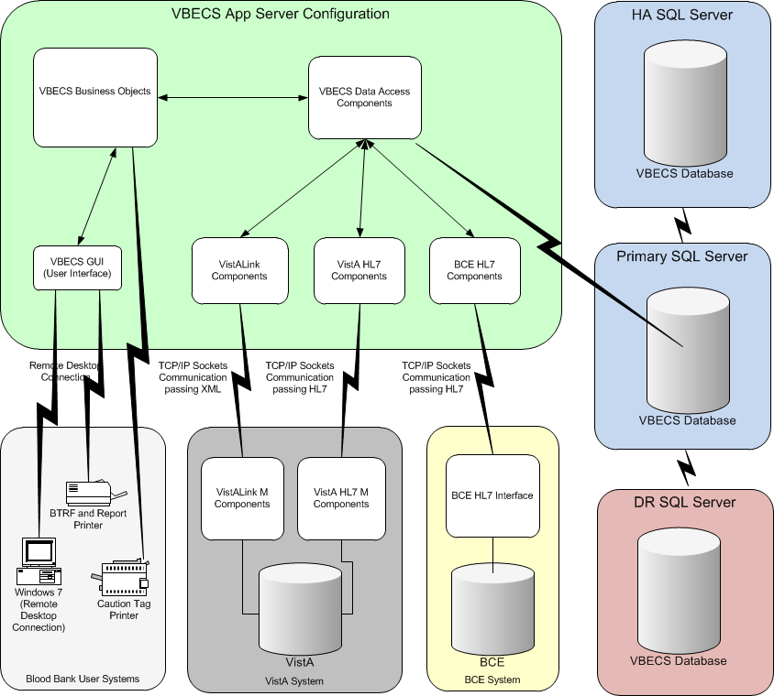

Users may not change or replace operating platforms.

## Customer Support DR 4514

### Problems?

Contact your **Local** Information Resource Management (IRM) or Laboratory Automated Data Processing Application Coordinator (ADPAC) if you encounter problems and for training support **before** contacting the National Help Desk.

**Problems with connectivity to VistA and CPRS may require personnel from Enterprise Operations (EO) with VBECS server admin access and also VistA IT support access. Please ensure local VistA Support and EO VBECS server administration contact information is available at all times.**

**If the problem remains unresolved after local and regional triage, contact the national Information Technology (IT) support service:**

*National help desk personnel do NOT have local VBECS server access and cannot assist with interface connection problems without assistance from EO personnel.*

**National VA Service Desk Contact**

For Information Technology (IT) support, call the VA Service Desk (VASD), 888-596-HELP (4357) (toll free), 24 hours per day, 7 days per week. [Users with access to the VASD-supported request tool (e.g., Remedy) may file a ticket in lieu of calling the VASD.]

**National VA Service Desk Alternate Contacts**

* Web site: <http://vaww.aac.va.gov/servicedesk/> (National Service Desk Tuscaloosa).
* Email : [NSDTuscaloosaUSD@va.gov](mailto:NSDTuscaloosaUSD@va.gov)

## Using the Software

Using the Software explains:

* How to access VBECS and VistA
* What users will see on the screen
* What the icons and other symbols mean
* Which conventions are used in this guide
* How to exit VBECS

## Software Basics

* When a message window requires a user response and VBECS displays it behind the active window, the user must minimize the active window or click and drag dialog boxes to expose the message window.
* Press the **F1 key** to view screen-specific online help.
* A user may click **Cancel**, **Close**, or **** in the upper right corner at any time to exit without saving.
* All operations depend on the user being logged into the appropriate division.
* A user may click a column heading to resort the items in that column (Figure 2 and Figure 3).
* BR\_2.48 Reaction results entries are allowed for only those reagents defined as part of the reagent rack.
* Select a date from the calendar in the drop-down list to edit a date, or click each part of the date to edit the date and time (Figure 4 and Figure 5).
* Labels shown in figures are visual aids only and do not represent actual labels.
* VBECS does not offer a spell-check feature. (The user may write text in Microsoft Word, spell check the text, and then copy and paste the text into VBECS.)

 Although the copy-and-paste function is enabled, do not use it to enter patient identification information. It is highly recommended that the user scan this information when possible; otherwise, enter it (DR 2,519).

Figure 2: Click to Sort by Patient Name

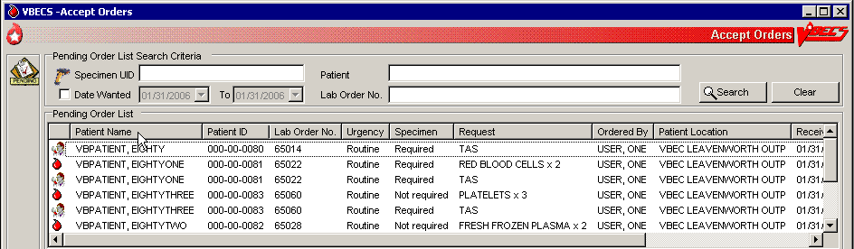

Figure 3: Click to Sort by Request

**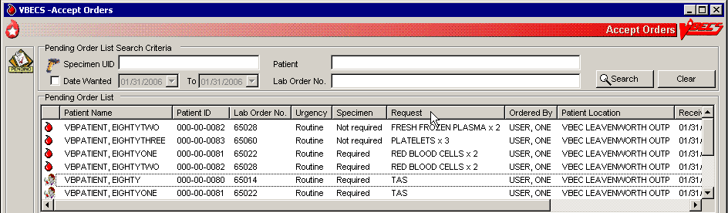**

Figure 4: Select a Date from the Calendar

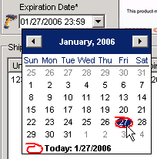

Figure 5: Edit the Date and Time



## Commonly Used System Rules

This section includes system rules that apply to several or all options.

### Date and Time

* Sites are not notified when an administrator changes the date or time on the server. Users must contact their System Administrator when the date or time is incorrect.
* The date, time, and time zone in VBECS is defined where the blood bank is located. Any requests for data from a particular blood bank database will reflect the time zone where the data was created and not the time zone where the report is generated. DR 3838
* Refer to *VistA Blood Establishment Computer Software (VBECS) Technical Manual-Security Guide* to change the time zone.

### Locking and Time-Outs

* In many cases, VBECS’s locking feature prevents more than one user from accessing data. When a user attempts to access locked data, VBECS displays a message indicating which user has the locked data.
* A local configurable setting (Lock Inactivity Timeout field) specifies how long a user can be idle and in control of data being edited. MBR\_2.13VBECS warns the user 60 seconds before the lock inactivity period expires that he will lose priority for the data. When he responds within 60 seconds, VBECS clears the warning and resets the lock activity timer. Otherwise, VBECS informs him that his lock was released and he must reenter his changes.

### Working with Data

* VBECS will emit an audible alert when a user exceeds the maximum character limit for a field. DR 3825
* The user may enter interpretations and reactions in full-service facilities. The user may enter only interpretations in transfusion-only facilities.
* Information displayed on an active window is updated with information from other options only when it is refreshed (i.e., closed and reopened) in the active window.
* BR\_1.03 When VBECS displays a scanner icon next to a data entry field, a user may enter or scan the data. The Caps Lock key must not be engaged. (DR 2,733)
* BR\_1.04 VBECS accommodates Codabar and ISBT 128-labeled units. VBECS uses special data identifiers embedded in an ISBT 128 product code to determine the label type scanned. The lack of data identifiers indicates that the barcode is for a Codabar unit (default: unknown).
* VBECS warns the user when a Codabar unit ID contains “A,” “B,” “I,” “O,” or “U” (invalid characters) and does not save the unit.
* BR\_28.26 VBECS captures all technologist IDs and the name of the technologist who displays and/or prints testing information on reports associated with entering test results on a worksheet.
* BR\_40.06 With each valid keystroke entry in the antibody screen and crossmatch test grids, VBECS moves the cursor from top to bottom in the far left column within the cells in which results are being entered. The cursor returns to the top cell in the next column to the right and so on across the worksheet grid. The cursor stays in the reaction results cells by default (the technologist may navigate independently) until the last entry is made in the reaction result portion of the grid, then the cursor moves to the first (top) interpretation cell.
* To clear an entry in a test grid cell, press the **Backspace** key.
* VBECS allows selection of deceased patients without a warning message presented when VBECS has not received a patient death update message from VistA. DR 3064
* BR\_2.18 VBECS displays the data that a user enters in a session. The user may edit the data and save them. When a user cancels, VBECS warns that it will not save the data. VBECS closes the form and returns the user to the main menu screen that may include unrelated open windows.
* BR\_38.08 VBECS displays and enforces active Transfusion Requirements (TRs) to all divisions in a multidivisional database.
* BR\_52.04 The user may not edit the title column of the data grid that specifies the reagent used in the test with a patient specimen.
* BR\_2.01 Unless otherwise indicated, data entry and retrieval are restricted to the division logged into.
* BR\_56.08 To enter data after VBECS has been unavailable, a user may enter a past date, time, and the technologist who performed the work.
* BR\_77.10 VBECS displays changes in reverse chronological order.
* BR\_3.22 VBECS calculates and displays the days (hours, if less than one day) remaining until a unit’s expiration based on the date and time of unit selection entered during modification.
* BR\_1.22, BR\_1.23 The format of an expiration date may be “mmddyy” or “mmddyyyy” (Codabar).
* Data are never deleted: they are saved indefinitely.
* Although a user may appear to select and delete data in gray fields, VBECS does not save such edits.
* A column’s width may be adjusted or hidden for a session. This view returns to the default presentation when the view is opened again. DR 2218

### Searching the Database

* BR\_3.20 A user may search for a patient by:
* Last name
* ID (omit hyphens) (“Full”)
* Initial of the last name and last four numbers of the ID (“Last 5”)
* Last four numbers of the ID (“Last 4”)
* BR\_4.01 A user must scan or enter a unit ID and a product code to select a unit from inventory.
* (BR\_6.02 This rule is included in the Security section.)
* BR\_27.13 When VBECS does not find a unit record, it displays an error message stating that the unit was not found and instructing the user to reenter unit information. A user may close this message, click **Clear**, and enter another unit ID and product code.
* BR\_2.13 VBECS associates the technologist ID, date, time, and division with each process for retrieval by division.
* BR\_5.02 VBECS lists all or part of a division’s blood component inventory, based on system rules. A user may enter a varied combination of unit information to create a customized list of selectable units, including:
* Unit ID
* Product type
* ABO/Rh
* Special testing
* RBC antigens (available only for the RED BLOOD CELLS component class)
* Received date range
* Expiration date range

VBECS displays this unit information in the selection list whether full inventory, subset, or filtered subset:

* Unit ID
* Unit ABO/Rh
* Product short name
* Product code
* Unit status
* Unit expiration date
* Donation type
* Date and time received (standard format)

### Testing

*  Administrator/Supervisors may configure reagent racks to use a tube, solid phase, or gel method.
* VBECS allows a user to perform QC testing at AHG and later perform patient testing at all phases using a rack configured for AHG only.
* VBECS does not verify that the phase of testing matches the reagents used for testing.
* Users working with reagent racks containing different reagents must do so in accordance with local policy and procedures.
* Reaction result cells in the data grid contain only symbols. A legend of the symbols and their meanings, specific to the data grid and its truth tables, is located in the bottom left corner of the form and is available to the user throughout data entry.
* Entry of a symbol (not a number or letter) into a test grid reaction result cell or interpretation field will not elicit a system response. The entry of the symbol is not allowed and does not overwrite the previous entry, if any. See Table 2 for valid observed test result entries.DR 2,877
* After entering a canned or free-text comment in the testing comment field of the testing grid, the user must press **Enter** to store the comment.
* The user may enter canned comments in comment cells by selecting from a pick list, or enter free-text comments by selecting “Other.”

Table 2: Valid Observed Test Result Entries

| **Entry** | **VBECS Translation** | |
| --- | --- | --- |
| H | Hemolysis | Positive |
| W | Weak | Positive |
| F | Mixed Field | Positive |
| M | Microscopic | Positive |
| 1 | 1+ | Positive |
| 2 | 2+ | Positive |
| 3 | 3+ | Positive |
| 4 | 4+ | Positive |
| X | Not Tested | Not Tested |
| 0 | No Agglutination | Negative |
| R | Rouleaux, No Agglutination | Negative |

* When recording test results:
* In the Test Details window, click a check box to select a rack.
* In the Date Tested field, select the default date and time (current date and time) for testing performed, which the user may edit to a past date and time.
* In the Tested By field, select the default identification (current user) for the testing technologist or another user from the drop-down menu.
* Click the appropriate radio button to determine the grid configuration for antibody screen and crossmatch grids [All phases or Anti-Human Globulin (AHG) only (pre-checked default varies with local configuration)]. DR 4345
* When an automated instrument is used, click the **Using Automated Instrument** check box, enter the instrument name in the Instrument Name field, and click the **Instrument QC’d?** check box, as appropriate.
* BR\_2.07 VBECS requires ABO confirmation testing for units in ICCBBA component classes[[1]](#footnote-1) containing red blood cells (forward typing), and Rh confirmation testing for units in ICCBBA component classes containing red blood cells labeled as Rh negative.
* BR\_2.22 The user may not edit VBECS-populated grid worksheet fields that contain unit or patient data.
* BR\_2.23 The user may sort worksheet entries only before beginning data entry, preferably during unit selection. When the user wishes to sort a worksheet after entering the first reaction result, he must exit without saving the work and begin again.
*  When a user enters an invalid symbol in a cell, VBECS emits an audible alert and prevents the cursor from moving to the next cell.
* BR\_2.29 VBECS moves the cursor to the comment cell automatically, when applicable; the user may also use the mouse to move to another cell.
* BR\_2.36, BR\_2.37, BR\_2.38 VBECS displays E (error) at the beginning of invalid rows and V (valid reagent) or W (reagent will expire within 24 hours) at the beginning of valid rows. These warning icons change as the user updates information. When the user holds the mouse over an icon, VBECS displays the message associated with the truth table interpretation (as with a tool tip).
* BR\_2.39 VBECS compares user-entered interpretations with truth table data.
* The user performs tests and enters data simultaneously.
* Throughout this option, the user may view the patient’s VBECS demographics, including the information entered in the patient Special Instructions (SIs), Transfusion Requirements (TRs), and other clinical lab results related to the transfusion through CPRS.
* The historical ABO/Rh display includes the date and division of creation or indicates that the record is from the VistA database conversion.
* BR\_56.06 The test record captures the entering and testing technologists’ ID and the display/print technologists’ name, the division, date, and time of the save, the content (details of the verified testing), QC rack ID (if not by automated instrument), test method, automated test instrument information, if indicated, data entries, interpretations, and comments. (When the configuration changes in Configure Testing after the test data are entered, the record is retrievable as originally configured.)
*  BR\_56.07 When a site is defined as “full service” and daily QC was not performed on the selected rack or the Not in Use Today check box was checked for the current 24-hour period (beginning with the time set for the alert defined in Configure Daily QC), VBECS emits an audible alert, warns the user, and asks whether he wishes to continue. **Yes** requires a comment and captures details for inclusion in the Exception Report (exception type: QC not performed on rack used for testing). **No** allows the user to select a different rack or cancel and return to the main menu.
* BR\_56.09 Repeat tests are not billable. Repeat tests are not available to the patient chart unless they are part of a corrected report test.
* BR\_28.09 When reagents or antisera are within 24 hours of expiration (23:59 on the expiration date), VBECS warns the user when the reagent will expire and asks whether the user wishes to continue. **Yes** allows the user to continue testing. **No** moves the cursor to a cleared lot number cell, which is ready for the user to enter a new lot number.
* BR\_3.56 The unit record will capture the entering tech ID, and display and/or print the entering tech name; the selecting tech ID, and display and/or print the selecting tech name; division, date, and time of the save; and the content (details of the unit selection), if indicated, data entries, interpretations, and comments.
* BR\_56.02 VBECS allows a user to save partially completed tests and allows the same or different user to complete the tests later. A first or second user may enter only new results and may not edit prior entries. VBECS allows the user to save partially completed testing. The user may return to complete the pending tasks, but may not edit saved interpretations.

### Creating and Viewing Reports

* A division’s printer name cannot exceed 50 characters in length.DR 2,897
* Click ☑ in the Include Report Sections area to select all report sections (Figure 6).
* Click **** in the Include Report Sections area to clear all report sections (Figure 7).

Figure 6: Click to Select All Report Sections

Figure 7: Click to Clear All Report Sections

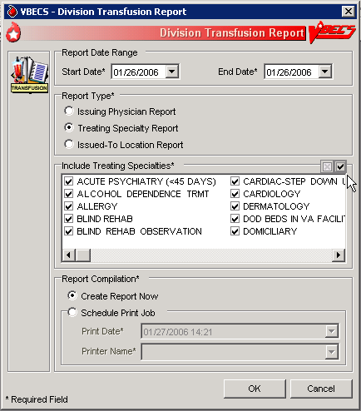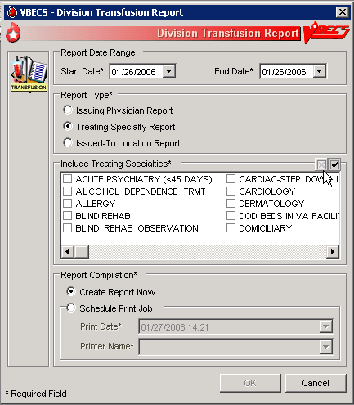

* BR\_20.17 In the Report Compilation area, click the **Create Report Now** radio button and **OK** to view the report, or click the **Schedule Print Job** radio buttonand **OK**, then enter or select a print date and printer name, then click **OK** to view and print the report.
* Reports are printed only in their entirety.
* BR\_77.02 A single-division report includes information from one division.
* BR\_104.02 When a site is a single division or a user does not have multidivisional access and a report has a multiple-division option, the user may not select a multidivisional report.
* BR\_27.10 VBECS maintains a cumulative history of all transactions, including testing and status changes, for every blood unit entered in the database (Unit History Report).
* BR\_12.02 VBECS captures changes to verified data for inclusion in an audit trail report (Audit Trail Report, Unit History Report, Patient History Report, and Order History Report).
* BR\_56.10 VBECS displays patient ABO/Rh results in reverse chronological order, regardless of division, then from the VistA database conversion. When no ABO/Rh records exist, VBECS displays “NR” (no records). When there are discrepant ABO/Rh results from the same universal ID (UID) or from two specimen UIDs, VBECS displays the results recorded just prior to the latest result that created the discrepancy and warns the user.
* BR\_49.05 When a search will return a large number of items on the report, VBECS notifies the user that the report will be longer than 50 pages and asks whether he wants to display and perhaps print the report. **Yes** notifies the user that the process will take a few minutes. **No** clears the screen and returns to the option’s main menu.
* BR\_49.07 When no information that fulfills search criteria is available, VBECS notifies the user that no information is available, per entered search criteria.
* BR\_77.01, BR\_77.03, BR\_77.05The user may change the default start and end dates (the previous day). The end date and time must be later than or the same as the start date and time. Report activity begins at and includes midnight on the start date, and ends at and includes midnight on the end date. When the date range includes the current date and time, VBECS displays “Preliminary” in the header on each page of the report.
* BR\_77.07 VBECS displays headers on every page of a report; it displays search and sort criteria and date ranges at the end of the report. VBECS identifies whether reports are generated from a test environment or from a production environment.
* BR\_77.11 A user may schedule a report to run and print in the future. When the activity date range includes a date that precedes the date and time of printing, VBECS processes the data on the date and time the report is scheduled to print. When a date range is greater than 30 days, VBECS warns the user and asks whether he wishes to continue.
* Local record retention policy instructs users to print, review, document, and save the Audit Trail, Exception, and Testing Worklist Reports. The reports contain only data entries generated in the user’s login division. BR\_77.08 Each entry includes an area for supervisor acknowledgement (signature or initials and date of review) and comment.
* The search functionality (binoculars icon) may not work in a displayed report. DR 2538
* BR\_85.06 When the processing technologist differs from the login technologist, the report includes both names.
* BR\_85.07 When the processing date differs from the data entry date, the report includes both dates.
* BR\_65.01 VBECS displays the patient historical ABO/Rh, antibodies identified, antigen negative requirements, and transfusion reaction history (date, division of testing, whether from the VistA database conversion), and whether the historical ABO/Rh was changed.
* BR\_65.02 When a patient has a history of an ABO/Rh change justified through Justify ABO/Rh Change, VBECS displays “History of justified ABO/Rh change” next to the historical ABO/Rh information.

Reports in VBECS are created using a Microsoft technology called SQL Server Reporting Services (SSRS). Reports are rendered on screen using ReportViewer control. Reports are not deployed on the reporting server but as a part of the main application. All reports can be exported. The user has the option to export reports in three different formats (PDF, Excel and/or Word).

## Report Toolbar DR 4581

Each report in VBECS will have a toolbar on top that allows the user to interact with the report (Figure 8). The following sub-sections elaborate on the controls found on the Report Toolbar. It is suggested that users create a local directory for exporting their reports (see the *VistA Blood Establishment Computer Software (VBECS) 2.0.0 Technical Manual-Security Guide*, Configure the Report Share and the Configure a Shortcut to the Report Share sections for more information).

Figure 8: Report Toolbar DR 4835



### Navigation Arrows and Report Pages DR 4761 DR 4589

Navigation arrows allow the user to move to the next or previous page of the report. If the user is on the first page of the report, the arrows pointing to the left will be disabled. If the user is on the last page of the report, the arrows pointing to the right will be disabled.

The first arrow button  moves the report by one page forward (or backward for left facing arrow). The second  moves the report to either the last or first page (in case of the left facing arrow). The number X of Y tells user which page is currently being viewed (X) and what is the total number of pages (Y).

### Report Layout

### DR 4835

There are two ways (layouts) in which reports can be displayed. By default, reports are displayed in Print Layout. It allows reports to appear on the screen exactly how they will look when printed. However when reports are displayed in Print Layout mode, the Report Search function (see Report Search) is disabled. In order to be able to use Report Search, the user has to turn off Print Layout mode by pressing this icon: . When Print Layout is disabled, the icon will look like this: . It can be pressed again to return to Print Layout mode.

Page size of reports not displayed in Print Layout mode differs from the regular letter size (8.5in. x 11in.) and that is why the total number of pages for the same report displayed in different layouts may differ.

### Report Zoom-in/Zoom-out

Clicking the drop-down menu showing 100% will give the user a choice of the report display size (Figure 9).

Figure 9: Report Zoom-in/Zoom-out Control

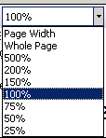

The default value is 100%. The option Page Width will resize the report to fit the screen horizontal size. The option Whole Page will display the entire page on the screen. Selecting an option less than 100% will zoom out the report making the font smaller and allowing more data to fit on the screen. Selecting an option higher than 100% will zoom in the report making the font bigger. If the report does not fit on the screen, the user will be able to use scroll bars to scroll up or down and left or right to view the entire report.

### Report Search DR 4835

This option allows the user to search for specific text in a report and is only enabled if Print Layout is disabled (see Report Layout). By default, the **Find** and **Next** buttons are disabled. Once the user enters text in the search box, the **Find** button becomes enabled (Figure 10).

Figure 10: Report Search Control



Clicking the **Find** button will search the entire report. If the searched text is found, the report will display the page where it was found. The **Next** button will then become enabled allowing the user to search for subsequent instances of the search string. If the searched text cannot be found, the user will be presented with the message shown in Figure 11.

Figure 11: Report Search Warning Message

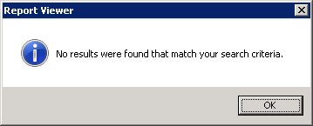DR 4589

### Report Export

The user has an option to export the report in three different formats: PDF, Excel and Word. The export to PDF creates a report that is Read-Only (may not be modified) and will match the report that users can see directly in VBECS in terms of data and format. The export to Excel and Word creates a report that may be modified. **VBECS reports exported to Excel or Word can be altered by a user. Only copies printed directly from VBECS should be shared with clinicians to ensure data integrity.**

**The data output from VBECS is not controlled by the medical device and must be strictly regulated by local facility personnel. Many of the reports contain patient sensitive information and must be treated as such. Use of the exported reports, including alteration of data, is the responsibility of the user.**

DR 4627

Export of the reports to Excel and Word comes with known problems. Reports exported to Excel or Word contain the same data as reports that can be seen directly in VBECS; however, their formatting may differ from the original report. Not all reports can be exported to all the identified formats. Table 3 lists the reports and their exportable formats.

Table 3: Exportable Formats for Reports

|  |  |  |  |
| --- | --- | --- | --- |
| **Report Name** | **PDF** | **Word** | **Excel** |
| Maintain Reagent Inventory | Yes | Yes | No |
| Testing Worklist Report | Yes | Yes | No |
| Blood Availability Report | Yes | Yes | No |
| Division Transfusion Report | Yes | Yes | No |
| Blood Bank Supplies Report | Yes | Yes | No |
| Unit History Report | Yes | Yes | No |
| Patient History Report | Yes | Yes | No |
| Other VBECS reports | Yes | Yes | Yes |

There is also a bug in Microsoft Word that causes the message “Word cannot start the converter MSWRD632.wpc” to display when opening files in Microsoft Word that were not created using Microsoft Word (e.g., a text file that was renamed as a .doc file). This message also shows for reports exported to Microsoft Word from VBECS. Microsoft published an article that describes the bug and steps on how to fix it ( <http://support.microsoft.com/kb/973904> ). The fix needs to be applied to the machine in which the exported reports are being opened and not to the VBECS application server. The PC used to view reports will get this error. Users can either click on the error to dismiss it each time an exported report is opened or apply the Microsoft hotfix to correct the issue.DR 4821DR 4627

By clicking on  , the user has the option to select and export to an Excel, PDF or Word file (Figure 12). Choosing any of these options will open the dialog shown in Figure 13. DR 4607

Figure 12: Report Export Toolbar



Figure 13: Example of Report Export Dialog with Assumption that Report Export Directory is D:\VBECSReports\

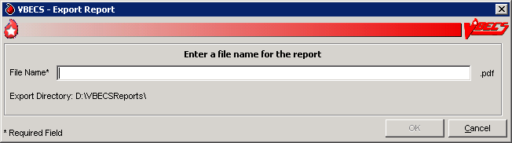

This dialog allows the user to specify the name of the file to which the report will be exported. The extension of the file is pre-filled for the user and depends on which export option was selected (.xls for Excel, .pdf for PDF or .doc for Word). The file name length is limited to 200 characters and will not accept special characters as part of the name (e.g., \ / ? % \* | : ’ ” < >).

If the user attempts to use a special character in the file name, it will be ignored and not appear on the screen.

Once the user enters a proper file name, the **OK** button will become enabled. Clicking the **OK** button will present the user with the message shown in Figure 14.

Figure 14: Report Exporting in Progress

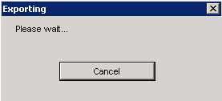

Clicking the **Cancel** button will stop the export and the user will be reverted back to viewing the report. If the export is successful, the user will be presented with the message shown in Figure 15.

Figure 15: Example of Report Exporting Success

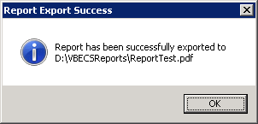

This dialog shows the full path to the report and its name allowing the user to find it quickly using Windows Explorer.

If the user enters the name of a report that already exists, the system will present the message shown in Figure 16.

Figure 16: Report File Already Exists

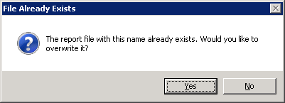

Clicking **Yes** will overwrite the existing file. Clicking **No** will allow the user to specify a new name.

### Copying an Exported Report

Here are some tips for copying a file or folder of files from one location to another.

**Before you begin:**

* Verify that you or the person copying the file has permissions to access both the folder you are copying files from and the folder you are copying the files to.
* Determine the type of file (i.e., PDF, Word or Excel) you want to use for your local document before you export. Do not change the file type during this process.

You may have a shortcut defined on your desktop that opens the report export folder on the server (Figure 17). This allows you to open files on the server on your local PC. It is the server’s D: drive, which is (Y) in this example.

Figure 17: Example of D: Drive



**Option One:** Drag and drop a copy of the file in “MY LOCAL FOLDER”.

This works well when you do not need to change the file name when placing it in your local folder.

1. When in ‘Windows Explorer’ (not Internet Explorer), left-click on the file and while holding down the mouse button, drag the file to the destination folder. The dark-blue “Admin Data Report 071514” is selected (Figure 18).

Figure 18: Example of Selection of "Admin Data Report 071514"



1. Release the left mouse button when hovering over “MY LOCAL FOLDER”. The file may copy without any notification or may have a copying window appear if it is a large file (Figure 19).

Figure 19: Example of a Copying Window



1. Skip to Step 3 of Option Two.

**Option Two:** Open the document and save a copy to another file.

1. Open the document from the server folder.
2. Select the **Save As** option and then the local folder, which in this example is called MY LOCAL FOLDER.

You may edit the file name at this point. The name you use for the file in your local folder should be something that allows you to manage those files as you use them. You can name the exported file accordingly or edit the file name in your local folder. A generic file name allows you to save and refresh the information. It may be appropriate for something like the Cumulative Transfusion Requirements report (Figure 20).

Figure 20: Example of File Name



You may also opt to save with a date in the file name to allow a snapshot report for historic purposes (Figure 21).

Figure 21: Example of Dated File Name



1. Verify that “MY LOCAL FOLDER” contains the saved file. You can edit and save to this folder with those changes (Figure 22). Unlike the server file, you may also delete this file.

Figure 22: Example of Saved File

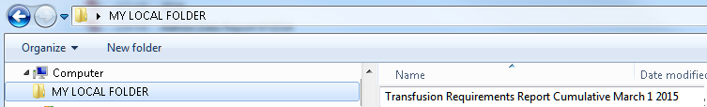

**Note:** The copy of the file you save to your local folder is separate and does not update the file in the server folder.

## Using VBECS

VBECS is a Windows-based application.

One VBECS system is implemented for each VistA database.

Subject matter experts (SMEs) at user sites will help implement VBECS and train blood bank staff and other authorized users.

The VA Software Document Library (VDL) site contains VBECS user documents (<http://www.va.gov/vdl/application.asp?appid=182>).

The VBECS Sharepoint site contains training, Frequently Asked Questions (FAQs), Technical Bulletins, ListServ messages and sign up, etc. to support the implementation and use of VBECS (<http://vaww.oed.portal.va.gov/projects/vbecs/default.aspx>). Users may access links to VBECS training modules and frequently asked questions, and join a ListServ (an email distribution list to manage discussion groups) for announcements and updates on the VBECS Sharepoint site. Contact information is provided for comments and questions.

#### Documentation

Users may retrieve VistA documentation from the VistA Documentation Library (VDL) Web page.

## Using Online Help

Select **VBECS Help** from the Help menu (Figure 23) to view a directory of help contents (Figure 24).

Figure 23: VBECS Help

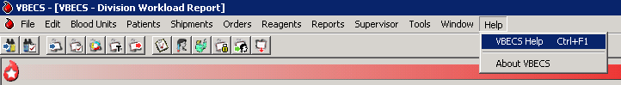

Figure 24: Example of VBECS Online Help Contents

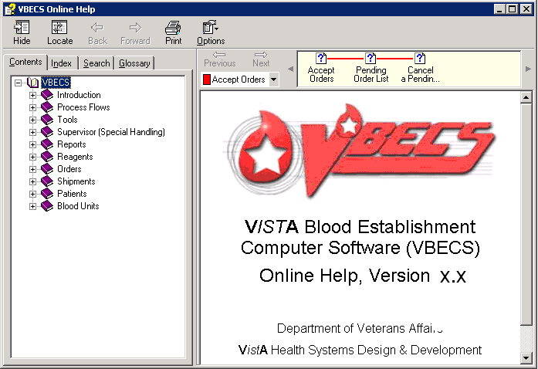

Press the **F1 key** to view screen-specific help (Figure 25). Click text in blue to expose more information.

Figure 25: Example of Screen-Specific Online Help

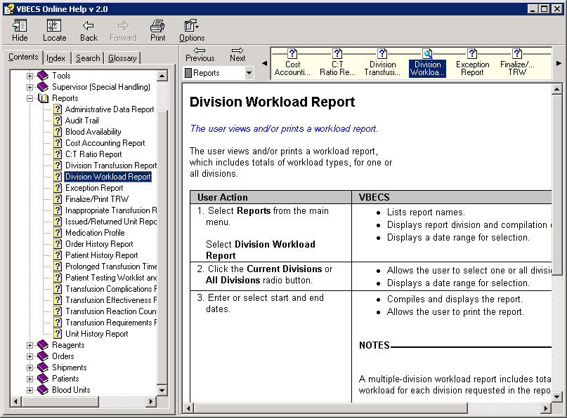

### Contents Tab

Click the **Contents** tab in the navigation panel on the left to display categories of VBECS functions. Click a plus sign (+) to view the topics in each category. Click a topic preceded by a question mark to view information on that topic on the right (Figure 26). Click a minus sign (–) to condense a list.

Figure 26: Using the Contents Tab

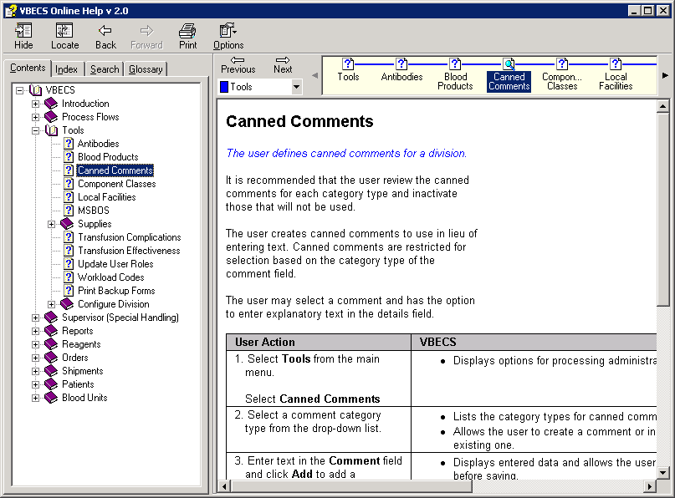

### Index Tab

Enter a keyword (or one or more letters of a keyword) in the text box to find a topic. Double-click the topic to view the topic on the right (Figure 27).

Figure 27: Using the Index Tab

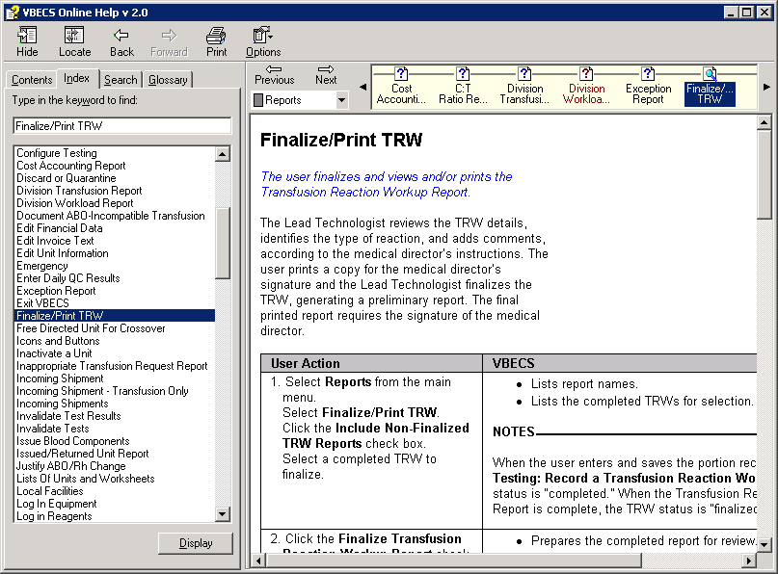

### Search Tab

Enter a keyword or phrase in the text box and click **List Topics**. Select a topic and click **Display**, or double-click the topic. The topic appears on the right; each instance of the keyword entered is highlighted (Figure 28). (To turn the highlight feature on or off, click **Options** at the top of the screen. Click **Search Highlight On** or **Search Highlight Off**.)

Figure 28: Using the Search Tab

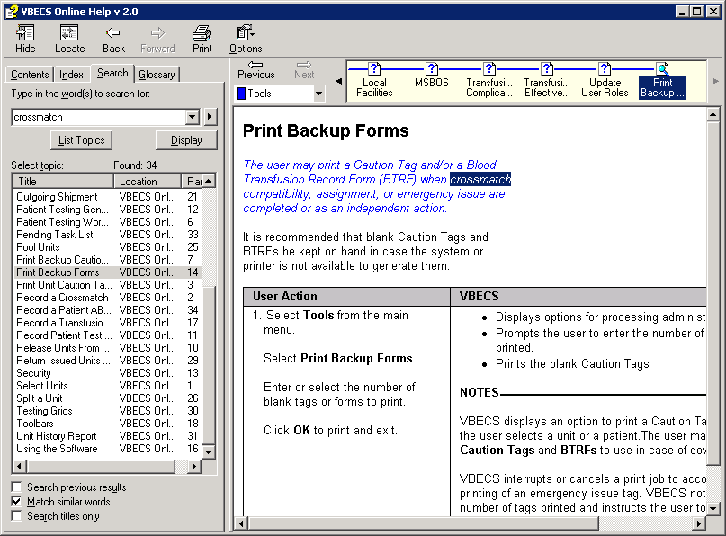

### Glossary Tab

Click and drag the scroll bar up or down to find a word or phrase. Click the word or phrase to display a definition at the bottom (Figure 29).

Figure 29: Using the Glossary Tab

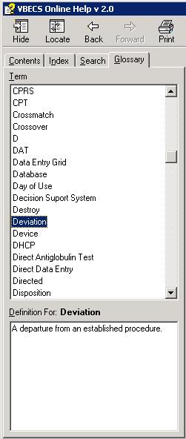

## Viewing the VBECS Version Number DR 4991 Task 1297

In earlier VBECS patch releases, the user documentation referred to the VBECS version in a 4-digit format (e.g., 2.0.0.2 – where 2.0.0 represents the patch version and the last 2 is the patch build number). The build number is used by VBECS Product Support for diagnostic and troubleshooting purposes.

The VBECS version will be represented with only the first three digits (e.g., 2.0.0) and will appear that way in all user documentation to simplify readability. The full 4-digit version can still be found under the **Help**, **About VBECS** window in VBECS (Figure 30 and Figure 31) and will appear in patch installation guides where build specific files are referenced. The revision letter tracks database-only updates (e.g., blood product table updates, canned comments updates). The revision letter is normally a single alpha character (e.g., C), but can be two characters (e.g., AA, AB, AC) in the unlikely event that more than 25 database updates are made before a code change is implemented. The revision letter starts at A with each new code release which means that when the first database-only update is made, it is incremented to B. The revision letter is then updated by one character in the alphabet for every successive database-only update until a new code release is implemented at which time the revision letter reverts back to A.

The VBECS **Help**, **About VBECS** window displays the release number (e.g., 1.5.0), the build number (e.g., 1.5.0.4) and the revision letter (e.g., Revision A).

When a version number is incremented, each number set is considered independent of the others. For example, “1.10” follows “1.9,” even though 1.10 is arithmetically smaller than 1.9. The exception to this rule is when a new release is started. The four-digit set is separated by decimal points. The first number is the Major release number. The second number is the Minor release number. The third number is the Patch release number. The fourth number is the Build number.

* At a major release start, the major number is incremented by one, the minor and patch numbers return to zero, and the build number returns to one (e.g., 1.7.0.4 🡪2.0.0.1).
* At a minor release start, the major number remains the same, the minor number is incremented by one, the patch number returns to zero, and the build number returns to one (e.g., 1.5.1.2 🡪1.6.0.1).
* At a patch release start, the major and minor numbers remain the same, the patch number is incremented by one, and the build number returns to one (e.g., 1.6.0.3 🡪1.6.1.1).

Figure 30: About VBECS

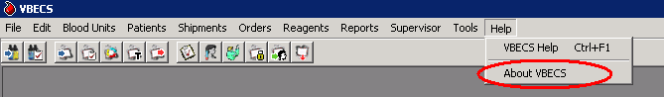

Figure 31: Example of VBECS Version and Build Numbers DR 4991

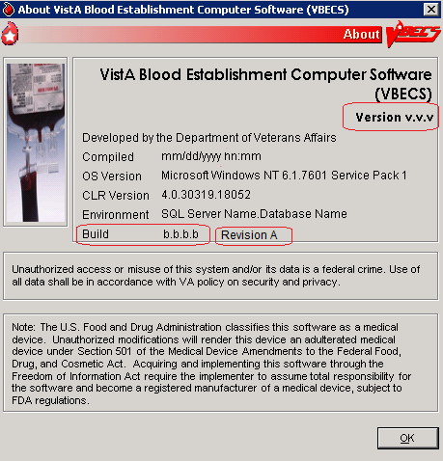

## VistA Records in VBECS

Historic VistA blood bank records were transferred to VBECS and validated during the database conversion. VBECS handles these records in accordance with system rules:

VBECS does not store or display patient name prefixes or suffixes from VistA. DR 3424

Patient names in VistA that exceed the database standard for File #2 (30 characters) or do not have a first or last name do not convert to VBECS.

* VBECS may display patient information differently from VistA. For example, VBECS displays patient names as “LAST NAME, FIRST NAME, MIDDLE NAME or INITIAL.”
* VBECS will truncate Special Instructions (SIs) text from the VistA database conversion.
* BR\_3.05 VBECS displays historic ABO/Rh types from the database conversion, but doesn’t use them for issuing blood or for comparing test results.
* BR\_37.05 SIs from database conversion entries are labeled as such.
* VistA SIs from the database conversion may include component or antigen negative requirements. The VistA SIs remain SIs and are not enforced unless they are entered in the Transfusion Requirements tab in Special Instructions & Transfusion Requirements.
* Patient antibody identifications from VistA are included in the database conversion.
* Antigen negative requirements properly set in VistA will be transferred to antigen negative requirements in VBECS.
* BR\_65.03 VBECS informs the user when the displayed historical ABO/Rh, transfusion reaction history, and/or antigen typing result from the database conversion.
* Transfusion reaction types without their associated units are transferred to VBECS.

## Accessing the System

### Log Into VBECS and VistA UC\_18, UC\_102

A user may work in only one division at a time. After login[[2]](#footnote-2), a user with access privileges in several divisions may change divisions. There is no option to change divisions in a single-division installation. A user must have access privileges in at least two divisions to change divisions.

#### Assumptions

* The user’s role is configured in both VistA and VBECS. (See Update User Roles.)
* BR\_18.01 A user must be associated with at least one division to gain access to VBECS.
* BR\_18.04 VBECS allows access only to valid divisions associated with the user.

#### Outcome

* A user is logged into the selected division.

#### Limitations and Restrictions

* BR\_18.05VBECS automatically logs a user with access to only one division into that division.

#### Additional Information

* It is recommended that local policy limit a user to only one VBECS session per terminal.
* The user may log into multiple terminals simultaneously.
* A user with multidivisional access privileges may change divisions during a VBECS session.
* BR\_102.03 VBECS provides an interface (VistALink) with VistA to allow the user to log onto VistA(not required for most options; see the list of options that use VistALink in Hardware and Infrastructure Architecture). VBECS checks the characters in the Access and Verify Codes and warns when there are fewer than six characters or when a semicolon (;), colon (:), or caret (^) is entered. VBECS sends the entered Access and Verify Codes to VistA. VistA checks the codes and responds to VBECS with a message stating whether the entered Access and Verify Codes are invalid or valid for the user attempting to log on. VBECS warns when VistA does not accept the Access and Verify Codes entered.
* BR\_102.05 After a number of unsuccessful attempts to log onto VistA (defined in VistA server settings), the VistA server terminates the logon session and displays a message prompting the user to log onto VistA again.
* BR\_102.01 The user initially logs onto VistA by entering VistA Access and Verify Codes. The system reuses the security credentials (VistA Access and Verify Codes) initially entered in the user’s session to perform VistA logoff and logon without user interaction.
* After 15 minutes of inactivity, VBECS disconnects the user from the server. When the user logs back in, he will see the last screen he worked on. After 30 minutes of inactivity, work done after the last save will be lost. The user must log in and start over.

#### User Roles with Access to This Option

All users

#### Log Into VBECS

| **User Action** | **VBECS** |
| --- | --- |
| 1. To log into VBECS, double-click the **Remote Desktop Connection** **icon** on the Windows desktop. | * Displays the Remote Desktop Connection screen. |
| 1. Enter or select the name of the VBECS server on the **Remote Desktop Connection** (Figure 32) screen and click **Connect**. | * Displays Security Warning screen. |
| 1. Click **OK** on the Security Warning screen. | * Displays Log On to Windows screen. |
| 1. Enter your user name, password and domain (log on to field) on the Log On to Windows screen.   Click **OK**. | * Displays VBECS server desktop with VBECS.exe, VBECS Test.exe, VBECS Administrator.exe, and VBECS Administrator Test.exe icons.   **NOTES**  Users with VBECS Administrator access can select to start VBECS administrator or VBECS. |
| 1. Click on the **VBECS.exe** or **VBECS Test.exe** icon to access VBECS. | * Displays the Select Division screen when the user has access privileges to multiple divisions in a single VBECS installation.   **NOTES**  BR\_18.08 A user may exit without logging into a division. BR\_103.03 |
| 1. Multidivision users will be prompted to select a division from the **Select Division** list and click **OK**, or double-click the division. | * BR\_18.10 Displays an error message to the user when logging into VBECS, or switching divisions, if the default printer for the division was removed.DR 2,884   **NOTES**  When VBECS is started, the user may have access to more than one division. |
| 1. Continue to the VistA logon screen (Figure 33). | * Opens the VistA Logon – Authorization screen. The user may log onto VistA or continue and log on as needed. * Displays a division login message.   **NOTES**  BR\_103.03 VBECS allows the user to log in without establishing a VistALink connection.  The division login message allows the display of data as each user logs into his division. When no login message text is entered, VBECS does not display a login message. |
| 1. Log onto VistA at VBECS startup or at the invocation of any option that uses VistALink when VistALink is not connected. | * BR\_102.06 Allows a user to log on by entering VistA Access and Verify Codes, separated by a semicolon (;), in the Access Code data entry field. * BR\_103.01 When a user accesses an option that requires a VistALink connection and the connection becomes unavailable, allows the user to restore the connection. * BR\_103.04 When a reconnection attempt is successful, VBECS closes the connection status window and returns to the desktop. The VistALink Connected icon in the status bar indicates a successful connection. When a reconnection attempt is unsuccessful, VBECS attempts to reconnect to VistALink until the user cancels.   **NOTES**  DR 1,116When a user logs into VBECS, the connection to VistA is established, and the data in the cache tables are out of date, VBECS retrieves the current data from VistA and saves them. This update process may delay user login.  BR\_103.02 When the VistALink connection is not restorable, VBECS displays a message stating that the requested use cannot be executed because VistALink is unavailable. |
| 1. Enter the VistA Access and Verify Codes. | * BR\_102.02 Verifies that the user credentials for the VBECS and VistA Access and Verify Codes belong to the same user. * BR\_102.09 VBECS will attempt to resend queued DSS information when VistALink is available after any user logs in. * Emits a tone to verify that the workstation’s sound works. |
| 1. Continue working in VBECS in the selected division. | * Displays the main menu. |
| 1. Users with multidivisional access: to change division, select **File**.   Select **Change Division**.  Continue at Step 2. | * Ensures that there are no incomplete activities for the user’s session. * Displays a division login message. * Opens the selected division.   **NOTES**  BR\_18.06 A user may log into or change divisions without being logged onto VistA.  BR\_18.02, BR\_18.09 VBECS displays a message advising the user to close dialogs and transactions with pending data changes, and closes open dialogs with no pending data changes before the user changes division.  BR\_102.04 VBECS automatically logs onto VistA for the selected division. |

Figure 32: Remote Desktop Connection Options

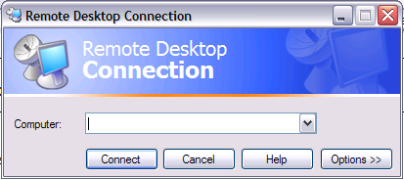

Figure 33: VistA Logon

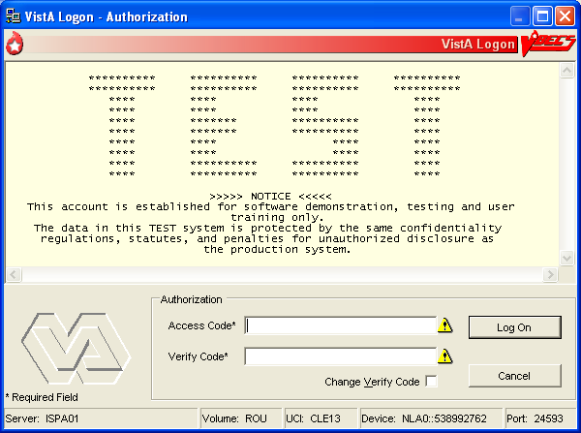

#### Restore VistA Connection UC\_103

When a user is logged into a VBECS division and a VistA connection is not in place, VBECS attempts to reconnect.

#### Restore VistA Connection

| **User Action** | **VBECS** |
| --- | --- |
| 1. Attempt to use a VBECS option that requires a connection to VistA for data retrieval. | * Displays a message that the VistA connection is not available and asks whether the user wishes to attempt to reconnect. * Allows the user to enter his VistA logon information. |
| 1. Enter personal logon information or cancel. | * Attempts to connect using the user’s information when logon information is entered. * When a connection is achieved, closes the pop-up and takes the user to the selected option. * When a successful connection cannot be achieved, does not allow the user to continue in the option. * Closes the pop-up when the user clicks **Cancel**. |
| 1. Continue in the selected option. |  |

### Exit VBECS

A user may shut down the VBECS session.

#### Shut Down VBECS

| **User Action** | **VBECS** |
| --- | --- |
| 1. To shut down VBECS, select **File**, **Exit VBECS**.   Click **Yes** at the prompt. | * Exposes the server desktop. |
| 1. Select **Start**, **Log Off**.   At the prompt, select **Log Off** or **Cancel**. | * Shuts down the session. * Terminates open applications. |

### Screen Settings

 VBECS was designed to operate with the settings described in this section to display complete screens. Failure to maintain these settings may result in partial display of safety-critical information.

#### Local Machine Screen Resolution

 Set the local machine’s desktop resolution to 1024 by 768 pixels or higher for optimal display. DR 3738

To adjust the resolution of the screens that you view:

1. Click **Start**, **Settings**, **Control Panel**.
2. Click **Appearance and Themes**.
3. Click **Change the screen resolution**.
4. Select the **Settings** tab(Figure 34).
5. Click, hold, and slide the pointer to a screen resolution of 1024 by 768 pixels.
6. Click **Apply**.
7. Click **OK** to save the setting.

Figure 34: Local Machine Screen Resolution

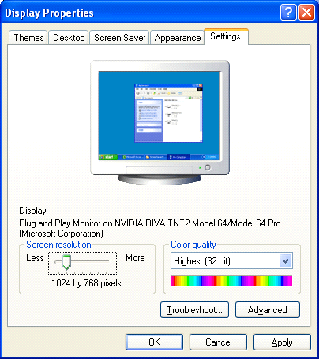

#### Remote Desktop Connection Screen Size

 The Remote Desktop Connection desktop size must be set to “Full Screen.”

To adjust the dimension of the screens that you view:

1. Double-click  the VBECS (**Remote Desktop Connection icon**) located on the local workstation desktop. DR 3738
2. Click **Options** (Figure 35).

Figure 35: Remote Desktop Connection Options



1. Click the **Display** tab (Figure 36).

Figure 36: Remote Desktop Connection Remote Desktop Size

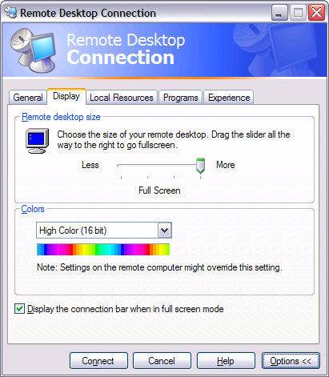

1. Click, hold, and slide the pointer to the right until “Full Screen” appears.
2. Click on the **General** tab. DR 3738
3. Click **SAVE** to save the setting.

### Screen Display

A *window* is the section of the screen that displays the active application or file.

Click the control buttons in the upper-right corner (Figure 37) of an open file or application window to:

* Minimize: reduce the window to appear as a button (rectangle) at the bottom of the screen. Click the button to enlarge the window to its original size.
* Maximize: enlarge a window to fill the entire screen
* Restore: return a window to a smaller size that can be adjusted (Figure 38)
* Close: shut down a document or application quickly

 Maximize option windows to display safety-critical information in full. UserDoc Task 1124.

Figure 37: Resize or Close a Window Figure 38: Restore a Window





Close

Minimize

Maximize

When a window is partially displayed or freezes; or when you move from one window to another, enter information, return to the original window, and the entered information is not available, minimize then maximize the window to refresh it.

To resize an open window:

* Make sure the Maximize symbol is visible.
* Change the width: move the mouse cursor to the left or right window border until the pointer changes into a horizontal double-headed arrow, then drag the border to the right or left.
* Change the height: move the mouse cursor to the top or bottom window border until the pointer changes into a vertical double-headed arrow, then drag the border up or down.
* Change the height and width together: move the mouse cursor to any window corner until the pointer changes into a diagonal double-headed arrow, and then drag the border in any direction.

A maximized window cannot be resized or moved.

To move a window, click the dark blue bar at the top of the window. While depressing the mouse button, drag the window to the desired position.

Select **Help**, **VBECS Help**, or press F1 at any time for screen-specific online help.

The first time a user opens a form [such as the Blood Transfusion Record Form (BTRF)], VBECS displays it in cascade style. When a user opens the form again, VBECS displays it in the size and position last selected.

Forms can be resized and moved in the same way that windows are resized and moved.

### Sound

To enable sound on Remote Desktop Connection:

1. Double-click  (the **Remote Desktop Connection icon**).
2. Click **Options** (Figure 39).
3. Click the **Local Resources** tab.
4. Select **Bring to this computer** from the Remote computer sound drop-down list.

Figure 39: Remote Desktop Connection Remote Computer Sound

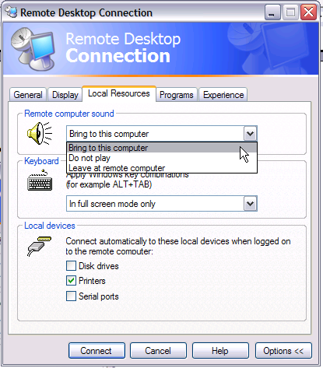

1. Click the **Experience** tab.
2. Select **LAN** from the **Choose your connection speed to optimize performance** drop-down list (Figure 40).

Figure 40: Remote Desktop Connection Choose Connection Speed

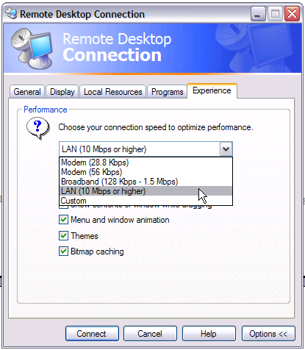

1. Click **Connect**.

### Volume

Do not change volume settings unless alerts are inaudible (muted) or low.

VBECS uses sound as one way to alert users. To restore the volume setting on your workstation so that alerts are audible:

1. Click **Start**, **Settings**, **Control Panel**.
2. Click **Sounds, Speech, and Audio Devices**.
3. Click **Sounds and Audio Devices**.
4. Select the **Volume** tab(Figure 41).
5. Click, hold, and slide the pointer to adjust the volume.
6. Click **OK** to save the setting.

Figure 41: Sounds and Audio Devices: Volume

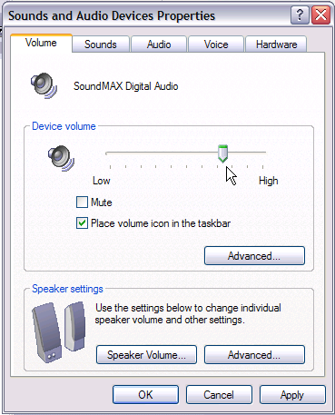

### Keyboard Shortcuts for Windows

Using a mouse to navigate VBECS requires fewer steps than using the keyboard. A user who prefers using the keyboard may refer to these keyboard shortcuts. Keys preceded and/or followed by “+” indicate that they must be pressed simultaneously:

Keyboard navigation of VBECS does not accommodate the presentation of error providers or tool tips. A mouse is required to reveal this information as needed. DR 3590

#### CPRS and VBECS

* Toggle between **VBECS** and **CPRS** or another application: **Alt** + **Tab**

#### Menus

* Display the **Start** menu (use the arrow keys to select an item): **Alt** + **Home**
* Start VBECS online help: **F1**
* Activate a menu bar option: **F10**
* Open a menu: **Alt** + underscored letter
* Move to and select a menu item: Arrow key + **Enter**
* Open a submenu item: **Shift** + letter (case insensitive)
* Open a drop-down menu: **Alt** + down arrow key
* Close a drop-down menu: **Alt** + up arrow key
* Display a shortcut menu for the selected item: Application key (http://msdn.microsoft.com/library/en-us/dnacc/html/atg_keyboardshortcuts_10.gif)

#### Buttons, Check Boxes, and Fields

* Move to and select fields and buttons: **Tab** + **Enter**
* Select or clear a check box: **Tab**, arrow key (or **Alt** + underscored letter), spacebar
* Select or clear a radio button: **Tab**, arrow key (or **Alt** + underscored letter)

#### Windows

* Display the **Control** window to restore, move, resize, minimize, maximize, or close the window: **Alt** + **Delete**
* Switch between a window and a full screen: **Ctrl** + **Alt** + **Break**
* Close the current window: **Alt** + **F4**
* Display the **Windows Security** dialog box to lock the computer, log off, shut down, change a password, and access **Task Manager**: **Ctrl** + **Alt** + **End**

#### Screen Prints

* Place a snapshot of the desktop on the local clipboard and paste it in another application: **Ctrl** + **Alt** + Plus (+ on the numeric keypad; **Ctrl** + **V** to paste)
* Place a snapshot of the active window on the local clipboard and paste it in another application: **Ctrl** + **Alt** + Minus (**–** on the numeric keypad; **Ctrl** + **V** to paste)

### Drop-Down Menus

A *drop-down menu* may appear when a button is clicked or text is selected. Click or hold the mouse pointer over an item in a drop-down menu to reveal other items and submenus. Press an underscored letter (mnemonic) to select a menu item. To view underscored letters:

1. Click **Start** at the bottom left of the screen.
2. Click **Settings**.
3. Click **Control Panel**.
4. Double-click **Display**.
5. Click the **Appearance** tab.
6. Click **Effects**.
7. Clear the **Hide underlined letters for keyboard navigation until I press the Alt key** check box.
8. Click **OK** to save the setting.
9. Click **OK** to close the Display Properties window.
10. Close the Control Panel.

A  (submenu arrow) next to a menu item indicates that a submenu is available. An option that is not available to a user is visible but grayed out.

### Tool Tips

A *tool tip* is a description or explanation that appears when the mouse pointer is held over (not selected or highlighted) a tool, button, or other object (without clicking a mouse button).

When a tool tip does not appear, wait a few moments, then reposition the mouse pointer over the tool, button, or other object. If necessary, exit and reenter the window.

Tool tips appear with:

* Some control buttons
* Icons in the Patient Information Toolbar

Text enclosed in angle brackets (< >) in tool tips and messages will change to reflect the current activity.

The user may click column headings in some data displays, such as the Pending Task List, Pending Order List, and Select Units, to sort the information in those columns.

### Icons and Buttons

VBECS uses several types of images to help you move through the system:

* *Icons* represent objects (information used in an application). The rectangular area in the lower right corner of the screen (system tray) contains icons of programs that always run in the background, such as the clock.
* *Buttons* are icons that represent tools or commands.
* *Radio buttons* are small circles preceding text. Related radio buttons are grouped together. Only one button in a group may be selected: clicking a button turns the other radio buttons off.

### Toolbars

A *tool* is a shortcut button, usually shown on a bar near the top of a window. Tools provide quick access to commonly used functions. A *toolbar* displays groups of tools. Toolbars may contain buttons, menus, or combinations of both. (See also Patient Information Toolbar.)

A toolbar with tools for several options (Main Toolbar) appears near the top of the screen.

Click a tool to open a function quickly.

A function may also be opened by pressing **Alt** and the **key for the underscored letter** in the tool name.

#### Main Toolbar

The *Main Toolbar* appears at the top of the screen. Click the icons in the Main Toolbar to access[[3]](#footnote-3):

[](#_Log_In_Reagents,_Update Inventory, ) Log In Reagents

[](#_Enter_Daily_QC_Results) Enter Daily QC Results

[](#_Incoming_Shipment) Incoming Shipment

[](#_ABO/Rh_Confirmation) ABO/Rh Confirmation

[](#_Modify_Units) Modify Units

[](#_Unit_Antigen_Typing) Unit Antigen Typing

[](#_Outgoing_Shipment) Outgoing Shipment

[](#_Accept_Orders:_Accept) Accept Orders: Accept an Order

[](#_Maintain_Specimen_1) Maintain Specimen

[](#_Patient_Testing:_Record_1) Patient Testing

[](#_Select_Units_1) Select Units

[](#_Issue_Blood_Components) Issue Blood Components

[](#_Post-Transfusion_Information) Post-Transfusion Information

Clicking an icon in the Main Toolbar saves a step: it’s the same as clicking the main menu item, and then on the option.

VBECS uses tree views to displays list items. Click a plus sign (+) to expand a list. Click a minus sign (–) to condense a list.

## Patient Information Toolbar

The *Patient Information Toolbar* appears in the active window when a patient record is displayed. VBECS displays only the icons appropriate to the option. Click the icons in the Patient Information Toolbar to display:

[small_blood_availability](#_Blood_Availability_UC_49) a Blood Availability Report (Blood Availability) UC\_49

[small_patient_medications](#_Medication_Profile_UC_46) a patient’s current medication profile (Medication Profile) UC\_46

[small_recent_orders](#_Patient_Information_Toolbar:_Recent) a patient’s recent orders (Recent Orders) UC\_65

[small_si_tr](#_View_Special_Instructions_and Trans) a patient’s Special Instructions and/or Transfusion Requirements (View Special Instructions and Transfusion Requirements) UC\_36

[small_transfusion_history](#_Patient_Information_Toolbar:_Recent_1) a patient’s recent transfusion history (Recent Transfusions/Issued Units) UC\_65

[small_transfusion_reactions](#_Patient_Information_Toolbar:_Transf) a patient’s transfusion reaction history (Transfusion Reaction History) UC\_65

[small_blood_availability](#_Blood_Availability_UC_49)

### Patient Blood Availability

The user views blood products available to a patient. The Blood Availability Report does not include unassigned, restricted blood products. To view unassigned, restricted blood products and other custom reports, see Blood Availability.DR 1,041

### small_patient_medications Medication Profile UC\_46

The user views a patient’s current medication profile.

#### Assumptions

* The connection to VistA is active.

#### Outcome

* VBECS displays a patient’s current medications.

#### Limitations and Restrictions

* None

#### Additional Information

* The user may access CPRS for additional information on a patient medication order.
* These data are accessible to the user through the Patient Information Toolbar on all patient-specific screens.

#### User Roles with Access to This Option

All users

#### Medication Profile

At the user’s request, VBECS queriesVistA to search for active prescriptions within a user-specified time frame or a default time frame of six months, regardless of division, in a multidivisional database.

| **User Action** | **VBECS** |
| --- | --- |
| 1. Select **Reports** from the main menu.   Select **Medication Profile.**  Select a patient, or  Select an option that displays the Patient Information Toolbar.  Click small_patient_medications to view a patient’s current medication list. | * Lists report names. * Displays the report date range, sections, and compilation criteria. * Displays options for processing patient-related functions. * Compiles the active patient identification data.   **NOTES**  BR\_46.02 The user may edit the default start date (six months before the current date) for the patient medication search. |
| 1. Accept or edit the default start and end dates. | * Displays each medication name status, order number, and issue/start date returned from the VistA query. * BR\_46.04 When a query does not return any medications, notifies the user that he may repeat the query with a different date range. |
| 1. View the display. When desired, go to Step 1 to repeat the query, | * Allows the user to print the displayed patient medication profile. |
| 1. Print the profile or click **Cancel** to exit. | * Displays and prints the medication information profile. |

### small_si_tr View Special Instructions and Transfusion Requirements UC\_36

The user views patient-specific Special Instructions (SIs) and Transfusion Requirements (TRs).

#### Assumptions

* SI entries were created through Special Instructions & Transfusion Requirements: Enter a Special Instruction or from database conversion.
* TR entries were entered through Special Instructions & Transfusion Requirements: Enter a Transfusion Requirement or Patient Testing: Enter Antibody Identification Results.

#### Outcome

* VBECS displays a patient’s SIs and TRs.

#### Limitations and Restrictions

* Changing a patient's antigen negative requirement or antibody identified after a unit is crossmatched does not provide an alert at Issue Unit regarding the type of crossmatch (electronic or serologic) performed on a unit available for issue.

#### Additional Information

* VBECS displays a patient’s known antibodies in all divisions in a multidivisional database. VBECS does not restrict viewing SI and TR entries by division; they are linked to the patient’s record and not to an order, a specimen, or a unit.
* VBECS does not enforce SIs; VBECS enforces TRs and persistent antigen negative requirements throughout the database.

#### User Roles with Access to This Option

All users

#### View Special Instructions and Transfusion Requirements

The user views a patient record. When SIs and TRs are available for the patient, VBECS activates the Patient Information Toolbar icons. VBECS alerts the user when a patient’s record includes SIs and TRs.

 It is highly recommended that the user click every active icon when reviewing patient data.

| **User Action** | **VBECS** |
| --- | --- |
| 1. Select **Patients** from the main menu.   Select **Special Instructions & Transfusion Requirements**, or  Click small_si_tr in the Patient Information Toolbar, when it is active. | * Displays options for processing patient-related functions. * Displays the option to select a patient, when one is not already selected.   **NOTES**   When a patient’s VBECS record includes an active TR, SI, or antigen negative requirement, VBECS emits an audible alert and notifies the user by enabling the icon. |
| 1. Select a patient and click **OK**.   View the data.  Click **OK** to continue. | * Displays the data.   **NOTES**  BR\_36.02 VBECS displays active TRs to all divisions within a multidivisional database.  BR\_36.07 VBECS alerts the user when an active TR, SI, or antigen negative requirement is in a patient’s record.  BR\_38.08 VBECS displays component requirements to all divisions in a multidivisional database. No division allows issue until requirements are met.  BR\_36.05, BR\_36.06 When VBECS displays the Patient Information Toolbar, it calculates the overall compatibility percentage of units to be screened to find compatible units.  DR 4503 The compatibility percentage displayed is based on the following calculation:  Type Specific ABO % x Antigen compatibility % as defined in Antibodies equals % compatible.  For example, if a patient is A Positive and has both Anti-E (compatibility percentage = 75%) and Anti-K (compatibility percentage = 91%) antigen negative requirements, the percentage of the population considered compatible for this patient would be .45 x .75 x .91 = .30 (rounded).  Rh type of the patient is not used in the calculation when the patient does not have an Anti-D as Rh Pos or Rh Neg units may be screened.  The blood type percentages in VBECS are as follows and are general percentages for the American population: A is 45%, B is 15%, AB is 6% and O is 45%. |
| 1. Select another patient and return to Step 2, if desired. |  |
| 1. Click **OK** to exit. |  |

### View Recent Orders, Recent Transfusions/Issued Units, and Transfusion Reaction History

The user views portions of a patient’s data previously recorded in VBECS in three formats: recent orders, recent transfusions/issued units, and transfusion reaction history.

#### Assumptions

* A VBECS record must be established for a patient in this database in at least one division, if multidivisional.

#### Outcome

* The user views:
* A patient’s active order data (recent orders).
* A patient’s transfusions and currently issued units (recent transfusion history).
* A snapshot of the patient’s VBECS clinical record (transfusion reaction history).

#### Limitations and Restrictions

* None

#### Additional Information

* None

#### User Roles with Access to This Option

All users

### small_recent_orders Patient Information Toolbar: Recent Orders UC\_65

The user views current (pending and active) order data (including reflex tests), which include clinical data from all divisions within a multidivisional database.

| **User Action** | **VBECS** |
| --- | --- |
| 1. In the Patient Information Toolbar, click small_recent_orders to view the patient’s recent orders. | * Allows the user to click an icon to view a patient’s recent orders.   **NOTES**  BR\_65.08 When the user selects small_recent_orders, VBECS displays all orders associated with the selected patient, including open orders and orders placed and processed within the last 14 days.  Diagnostic Test orders sort and display by the date the order was placed in CPRS. Component orders sort and display by the date the order was accepted in VBECS.  Orders with a status of Canceled, Completed, Expired or Filled are not displayed in this view. See Order History Report. DR 2218 DR 3727 |
| 1. View the data and click **Close** to exit. |  |

### 

### small_transfusion_history Patient Information Toolbar: Recent Transfusions/Issued Units UC\_65

The user views transfused and currently issued units for a patient.

| **User Action** | **VBECS** |
| --- | --- |
| 1. In the Patient Information Toolbar, click small_transfusion_history to view the recent transfusion history. | * Allows the user to click an icon to view a patient’s recent transfusion history.   **NOTES**  BR\_65.07, BR\_65.09 When the user selects small_transfusion_history, VBECS displays blood units issued and transfused within the last seven days in reverse chronological order. The date and time issued or the location issued to does not display.DR 3666 |
| 1. View the data and exit. |  |

### small_transfusion_reactions Patient Information Toolbar: Transfusion Reaction History UC\_65

The user views a snapshot of the patient’s transfusion reaction record.

| **User Action** | **VBECS** |
| --- | --- |
| 1. In the Patient Information Toolbar, click small_transfusion_reactions to view the transfusion reaction history. | * Allows the user to click an icon to view a patient’s transfusion reaction history.   **NOTES**  BR\_65.03, BR\_65.05 When the user selects small_transfusion_reactions, VBECS displays all transfusion reaction entries in the database. |
| 1. View the data and exit. |  |

#### Main Status Bar

The following icons are displayed in the main status bar:

small_order_alert The Order Alert icon blinks three times and remains visible when orders are added to the system. Hold the mouse pointer over the icon to see order information. Click the associated button to open the Pending Order List. DR 4963

small_patient_alert The Patient Alert icon flashes three times and remains displayed when patient information is updated. Hold the mouse pointer over the icon to see what type of patient change occurred. Click the associated button to view updated patient information.

small_vistalink The VistALink icon indicates that the connection to VistA is active.

small_vistalink_fail The VistALink Failure icon indicates that the connection to VistA is severed.

#### Throughout VBECS

small_delete The Delete/Invalidate icon appears on buttons that cause entries to be deleted or invalidated in the database.

☑ Click to select all items in a list.

**** Click to clear all items in list.

Click the **find** button to display a list of items for selection.

small_print Click the **Print** icon’s associated button to print a document.

small_save Click the **Save** icon’s associated button to update the database.

small_scanner The Scanner icon indicates which screen prompts permit scanned entries.

small_search Click the **Search** icon’s associated button to search for entries meeting search criteria entered.

small_view_order Click the **Order Details** icon’s associated button to display the full details of a selected order.

small_warning The Input Error icon indicates that a user made an invalid entry at a screen prompt. The icon appears and flashes next to the invalid entry. Hold the mouse pointer over the icon to see a message explaining the problem. Enter valid information to make the icon disappear.

## Other VBECS Functions

### Collecting Workload UC\_15

In some options, VBECS collects workload (statistical data used to calculate productivity) when the user saves data:

* ABO/Rh Confirmation
* Discard or Quarantine
* Document ABO Incompatible Transfusion
* Edit Unit Information
* Enter Daily QC Results
* Finalize/Print TRW
* Free Directed Unit For Crossover
* Invalidate Test Results
* Issue Blood Components
* Modify Units
* Modify Units: Pool Units
* Modify Units: Split a Unit
* Outgoing Shipment
* Patient Testing: Enter Antibody Identification Results
* Patient Testing: Record a Patient Antigen Typing
* Patient Testing: Record a Transfusion Reaction Workup
* Patient Testing: Record Patient Test Results
* Post-Transfusion Information
* Processing Incoming Shipment
* Release Units From Patient Assignment
* Remove Final Status
* Return Issued Units To Blood Bank
* Select Units
* Unit Antigen Typing

# Configuring Site Parameters

Configuration must be done as part of the VBECS installation.

## Update User Roles UC\_19

The user reviews and changes the user roles and associated security levels that determine which options and functions are available to a user in the division.

#### Assumptions

* The user is logged into VBECS in the division of the users to be edited.
* A VistA System Administrator added the users to the VBECS database and assigned a division-specific role to each user.

#### Outcome

* A user’s role code changed.

#### Limitations and Restrictions

* BR\_19.01, BR\_19.03 One role at a time may be assigned to a user at a division. The role may be reset.
* VBECS does not allow users BR\_19.06 to edit or delete the sole Administrator/Supervisor.

#### Additional Information

* An inactivated user remains in the VBECS database.
* BR\_19.16, BR\_19.11 There must be at least one Administrator/Supervisor in the division to maintain users.
* A VBECS user ID is the user’s NT Logon ID.
* One or more users may be selected for batch update.
* A VistA System Administrator activates and inactivates VBECS users.
* A user may be defined at multiple divisions within a multidivisional database. The settings for a user may differ from division to division and are mutually exclusive.
* See *VistA Blood Establishment Computer Software (VBECS) Technical Manual-Security Guide* to add a user to a mail group that receives messages when VistALink errors occur.

#### User Roles with Access to This Option

 Administrator/Supervisor

 Lead Technologist

#### Update User Roles

 An Administrator/Supervisor maintains assigned user roles, including associated levels of system access and the ability to process system overrides. These roles determine the available options and the ability to override certain warnings.

It is recommended that only one staff member be assigned the role of Administrator/Supervisor: when more than one Administrator/Supervisor updates roles simultaneously, changes made by one user are not visible to the other.

One of six user roles may be assigned to users, by division:

* Level 1: Technologist
* Level 2: Enhanced Technologist
* Level 3: Lead Technologist
* Level 4: Traditional Supervisor
* Level 5: Enhanced Supervisor
* Level 6: Administrator/Supervisor

The functions associated with each user role are described in Table 1: PT\_19.01 User Roles and Functions.

| **User Action** | **VBECS** |
| --- | --- |
| 1. Select **Tools** from the main menu.   Select **Update User Roles**. | * Displays options for processing administrative functions. * Lists active users and associated information, including user name, ID, role, initials and email address. * Displays an option to print a VBECS User Report.   **NOTES**  BR\_19.17 Click **Print** at any time in this process to print a VBECS User Report. |
| 1. Click one or more check boxes to select users. | * BR\_19.05 Allows the assignment of a security level to one or more users at a time.   **NOTES**  The role that a user selects is assigned to all selected users. |
| Select a user role from the drop-down list in the Use Role field.   1. Click **OK**. | * Requests confirmation of the names of users to be changed and the role to be assigned. |
| 1. Click **Yes** to confirm the save or **No** to change the users selected. | * Creates an Audit Trail Report entry.   **NOTES**  See the sample VBECS User Report. |
| 1. Repeat Steps 2–4 to change the roles of additional users. |  |
| 1. Click **Cancel** to exit. |  |

#### VBECS User Report

The user may generate a division report that includes the names, VBECS user IDs, and roles of active users.  A Lead Technologist may generate a report of current VBECS users, by division, that includes the users’ name, user ID, division, and role.

## Component Classes UC\_50

The user configures the component class parameters for the selected division.

#### Assumptions

* The connection to VistA is active.
* BR\_50.03 The WHOLE BLOOD and RED BLOOD CELLS component classes are deployed as requiring current specimen ABO/Rh results before issue and may not be edited.
* The FFP, PLT, CRYO and OTHER component classes do not have a specimen requirement defined at deployment.

#### Outcome

* Divisions have local settings for all component classes.

#### Limitations and Restrictions

* The user may not change the specimen requirement for a component class when there are incomplete orders for that component class.
* There is no retrospective data entry or user selection for this option.

#### Additional Information

* None

#### User Roles with Access to This Option

 Administrator/Supervisor

#### Component Classes

The user configures the parameters for the division’s component classes. These parameters are applied to all blood units that descend from this class. Component classes may be reset when business practices affecting the use of component classes change at a division.

| **User Action** | **VBECS** |
| --- | --- |
| 1. Select **Tools** from the main menu.   Select **Component Classes** (Figure 42). | * Displays options for processing administrative functions. * Lists component classes. * Displays options for configuring division component classes: * Require Current Specimen ABO/Rh Results? * Maximum Transfusion Time. * Displays options for defining inappropriate request indicators.   **NOTES**  See Appendix B: Table 17: PT\_1.06 CPRS Orderable Blood Components (Component Classes) Mapped to ICCBBA Component Classes. |
| 1. Select a class from the Select Component Class list.   Click **OK** to accept the list, or click the **Require Current Specimen ABO/Rh Results?** check box, when appropriate. | * Requires current specimen ABO/Rh results for issue. * Defines the maximum transfusion times. * Defines inappropriate request indicators. * Allows the user to edit this parameter for component classes that do not contain only red blood cells. * Saves the component to the division list.   **NOTES**  Component class configuration is required. Component classes: RED BLOOD CELLS, FFP, CRYO, PLT, WHOLE BLOOD, and OTHER. |
| 1. Edit the maximum transfusion time. | **NOTES**  BR\_50.04 VBECS records the maximum transfusion time from the transfusion start to the transfusion end time in minutes with a default of 270 minutes. The user may edit the maximum transfusion time to a minimum time of 5 minutes and a maximum time of 999 minutes.  VBECS uses the maximum transfusion times in minutes to determine whether the time used to transfuse a unit of blood is inappropriate for a class. |
| 1. Define the inappropriate request indicators.   Click the **find** button to search for a new laboratory test name.  Enter a partial laboratory test name and click **Search**.  Select a laboratory test name and click **OK** to add it.  Click the **Show Inactive Inappropriate Request Indicators** check box, if desired. | * Facilitates data entry of one or more inappropriate request indicators: * Laboratory Test Name * Specimen Type * Threshold Result * Uses VistALink to retrieve the laboratory test name and specimen type indicators. The user enters the threshold result indicator. * Displays the entry and allows the user to edit it. * Displays inactive tests and allows the user to reactivate them.   **NOTES**  BR\_33.01 VBECS uses the laboratory test name as the only input parameter to search for all possible matches and return the Laboratory Test Name, Specimen Type(s), and VistA Lab Test Internal Entry Number (IEN).  BR\_50.05 A numeric threshold result must include “<” or “>”and a numerical result, e.g., “>8.0.”  The settings here indicate predetermined levels used to determine the appropriateness of a component order. Settings are different for each component class. The example of a “>8.0” hemoglobin level is set according to local policy.  An example of an inappropriate request indicator:   * The test name is “HGB.” * The specimen is entered as “Blood.” * The threshold result is set to “>8.0.” |
| 1. Click **Add** to add the VBECS component class site parameters to the database. | * Displays the component class parameters and allows the user to edit them before saving. |
| 1. Repeat Steps 2–6 for each component class to be edited. |  |
| 1. Click **OK** to save.   Click **Yes** to confirm changes and exit. | * Updates the database and captures changes to previously defined parameters for inclusion in an Audit Trail Report. |

Figure 42: Component Classes

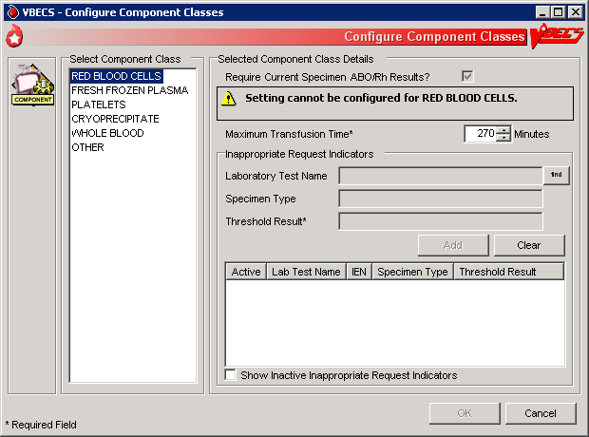

## Configure Daily QC UC\_51

The user sets up the routine reagent racks and QC template for the division before performing daily reagent QC.

#### Assumptions

* The division is “full service.”
* In the first use of this option, there are no defaults or data in place until the user selects the type of QC template (commercial or non-commercial).

#### Outcome

* A testing template is available for Enter Daily QC Results; reagent racks and identifiers were created.
* Minimum reaction strengths for each reagent type are defined and used by Enter Daily QC Results.
* BR\_51.16 A historical record for each rack will be maintained.
* BR\_51.11 Rack names created are available for use by other options.

#### Limitations and Restrictions

* This option pertains only to routine reagents.
* When there are partially or currently QC’d racks in the system, the user may not change the QC template.

#### Additional Information

* BR\_41.32This option is disabled for transfusion-only facilities.
* The naming convention for the active template is not editable. When fewer racks are indicated, the system will inactivate existing rack names to keep the list in order without skipping a number or letter. Rack names are reusable.
* BR\_51.09 The daily use field for QC Rack template entries exported as REQUIRED for Daily Use are not editable by the user. The daily use field for entries exported with the daily use as OPTIONAL may be changed to be REQUIRED and remain editable by the user at any time.
* BR\_51.08 If Screening Cell 3 (SC3) and/or (SC4) are set to “required” as part of the configuration of the antibody screening cell set they are enabled on the antibody screen data grid.
* BR\_51.07 The user must identify an enhancement media reagent type as the primary. In addition, the user must identify the Anti-Human Globulin serum used during daily quality control testing of the screening cells and primary enhancement media.
* VBECS does not evaluate maximum strength of reaction for daily QC, as required by CAP. Local policy must define maximum strength of reaction.

#### User Roles with Access to This Option

 Enhanced Supervisor

#### Configure Daily QC

The user sets up the daily reagent QC template for reagent rack testing for the division. In the first use of this option, all fields default to blank with no template preferred. BR\_51.19 Additional tests are available and may be included in the daily QC testing template in accordance with local practice. When a user changes the active template, there is no carryover of field settings to the new template. All are set to the default and configuration must be completed.

| **User Action** | **VBECS** |
| --- | --- |
| 1. Select **Reagents** from the main menu.   Select **Configure Daily QC**. | * Displays options for processing reagents. * Displays an option to configure online Daily Reagent Rack Quality Control. |
| 1. Click the **Commercial** or **Non-Commercial** radio button (Figure 43). | * Lists the two system-supplied Daily QC templates. * Commercial Daily QC * Non-commercial Daily QC * When there are partially or currently QC’d racks in the system, warns the user to wait until QC expires (passes the daily alert time) and then make the changes. |
| 1. Set the daily alert time. | * Asks the user to set the time the daily alert to all users at the site will begin.   **NOTES**  BR\_51.02 The user indicates the local time that defines the start of the 24-hour period (the QC day) during which a rack is considered QC’d. VBECS alerts users when a rack was not performed after this local time passed.  The user may test a rack no earlier than the alert time for the next 24 hours. (DR 2,716) |
| 1. Enter the number of racks at the site.   Select a naming convention. | * Asks the user to set the number of racks to be QC’d daily at the division. * Asks the user to set the naming convention for racks.   **NOTES**  BR\_51.01, BR\_51.13, BR\_51.14 A user may indicate 1–26 racks per site and names them according to the convention selected (A–Z or 1–26). |
| 1. Accept or edit the default settings of the template.   Select primary and secondary enhancement medium options from the drop-down menus. | * Lists the default reagent types for inclusion in the daily reagent rack quality control and expected minimum reactions for each test type. * Displays changes and edits for review before saving.   **NOTES**  One setting covers all racks at the site.  BR\_51.10 Reagent types selected display on the rack lot number template and the reaction result entry worksheet for each rack in Enter Daily QC Results with some exceptions: gel kit, selected AHG, and automated testing lots numbers.  BR\_51.15 When previously entered parameters for daily QC rack definitions are changed, VBECS requires a comment before the user saves the update. |
| 1. Click **OK** to save. |  |

Figure 43: Commercial and Non-Commercial Radio Buttons

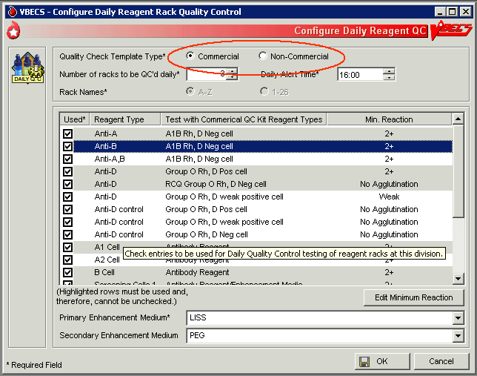

## Configure Division

### Configure Division UC\_09

A user defines site parameters that affect how VBECS behaves at a specific division. VBECS may be configured to function differently at each division within a consolidated database. Site parameters may be redefined.

#### Assumptions

* The site administrator defines the VBECS configuration, adds users, and assigns privileges for each division so that they mirror the associated VistA database.

#### Outcome

* Functional parameters are set for divisions that use the VistA database.

#### Limitations and Restrictions

* Changes made to the division setting are not applied to a user until they re-connect to VBECS after the change is made. It is highly recommended that all users log off VBECS prior to any configuration setting change. DR 4136

It is recommended that users configure a division before configuring testing (click the **Configure Testing** tab).

#### Additional Information

* To incorporate changes in division codes and names from VistA to VBECS, and to change time zones, see *VistA Blood Establishment Computer Software (VBECS) Technical Manual-Security Guide*.
* VBECS records configuration changes (such as time zone) on the Audit Trail Report.

#### User Roles with Access to This Option

 Administrator/Supervisor

#### Configure Division

Once VBECS is configured to identify all of the divisions, the user sets up critical fields required for routine use of VBECS.

| **User Action** | **VBECS** |
| --- | --- |
| 1. Select **Tools** from the main menu.   Select **Configure Division** (Figure 44). | * Displays options for processing administrative functions. * Displays the Configure Division tab with fields for entering division-specific blood product information. |
| 1. Enter the ICCBBA Registration Number, the medical director’s name (or select it from the drop-down list), and the maximum number of days until the specimen expires in their respective fields. | **NOTES**  BR\_9.04 An ICCBBA Registration Number contains an alphabetical character followed by four numeric characters.  BR\_9.07 A user may enter the name of the blood bank medical director or acting medical director to appear on reports. The user may edit the name and title but may select only one name at a time for use. VBECS saves these edits for retrieval.  BR\_9.05 The user may edit the default setting for the maximum number of specimen expiration days from “3” to any value from “3” to “93.”  This setting allows the user to extend the expiration date of any one specimen to the maximum date indicated. This does not change the normal specimen expiration date of all specimens received. DR 3592 |
| 1. Click **OK** to save and click **OK** again to confirm the save and exit, or click another tab. | * Displays the information entered. * Requests confirmation to update the database. * Updates the database. |

Figure 44: Configure Division Tabs

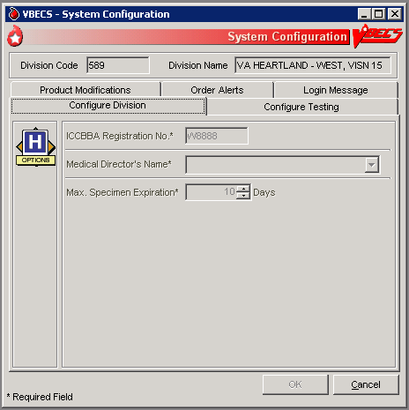

### Configure Testing UC\_55

The user sets testing preferences according to a division’s medical policies.

#### Assumptions

* A division’s worksheets affected by the option are not open or incomplete at the time of configuration.

#### Outcome

* Division testing preferences are configured.

#### Limitations and Restrictions

* None

It is recommended that users configure testing before modifying products (click the **Product Modifications** tab).

#### Additional Information

* None

#### User Roles with Access to This Option

 Administrator/Supervisor

#### Configure Testing

The user sets the system to display testing grids to the users in their division. The user determines whether an autocontrol is used and whether a Direct Antiglobulin Test (DAT) is added as part of the routine Antibody Screen Test (ABS) described in Patient Testing: Record a Patient Antibody Screen.

| **User Action** | **VBECS** |
| --- | --- |
| 1. Select **Tools** from the main menu.   Select **Configure Division**. | * Displays options for processing administrative functions. * Displays the Configure Division tab with fields for entering division-specific testing information. |
| 1. Click the **Configure Testing** tab (Figure 45). | * Displays the Configure Testing tab with fields for entering division-specific blood product information. * Displays options to set standard operating procedures for a division’s laboratory testing. |
| 1. Click the appropriate radio buttons to:   **Enable** Electronic Crossmatch  Determine antibody screen (display antibody screen only, or with a DAT or Autocontrol)  Determine the default test grid displayed for ABS and XM Testing Phases | * Displays default configuration settings of: * Electronic Crossmatch: Disabled * Antibody Screen: Antibody Screen Only * ABS and XM Testing Phases: All Phases * BR\_55.04 Changes to the configuration settings are captured for the Audit Trail Report. |
| 1. Click **OK** to save and click **OK** again to confirm the save and exit, or click another tab. | * Displays the appropriate testing grids for subsequent patient orders. |

Figure 45: Configure Testing Tab

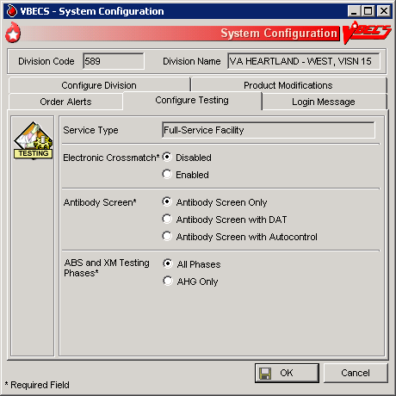

### Product Modifications UC\_10

The user enables the types of modifications made at a division.

#### Assumptions

* An ICCBBA number was entered for the division.
* BR\_55.02 VBECS locks a user out when the user attempts to change the configuration and there are open or partially completed worksheets or processes in the division.

#### Outcome

* This option dictates the available modification types displayed in Modify Units: Pool Units, Modify Units: Split a Unit, and Modify Units.

#### Limitations and Restrictions

* None

#### Additional Information

* None

#### User Roles with Access to This Option

 Administrator/Supervisor

#### Product Modifications

The user enables specific modification type procedures performed in the blood bank in the hospital division. The user may enable one, all, or some of the modification processes. Once the types of modifications are enabled, individual blood unit modification is controlled by the rules of modification truth tables. VBECS is exported with all modification types disabled. VBECS allows for full customization upon deployment as well as changes to the enabled modifications when a division’s capabilities and procedures change.

| **User Action** | **VBECS** |
| --- | --- |
| 1. Select **Tools** from the main menu.   Select **Configure Division**. | * Displays options for processing administrative functions. * Displays the Configure Division tab with fields for entering division-specific testing information. |
| 1. Click the **Product Modifications** tab (Figure 46). | * Lists valid modification procedures.   **NOTES**  A user may enable one, more, or all modification types. |
| 1. Click one or more check boxes to enable modification types.   Enter the processing cost associated with each modification procedure. | * Lists modification procedures.   **NOTES**  Modification procedures:   * Thaw * Pool * Thaw/Pool Cryo * Split/Divide * Irradiate * Leukoreduce * Volume reduce * Wash * Rejuvenate * Freeze * Deglycerolize   BR\_10.03 The modification process fee is added to the base unit cost of the first target unit and special testing costs, creating a patient bill for a transfused blood product, not including on-site antigen typing performed. The modification process fee may be U.S. $0.00 to $9,999.99. VBECS will generate an audit trail report entry when this field is filled or changed. |
| 1. Click **OK** to save and click **OK** again to confirm the save and exit, or click another tab. | * Updates the database and captures changes to any previously defined parameters for inclusion in the Audit Trail Report. |

Figure 46: Product Modifications Tab

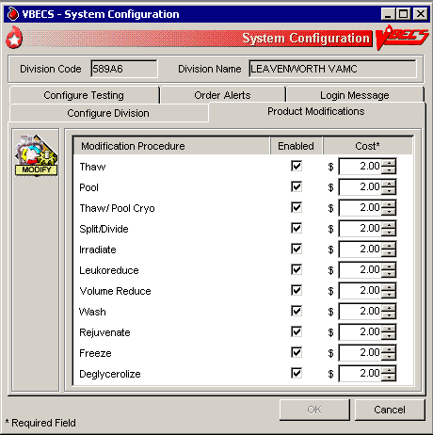

### Order Alerts UC\_95

The user configures VistA alerts that appear at login.

#### Assumptions

* None

#### Outcome

* User alerts of physician orders for blood bank diagnostic tests and blood components are configured.

#### Limitations and Restrictions

* This option does not create a mechanism to accept or reject orders or specimens or define reports for viewing orders.
* The user may select the option to display printer alerts only when the designated printer is configured and available.
* The printer must be configured by the System Administrator.

#### Additional Information

* A user may review current user alert configurations.
* VBECS uses other alerts (patient update alerts, VistALink status alerts) that do not require configuration.
* The user may set VBECS to automatically print an order alert on the designated printer when VBECS acknowledges the order. This is an alert only and contains limited information from the CPRS order. The CPRS can be configured to print a copy of the order on a printer in the blood bank.

#### User Roles with Access to This Option

 Administrator/Supervisor

#### Order Alerts

The user configures diagnostic test or component order alerts, and turns them on or off. The alerts notify users when new orders are entered, updated, or canceled in VistA.

| **User Action** | **VBECS** |
| --- | --- |
| 1. Select **Tools** from the main menu.   **Select Configure Division.** | * Displays options for processing administrative functions. * Displays configuration tabs. |
| 1. Click the **Order Alerts** tab (Figure 47).   Click the **Printer Alerts On** and/or the **Icon Alerts On** check box.  Select the order alert type from the drop-down menus in the Order Alert Type fields. | * Displays the existing order alert configuration and allows the user to edit it. * BR\_95.08 Requires the user to select a printer name and to define which orders to print. * BR\_95.05 Displays the selected printer, the selected order alert type, and the number of hours (default: 48 hours) entered for review.   **NOTES**  BR\_95.03 VBECS lists local and network printers.  BR\_95.04 The user must select an order alert type:   * All orders (orders received by VBECS) * Hours limit to fill order (orders received by VBECS needed in the next *n* hours) * Specimen OK or N/A (orders where no specimen is required) |
| 1. Enter or select a refresh rate (the interval between searches for new orders) for the order alert in the Refresh Rate field. | * BR\_95.07 Requires the user to enter a refresh rate (default: 60 seconds) (Icon Alerts On). * Displays the updated refresh rate. * Displays the selected order alert type. |
| 1. Click **OK** to save | * Saves the user alert configuration settings. |
| 1. Click **Yes** to confirm the changes and exit. |  |

Figure 47: Order Alerts Tab

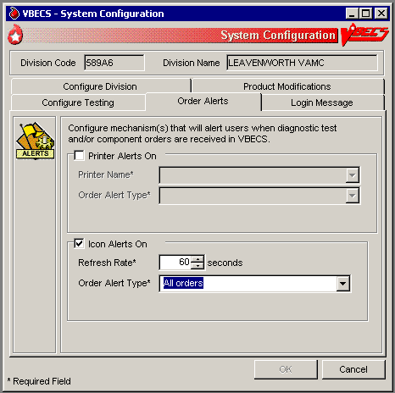

### Login Message

The user creates a division-wide VBECS message that appears at login.

#### Assumptions

* None

#### Outcome

* A message was created for display when users log into a VBECS division.

#### Limitations and Restrictions

* None

#### Additional Information

* None

#### User Roles with Access to This Option

 Lead Technologist

#### Login Message

The user may add, update, or delete a message that VBECS displays to users logging into the division.

| **User Action** | **VBECS** |
| --- | --- |
| 1. Select **Tools** from the main menu.   Select **Configure Division**. | * Displays options for processing administrative functions. * Displays configuration tabs. |
| 1. Click the **Login Message** tab (Figure 48).   Enter a message in the message field to display at login. | * Displays the existing login message and allows the user to edit or delete it. * Displays the updated login message.   **NOTES**  VBECS does not display a blank login message.  The user may click **Clear** to clear the message field and enter a new login message. |
| 1. Click **OK** to save. | * Saves the login message changes. |
| 1. Click **Yes** to confirm the changes and exit. |  |

Figure 48: Login Message Tab

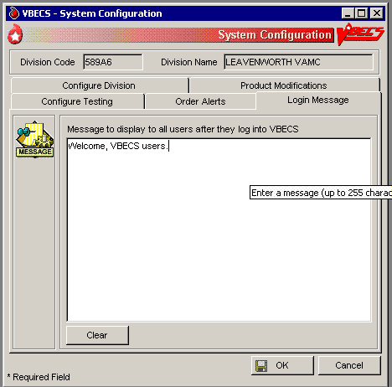

## Local Facilities UC\_06

The user customizes collection facility information. (A “collection facility” is not a facility for blood collection: it is for blood distribution only.)

#### Assumptions

* A table of known FDA-registered facilities accompanies VBECS.

#### Outcome

* The supplier is configured for a division.

#### Limitations and Restrictions

* A user may:
* Activate and edit collection facility records distributed with VBECS.
* Add and locally edit active collection facilities.
* Activate and/or deactivate local collection facilities.
* Edit a division name, which may result in a mismatch between VistA and VBECS division names. (DR 2,113)
* The Local Facility Address maximum length is 45 characters including spaces to allow the address to display on VBECS reports. The third line of the facility address is not displayed on VBECS reports. DR 4980

#### Additional Information

* A facility must be activated and have at least one blood product defined to be a shipper.
* A user may identify his site as a collection facility through this option.
* BR\_6.11 An ICCBBA Registration Number has one letter, indicating the country of origin (“W” for the U.S.) and four numbers. The field is five characters long.
* The user may change facility addresses that appear on reports.

#### User Roles with Access to This Option

All users

#### Local Facilities

This option allows a user to activate an entry from the national collection facility table, thereby adding it to a division’s local collection facility table, and add or update the facility’s information (except for the FDA Registration Number). A user may select an active collection facility to associate blood products (which makes the facility a shipper).

This option also allows a user to create a collection facility.

Verify that site information entered during installation is correct prior to adding local facilities.

| **User Action** | **VBECS** |
| --- | --- |
| 1. Select **Tools** from the main menu.   Select **Local Facilities**. | * Displays options for processing administrative functions. * Displays fields for entering facility information. * Allows a user to access an existing facility record. |
| 1. To find a collection facility, scan or enter an FDA Registration Number in the FDA Reg. No. field and go to Step 4 (or click the **find** button to open the Facility Search window). | * Displays the collection facilities that match the search criteria. |
| 1. In the Facility Search window, enter a full or partial facility name in the Partial Facility Name field (or enter a full or partial FDA Registration Number in the FDA Reg. No. field), and click **Search** to view a list of active facilities.   Select a facility name from the list and click **OK**. | * Displays properties of the selected collection facility.   **NOTES**  The collection facility is tied to the user’s current login division.  BR\_6.05 A user may activate a facility. By default, VBECS marks active facilities as collection facilities.   The Enhanced Supervisor may enter search criteria that do not exist in the national or the local collection facility tables to add a collection facility to the division’s local list. By default, VBECS marks such entries as a collection facility.  BR\_6.06 When a user clears the Active Facility check box for a collection facility in a division, warns the user, and asks whether he wishes to inactivate this facility and continue.  **Yes** allows the action to continue. **No** leaves the collection facility marked as active for the division.  BR\_8.11 VBECS does not allow inactivation of the product type for a shipper with in-date blood component units. VBECS warns that it is unable to inactivate the product type or shipper as there are in-date products for the shipper. |
| 1. Edit or enter information in the collection facility information fields (for example, address, telephone number, whether the facility is a testing and/or collection facility) (Figure 49) and click **OK** to save the updated information. | * Displays entries for review and acceptance. * Prompts to save.   **NOTES**  **OK** remains disabled until the user edits or enters information or simply clicks in a field or check box.  BR\_6.07 The Codabar eye-readable prefix (when used) is always two characters. |
| 1. Click **Yes** to confirm the save. | * Saves the active collection facility record and prompts to add or edit another facility.   **NOTES**  BR\_6.09 VBECS saves an active collection facility only when it is identified as a collection facility.  A facility must be activated and have at least one blood product defined to be a shipper. Refer to Blood Products section for more information. |
| 1. Repeat these steps to process another facility. |  |
| 1. Click **Cancel** in the Maintain Facility screen to exit. |  |

Figure 49: Maintain Facility

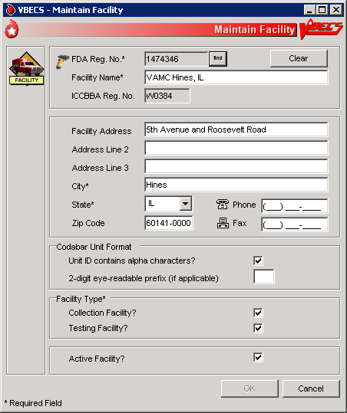

### Blood Products UC\_08

The user activates, deactivates, and edits a limited number of variables for an existing blood product site parameter. VBECS provides a Codabar and an ISBT 128 Blood Product reference table to facilitate these and other actions.

#### Assumptions

* The connection to VistA is active.
* The user understands Healthcare Common Procedure Coding System (HCPCS) codes. (See Additional Information.)
* BR\_8.03 A shipper must be marked as an active collection facility for a division before a user may select it as a valid shipper for a blood product for that division. This includes marking the division facility itself as an active collection facility to accommodate the creation of new blood products through modification.

#### Outcome

* Blood product codes are activated in the user’s division.
* BR\_8.07 Each product’s HCPCS code and its activation and deactivation dates are maintained in a permanent historical record.

#### Limitations and Restrictions

* Blood product records distributed through VBECS are national standards.
* The division must have activated the valid target blood products for modification.

#### Additional Information

* HCPCS codes are required for medical and surgical services and supplies for the outpatient setting under the final code set standards for the Health Insurance Portability and Accountability Act of 1996 (HIPAA). See your local Current Procedural Terminology (CPT) coordinator for more information.
* BR\_8.04 At least one valid shipper and product cost must be defined for each active product code in use in the division; multiple shippers may be associated with a blood product code.

#### User Roles with Access to This Option

All users

#### Blood Products

Before processing a blood unit in an incoming shipment, or activating or creating a blood unit in-house, the user identifies the shipper(s), cost, and return credit percentage for each shipper. The user also tags each product as active for use within the division and assigns an HCPCS code to each. These are the only fields the user may edit when maintaining an existing blood product code.

A “shipper” is the collection facility that delivers and bills for the blood product, regardless of the facility named on the unit’s label. The collection facility that delivers the product to the shipper is not considered a shipper nor does it have a product cost associated with it, but it needs to be activated in the division for VBECS to interpret the unit ID. When components are modified within the division, the shipper is defined as the division. The cost may be $0.00 or other U.S. dollar value assigned by the shipper.

| **User Action** | **VBECS** |
| --- | --- |
| 1. Select **Tools** from the main menu.   Select **Blood Products**. | * Displays options for processing administrative functions. * Displays fields for entering blood product information. |
| 1. To identify the product, scan or enter a Codabar or ISBT product code.   Click the **find** button to search for a product.  Select a product type from the drop-down Product Type list or enter a partial product name in the Partial Product Name field.  Click **Search**. | * Displays current blood product information.   **NOTES**  BR\_8.12 When a user enters a product code that VBECS does not recognize, VBECS warns that the blood product was not found and that it does not support entry of new blood products.  **OK** returns the user to a blank screen to enter a different product. VBECS clears the screen. The user may enter a different product code. |
| 1. Select a product from the Search Results list and click **OK** (Figure 50).   Select an HCPCS code from the drop-down HCPCS Code list or enter an HCPCS code. | * Allows a user to enter the HCPCS code.   **NOTES**  BR\_8.06 A blood product may have only one HCPCS code at a time. |
| 1. Select or enter product shipper information: shipper name, FDA Registration Number, cost, and return credit percentage. | **NOTES**  BR\_8.01 Site parameters determine which products are active for a division. Products marked as active can be received in an incoming shipment or created in-house through modification.  BR\_8.02 A user with no increased security can maintain an existing blood product for use only within the user’s current division.  The return credit default is “100%.”  BR\_8.11 VBECS does not allow inactivation of the product type for a shipper with in-date blood component units. VBECS warns that it is unable to inactivate the product type or shipper as there are in-date products for the shipper. |
| 1. Repeat Steps 3 and 4 for each selected product’s shipper and for other products. | * Displays the information entered. * Requests confirmation to update the database. * Updates the database or warns the user with no override for discrepancies. |
| 1. Click **OK** to exit. |  |

Figure 50: Maintain Blood Products

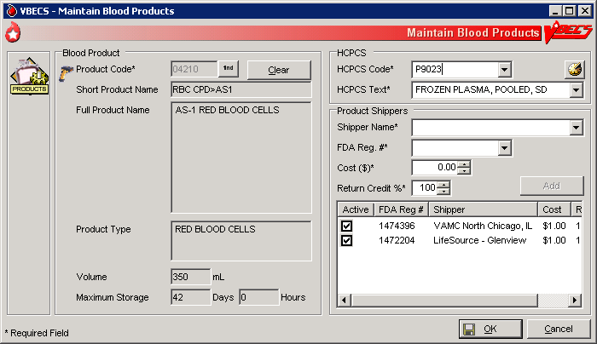

### Antibodies UC\_23

The user edits certain fields in the supplied antibody table.

#### Assumptions

* VBECS is configured to reflect antibody reference parameters. Only some of these parameters may be changed locally.
* The default settings are enforced without user interaction.

#### Outcome

* Each division has a populated antibody table whether or not the user makes any edits.

#### Limitations and Restrictions

* None

#### Additional Information

* The antibody table defines an antigen negative requirement for all instances of the antibody for all patients in the division. When an antibody specificity does not generally require antigen negative blood but a patient has a unique appearance of that antibody that requires antigen negative blood, the user may enter the antigen negative requirement for that patient in Special Instructions & Transfusion Requirements: Enter a Transfusion Requirement.

#### User Roles with Access to This Option

 Enhanced Supervisor

#### Antibodies

The user chooses to edit the system-supplied blood antibody table. The Compatibility Percentage field is fully editable (except for ABO antibodies and anti-D) to allow facilities to reflect local populations. The user may edit only the Clinically Significant entries initially exported as “No.”

| **User Action** | **VBECS** |
| --- | --- |
| 1. Select **Tools** from the main menu.   Select **Antibodies**. | * Displays options for processing administrative functions. * Lists available antibodies based on the system-supplied table.   **NOTES**  See Appendix B: Table 13: TT\_23.01A Antibody and Antigen Table: Irregular Antibodies.  BR\_31.07 The table’s presentation order is predefined at implementation and may not be sorted. |
| 1. Select the antibody, edit each field, and click **Update** (Figure 51). | * Displays data and allows the user to edit them. * Accommodates data entry of whole numbers (0–100) and edit of the Antigen Negative Compatibility Percentage and Higher-Level Override fields. The user may not edit fields displayed on a gray background.   **NOTES**  BR\_23.01 When Table 13: TT\_23.01A Antibody and Antigen Table: Irregular Antibodies “antibody sets an antigen negative requirement” field is defined as REQ (required) at installation, it is not editable. When the default settings is OPT (optional), the user may change the name to REQ at any time and it will remain editable. |
| 1. Repeat for each antibody to be edited. |  |
| 1. Click **OK** and **Yes** to confirm changes and exit. |  |

Figure 51: Maintain Antibodies

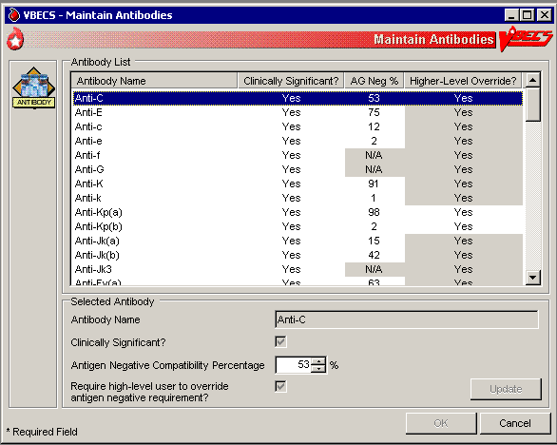

### Canned Comments UC\_31

The user defines canned comments for a division.

#### Assumptions

* None

#### Outcome

* Canned comments for a division are available for selection.

#### Limitations and Restrictions

* The user may not edit comments provided with VBECS but may create additional comments.
* Site personnel must enter comments in accordance with local policy and procedures.

#### Additional Information

* BR\_31.01 Canned comments are specific to each division. See Appendix B: Table 16: PT\_31.01 Canned Comment Category Types and Text defines the category types and comments.

#### User Roles with Access to This Option

 Enhanced Supervisor

#### Canned Comments

It is recommended that the user review the canned comments provided with VBECS for each category type and inactivate those that will not be used.

The user creates canned comments to use in lieu of entering text. Canned comments are restricted for selection based on the category type of the comment field.

The user may select a comment and has the option to enter explanatory text in the details field.

| **User Action** | **VBECS** |
| --- | --- |
| 1. Select **Tools** from the main menu.   Select **Canned Comments**. | * Displays options for processing administrative functions. |
| 1. Select a comment category type from the drop-down list (Figure 52). | * Lists the category types for canned comments. * Allows the user to create a comment or inactivate an existing one. |
| 1. Enter text in the Comment field and click **Add** to add a comment.   Click one or more check boxes to inactivate existing comments. | * Displays entered data and allows the user to edit them before saving.   **NOTES**  BR\_31.03, BR\_31.04, BR\_31.06, BR\_31.05, BR\_31.02 A user may:   * Add canned comments. * Inactivate canned comments. * Reactivate inactive comments. * View inactive comments and dates of inactivation. * Control the order in which VBECS displays comments in a context. |
| 1. Click the **Show inactive Comments** check box to view inactive comments.   Click one or more check boxes to reactivate inactive comments. | * Displays inactive comments and allows the user to reactivate them. |
| 1. Repeat Steps 2–4, as needed.   Click **OK** and **Yes** to save and exit, or **Cancel** to exit without saving. | * Updates the database. |

Figure 52: Maintain Comments

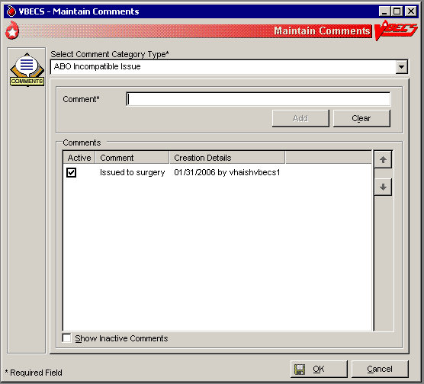

## Setting Transfusion Parameters

### Transfusion Complications UC\_34

The user defines Laboratory tests and threshold values used to generate a report listing patients who were transfused within a specified period and who may have developed a transfusion-associated disease.

#### Assumptions

* VistA tests are defined.
* The connection to VistA is active.

#### Outcome

* Parameters are defined for future Transfusion Complication Reports.

#### Limitations and Restrictions

* None

#### Additional Information

* None

#### User Roles with Access to This Option

 Enhanced Supervisor

#### Transfusion Complications

The user defines Laboratory tests for use in the transfusion complication table.

| **User Action** | **VBECS** |
| --- | --- |
| 1. Select **Tools** from the main menu.   Select **Transfusion Complications**. | * Displays options for processing administrative functions. * Displays fields for entering transfusion complication threshold data. |
| 1. Click the **find** button to search for a Laboratory test.   Select a test.  Click **OK**. | * Allows the user to edit or add previously defined tests for use in a Transfusion Complication Report.   **NOTES**  BR\_34.03, DR 4364 VBECS displays the entered laboratory test names in all uppercase letters. The retrieval of lab tests occurs in VistA and results for the Transfusion Complications Report are not case sensitive. There is a limit of 25 active entries. (If the user enters all of the available results for the test, he can get results that are not filtered by VBECS.) |
| 1. Click the **Numeric Threshold** radio button and enter or edit test threshold information (Figure 53).   Click **Add** to add the test to the list, or  Click **Update** to save changes to a previously saved test.  Click **OK** to save and **Yes** to confirm the save. | * Allows the user to enter one or more tests. * Uses VistALink to retrieve test data.   **NOTES**  BR\_34.02 When defining a test reported as a text value, VBECS accommodates the input of specific text (1–255 characters) that will be used to search for matching values. |
| 1. Click **OK** to save and **Yes** to confirm the save and exit. | * Updates the database. |
| 1. Repeat Steps 2–4 for each transfusion complication test to be defined or click **Cancel** to exit. |  |

Figure 53: Transfusion Complication Thresholds

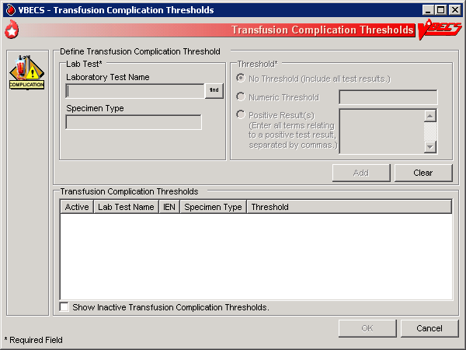

### Transfusion Effectiveness UC\_33

The user defines Laboratory tests to monitor the effectiveness of transfusions.

#### Assumptions

* VistA lab tests are defined.
* The connection to VistA is active.

#### Outcome

* Parameters are defined for future reports.

#### Limitations and Restrictions

* None

#### Additional Information

* None

#### User Roles with Access to This Option

 Enhanced Supervisor

#### Transfusion Effectiveness

The user enters the tests to be included in the Transfusion Effectiveness Report.

| **User Action** | **VBECS** |
| --- | --- |
| 1. Select **Tools** from the main menu.   Select **Transfusion Effectiveness**. | * Displays options for processing administrative functions. * Allows the user to edit a previously defined Transfusion Effectiveness Tests or add a test. |
| 1. Click the **find** button to search for a Transfusion Effectiveness Test.   Enter part or all of a laboratory test name.  Click **Search**.  Click one to four check boxes to select tests.  Click **OK**.  Click **Add** to add the tests (Figure 54), or  Click the **Show Inactive Transfusion Effectiveness Report Tests** check box, if desired.  Click **Update** to edit the tests. | * Allows the user to enter one or more Transfusion Effectiveness Tests. * Uses VistALink to retrieve Laboratory test data for each of these indicators: * Laboratory test name * VistA Laboratory test Internal Entry Number (IEN) * Specimen type |
| 1. Repeat Step 2 for each Transfusion Effectiveness Test to be defined, or click **Cancel** to exit. |  |
| 1. Click **OK** to save and **Yes** to confirm the save. | * Updates the database, including the date and time and the technologist ID. Saves changes to previously defined tests for inclusion in an Audit Trail Report. |

Figure 54: Transfusion Effectiveness Report Tests

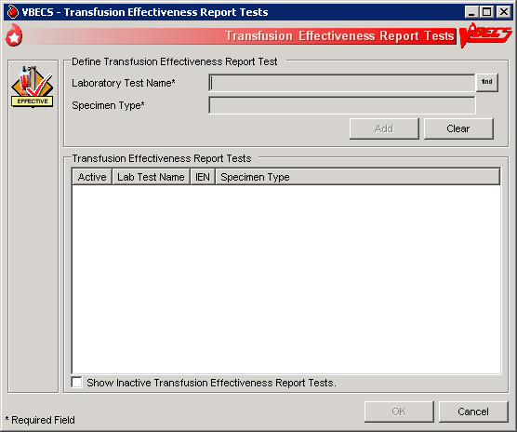

### MSBOS UC\_32

The user defines parameters for comparing blood component orders placed by a clinician with the Maximum Surgical Blood Ordering Schedule (MSBOS).

#### Assumptions

* A table of generic surgery names is available for MSBOS activation.

#### Outcome

* CPRS users will see only active surgery names when placing a blood bank order.
* MSBOS will be available to VBECS users to evaluate the appropriateness of pre-op orders.

#### Limitations and Restrictions

* None

#### Additional Information

* The maximum number of blood products serves as a guideline. Orders in excess of the MSBOS are not prohibited.
* The VBECS user may view active and inactive surgery names.

#### User Roles with Access to This Option

 Enhanced Supervisor

#### MSBOS

The user selects a surgery name from the generic surgery list or creates a new surgery name, then defines the associated MSBOS recommendation. MSBOS is used when VBECS acknowledges orders from VistA that are written for preoperative patients.

| **User Action** | **VBECS** |
| --- | --- |
| 1. Select **Tools** from the main menu.   Select **MSBOS**. | * Displays options for processing administrative functions. * Displays the schedule and component recommendation options. |
| 1. To activate an existing surgery name, click the **Show Inactive MSBOS entries** check box (Figure 55).   Select a surgery name.  Click the **Active MSBOS Entry?** check box, or  To add and activate a surgery name, click **New Surgery** and enter a surgery name in the Surgery Name field. Click **Add**, or  To edit and/or inactivate an existing surgery name, click the appropriate options in the MSBOS Component Recommendation area of the screen edit. Click **Update**. | * Lists active surgery names or allows the user to create an entry. * Activate, add, or edit a MSBOS entry and its associated data. * Displays surgery names available for activation. * Displays entries for review and acceptance.   **NOTES**  BR\_32.01 MSBOS is specific to the division.  See Appendix B: Table 24: PT\_32.01 VBECS Maximum Surgical Blood Order Schedule (MSBOS).  BR\_32.04 Each surgery name has a Type & Screen (TAS) (no blood order recommended) or one or more component classes defined as recommended orders.  BR\_32.02, BR\_32.03 The user may select one or more component classes for MSBOS recommendation. Each defined component class must have an associated maximum number recommended. The user may inactivate previously activated component classes for an MSBOS recommendation. The OTHER component class is not available for selection. |
| 1. Repeat Step 2 until all new entries are created or existing entries are edited.   Click **OK** to save the updated data. | **NOTES**  VBECS does not save changes to the database when the user clicks **Cancel** without clicking **OK**. |
| 1. Click **Cancel** to exit. |  |

Figure 55: Maintain MSBOS

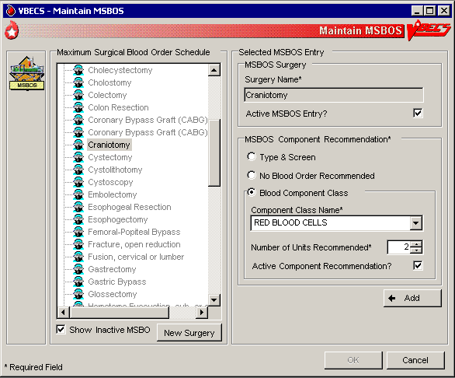

### Workload Codes UC\_29

The user assigns workload Laboratory Management Index Program/National Laboratory Test (LMIP/NLT) tests to processes performed through VBECS. VBECS test names are associated with VistA workload codes, which VBECS uses when compiling and storing data to provide workload-related reports to VistA.

#### Assumptions

* The VistA database was updated to include all required workload codes for the VBECS process.
* The VistA database was updated to associate CPT codes and costs with the workload codes to be used by VBECS.
* The connection to VistA is active.

#### Outcome

* Data are available to the VistA workload package.

#### Limitations and Restrictions

* Transfusion-only sites must not map workload codes to processes, such as ABO/Rh testing, not performed on site.
* Retrieved LMIP/NLT codes from VistA may have multiple CPT codes. Inactivating any of the associated CPT codes in VBECS will inactivate the LMIP/NLT code. Editing of the LMIP/NLT code associations must be done in VistA. DR 3090

#### Additional Information

* VistALink is required to query VistA files 64 (NLT/LMIP) and 81 (CPT) for appropriate entries.
* The division provides CPT codes and costs associated with the workload codes when they need updating.
* Each site is responsible for notifying users when incorrect CPT codes are used.
* BR\_15.09 Workload events are placed in a queue for transmission via VistALink.

#### User Roles with Access to This Option

 Administrator/Supervisor

#### Workload Codes

As part of record-keeping activity, VBECS allows the user to account for workload units associated with each activity and to assign costs incurred by the blood bank due to these activities. Data gathered because of this workload collection are available to VistA, as needed, for various reports.

| **User Action** | **VBECS** |
| --- | --- |
| 1. Select **Tools** from the main menu.   Select **Workload Codes**. | * Displays options for processing administrative functions. * Displays fields for entering workload-related data. * Lists and retrieves processes that may involve workload. |
| 1. Select a process for which to define workload codes. | * Allows the user to edit existing data or add data.   **NOTES**  BR\_29.02 The user may assign multiple LMIP and CPT workload codes to a process.  BR\_29.08 VBECS checks for active and inactivated workload associations and does not allow the user to enter a duplicate association. VBECS allows the user to reactivate previously inactivate entries and add workload associations. |
| 1. Select an LMIP/NLT code.   Click **Add** to add the code, or click **Update** to select a current association to edit. | * Lists previously assigned LMIP/NLT codes for the selected process. * Allows the user to select an LIMP/NLT code.   **NOTES**  VBECS uses VistALink to query the VistA WKLD CODE File (#64) for valid LMIP/NLT codes.  VistA uses the LMIP/NLT code to create workload reports as well as reports to patient care encounter (PCE) and the decision support system (DSS) database. |
| 1. Enter the start or stop date (whichever is appropriate) of the workload code association with the VBECS process (Figure 56). | * Allows the user to enter a date.   **NOTES**  BR\_29.05 The user may enter an inactivation date only when an activation date was previously entered (default start date and time: current date and time).  BR\_29.06 The inactivation date must be later than or the same as the activation date. When the user attempts to enter an inactivation date that is earlier than the activation date, VBECS warns the user. There is no override. |
| 1. Repeat Steps 4–5 for each LMIP/NLT code to be associated with the selected process. |  |
| 1. Add the selected parameters to the selected process. | * Allows the user to add the selected parameters. |
| 1. Repeat Steps 1–8 for to define workload parameters for another process, or exit. |  |

Figure 56: Assign Workload Codes

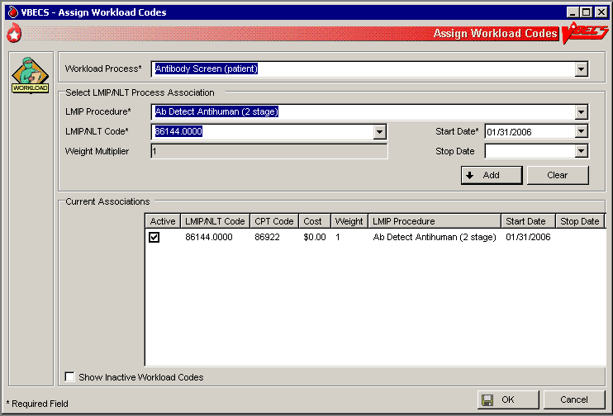

#### Remapping Workload Codes DR 3762

When workload codes or a workload code multiplier is changed VBECS must be updated. The active workload process to LMIP/NLT Code association must be inactivated and remapped for VBECS to track workload correctly.

| **User Action** | **VBECS** |
| --- | --- |
| 1. Select **Tools** from the main menu.   Select **Workload Codes**. | * Displays options for processing administrative functions. * Displays fields for entering workload-related data. * Lists and retrieves processes that may involve workload. |
| 1. Select a process to edit workload codes. | * Allows the user to edit existing data or add data. |
| 1. Click one or more check boxes to inactivate LMIP/NLT Code.   Click **OK** and **Yes** to save and exit. | * Removes the code from the Current Associations window.   **NOTES**  Inactive codes can be viewed by clicking the Show Inactive Workload Codes checkbox. |
| 1. Click **OK** and **Yes** to save and exit. | * Saves the changes to the workload code mapping. |
| 1. Select **Tools** from the main menu.   Select **Workload Codes** | * Displays options for processing administrative functions. * Displays fields for entering workload-related data. * Lists and retrieves processes that may involve workload. |
| 1. Select a process to edit workload codes. | * Allows the user to edit existing data or add data. |
| 1. Select an LMIP/NLT code.   Click **Add** to add the code. | * Allows the user to select an LIMP/NLT code.   **NOTES**  LMIP/NLT weight multipliers values are set in VistA and that value is imported into VBECS.  Changes made to VistA files 64 (NLT/LMIP) and 81 (CPT) are updated in VBECS on a rolling 24 hour clock. The first user to log in 24 hours after the last update will trigger the next update. |
| 1. Repeat Steps 1–7 for to edit workload parameters for another process. |  |

## Reagents and Supplies

### Enter Daily QC Results UC\_28

The user enters observed serological reactions for all phases of testing and interpretations of the various routine reagents.

#### Assumptions

* The division is “full service.”
* Site parameters regarding reagent quality control are set up.
* Minimum inventory levels for reagent types are defined.
* Inventory control functionality is in use and reagents are in the inventory of the user’s division.
* Daily QC testing does not include reagents used in special antigen typing.

#### Outcome

* Routine reagents are available for use, shutting down the alert for the day associated with the rack.
* The user may enter and save reaction results below the minimum expected reaction; an Exception Report may be generated for supervisory review; the rack may or may not be used by the site for routine testing throughout that day.

#### Limitations and Restrictions

* Additional user-defined reagent types not available in Configure Daily QC or Enter Daily QC Results are not part of a reagent rack’s daily QC testing.

#### Additional Information

* BR\_28.19 VBECS allows the user to save a partially filled worksheet for a specific QC rack ID and allows the same or a different user to redisplay the form for the entry of remaining test results at a later time. The user, first or second, may enter new results but may not edit prior entries. VBECS records the ID of each user who enters test observations on a worksheet.
* VBECS issues warnings when they are defined in Maintain Minimum Levels.
* VistALink does not need to be active when a user enters daily quality control results.
* A testing template is generated for daily quality control testing of routine reagents for each rack in a division. (Multiple templates may be used on a given day.)
* System rules determine the validity of the test interpretations and determine if all phases of testing were recorded for both scenarios.
* A user must enter and may view one day’s QC data at a time. The supervisor or administrator must review these entries and the reagent information daily.
* VBECS compares the current rack QC results with the prior day’s QC results.
* Multiple technologists may use the same rack.
* Rack number and reagents used to test a specimen are linked to the lot number, manufacturer, and expiration date of the reagent type as well as the rack identifier.
* A user may use more than one testing method in accordance with local policies and procedures.
* If a rack has never been used with reagents prior to using the QC Documentation Offline option and the rack is not so checked when the user attempts to use this untested rack, the message appears that this rack has never been tested and cannot be used. The user may not proceed. To use this rack on this date, the QC Offline check needs to be indicated or testing performed. DR 4317

#### User Roles with Access to This Option

All users

#### Enter Daily QC Results

The American Association of Blood Banks’ *Standards for Blood Banks and Transfusion Services* requires that commercial reagents in the blood bank—antisera and routinely-used red cell reagents—must be tested for performance “on the day of use.” As routine reagents are always used, they are tested daily. Records of these reagents, their lot numbers, and their testing results must be stored for reference. VBECS verifies and indicates whether the reagent is satisfactory for use.

This option facilitates the direct entry of reaction results and interpretations, constituting daily reagent quality control testing for a rack of reagents.

VBECS allows the user to change individual reagents without repeating the QC for the full rack during the day.

| **User Action** | **VBECS** |
| --- | --- |
| 1. Select **Reagents** from the main menu.   Select **Enter Daily QC Results**. | * Displays options to perform daily reagent rack QC. |
| 1. Verify the default date tested and tester, and edit them, if needed. | * Displays the date and time the testing was performed; the default is the current date and time, which are editable to allow retrospective entry. * Displays the testing technologist’s identification; the default is the current user. Lists valid division users for selection. * Displays the option to indicate the rack number of the reagents to test, a list of racks to be tested for the current date, and a retest option for the racks with testing completed for the date.   **NOTES**  Daily QC testing does not include reagents used in special antigen typing. |
| 1. Select the **Test Rack(s)**, **Partially Tested Rack(s)**, or **Retest Rack(s)** tab (Figure 57).   Click one or more check boxes to select rack numbers.  Click **OK**. | * Displays the lot number verification template for each rack selected.   **NOTES**  BR\_28.33 A reagent rack is displayed on one of three tabs based on its testing status and the daily alert time setting:   * Test Rack(s): the current alert time has passed and is/are considered “untested” * Partially tested: racks that have incomplete test results for the current 24 hour time clock and are considered “untested” * Retest Racks: racks that are fully tested within the current alert time and are available for new lot number selection and its testing.   The user may test a rack no earlier than the alert time for the next 24 hours. DR 4014  On occasion, a user may save a partially completed QC worksheet and finish it later. The same user or a different user may complete the testing.  The user may retest a rack when a reagent lot number changes after initial testing. VBECS does not allow the user to retest saved valid results.  PT\_28.01 VBECS requires the user to indicate the rack identifier to provide a testing template for each daily reagent rack QC.  BR\_28.11, BR\_28.23 Site settings determine reagent types and lot numbers present. VBECS displays only reagent types previously entered for the division using the reagent inventory function. VBECS allows entry of lot numbers only. When VBECS displays lot numbers for selection, it checks the inventory system for the reagent name and lot numbers in use in a rack. VBECS does not offer a reagent with an unsatisfactory value in the “Inspection” field or with a quantity of zero as a selectable reagent. The user cannot force the entry of a lot number that VBECS disallowed on the selection list. The user must choose a different reagent.  BR\_28.24  VBECS compares the expiration date of each reagent on the selected rack to the testing date, emits an audible alert, and warns when the reagent is expired.  **Yes** requires a comment and VBECS captures details for inclusion in an Exception Report (exception type: expired reagent QC’d).  **No** removes the unsatisfactory reagent from the daily QC rack. The user must select a new one. VBECS does not display unsatisfactory lot numbers.  BR\_28.32 The user may enter the lot numbers of the reagents used for the daily QC rack and the lot numbers of the enhancement media reagents defined in Configure Daily QC. VBECS does not display these reagents on the reaction results grid for a rack. |
| 1. Select a worksheet to complete the testing (Figure 58), or   BR\_28.05 Click the **Rack not in use today** check box to indicate that testing of a rack will not be performed.  BR\_28.34 Click the **QC Testing Documentation Offline** check box to acknowledge QC is not performed in VBECS but has been properly documented. Click **Yes** to save changes. Close the window. | * Displays the selected worksheet. * Displays the selected partially completed worksheet with the option to cancel the worksheet or continue to enter more testing information.   **NOTES**  When the QC Testing Documentation Offline check box is checked for a reagent rack, VBECS allows the rack to be used for patient testing until the next daily alert time.    The primary lot number can be tested and changed and the results for both will display on the Testing Worklist Report.   A user may cancel or invalidate a partially completed QC rack worksheet when it is available. VBECS emits an audible alert and warns that invalidating this worksheet will necessitate starting over and asks whether the user wishes to continue.  **No** returns the user to the partially partially-completed worksheet.  **Yes** invalidates the worksheet. VBECS does not delete reaction results from the database.  An Exception Report comment documents the invalidation of the rack’s worksheet. VBECS does not record workload calculation for invalidated testing. The invalidated reaction results and associated testing information remain in the database for future retrieval (exception type: deletion of partially completed QC).  BR\_28.12  VBECS compares the results entered to those of the previous day for the same rack number and alerts the user when there is a change in reactivity of two or more or when the result is changed from positive to negative for each reagent type by lot number. VBECS emits an audible alert and warns that there is a decrease in reagent reactivity of two or more and asks whether the user wishes to continue to use this vial.  **Yes** allows the user to continue and requires a comment. VBECS captures details for inclusion in an Exception Report and allows this reagent to be used with the change (within acceptable limits) (exception type: QC decrease reagent reactivity ≥2).  **No** allows the user to return to the lot number entry for this reagent type and approve this lot number (different vial) or enter a new lot number. VBECS returns to the testing worksheet where the user left off. (An individual vial of the same lot number may replace the one losing its reactivity.)  BR\_28.30, BR\_28.31The screening cell and reverse typing reagents are delivered in sets and share the same lot number; therefore, VBECS displays only one reagent type on the lot number template. |
| 1. Verify or select from the drop-down menu the reagent type lot number and test method for each rack chosen for processing.   Click **OK**. | * Displays the lot numbers and expiration dates for verification, if any. * Displays each rack in its own tab.   **NOTES**  BR\_28.02, BR\_28.03 VBECS allows for one lot number entry per reagent type per rack template.  BR\_28.13 When an entry was made, VBECS fills in the reagent type lot number, the expiration date of that lot number, and the manufacturer. The user may edit the lot number. The user must verify the lot numbers of racks in the selected batch before VBECS allows the user to move to the reaction results grids.  BR\_28.15 Each reagent rack has a separate reaction results grid to collect the user’s direct observations. See PT\_28.02 Commercial QC Kit in Use and PT\_28.03 Non-Commercial Daily QC Template.  BR\_51.10 VBECS displays reagent types (except for the gel and the instrument lot numbers) listed as REQUIRED (by VBECS or by the user) in the daily use field on the rack lot number template and the reaction result entry worksheet for each rack in Enter Daily QC Results.  BR\_28.06, BR\_28.07 When a rack is tested, VBECS displays a retest option at the daily reagent QC prompt with the untested rack numbers. When a user requests to retest a rack on a given date, VBECS displays the option to reenter a lot number for reagent types for all or part of the daily QC with a comment. All other reagent type results previously entered are locked and may not be edited. VBECS saves the new information and the original data, then generates a report entry.  When a user changes a reagent lot number, VBECS clears the testing template for that reagent type and allows the user to enter new results.  TT\_28.01 Daily QC Using a Commercial QC Template or PT\_28.02 Commercial QC Kit  TT\_28.02 Daily QC Using Non-Commercial QC Template  PT\_28.03 Non-Commercial Daily QC Template |
| 1. Enter the observed serologic reactions (Figure 59).   Click **OK** and **Yes** to save and exit.  Repeat for each rack selected in Step 3. | * Displays the testing template reaction results grid for each rack selected, whenno lot number changes were made. * Determines whether the entered results are acceptable and indicates acceptability of the lot number for the reagent type. * Verifies (by type and lot number) that the reagent is satisfactory or unsatisfactory for use. * Saves the partially or fully completed data.   **NOTES**  The user may enter results on multiple reagent racks. VBECS displays each rack in its own tab.  BR\_28.20 VBECS verifies satisfactory and unsatisfactory QC testing based on site parameters and user data entry. If the user-entered test results indicate a satisfactory interpretation, VBECS displays “Satisfactory.” VBECS saves results that are satisfactory only when the testing for a row is complete and the worksheet is saved. VBECS clears results associated with an unsatisfactory interpretation from the screen/worksheet and the testing for the affected QC rack is considered incomplete until the rack is retested with satisfactory results for the affected row. (Warnings generated by other options when QC testing is incomplete apply).  BR\_28.14 The daily reagent QC for a date requires a valid entry for each reagent displayed on the worksheet. VBECS considers a rack ready and available for patient testing on that date when all reagents on a rack have valid test results. |

Figure 57: Enter Daily QC Results

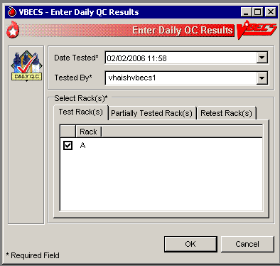

Figure 58: Record Lot Numbers for Daily QC Testing

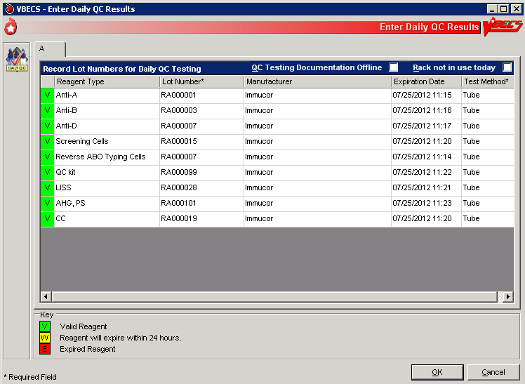

Figure 59: Enter Daily QC Results with Serologic Reactions

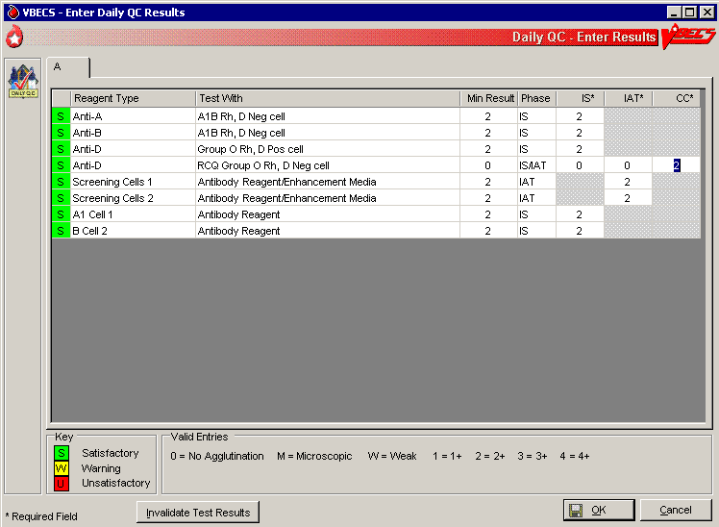

## Reagents UC\_20

The options related to reagent inventory control record the receipt of specific reagents by reagent type for each division.

#### Log In Reagents, Update Inventory, View/Print Inventory, Maintain Minimum Levels

The reagent log is maintained by individual division even in a multidivisional database. Update Inventory allows the user to update reagent inventory by changing the number of vials available. The user may view inventory online using various search criteria and print a copy of the search results.

#### Assumptions

* The division is “full service.”
* Reagents are in the inventory of the user’s division.

#### Outcome

* A user may select previously logged-in reagents through Enter Daily QC Results, Patient Testing: Record a Patient Antigen Typing, and Unit Antigen Typing.
* Reagents entered are accessible only within the division in which they were entered.

#### Limitations and Restrictions

* VBECS does not display a reagent report by invoice number.
* The unsatisfactory portion of a shipment must be recorded individually.
* There is no retrospective data entry or user selection for these options.
* Each site must set a standard for recording quantity: it may use the number of cases or the number of units within the cases.
* When a user enters a lot number in the Lot # field and clicks the **magnifying glass**, VBECS displays only the first instance of a duplicate lot number. (UserDoc Task 1083)
* Free text details can be added only when “Other” is selected as the canned comment. DR 2218

#### Additional Information

* BR\_41.32This option is disabled for transfusion-only facilities.
* VBECS displays alerts, as appropriate, during execution of Enter Daily QC Results to notify the user when reagent inventory levels fall below minimum inventory levels, as defined in Maintain Minimum Levels.
* Local policies and procedures must define the use of patient antisera as reagents.

#### User Roles with Access to This Option

All users

#### Log in Reagents

A user records the receipt of specific reagents by type. The reagent record includes the date the shipment was received, reagent name, lot number, expiration date, manufacturer, and number of vials received in a shipment.

| **User Action** | **VBECS** |
| --- | --- |
| 1. Select **Reagents** from the main menu. | * Displays options for Quality Control functions. * Displays options for processing reagents. |
| 1. Select **Log In Reagents**. | * Displays fields for entering invoice and reagent information. |
| 1. Invoice Information:   Select or edit the date and time in the Date Received field.  Enter the invoice number in the Invoice Number field.  Enter the name of the manufacturer in the Manufacturer field, or select a name from the drop-down list. | **NOTES**  BR\_81.10 More than one technologist at a time may process a large shipment of reagents; only one technologist at a time may process individual reagents in the shipment.  BR\_20.01 The default date received is the current date and time. The user may edit it to a past date and time only.  BR\_81.07 When the reagent type and lot number were already entered for this invoice, VBECS warns that the user is trying to enter a reagent that was already logged into the system for this invoice. **Yes** takes the user to the “Update Reagent Inventory” screen where VBECS displays the reagent type and lot number for update. **No** clears all fields on the screen, allowing the user to log in another reagent. |
| 1. Reagent Information:   Enter the reagent name and reagent type in the Manufacturer Reagent Name and Reagent Type fields, or select from the drop-down lists.  Enter the lot number in the Lot Number field.  Select or edit the date and time in the Lot Expiration Date field.  Enter (or select) a quantity (1–999) in the Vials Received per Lot Number field. | **NOTES**  The default lot expiration date is one minute before midnight (23:59) of the current date. |
| 1. Visual Inspection Information:   Click the **Satisfactory** radio button, or click the **Unsatisfactory** radio button and select a comment from the drop-down list in the Comment field.  Click **Add** to add the reagents to the inventory list. | **NOTES**  Satisfactory reagents are available for later selection, unsatisfactory reagents are not.  When a user selects Other from the drop-down list in the Comment field, entry of additional text in the Details field is required. |
| 1. Repeat Steps 3–5 to log in more supplies, as desired. | **NOTES**  BR\_81.03 Click **Clear** to clear all but the Invoice Number, Date Received, Manufacturer, and Lot Expiration Date fields. |
| 1. Click **OK** to save.   Click **Yes** to confirm the save and exit. | * Requests confirmation to update the database. |

#### Update Reagent Inventory

The user changes the number of available items in the reagent inventory.

| **User Action** | **VBECS** |
| --- | --- |
| 1. Select **Reagents** from the main menu. | * Displays options for Quality Control functions. * Displays options for processing reagents. |
| 1. Select **Update Inventory**. | * Lists existing satisfactory reagents by default. |
| 1. Select a reagent to edit.   To view reagents with a specific lot number, enter the lot number in the Lot # field and click the **magnifying glass**. | **NOTES**  Click a reagent type to reveal manufacturer names. Click a manufacturer name to reveal lot numbers. |
| 1. Click a lot number to enable the Number of Vials Available field.   Enter (or select) a quantity that is less than or equal to the current entry in the Quantity Available field.  Select or edit the date and time in the Date Changed field (Figure 60). | **NOTES**  The default change date is the current date and time. The user may edit it to a past date and time only.  When a user selects Other from the drop-down list in the Reason for Change field, he may enter additional text in the Comments field. |
| 1. Repeat Steps 3 and 4 to edit more reagents, as desired. |  |
| 1. Click **OK** to save.   Click **Yes** to confirm the save and view the updated list. | * Prompts the user to confirm the save. * Saves the record and redisplays current inventory, as in Step 3. * Displays an option to exit. |
| 1. Click **Close** to exit. |  |

Figure 60: Update Reagent Inventory

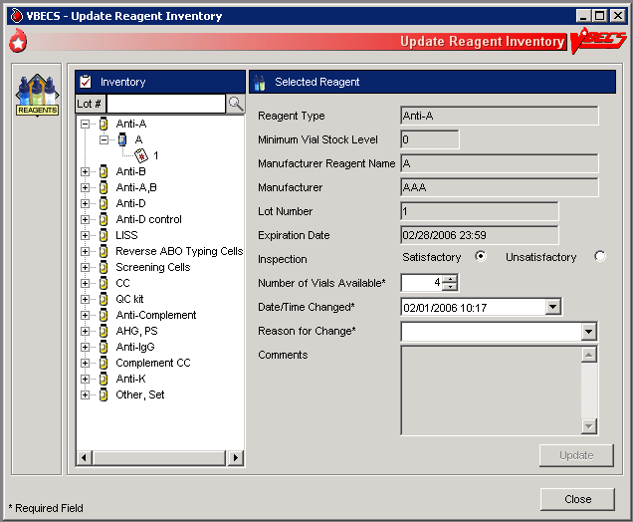

#### View/Print Reagent Inventory

The user views inventory online based on various search criteria and prints the search results.

| **User Action** | **VBECS** |
| --- | --- |
| 1. Select **Reagents** from the main menu. | * Displays options for Quality Control functions. * Displays options for processing reagents. |
| 1. Select **View/Print Inventory**. | * Lists reagent types. |
| 1. Click one or more check boxes in the Reagent Type list to select reagent types. | * Displays or allows the user to print a report of all current in-date, unsatisfactory, expired reagent inventory and minimum stock levels as a read-only display based on the selection criteria entered: * Reagent type * In-date (active) reagents * Unsatisfactory reagents * Expired (inactive) reagents * Expiration date range (the user enters a date to begin and end the search) * Date received (the user enters a date to begin and end the search)   **NOTES**  BR\_20.16 VBECS display only reagents selected based on search criteria. |
| 1. Click **OK** to accept the displayed selection criteria (Figure 61). | * Compiles the report and displays an option to print or exit the report. |
| 1. Click **Print** to print the list of reagents. | * Sends the report to print on the printer selected by the user. |
| 1. Print another report or click **Close** to exit. |  |

Figure 61: Reagent Search

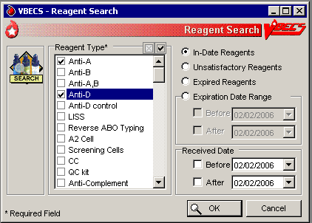

#### Maintain Minimum Levels

The user sets minimum stock levels for reagent types used in the division.

| **User Action** | **VBECS** |
| --- | --- |
| 1. Select **Reagents** from the main menu. | * Displays options for processing reagents. |
| 1. Select **Maintain Minimum Levels**. | * Lists available reagent types and their associated minimum stock levels. |
| 1. Select a **Reagent Type** to edit the minimum level threshold. | * Displays the reagent type selected and allows the user to edit the Minimum Stock Level field or select another reagent.   **NOTES**  A minimum inventory level (a whole number from 0 to 999) is set for each reagent type. This is related to the reagent type, independent of manufacturer name and lot numbers. |
| 1. Enter (or select) a minimum number of vials in the **Minimum Stock Level** field. | * Displays the changes and allows the user to select another reagent to edit.   **NOTES**  BR\_20.09 When the number of vials in stock is at or is less than the stock minimum, VBECS notifies the user and instructs him to check the inventory.  Inventory levels are tied to the reagent type, not to the manufacturer reagent name or the lot number. A particular type may have multiple manufacturer reagent names and multiple lot numbers associated with that manufacturer reagent name, all of which are summed to create the inventory of that reagent type. VBECS tracks the total number of vials in the system for a particular reagent type.  BR\_58.02 Each reagent type has one minimum inventory level established regardless of manufacturer name and lot numbers. Valid entries are whole numbers from 0 to 999. |
| 1. Review the displayed information and click **Update** (Figure 62). | * Displays the changes and allows the user to select another reagent to edit. * Prompts the user to confirm the save. |
| 1. Repeat Steps 3–5 until all minimum reagent levels are set. |  |
| 1. Click **OK** to save, and **Yes** to confirm the save. | * Saves the record and exits. |

Figure 62: Maintain Minimum Reagent Levels

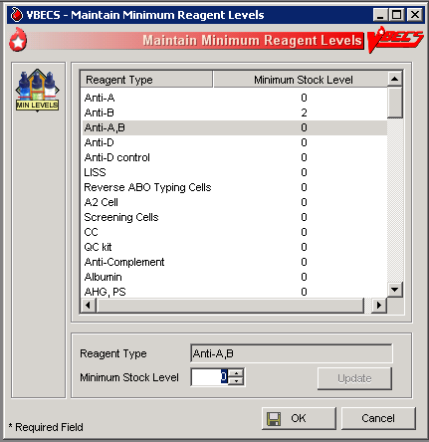

### Supplies UC\_81

The user documents the receipt of supplies, and updates and views the supply inventory.

#### Assumptions

* BR\_81.01 A user may maintain supply inventory only in the division logged into.

#### Outcome

* A supply inventory that is accessible only within the division of entry was established.

#### Limitations and Restrictions

* The division’s modification processes may allow or require the user to select previously entered supplies for association with a blood unit’s modification. An inventory of containers (transfer bags) and sterile connection device (SCD) wafers is *required* for various modification processes.
* There is no retrospective data entry or user selection for this option.
* The unsatisfactory portion of a shipment must be recorded individually.
* Each site must set a standard for recording quantity: it may use the number of cases or the number of units within the cases.

#### Additional Information

* Maintaining Blood Bank Equipment (Equipment: Log In Equipment, Equipment: Maintain Equipment) and Reagents (Log In Reagents, Update Inventory, View/Print Inventory, Maintain Minimum Levels) accommodate the maintenance of reagents and equipment, respectively.
* VBECS saves the lot number, manufacturer name, and expiration date of supplies used in a unit’s modification process as part of a unit’s modification record when associated during the modification transaction.
* VBECS creates a list of manufacturers as they are entered and makes the list available for selection. Users may not edit entries.

#### User Roles with Access to This Option

All users

#### Log in Supplies

The user records the receipt of specific supplies by type. The supply record includes the date the shipment was received, supply name, lot number, expiration date, manufacturer, and number of items received in a shipment.

| **User Action** | **VBECS** |
| --- | --- |
| 1. Select **Tools** from the main menu.   Select **Supplies**. | * Displays options for processing administrative functions. * Displays options for processing supplies. |
| 1. Select **Log In Supplies**. | * Displays fields for entering invoice and supply information. |
| 1. Invoice Information:   Enter the invoice number in the Invoice Number field.  Select or edit the date and time in the Date Received field.  Enter the name of the manufacturer in the Manufacturer field, or select a name from the drop-down list. | **NOTES**  BR\_81.10 More than one technologist at a time may process a large shipment of supplies; only one technologist at a time may process individual supplies in the shipment.  BR\_20.01 The default date received is the current date and time. The user may edit it to a past date and time only.  BR\_81.07 When the supply type and lot number were already entered for this invoice, VBECS warns that the user is trying to enter a supply that was already logged into the system for this invoice. **Yes** takes the user to the “Update Supply Inventory” screen where VBECS displays the supply type and lot number for update. **No** clears all fields on the screen, allowing the user to log in another supply. |
| 1. Supply Information:   Enter the name of the manufacturer and supply type in the Manufacturer and Supply Type fields, or select from the drop-down lists.  Enter the lot number in the Lot Number field.  Select or edit the date and time in the Lot Expiration Date field.  Enter (or select) a quantity (1–999) in the Quantity Received field. | **NOTES**  The default lot expiration date is one minute before midnight (23:59) of the current date. |
| 1. Visual Inspection Information:   Click the **Satisfactory** radio button, or click the **Unsatisfactory** radio button and select a comment from the drop-down list in the Comment field.  Click **Add** to add the supplies to the inventory list (Figure 63). | **NOTES**  Satisfactory inventory is available for later selection, unsatisfactory inventory is not.  When a user selects Other from the drop-down list in the Comment field, entry of additional text in the Details field is required. |
| 1. Repeat Steps 3–5 to log in more supplies, as desired. | **NOTES**  BR\_81.03 Click **Clear** to clear all but the Invoice Number, Date Received, Manufacturer, and Lot Expiration Date fields. |
| 1. Click **OK** to save.   Click **Yes** to confirm the save and exit. | * Requests confirmation to update the database. |

Figure 63: Log In Supplies

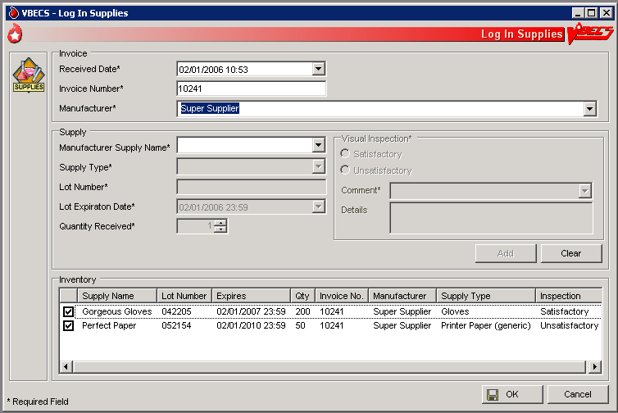

#### Update Supply Inventory

The user changes the number of available items in the supply inventory.

| **User Action** | **VBECS** |
| --- | --- |
| 1. Select **Tools** from the main menu.   Select **Supplies**. | * Displays options for processing administrative functions. * Displays options for processing supplies. |
| 1. Select **Update Supply Inventory**.   BR\_81.12 Click the **Include Expired Supplies** check box to include expired supplies in the list. | * Lists existing satisfactory supplies by default. |
| 1. Select a supply to edit.   To view supplies with a specific lot number, enter the lot number in the Lot # field and click the **magnifying glass**. | **NOTES**  Click a supply type to reveal manufacturer supply names. Click a manufacturer supply name to reveal lot numbers. |
| 1. Click a lot number to enable the Quantity Available field.   Enter (or select) a quantity that is less than or equal to the current entry in the Quantity Available field.  Select or edit the date and time in the Date Changed field (Figure 64). | **NOTES**  The default change date is the current date and time. The user may edit it to a past date and time only.  When a user selects Other from the drop-down list in the Reason for Change field, he may enter additional text in the Comments field. |
| 1. Repeat Steps 3 and 4 to edit more supplies, as desired. |  |
| 1. Click **OK** to save.   Click **Yes** to confirm the save and view the updated list. |  |
| 1. Click **Print Supply Inventory** to print the list of supplies. | * Displays the Supply Inventory window (see View/Print Supply Inventory). |
| 1. Click **Cancel** to exit. |  |

Figure 64: Update Supplies

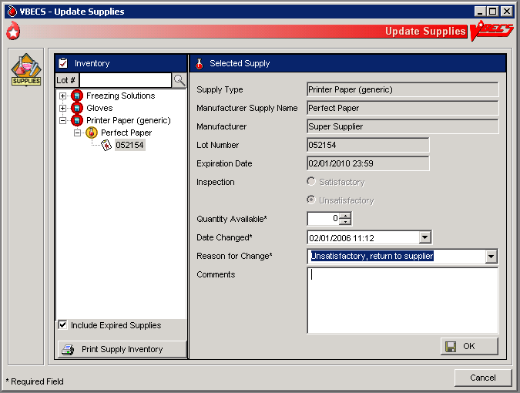

#### View/Print Supply Inventory

The user views inventory online based on various search criteria and prints the search results.

| **User Action** | **VBECS** |
| --- | --- |
| 1. Select **Tools** from the main menu.   Select **Supplies**. | * Displays options for processing administrative functions. * Displays options for processing supplies. |
| 1. Select **View/Print Supply Inventory**. | * Lists supply types. |
| 1. Click one or more check boxes in the Supply Type list to select supply types. | * Displays or allows the user to print a report of all current in-date, expired, and unsatisfactory supply inventory and minimum stock levels as a read-only display based on the selection criteria entered: * Date range (the user enters a date to begin and end the search) * Supply type * In-date (active) Supplies * Expired (inactive) Supplies * Expiration date of the supply * Date received   **NOTES**  BR\_81.08 A user may view the supply inventory by one, some, or all of the selection criteria.  PT\_81.01 Supply Types |
| 1. Click **OK** to accept the displayed selection criteria. | * Compiles the report and displays an option to print or exit the report. |
| 1. Click **Print Supply Inventory** to print the list of supplies. | * Sends the report to print on the printer selected by the user.   **NOTES**  BR\_81.09 VBECS displays and prints the report in the supply type order (as defined in PT\_81.01): in-date by lot number in reverse chronological order of expiration date, followed by expired and unsatisfactory supplies. Details included in the report:   * Supply Type (Unit of Measure) * Manufacturer * Manufacturer’s Supply Name * Lot Number * Expiration Date * Number Available * Inspection upon receipt * Invoice Number * Received Date/Time * Received by Tech Name * Comments |
| 1. Print another report or click **Cancel** to exit. |  |

### Equipment UC\_22

The user registers blood bank instruments and other equipment (refrigerators, freezers, thawing bath, incubators, centrifuges, etc.) and records associated maintenance activities.

#### Assumptions

* BR\_22.01 A user may maintain equipment inventory only in the division currently logged into.

#### Outcome

* An equipment maintenance record, accessible within the division of entry, was established.

#### Limitations and Restrictions

* VBECS does not check for duplicate entries of equipment names and identifiers.
* There is no retrospective data entry or user selection for this option.

#### Additional Information

* VBECS does not calculate inventory levels for supplies or equipment.

#### User Roles with Access to This Option

All users

#### Equipment: Log In Equipment

A user adds new equipment or maintains existing equipment. After equipment is registered, the user must record periodic maintenance. The equipment records are updated and retained according to local procedure and policy. Once an equipment record is established, it may be selected as equipment used during a blood product modification.

| **User Action** | **VBECS** |
| --- | --- |
| 1. To add new equipment, select **Tools** from the main menu.   Select **Equipment**. | * Displays options to maintain equipment maintenance. |
| 1. Select **Log In Equipment** to create an equipment record or **Maintain Equipment** to record maintenance (see Equipment: Maintain Equipment). | * BR\_22.05 Displays an empty equipment property template. * Displays all in-service equipment items for the blood bank associated with the user’s division and offers the option to display out-of-service equipment. |
| 1. Equipment Info area: Enter the equipment information in the appropriate fields. Enter or select an equipment type from the drop-down menu.   Installation Info area: Select or edit the date and time in the Date Received/Installed field.  Click the **Expiration/Renewal Date** check boxwhen there’s an expiration or renewal date, and edit the date as above.  Manufacturer Info area: Enter the manufacturer name or select a manufacturer from the drop-down list.  Enter the manufacturer’s contact information in the appropriate fields or click the **find** button to select the manufacturer’s address.  Click **Add** to add the equipment to inventory (Figure 65). | * Displays fields for entering equipment name, ID, serial number, and type in the Equipment Info area. * Displays fields for entering the date the equipment was received or installed, warranty or service contract number, and expiration or renewal service contract date in the Installation Info area. * Displays fields for entering the manufacturer name, address, and phone in the Manufacturer Info area. |
| 1. Repeat Step 3 to add new items to the equipment list.   Click **OK** to save. | * BR\_22.02 VBECS maintains a historical record for each piece of equipment entered. |
| 1. Click **Yes** to confirm and exit. |  |

Figure 65: Log In Equipment

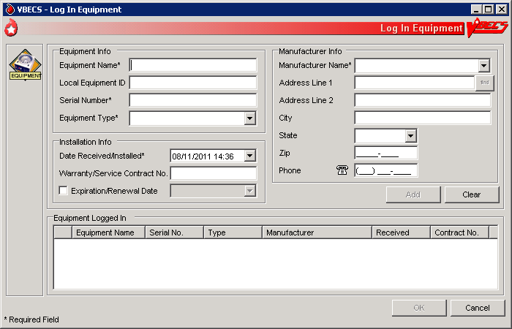

#### Equipment: Maintain Equipment

The user maintains an online equipment record to record periodic maintenance. Equipment records are updated and retained according to local procedure and policy.

| **User Action** | **VBECS** |
| --- | --- |
| 1. To maintain equipment, select **Tools** from the main menu.   Select **Equipment**. | * Displays options to maintain equipment maintenance. |
| 1. Select **Maintain Equipment** to record maintenance or **Log In Equipment** to create an equipment record (see Equipment: Log In Equipment). | * Displays entered in-service equipment items for the blood bank associated with the user’s division and offers the option to display out-of-service equipment. |
| 1. In the Equipment tab, enter the equipment serial number (or enter part of the serial number and click the **magnifying glass** to view serial numbers), or click + in front of each equipment type and name to view equipment items.   Select the serial number of the item whose record will be maintained.  Click the **Include Out of Service Equipment** check box, if desired. | * Displays fields for entering the type of maintenance event performed, the date the maintenance was performed, the results of the event, the next scheduled event, the next scheduled maintenance date, and pending maintenance issues in the Maintenance tab, and allows the user to select a maintenance event type and event details. * Displays entered information. |
| 1. Review and edit the equipment data in the Equipment tab. | * Displays entered information. |
| 1. Select the **Maintenance** **tab**.   To add a maintenance event, enter the maintenance type or select it from the drop-down list.  Select or edit the date and time in the Maintenance Date field.  Enter details in the Maintenance Results and Pending Issues fields.  Click **Add** to add the maintenance event to the Maintenance Events list (Figure 66).  Click **Print** to print the record. | * Displays recorded maintenance information and allows the user to update information. * Displays an option to print an Equipment Report. |
| 1. Click the **Out of Service Equipment** check box to remove equipment. | * Removes the equipment from the list of currently maintained equipment. |
| 1. Repeat Steps 3–6, as desired. |  |
| 1. Click **OK** and **Yes** to save and continue, or **No** to return to the screen and continue.   Click **Cancel** to exit without saving. | * Prompts the user to confirm the save. * Saves the updates to the equipment record. |

Figure 66: Maintain Equipment

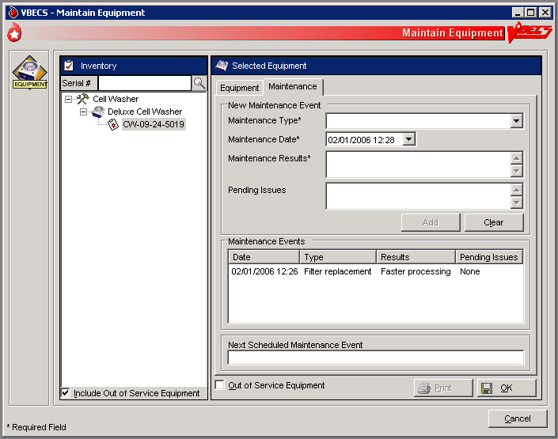

This page intentionally left blank.

# Component Processing

## Shipments

### Incoming Shipment UC\_01

A shipment handled in this option contains one or more containers of human blood products.

The user may use a barcode scanner to read information from a unit blood bag (recommended) or enter this information. The user reviews and confirms the information before adding a unit to the database.

#### Assumptions

* The connection to VistA is active.
* The division is configured.
* The shipper is active.
* Units are inspected and deemed satisfactory for receipt before they are entered in VBECS.

#### Outcome

* A shipment or partial shipment of blood units was processed and added to the blood bank inventory.
* The initial status for each unit was set in accordance with component class.

#### Limitations and Restrictions

* VBECS does not compare the ABO/Rh of an autologous unit or display a message when the ABO/Rh is incompatible with the restricted for patient.

When a product type, code, or local code is not in VBECS or a blood supplier creates a product code, contact the Help Desk. See Customer Support for contact information.(DR 2,640)

* The user must enter the donation type for Codabar-labeled units.
* The unit expiration [Maximum Storage Time (MST)] is set to the longest possible storage time based on product type, core condition, attributes, and available references as a guide. The MST is set at a higher level than an individual collection product code. VBECS does not know the specific collection details. It is the responsibility of each user to accurately enter and process any one blood unit based on its expiration date/time as labeled by the collection facility. Task 1280
* When a user inadvertently enters a unit ID that is longer than seven characters for a Codabar unit, or 13 characters for an ISBT 128 unit, VBECS accepts the entry but will not associate it with the scanned unit ID. DR 2,671
* When blood products intended for quarantine are scanned, VBECS does not automatically quarantine them: the user must do so.
* The display of Special Testing for a unit is limited to 253 characters in Incoming Shipment. All of the special testing is saved in VBECS and is available on reports. DR 3781
* The display label that is built when logging a blood product into VBECS does not change from volunteer donor to autologous when the donation type is changed. DR 3041
* VBECS does not accept scanned information for some modified ISBT 128 blood units. VBECS accepts entered information in these instances.UserDoc Task 1085, based on CR 1594 (deferred) UserDoc Task 1091, based on DR 1922
* VBECS does not recognize scanned labels for para-Bombay or Bombay ISBT units.
* VBECS does not check whether blood products with the same unit ID and different product codes are the same blood type.
* VBECS does not allow duplicate IDs for the same product code.
* VBECS reads Codabar prefixes and translates them into digits. When this results in identical Codabar unit IDs, keep the original unit and return the other unit to the supplier. DR 2,540
* When a user scans a product code or expiration date barcode in the Unit ID field, VBECS does not display the entered information or an error icon.
* When a user scans an ISBT product ID with “0” as the donation type (sixth character), VBECS indicates that the donation type is not specified. When the user selects a donation type from the drop-down menu, VBECS replaces “0” with a recognizable character in the product code text box and stores it as such. When the user rescans the product ID, he must manually replace “0” or search using the unit ID alone, or the unit ID and the first five characters of the product ID.
* Blood product code entries in the blood product table include those from ICCBBA for ISBT 128 and from the AABB Codabar table. Product codes created after the release of VBECS cannot be entered until the updated tables are incorporated through patches to VBECS. Refuse acceptance of the unit, if possible. Users may not edit the blood product table.
* ISBT 128 tables include blood product codes labeled as not for manufacturing or transfusion. VBECS does not restrict such products from being entered, issued, or transferred (local policy controls their use), but does not accommodate blood modification for these products.
* A user cannot bring in pooled ABO or pooled Rh types for plasma or FFP. Cryoprecipitate is **not** affected. DR 4316

#### Additional Information

* BR\_1.14 A unique blood unit record is defined by the following data elements:
* VBECS Division
* Unit ID
* Product type code (Codabar Only)

For example: Product Code: 12000 will present a choice of Product type code:

* + - Platelets
    - Washed Platelets
* Product code

Codabar (5 digits)

ISBT 128 (8 alphanumeric characters).

* VBECS stores scanned ISBT 128 product codes and displays them as eight characters:
* Characters 1–5: product type
* Character 6: donation type
* Characters 7 and 8: division code (split)
* BR\_1.13 VBECS may display a scanned Codabar product code as seven characters.
* When ISBT 128 units received during downtime must be issued, it is recommended that the user record the check character. When a blood unit is to be logged in after downtime and the unit is unavailable for scanning, the user must enter the ISBT unit ID and the case-sensitive check character (the character in the square following the unit ID).
* To calculate a check character, see the Quick K Calculator on the ICCBBA Web page under ISBT 128, Other Tools. Follow the instructions to download the application.
* Each division may have only one blood unit record of the same product type, product code, and unit ID. A unit shipped out (transferred) and subsequently shipped to (received by) a division in the same database will maintain individual records of the unit ID and product code for each division.
* Several data elements, including the unit ID and product code, define a blood unit record as unique. The unit record also includes expiration date and time, blood type, and donation type. These data elements are not editable.
* Some suppliers relabel blood products and do not affix their own FDA Registration Number to those units. It is recommended that the user obtain FDA Registration Number barcodes from their suppliers and use them for scanning the shipper.

#### User Roles with Access to This Option

All users

#### Incoming Shipment

In a “transfusion-only” facility, units must be restricted for use by a specific patient while an incoming shipment is processed. VBECS identifies the original collection facility to determine the presence of an eye-readable prefix and/or alphabetical characters in a Codabar unit ID. A user may enter unique unit information regarding special testing and antigen phenotyping. The user confirms that all entered units from the shipment were added to the database in the blood bank.

| **User Action** | **VBECS** |
| --- | --- |
| 1. Select **Shipments** from the main menu.   Select **Incoming Shipment**. | * Displays options for processing blood product shipments. * Displays invoice information fields for entering shipment information. |
| 1. Scan the invoice number barcode or enter the invoice number.   To search for an existing invoice, click the **find** button. Enter an invoice number and/or select a shipper from the drop-down list, then click **Search**. Click an invoice number to select it and click **OK**. | * When an identified invoice does not exist, asks the user whether he wants to create an invoice and add units to it. * Displays the option to search for existing invoices by invoice number and/or by active shipper. When no match is found, notifies the user.   **NOTES**  BR\_1.63 When a user chooses to select an existing invoice to add units, VBECS ensures that the shipper is marked as active. VBECS displays and allows the user to edit existing invoices associated with active shippers.  To correct an invoice associated with an inactive shipper, the user must reactivate the shipper.  BR\_1.38 Multiple users may process different units from a shipment.  When more than one user intends to work on an invoice, one user must create the invoice. The other users must select that invoice and add units to it. |
| 1. Select a source from the Source (Shipper) drop-down list. If needed, edit the date received in the Date Received field. | **NOTES**  The date and time a shipment is received cannot be in the future.  After a user enters or selects an invoice number, the user may enter information in the shipper, date received, and processing technologist fields.  During retrospective entry, the user must enter the shipment date and time before entering any other unit transaction. |
| 1. Click the **ISBT** or **Codabar** radio button to select a labeling type, or scan the unit ID barcode. Click **OK** again to continue. | * When the barcode is scanned, determines the labeling type (autodiscriminates). |
| 1. Click **Yes** to add units to the invoice or click **No** to select another invoice. | * When a user selects an existing invoice, displays the shipment information and blood unit details associated with the invoice. |
| 1. Select a unit to add.   For a Codabar-labeled unit, scan the FDA Registration Number barcode or enter the FDA Registration Number.  For an ISBT 128-labeled unit, continue at Step 7. | * Displays shipment data and prompts the user to scan individual units. * Displays information corresponding to the FDA registration barcode scanned or allows a user to search for the FDA Registration Number and facility information (all users may activate a facility). * When a facility receives a blood product from a shipper for the first time, prompts the user to activate the blood product for that shipper.   **NOTES**  BR\_1.11 VBECS may display a scanned FDA Registration Number with two additional characters.  For United Blood Services (UBS) facilities other than Scottsdale, see Appendix L: United Blood Services (UBS) Facility Barcodes.  BR\_1.12 When VBECS does not recognize an FDA Registration Number, it warns the user. The user may edit or reenter the number. If VBECS still does not recognize the number, the user must add the unknown facility to continue. |
| 1. For an ISBT 128-labeled unit, scan the label, or enter the unit ID and check character (in that order). | * Disables the FDA Registration Number field. * Displays information corresponding to the unit ID barcode scanned. When a user enters an ISBT 128-labeled unit ID, VBECS prompts the user to enter the check character from the blood bag. * BR\_1.09 BR\_1.08 When a user scans ISBT 128 labels units and the cursor is in an inappropriate field, VBECS warns that the incorrect barcode was scanned.   **NOTES**  For Codabar-labeled units:  BR\_1.11 VBECS may display a scanned FDA Registration Number with two additional characters.  BR\_1.12 When VBECS does not recognize an FDA Registration Number, it warns the user. The user may edit or reenter the number. If VBECS still does not recognize the number, the user must add the unknown facility to continue.  BR\_1.15, BR\_ 1.16 When no FDA Registration Number barcode was scanned, VBECS displays an error message to remind the user to scan it so that VBECS can properly interpret the Codabar unit ID.  When a user scans a unit ID barcode but enters other unit information, VBECS marks the unit record as scanned and does not indicate that other data field information was entered during incoming shipment of that unit.  BR\_1.05 When a unit ID or its prefix does not match the format defined for the collection facility, VBECS warns the user.  The ID of a unit associated with a local supplier with a facility prefix and alphabetic characters has two numbers for the facility prefix, and one or two alphabetic characters. When there is one alphabetic character, at least six numbers must follow. When there are two alphabetic characters, at least five numbers must follow. Codabar unit IDs cannot contain “A,” “B,” “D,” “I,” “O,” or “U.”  For ISBT 128-labeled units:  BR\_1.19 When the user-entered check character from the label does not match the VBECS-generated check character, VBECS warns the user.  BR\_1.64 When VBECS does not find a matching entry for the ICCBBA Registration Number on the local supplier table, the user must activate or add a local supplier before continuing. |
| 1. Scan the product code barcode or enter the product code. | * When a user scans a product code barcode that is not activated in the user’s division, prompts the user to activate the code. (See Blood Products.) * Displays the corresponding product code, product name, and (for ISBT) donation type (see Step 11). * When a unit ID of the same product type and code exists in a division, the expiration date is in the future, and there is no record of inactivation or transfer of that unit ID and product code in the division’s record: * Warns that the blood unit already exists in the division. * Clears the data entry fields. The user may enter a different unit ID and product code. * When a unit ID of the same product type and code exists in a division and the unit in the division has an expiration date in the past, warns that the blood unit already exists in the division. * When a unit ID of the same product type and code exists in a division, the unit status is “Transferred,” and the ABO/Rh and unit expiration date are identical to the existing unit of record: * Makes the existing unit record available. * Warns that the user is attempting to reenter a unit in inventory. **No** clears the unit. **Yes** and saves the unit. * Updates the unit status to “Limited” or “Available.” * Updates the unit record to reflect the reentry of the unit in the division’s inventory. The user may add new information about this unit through Edit Unit Information.   **NOTES**  Scanned Product Codes  BR\_1.42 When a unit is transferred between facilities in a consolidated database or is reentered after transfer to an unrelated facility, VBECS records all unit activity.  BR\_1.58, BR\_1.59 Codabar units may not be added to an ISBT 128 shipment in the same session and ISBT 128 units may not be added to a Codabar shipment in the same session. However, a completed incoming shipment invoice may contain both types of units.  BR\_1.53 When a blood product code in the RED BLOOD CELLS, WHOLE BLOOD, or APHERESIS RED BLOOD CELLS ICCBBA component class is entered, VBECS enables data entry of sickle cell negative and antigen typing. The cytomegalovirus (CMV) negative data entry option is always enabled.  BR\_8.12 When a user enters a product code that VBECS does not recognize, VBECS warns that the blood product was not found and that it does not support entry of new blood products.  **OK** returns the user to a blank screen to enter a different product. The user may enter a different product code.  VBECS requires the full 8-digit ISBT 128 product code. The user should enter the 8-digit ISBT 128 product code as it appears on the blood unit label of the actual blood unit being entered into VBECS. When a user does not enter the sixth through eighth characters, VBECS automatically completes the required information with defaults, V and 00, respectively. This may be changed by clearing the unit information and entering the complete 8-digit ISBT 128 unit product code. DR 4484  BR\_1.50 VBECS assigns a volume to the unit based on the average volume field from the Blood Product Table entry corresponding to the unit’s blood product code.  BR\_1.02 For each product type in a shipment, site parameters must indicate that the product is marked as active for the division and that a cost is associated with the shipper. If not, VBECS prompts the user to mark the component as active.  For Codabar-labeled units:  BR\_1.13 VBECS displays a scanned Codabar product code as seven characters.  In some instances, Codabar product codes are not unique when they are modified.  For ISBT 128-labeled units:  BR\_1.14 VBECS stores scanned ISBT 128 product codes and displays them as eight characters:   * Characters 1–5 are used to search the ISBT Blood Product Table to identify the product type. * Character 6 indicates donation type. * Character 7 indicates a division at the time of collection. * Character 8 indicates an additional aliquot. |
| 1. For Codabar- and ISBT 128-labeled units, scan the ABO/Rh number barcode, enter the ABO/Rh, or select the ABO/Rh from the drop-down list. | * Displays the corresponding ABO/Rh. * Allows the selection of only ABO/Rh types acceptable for ICCBBA component classes. * BR\_1.66 Enables the ABO/Rh field when a valid product code is entered. |
| 1. Scan the expiration date barcode or enter the expiration date and time when an expiration time is required. | * Displays the corresponding expiration date and time.   **NOTES**  BR\_1.22, BR\_1.23 The default unit expiration time is 23:59.  BR\_1.31 VBECS compares the entered blood product’s expiration date to the maximum storage date and time limit for the product type. The date and time of shipment receipt are used as the collection date and time. When the expiration date entered exceeds the defined maximum storage time, VBECS displays an error message and clears the field. The user may reenter an expiration date and time for the product.    Products with a maximum expiration date and time of <24 hours default to an expiration time <24 hours from the time of the incoming shipment. Product types with a maximum expiration date and time of > 24 hours have a default expiration time of 23:59.  BR\_1.61  When a unit expiration date precedes the incoming shipment date and time, VBECS emits an audible alert, warns that the user is attempting to enter an expired unit, and asks whether the user wishes to continue.  **No** clears the unit expiration date field. The user must enter a new, acceptable expiration date. **Yes** requires the user to enter a comment.  VBECS captures details of this override in an Exception Report. |
| 1. For Codabar-labeled units, accept “voluntary allogeneic” or select another donation type.   For ISBT 128-labeled units, accept the donation type based on character 6 of the product code (cannot be edited) or, when character 6 is “0,” indicate a donation type. | * Assigns the donation type to the unit or requires user input, as needed. * For Codabar, assigns the “voluntary allogeneic” donation type to the unit. * Requires data entry of the “reserved for” patient name and/or patient ID and the disease market testing status for “autologous” and “directed” donation types.   **NOTES**  For ISBT 128, donation types other than “Special Testing Barcode” and “Not Specified” cannot be edited. When the donation type is “Special Testing Barcode” or “Not Specified,” the user must select a different donation type.  Codabar barcodes do not include donation type codes, so a user must select a valid donation type. When a donation type requires restriction (directed or autologous), the user must associate the unit with a patient name.  BR\_1.36, BR\_1.26 When a site is a transfusion-only facility, each unit processed must be restricted to a specific patient regardless of donation type. |
| 1. Click the **find** button next to the Restricted For Patient field to indicate the patient for whom the unit is reserved, as needed. | * Allows the user to search for active VistA patients to associate with the unit. * Requires data entry of a patient name and/or patient ID to associate the unit with that patient when a unit has a “directed” or “autologous” donation type or the receiving facility is a “transfusion-only” facility. * When no match exists, warns the user. * When the unit is autologous, requires a user to indicate the disease marker testing status: * NEG: unit fully tested and negative for all disease markers * POS: unit tested and positive for one or more disease markers (biohazard) * NFT: unit not fully tested for one or more disease markers (biohazard)   **NOTES**  Displays a message when the user selects a patient with a blank first or last name, or the name is too long. The user is instructed to contact the VBECS Administrator for assistance. DR 3444  DR 1,041The Patient Blood Availability Report does not include restricted units not assigned to a patient. To track such units, the user may enter restricted units’ IDs in the Special Instruction field in Special Instructions & Transfusion Requirements: Enter and Remove Special Instructions. When a user restricts a unit to a patient and VBECS does not find that patient in its database, VBECS searches VistA. When it finds a valid patient, VBECS adds the patient to the database. |
| 1. Do one or more:   Accept the blank check boxes or click a check box to indicate that a unit is CMV Negative or Sickle Cell Negative.  Enter an additional cost.  Enter an antigen phenotype for a unit (Figure 67). | * Displays an option to save or clear unit information.   **NOTES**  VBECS accommodates data entry of:   * BR\_1.44 Special testing results (antigen phenotype results, CMV negative, or sickle cell negative). * BR\_1.46 A single special typing cost (the sum of charges from $0.00 to $999.00, other than the base unit cost) to associate with a unit.   BR\_1.45 An antigen type may be positive or negative for any antigen listed as a VBECS corresponding antigen in Appendix B: Table 13: TT\_23.01A Antibody and Antigen Table: Irregular Antibodies. An antigen may not be positive and negative for the same unit. |
| 1. Review and click **Save** to accept the unit. | * BR\_1.68 Asks the user whether he has inspected the units and that they are satisfactory. * When the user clicks yes, the unit record is added to the division’s inventory. When the user clicks no, the unit information is cleared and the unit is not entered into the division’s inventory. * Adds the unit to the database. * Lists summary information for the accepted unit. * Allows the user to begin processing a new unit.   **NOTES**  If the unit is not satisfactory per the visual inspection, the user must click no. The unit is not entered into VBECS inventory and should be processed according to local procedure and policy.  VBECS assigns unit statuses based on a site’s configuration in Configure Division. For a:   * “Full-service” facility, VBECS assigns “Limited” status to blood products that contain red cells and “Available” status to all other components. * “Transfusion-only” facility, VBECS assigns “Available” status to the units. ABO/Rh confirmation testing is not required.   Units are available only to users in the division in which the units were processed (separate inventories are maintained in a multidivisional site).  To edit incorrect saved information, inactivate the unit through Edit Unit Information, then reenter unit information in Incoming Shipment. |
| 1. Repeat until all units are entered. | * Displays all unit data entries. |
| 1. Click **Close**. |  |

Figure 67: Process Incoming Shipment

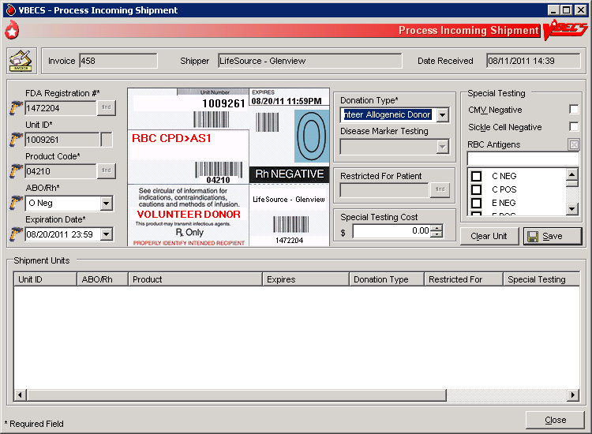

#### Outgoing Shipment UC\_11

The user processes and ships available blood units from his division to an outside facility, blood center, or hospital.

The user may edit return credits (additional fees or credits may be issued from one site to another) before processing the shipment.

VBECS generates a shipping invoice.

#### Assumptions

* Users are authorized to release units from inventory.
* Blood units being shipped:
* Were entered in the division.
* Are available for scanning.
* Are located in the user’s division.

#### Outcome

* An invoice for a completed shipment is closed and may not be modified.
* An invoice for a shipment that is not confirmed is open and may be edited.
* The units are not available in the division’s inventory.
* When a unit is transferred to another division in the database, VBECS displays the history of the unit at both divisions. The unit is active in one division at a time.
* A credit for a returned product may be assigned.

#### Limitations and Restrictions

* A user may edit only unconfirmed invoices.
* The number of tests displayed on an invoice is limited to 8,000 characters per unit.
* When the user creates an invoice and cancels before saving it, VBECS excludes the invoice number from use.

#### Additional Information

* None

#### User Roles with Access to This Option

All users

#### Outgoing Shipment

A user ships blood units from his division’s inventory to a facility that is not a transfusion location of his division. These units were removed from inventory and are available for scanning and packaging.

The user identifies the shipment destination, scans the unit ID and product code for the first unit in the shipment, and repeats this process for each unit added to the shipment. The user completes the data entry and then reviews and accepts the shipment information. When the shipment is confirmed, the user may print a shipping invoice.

VBECS generates an invoice that includes information for the blood units on that invoice.

A user may edit return credits (additional fees or credits may be issued from one site to another) before processing the shipment.

| **User Action** | **VBECS** |
| --- | --- |
| 1. Select **Shipments** from the main menu.   **Select Outgoing Shipment.** | * Displays options for processing shipments. * Displays options for selecting a new invoice or an existing (recent) invoice. |
| 1. To process a new invoice, select **New Invoice**. (To process an existing invoice, continue at Step 3.)   Enter the invoice number provided by the outside facility or leave the Invoice Number field blank.  Select a shipment destination from the drop-down list.  Click the **Return to Shipper** or **Send to Unrelated Shipper** radio button to select a shipment type (Figure 68).  Continue at Step 4. | * Displays fields for entering shipment information. * Generates an invoice number when the Invoice Number field is blank.   **NOTES**  To select an existing invoice while in the new invoice window, click **Use Existing Invoice**. |
| 1. To process an existing invoice, select **Recent Invoice** from the Outgoing Shipment menu.   Select an invoice. | * Displays a list of open (unconfirmed) invoices.   **NOTES**  To select a new invoice while in the existing invoice window, click **Create New Invoice**.  BR\_11.20 A user may edit only saved, not confirmed, outgoing shipment invoices.  BR\_11.10 A user may select shipping destination (ship-to) facilities based on site parameters that define a shipper for a division.  BR\_8.03 A shipper must be marked as an active collection facility for a division before a user may select it as a valid shipper for a blood product for that division. This includes marking the division facility itself as an active collection facility to accommodate the creation of new blood products through modification. |
| 1. Click **OK** to save the information entered (Figure 68). | * Displays fields for entering unit information. |
| 1. For each unit to be added to the shipping invoice, scan the unit ID and product code barcodes or enter them in the Unit ID and Product fields (Figure 69 and Figure 70).   Click **OK**. | * Displays corresponding unit data.   **NOTES**  BR\_11.15 When a unit selected for inclusion in a shipment is quarantined, VBECS warns the user and asks the user whether he wishes to continue.  **No** clears the unit information and allows entry of a new unit or shipment process. **Yes** adds the unit to the shipment.  BR\_11.03 VBECS allows the shipment or transfer of units located only in the same division as the user and in the blood bank (for “Limited,” “Available,” “Assigned,” and “Crossmatched” unit statuses only).  BR\_11.12 When a unit is expired, VBECS warns the user.  BR\_11.05 When units selected for shipment are assigned or crossmatched to a patient, VBECS warns the user and asks the user whether to release the unit before shipping.  **Yes** releases all patient assignments from the unit prior to adding the unit to the invoice (no assignment information is displayed on the invoice). **No** indicates that the outgoing shipment invoice must include the unit’s patient association details. |
| 1. Respond to warnings, when indicated.   Click **Select** to add the selected unit to the shipping invoice or click **Clear** to delete a unit (Figure 71). | * Adds unit to or removes unit from a temporary list of selected units. |
| 1. Repeat Steps 5 and 6 until all units for outgoing shipment are entered.   Click **Save** to save the information entered (Figure 72) and **Yes** to confirm the save.  To cancel the shipment, click **Cancel Shipment**, then **Yes** to delete the invoice and return to Step 1 to begin again, or click **No** to return to the invoice (Figure 73). | * Displays shipment information. * When a user clicks **Cancel Shipment**, asks whether the user wants to remove all units from the invoice. **Yes** deletes the invoice. **No** returns to the invoice.   **NOTES**   * A user may add or delete units from a temporary list before accepting the information entered. |
| 1. To change the return credit amount for a unit in a “Return to Shipper” unconfirmed shipment, select a unit and right-click the mouse. Select **Return Credit Update** (Figure 74).   Enter the return credit amount.  Click **OK** to save the information entered or **Cancel** to return to the invoice. | * Prompts the user to accept the new amount. * Returns to the invoice and displays the return credit amount on the invoice. * Displays the unit’s financial information and allows the user to edit the return credit amount.   **NOTES**  BR\_11.14 VBECS applies a return credit (equal to the return credit percentage of the original cost of the unit) to units processed in an outgoing shipment to the original shipper. Users may edit return credits for individual units.  Instead of right-clicking the mouse, a user may press the application key (http://msdn.microsoft.com/library/en-us/dnacc/html/atg_keyboardshortcuts_10.gif) on the keyboard. |
| 1. To confirm the shipment, click **Save**, then **Yes** to save the invoice, or **Cancel** to return to the invoice (Figure 75).   Click **Print Invoice** to generate and view an invoice.  Click **Printer** to print an invoice to send with the shipment or click **Close** to return to the invoice.  Click **Cancel** to exit or move to Step 9 to change a return credit amount. | **NOTES**  BR\_11.21When units selected for shipment are currently restricted to a patient and the donation type of the unit is Voluntary Allogeneic, in addition to releasing the patient assignment, VBECS also removes the unit restriction in a Transfusion Only division configuration. |
| 1. Cancel or confirm the shipment as in Step 9. | * Displays a “Confirm Shipment” option and stores the open invoice until the user chooses to complete the shipment.   **NOTES**  BR\_11.18 When a shipment is saved but not confirmed, VBECS displays “NOT CONFIRMED” as the shipment date on the print version of the invoice.  BR\_17.02 The shipping invoice includes patient assignment, restriction, quarantine indicator, biohazard information, antigen typing (specificity and interpretation only), special testing information, and (when it is in a unit record) the autologous unit testing status. |
| 1. When the shipment is confirmed, select or edit the date and time in the Shipment Date/Time field.   Click **OK** to save the information entered or **Cancel** to return to the invoice. | * Displays shipment information, including the shipment date and time. When a user accepts the entered date and time, displays the invoice to be printed. * Updates the status of each unit in the shipment to show that each unit was transferred to the ship-to facility and assigns the shipment date and time as the date and time of the transaction.   **NOTES**  When VBECS confirms an outgoing shipment, it:   * BR\_11.08 Adds the shipment information to the unit record, changes the status of each unit in the shipment to “Transferred,” and assigns the date and time of the transaction to the shipment. * BR\_11.09 Saves the technologist ID, the name of the printing technologist, the division, and the date and time the shipment was processed. It also saves the confirmation date and time as the date and time of shipment. The user may accept or edit the current date and time displayed (no future date or time may be entered). The unit status is changed to transferred upon invoice confirmation. |
| 1. Click **Print Invoice** to generate and view an invoice as in Step 9, or click **Cancel** to exit. | * Displays the information to be printed on the invoice. * Prints the shipping invoice.   **NOTES**  BR\_92.07 When a user prints an invoice and VBECS does not find information to include in the invoice, VBECS notifies the user and asks whether he wants to continue to print. The user may cancel or print the report, which will include “No pending orders found.” |

Figure 68: Process Outgoing Shipment

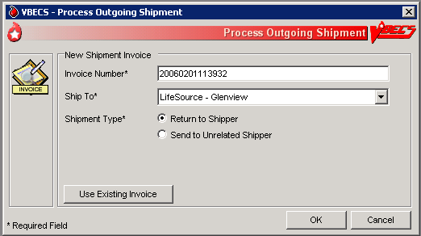

Figure 69: Select Units 1

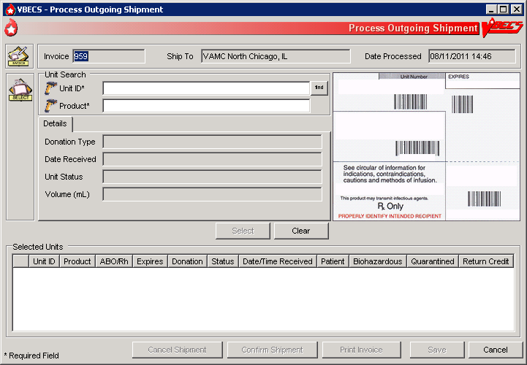

Figure 70: Select Units 2

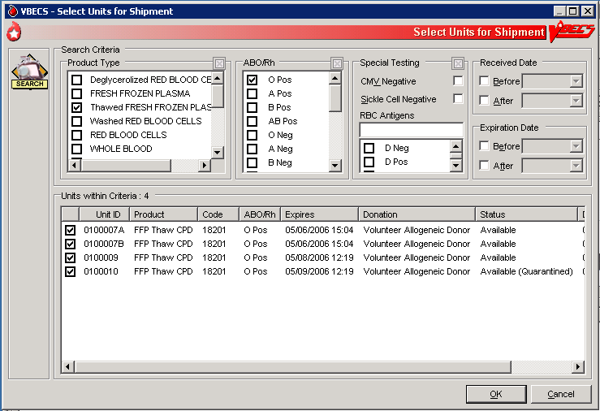

Figure 71: Select Units 3

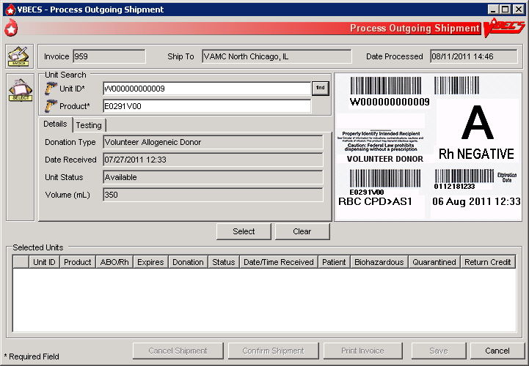

Figure 72: Select Units 4

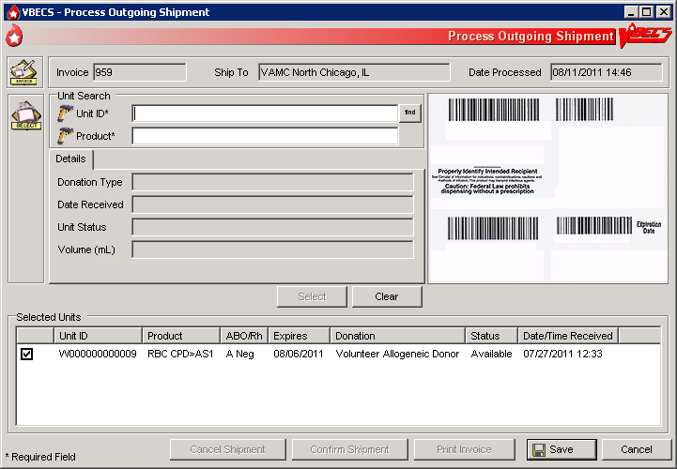

Figure 73: Select Units 5

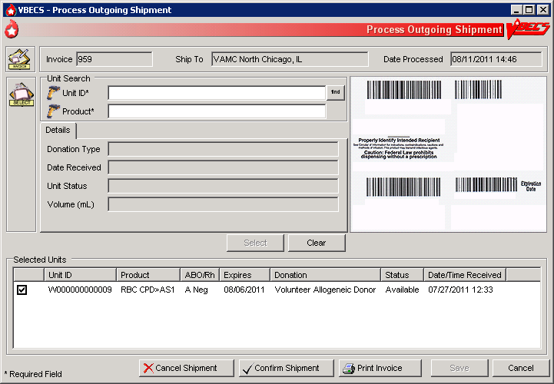

Figure 74: Return Credit Update

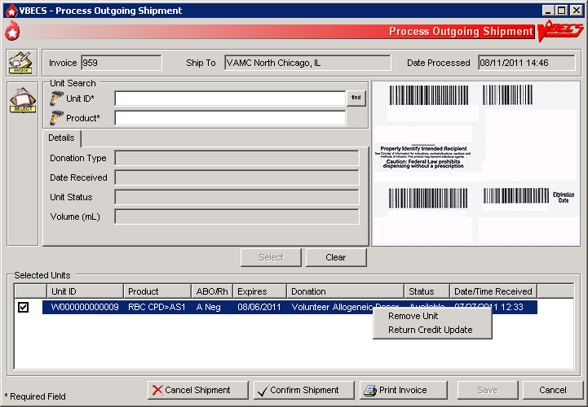

Figure 75: Confirm Invoice



Figure 76: Modify Return Credit

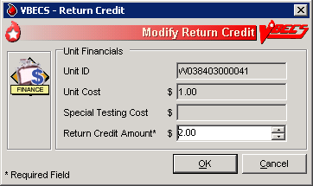

Figure 77: Confirm Shipment

****

Figure 78: Confirm Shipment Date

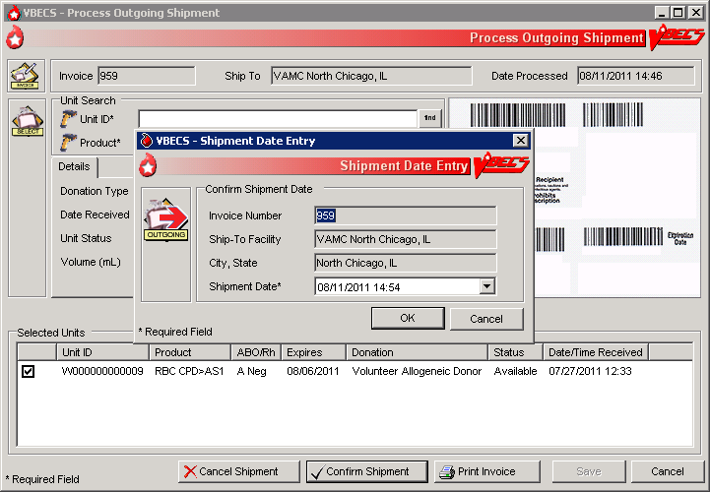

Figure 79: Confirmation of Invoice

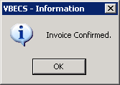

### Edit Invoice Text UC\_17

VBECS includes a shipping invoice. The user may edit the explanatory text above the signature on the last page of a shipping invoice.

#### Assumptions

* Information on the outgoing shipment invoice is generated during Outgoing Shipment.

#### Outcome

* A division customized the text displayed on an outgoing shipment invoice.

#### Limitations and Restrictions

* None

#### Additional Information

* BR\_17.05The default explanatory text reads: “I certify that the blood products listed were properly maintained, in accordance with the Code of Federal Regulations, while in storage at this institution. Components were inspected when packed for shipment and found to be satisfactory in color and appearance.”

#### User Roles with Access to This Option

 Enhanced Supervisor

#### Edit Invoice Text

The blood bank user needs to edit the shipping invoice text box to conform to changes in regulations or division requirements. When the edit is complete, the user saves the altered text for future shipping invoices. An audit trail of changes is maintained.

| **User Action** | **VBECS** |
| --- | --- |
| 1. Select **Shipments** from the main menu.   Select **Edit Invoice Text.** | * Displays options for processing blood product shipments. * Displays the current text for outgoing shipment invoice. |
| 1. Edit the text. | * Displays entered data and changes for review. * Prompts the user to save or reject the changes. |
| 1. Review the changes.   Click **OK** to save the text.  Click **Yes** to confirm the save and exit. | * Saves the new text and makes it available for outgoing shipment invoices. |

## Unit Search Screen

VBECS displays the Unit Search screen (Figure 80) when the user clicks the **find** button to select a unit through some of the Blood Units, Patients, Shipments, and Supervisor main menu items. The title of the screen may vary (e.g., Select Unit for Printing, Unit ABO/Rh Confirmation, Unit Antigen Typing, Edit Unit Information) depending on the option selected. (The user then selects criteria to continue the search.)

| **User Action** | **VBECS** |
| --- | --- |
| 1. Select an item from the main menu and the desired option.   Click additional buttons as needed. | * Displays the Unit Search screen.   **NOTES**  Although multiple search criteria can be checked, the Unit Search screen performs independent searches not a summary search for all the selected variables. DR 3597  Users can obtain a listing of all available unit specifics by creating a custom Blood Availability Report allowing them to make the appropriate selections without looking at each unit’s record. DR 3597 |
| 1. To search for a unit, enter the full or partial unit ID and click the **find** button, or just click the **find** button(Figure 80).   Click a check box to select a unit.  Click **OK**. | * Lists units that meet the search criteria. * Displays unit-associated data.   **NOTES**  To speed the search, enter a full or partial unit ID instead of just clicking the **find** button (which causes VBECS to search the entire database and takes longer). |

VBECS checks unit IDs and product codes after the user enters the product code. When there is a discrepancy, VBECS displays the Input Error icon and allows the user to edit the data.

Figure 80: Click the Find Button

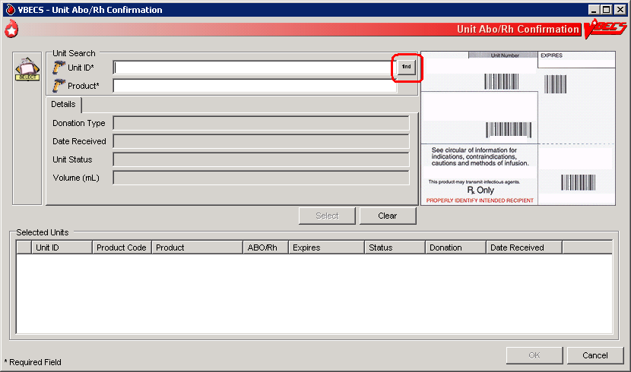

Figure 81: Display Unit Search Screen

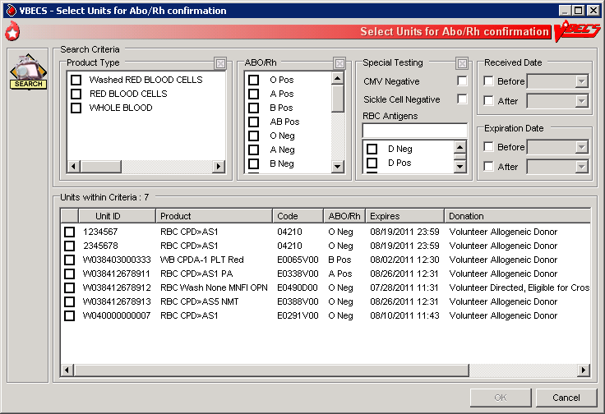

## Test Units

### ABO/Rh Confirmation UC\_02

Blood products that contain red blood cells require ABO/Rh confirmation. The user may process ABO/Rh confirmation results by selecting an invoice or individual units of blood received in a shipment. VBECS records the ABO/Rh test results for the list of blood units tested.

#### Assumptions

* The division is “full service.”
* A unit’s labeled ABO/Rh was entered in the same division as the user during login of an incoming shipment.
* BR\_2.02 Only invoices processed within a user’s division may be accessed to create an ABO/Rh confirmation worklist.

#### Outcome

* Unit ABO/Rh observed test results and interpretations are available for selection for patient use.

#### Limitations and Restrictions

* BR\_2.04 When the user builds a custom worklist or a worklist by invoice number, VBECS includes only units not previously tested or confirmed, and those not selected on another worklist.
* BR\_27.09 For batch processing, the user can select incoming shipment invoices from his division, processed within the previous five days.
* VBECS does not display product codes associated with unit IDs in ABO/Rh Confirmation. Therefore, do not create ABO/Rh confirmation worklists containing units with the same unit ID.

#### Additional Information

* BR\_41.32This option is disabled for transfusion-only facilities.
* BR\_2.11 Within a multidivisional facility when ABO/Rh confirmation is repeated on units from a facility within the same database, both the originating facility ABO/Rh confirmation testing results and the current testing results are stored.
* BR\_2.19 The ABO/Rh confirmation worklist may be sorted by Unit ID, ABO/Rh, Product Type, Component Type, or Date/Time Received. When displaying the Date/Time Received, seconds are not displayed, but are used to sort the worklist when selecting Date/Time Received for the worklist sort criteria. VBECS uses seconds for calculations, for example in sorting items by time, even though it may not display seconds when time is shown.

#### User Roles with Access to This Option

All users

#### ABO/Rh Confirmation Testing

To confirm ABO/Rh testing, the user creates a worklist of individual units from an invoice, or creates a custom worklist. The user records observed test reactions and interpretations. VBECS uses truth tables to verify that user-entered interpretations are consistent with observed reactions. VBECS compares ABO and/or Rh interpretations to units labeled “ABO/Rh” during login and displays warnings when there are inconsistencies.

 When a unit’s ABO/Rh confirmation test is repeated after issue to a patient, VBECS does not compare the test results to the patient’s blood type at time of issue. The user must detect discrepancies and notify clinical personnel, in accordance with local policy.

| **User Action** | **VBECS** |
| --- | --- |
| 1. When processing a shipment, select **Shipments** from the main menu.   When processing selected units, select **Blood Units** from the main menu.  Select **ABO/Rh Confirmation**.  Select an invoice or units.    Click **OK**. | * Displays options for processing blood product shipments. By default, displays units in the worklist in the order in which they were entered during Incoming Shipment. * Lists invoices processed within the last five days in reverse chronological order. * Displays fields for entering rack information. * Allows units to be deleted from or added to the worklist.   **NOTES**  BR\_5.03 The user may select only active units and those not in an inactive or final status.  To create a customized list of units:   * Enter a unit ID or click the **find** button to search for a unit. VBECS lists units with “limited” status. * Select parameters from the options on the Select Units for ABO/Rh Confirmation screen. * Select **Units within Criteria** to work with. * Click **OK**. * Repeat this step until all units are included in the Selected Units list on the Unit ABO/Rh Confirmation screen. * Click **OK**. |
| 1. Select a rack.   Select a date or accept the default.  Select a Tested By name.  Click **Using Automated Instrument**, as appropriate.  Click the **Perform Anti-D Testing** check box, when appropriate.  Click **OK**. | * Displays the racks available using the pick list provided. * Displays the date and time testing was performed. The default is the current date and time. The date may be edited using the pick list provided. * Displays the testing technologist’s identification. The default is the current user. Select a name from the pick list of valid division users to show a different testing technologist. * Displays warnings and the option to indicate that the user is ready to begin entering results after all warnings are addressed. * Generates an Exception Report entry when the user inactivates or deletes the partially completed result grids and enters a comment.   **NOTES**  BR\_2.47 A user may disable the anti-D testing grid column in the ABO/Rh unit confirmation worksheet. |
| 1. Select a unit for which to record test results.   Select a cell and enter an observed test result from the legend at the bottom of the screen.  BR\_2.30, BR\_2.31 Enter a valid interpretation, then press the **Enter key** to go to the next data grid interpretation or Comment cell.  Select enter comments from the Unit Testing for the ABO and Rh interpretations, as needed.  Repeat until all test results for the selected unit are entered. | * Creates a grid for data entry of results and interpretations, displaying units in the order selected. * Allows the user to select a blood test type and enter a test result for the unit. * Restricts data entry to valid selections for testing results. Displays testing results and interpretations entered. * An interpretation indicates that all appropriate test results were entered for the unit.   **NOTES**   VBECS emits an audible alert and generates a warning requiring override when the ABO and/or Rh confirmation interpretation does not match the ABO and/or Rh of the unit at initial login. When the user confirms the discrepancy, inventory units whose ABO/Rh confirmation does not match the ABO/Rh at login are marked “Quarantined.” VBECS captures details for inclusion in an Exception Report (exception type: Unit ABO/Rh login vs. confirmation do not match, unit quarantined).  BR\_2.03 ABO/Rh confirmation testing data grids accommodate uniform data entry for Forward ABO testing.  BR\_2.27 The cursor moves with a single valid keystroke from the top left cell across the row, returning to the leftmost cell in the next row, and so on down the worksheet grid. The cursor stays in the reaction results cells by default (the technologist may use the mouse to click in the interpretation area) until the last entry is made in the reaction result portion of the grid. The cursor then goes to the first (top) interpretation cell.  The user may enter free-text comments or comments from the Unit Testing for the ABO and Rh interpretations (Table 4).  Table 4: BR\_2.10 Valid Interpretations   | **ABO** | **Rh** | | --- | --- | | A | P, POS (positive) | | B | N, NEG (negative) | | AB | I, Inconclusive | | O |  | | I, Inconclusive |   BR\_2.15 When a user saves a partially completed ABO/Rh testing worklist, VBECS clears unit entries with incomplete or no results, releases them from the worklist, and makes them available for inclusion in a future worklist.  BR\_2.35 Row validation is established for the interpretation vs. reaction results pattern by system rulesTT\_2.01 Forward ABO Confirmation and TT\_2.02 Rh Confirmation: Forward Testing Truth Tables.  BR\_2.05, BR\_2.06 ABO/Rh interpretations are consistent with observed test results based on system rules. Discrepancies are resolved before VBECS can verify ABO/Rh confirmation results and add them to the database. The user may reenter valid results or delete entries and start over. |
| 1. Confirm that all results were reviewed and are acceptable. | * Repeats data validation and prompts the user to save.   **NOTES**  BR\_2.44 VBECS warns that it doesn’t save partially completed unit ABO/Rh confirmation worksheets.  BR\_2.21  When VBECS verifies that the ABO or Rh interpretation is “Inconclusive,” it assigns the unit a “Quarantine” indicator, emits an audible alert, and captures details for inclusion in an Exception Report (exception type: ABO/Rh confirmation Inconclusive, unit quarantined).  BR\_2.12 Upon successful completion of ABO/Rh confirmation, inventory units are given a status of “available.” Successful completion means that the ABO and Rh (if required) interpretation is consistent with recorded observed results and matches the ABO/Rh at unit login and any repeat ABO/Rh tests on the unit that are not invalidated. |
| 1. Click **OK** to save the ABO/Rh confirmation testing. | * Prompts the user to confirm that all results were reviewed and are acceptable. |
| 1. Click **OK**. |  |

### Unit Antigen Typing UC\_41

The user performs antigen typing for one or more of the antigens in a blood unit and records the results in a worklist.

#### Assumptions

* BR\_2.43 The division is “full service.”
* The units and the user are in the same division.
* Antiserum inventory is entered during Log In Reagents.
* Workload codes are assigned through Workload Codes.

#### Outcome

* Antigen typing was applied in the unit record for informational purposes in other options.
* BR\_41.06 VBECS stores the lot number, vial identifier, manufacturer, and expiration date of the positive and negative control cells with the testing record.

#### Limitations and Restrictions

* Antigen typing applies only to blood products that contain red blood cells. This option does not address platelet, histocompatibility locus antigens (HLAs), or Immunoglobulin A (IgA) antigenicity.
* VBECS does not check whether the lot and vial numbers selected for the positive control cells differ from those of the negative control cells.
* D antigen typing must not be combined in batch testing of Rh positive units.

#### Additional Information

* BR\_41.32This option is disabled for transfusion-only facilities.
* Clinical significance and availability of typing reagents are not implied when antigens are included in the list of antigen type tests.
* A CPRS patient order is not required to perform antigen typing of units.
* A user may query the database for the presence of antigen-typed units and display or print the query results in Blood Availability.
* A user may retrieve evidence of antigen typing for any date or date range. Regulatory agencies require documentation of the reagent name, lot number, reagent expiration date, and positive and negative control.
* A user is required to complete antigen typing QC in order to save test results. If an antigen testing worklist is started but not saved and a second testing worklist is started for the same antigen, the QC grid will display and require completion because the first worklist has not been saved. Task 1307

#### User Roles with Access to This Option

All users

#### Unit Antigen Typing

The user performs antigen typing for one or more of the antigens on blood units. VBECS creates a list of available antigen specificities, including weak D, that can be tested. For each antigen tested, the user must select a reagent from available inventory. VBECS will check to see if valid positive and negative controls were tested for the selected reagent on the calendar day of testing. When controls are not tested, VBECS adds tests for the positive and negative controls to the worksheet.

Red cell units prepared for patient transfusion may need to be negative for this antibody specificity based on their setting in the antibody table defined in Antibodies.

 Deletion of a partially completed antigen typing worklist invalidates any completed tests contained on the worklist regardless of the status of the unit, including transfused units.

It is the user’s responsibility to verify that the records are being invalidated appropriately.

| **User Action** | **VBECS** |
| --- | --- |
| 1. Select **Blood Units** from the main menu.   Select **Unit Antigen Typing**. | * Displays options for processing blood units. * Displays options for processing antisera. |
| 1. Click **Create New Worklist**.   When partially completed worklists exist, click a check box to select an existing worklist and go to Step 5.  Click **Delete** to delete the worklist from the list or **OK** to continue. | * Accommodates selection of a partially completed testing worklist or creation of a new testing worklist. * Displays an option to select or delete a partially completed worksheet. * BR\_41.15 When selecting a partially completed worklist, the user verifies the lot numbers, manufacturer name, and expiration date of the antiserum and control cells previously selected. These may not be edited. When a discrepancy is found, the user must delete the worklist and start over.   **NOTES**  VBECS displays the date and time the testing was performed (default: current date and time). These are editable to allow for retrospective entry.  VBECS displays the testing technologist ID (default: current user). A pick list of valid division users is available for the user’s selection.  BR\_56.14 When an automated instrument was used for testing, the user enters the name of the instrument and may indicate that successful quality control testing was done for the date. |
| 1. To create a new testing worklist, select a date or accept the default.   Select a “Tested By” name.  Click a radio button to select Tube, Gel, or Solid Phase.  Click **Using Automated Instrument**, as appropriate.  Click **OK**. | * Displays an option to select antiserum types. * Displays an option to select a lot number for each antiserum type selected. * Displays the lot number information. * Prompts the user to select the correct antiserum entry for the specificity selected.   **NOTES**  BR\_41.01 VBECS lists available antigen type tests from which the user may select and allows the user to enter the specificity to expedite the search. The list of antigen type tests is derived from the Corresponding Antigens field from Appendix B: Table 13: TT\_23.01A Antibody and Antigen Table: Irregular Antibodies.  BR\_41.04  VBECS displays data fields for the user to select or enter the lot number, and displays the manufacturer and expiration date of each antiserum to be used in this transaction to allow the user to choose the correct antiserum. VBECS displays in-date antisera and allows the selection of outdated antisera, if needed, emits an audible alert, and requires an override and generation of an Exception Report (exception type: expired antisera used). A comment is required.  BR\_41.26  When a user attempts to change the phases of reactivity, VBECS emits an audible alert, warns that the user selected phases that were not used previously for this reagent, and asks whether the user wishes to continue.  **No** returns the user to the screen to select the correct testing phases. **Yes** requires the user to enter a comment explaining why different testing phases are selected, and captures details for inclusion in an Exception Report (exception type: antigen testing phase change).  BR\_41.30 When a user selects a reagent rack for which quality control (QC) testing was never performed in Enter Daily QC Results, VBECS displays a warning message, clears the selection, and allows the user to select a different rack. DR 3945  BR\_41.27 When the user QC’d the antigen typing reagent lot number and performed patient antigen typing on the same date under different testing phases, VBECS enables the QC grid for the antisera in the phases the user selected. |
| 1. Define the antiserum used.   Enter a lot number for each antiserum specificity.  Select the testing phase:   * IS * IS/RT * IS/37 * AHG/CC.   Select the rack, if applicable.  Select **Add**.  Select additional antisera, if desired.  Respond to warnings and enter comments, when indicated.  Select **OK** (Figure 82). | * Displays an option to select the testing phases for the antiserum specificity by lot number. * Displays a testing grid disabling the phases not to be entered. * Stores the antiserum information and checks whether the positive and negative controls need to be tested with this batch. * Prompts the user to enter the lot number and vial identifier for the positive and negative control used for each antiserum tested.   **NOTES**  BR\_28.23 When VBECS displays lot numbers for selection, it checks the inventory system for the reagent name and lot numbers in a rack. The user cannot force the entry of a lot number that VBECS disallowed on the selection list. The user must choose a different reagent. The user may not select a reagent with an “unsatisfactory” value in the Inspection field or with a quantity of zero.  BR\_28.24  VBECS compares the expiration date of each reagent on the selected rack to the testing date, emits an audible alert, and warns when the reagent is expired.  BR\_41.02 VBECS enables the rack identifier field when a user selects the weak D or AHG/CC phase and disables the field when a user selects other phases.  BR\_41.03 VBECS automatically adds the positive and negative control tests to the selected reagent type worklist if they have not been tested on that calendar date for the selected antisera lot number. DR 3717  BR\_41.25 Reagent lot numbers that are selectable for positive and negative control cells:   * Reverse ABO Typing Cells (set) * A2 cell (vial) * Screening Cells (set) * Check Cells (vial) * Panel (set) * Other (set)   VBECS requests information about an antigen lot number only the first time it is used on a specific day.  If there are multiple test tabs, VBECS displays a message that may not correspond to the selected tab, but will correspond to information required by one of the requested tests. |
| 1. Select one or more blood units to add to the worklist.   Enter the unit ID and the product code from the inventory, or click the **find** button to search for a blood unit and select from the list of available units.  Click **OK** when all units are selected. | * Allows the user to scan or enter units to be included in the worklist or select them from a list. * Lists the selected units. |
| 1. Select the lot number for the reagent and the positive and negative control cells. Enter the vial identifiers, if required. Enter “0” when not using panel cells.   Verify the reagent type and the positive and negative control cell lot numbers selected and vial identifiers entered, if required. | * Displays the reagent type and lot numbers, including the vial identifier.   **NOTES**  The vial identifier, comprising one or two digits, identifies the vial contained in a kit of reagent red blood cells. A vial contains antigen positive or antigen negative blood cells to be used in quality control of the antisera. |
| 1. Respond to warnings and continue with antigen typing.   Review the lot number, manufacturer name, and expiration date for the antiserum and control cells. If they are not correct, start over.  Select a control cell or unit to begin entering serologic reactions and interpretations in the data entry grid. | * Displays each selected unit in a separate tab for each selected specificity with its own grids and quality control. * Displays a direct data entry (DDE) grid to enter serologic reaction results for antigen typing of units. This may already be filled with results from a previously saved partially completed worksheet. * Allows a user to select a unit or control cell and enter a test result. * Allows only valid data entries in the grid reaction result and interpretation cells. * Restricts data entry to valid selections for testing results. * Keeps all testing results and entered interpretations on the screen until the user saves them.   **NOTES**  BR\_41.07 VBECS displays the worklist for the grids by antiserum types.  BR\_41.09 Valid observed test results entered by a user:   * 1 [1+ (positive)] * 2 [2+ (positive)] * 3 [3+ (positive)] * 4 [4+ (positive)] * W [Weak (positive)] * F [Mixed Field (positive)] * M [Microscopic (positive)] * R [rouleaux (negative)] * 0 (zero) [No Agglutination (negative)] * X (Not Tested) (does not indicate a disabled cell)   When the AHG phase is selected for testing, the AHG must be negative and the CC must be at least 1+ positive to consider the test negative for a unit or for the negative control cell.  BR\_41.17 The column heading of the data grid specifies the phases of reactivity that may be used in a test selected for the specificity.  BR\_41.18 The row heading of the data grid specifies the unit ID being tested. These fields cannot be edited.  BR\_41.21 The rows for each antiserum type grid display the positive and negative control cells, then units, in the order in which a user added units to the worklist.  BR\_41.14 A comment can be associated with any antigen test performed. A user may select canned comments required by an override from the drop-down list or select **Other** to enter free-text comments. |
| 1. Enter results for the control cells and for all selected units. Refer to the legend at the bottom of the screen (Figure 83). | * Prompts the user to confirm that all results were reviewed and are acceptable.   **NOTES**  The positive and/or negative control cell test results on the date of testing must be a valid positive or negative.  BR\_41.22 When a weak D interpretation is positive or inconclusive and is verified for a tested blood unit that was labeled as (Rh) D negative, VBECS warns the user and adds the quarantine indicator to the unit.  BR\_41.12 VBECS compares the antigen typing interpretation a user enters to previously assigned antigen typings for the same antigen (as assigned during Incoming Shipment, Edit Unit Information, or previous testing). When the previous interpretation was not “inconclusive” and the current interpretation does not match the previously identified antigen type, VBECS warns the user and quarantines the unit.  BR\_41.19System rules establish row validation for the interpretation vs. reaction results pattern [for all user-indicated phase(s) of reactivity] for blood unit and quality control tests. |
| 1. Repeat Steps 4–8 for each antiserum type. | * Displays the option to save. |
| 1. Respond to warnings and save. | * Saves the completed QC results with partially or fully completed unit testing data. * Reconfirms that all appropriate test results were entered, repeats all data validation, and saves the information on the worksheet displayed.   **NOTES**  BR\_41.16 VBECS saves the testing of one antiserum specificity at a time.  BR\_41.33 The Positive and Negative control cells must be complete and valid prior to the save of a unit antigen typing result. VBECS will display a tooltip message to the user if an attempt to save is made and the QC is not valid.  BR\_41.06 VBECS stores the lot number, vial identifier, manufacturer, and expiration date of the positive and negative control cells with the testing record. |
| 1. Click **OK** to exit. |  |

Figure 82: Unit Antigen Typing

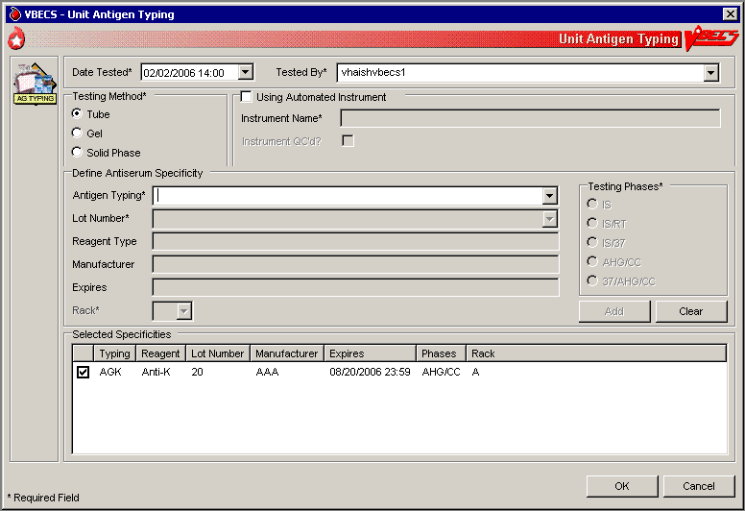

Figure 83: Unit Antigen Typing Serologic Results

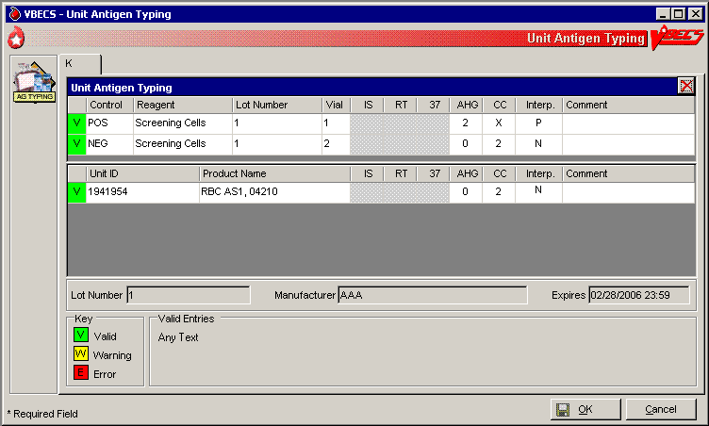

## Modify Components

### Modify Units UC\_26

The user modifies a unit, which results in a different blood product (target product) with its own properties. A division’s configuration determines the available modification types.

#### Assumptions

* Product Modifications was executed.
* The division is the active shipper for target blood products.
* A unit may be modified with or without patient assignment or restriction.
* A unit may be modified with or without a patient order.
* Units selected for modification must be in the same division as the user.
* Product labels and unit numbers for modified products are on hand.
* Supplies needed for the unit modification were entered in VBECS.

#### Outcome

* Data generated for an Exception Report are stored for inclusion in the next Exception Report.
* Workload-related data collected as the result of unit modification are stored for inclusion in Workload Reports.
* At the completion of a unit modification, VBECS assigns the original unit a final status of “modified.”
* A permanent virtual link exists between the original unit and target units created.
* The shipper of the target unit created is the division in which the modification was performed. The cost assigned to the target unit is based on what was defined in Blood Products.

#### Limitations and Restrictions

* VBECS allows modification of units only in limited, assigned, crossmatched, and available statuses.
* VBECS presents the conservative expiration date for target units. VBECS does not know the specific collection details. It is the responsibility of each user to accurately enter and process any one blood unit based on its expiration date/time as labeled by the collection facility. Task 1324

#### Additional Information

* VBECS requires the identification of the transferred-to container when using an open method or a sterile connection device (SCD).
* VBECS requires the identification of the SCD wafer data when using an SCD.
* When a user extends an expiration date beyond the default expiration date, the override message displays the original expiration date.
* Due to the variations in supplies and equipment used for other modification types, VBECS does not require supply or equipment entry, but allows entry of those data as part of the modification record.
* During the modification options (Modify Units: Pool Units; Modify Units: Split a Unit; Modify Units), a user may select an assigned blood unit for modification and transfer one patient assignment to the target units created.
* To reverse other modifications, remove the “modified” status from each unit through Remove Final Status.
* To edit the number of units in an existing pool, use Add/Remove Units from a Pool.

#### User Roles with Access to This Option

All users

#### Modify Units

The user selects the units to be modified. The user indicates the type of modification to be performed, then enters (preferably by scanning) the unit ID and product code.

VBECS displays a creation date and time (default: current date and time) for the target units, which the user may change to a date and time in the past and not before the login date and time of the original unit. VBECS calculates a new expiration date for the target unit (based on the creation date and time, modification type, method, and original unit product type) and records the date and time the original unit was modified. Some modification procedures require materials in addition to the new container. VBECS requires the entry of a new container lot number and SCD wafer, if indicated.

The modified target unit is now available for use.

| **User Action** | **VBECS** |
| --- | --- |
| 1. Select **Blood Units** from the main menu.   Select **Modify Units**. | * Displays options for processing blood units. * BR\_26.32 Displays valid modification options configured for the division and allows the user to select an option. |
| 1. Enter the date and time of the unit modification.   Enter the name of the user who modifies the unit. | * Displays the default (current) date and time as the modification date and time. * Allows the user to change the date and time to a past date and time.   **NOTES**  BR\_26.01 The user may not enter a future date and time. |
| 1. BR\_26.10 Click a radio button to select a modification type:  * Thaw * Pool (See Modify Units: Pool Units.) * Thaw/Pool Cryo (See Modify Units: Pool Units.) * Split/Divide (See Modify Units: Split a Unit.) * Irradiate * Leukoreduce * Volume Reduce * Wash * Rejuvenate * Freeze * Deglycerolize * Add/Remove Units from Pool (See Add/Remove Units from a Pool.) | * Allows the user to enter data based on the modification type selected. * Allows the user to select a different processing technologist. * Displays only modifications enabled for the division. |
| 1. Click a radio button to select a modification method, if required:  * Open * Closed * Sterile Connection Device (Figure 84) | * Displays the selected method.   **NOTES**  BR\_26.22 VBECS stores the date and time for the original unit when it is modified. The modification date and time are also stored as the creation time for the target unit.  BR\_26.37 When the modification method is “Open” or “Sterile Connection Device (SCD),” the user must select a container supply type. When the modification method is “Closed,” VBECS does not allow the user to select a container supply type.  BR\_26.30 For an SCD modification method, the user must indicate the completeness of the weld, in accordance with local policy and procedures. VBECS defines weld status as:   * Complete: the weld is complete and has no leakage or air bubbles. * Incomplete: the weld has a leak or air bubbles are present. VBECS changes the expiration date and time of the unit to those of an open system for that product type. VBECS stores this weld check with the historic record of the target unit created in the modification. |
| 1. Click **OK** to accept the selected method, or edit it. | * Allows the user to scan, enter, or select units to modify. |
| 1. Scan, enter, or select the ID and product code of the unit to be modified. | * Displays current data for the selected unit. * Verifies the appropriateness of the selected unit based on system rules and truth tables and displays error and warning messages based on the modification type selected and the user’s security level. * Prompts the user to continue with the selected unit or select a new unit based on the data in the review window.   **NOTES**  BR\_26.43 VBECS allows the user to select a product type for the original unit based on the selected modification type.  See Appendix B: Table 21: TT\_26.02A Allowable Product Modifications by Original Product Type.  BR\_5.03 The user may select only active units and those not in an inactive or final status.  BR\_26.33 When the user selects a status other than “limited,” “available,” “assigned,” or “crossmatched” for an original unit, VBECS warns the user. There is no override.  BR\_26.36 When the selected unit is not appropriate for the modification type selected, VBECS warns the user and instructs him to verify the selected unit and modification type. There is no override. When the unit is expired or quarantined, VBECS displays an error message.  BR\_26.09 The user may select units containing red blood cells chosen for rejuvenation within three full days past their labeled expiration date. (For example, when a unit’s expiration date is the current day, VBECS counts this day as “day 0,” the next day as “day 1,” etc. The last acceptable date and time for selection is day 3 at 23:59). After this three-day period, VBECS considers the unit to be expired.  BR\_26.41 When the modification type is “volume reduce,” VBECS records the discarded plasma volume on the unit record. Otherwise, the user may not edit the Discarded Plasma Volume field. The discarded plasma volume may not be “0” (zero).   See Table 5 for alerts that may occur during this option. |
| 1. Click **OK** to accept the unit for modification. | * When the modification type is “thaw” or “irradiate,” allows the user to select additional units to process or to continue processing the selected units. Otherwise, go to Step 8.   **NOTES**  BR\_26.02 The user may process multiple products in a batch when the units are thawed or irradiated. The creation date and time apply to all units in the batch. |
| 1. Click the **Weld Complete** or **Weld Incomplete** radio button to indicate the integrity of the SCD weld, when indicated.   Click the **Container**, **Supplies**, **Equipment**, or **SCD Wafer** tab and enter another supply and/or equipment lot or ID number (Figure 85). | * Calculates and displays a default expiration date and time of the target unit based on rules specific to the original blood product, the modification type, and processing conditions (open, closed); prompts the user to accept the date and time; and allows the user to edit them.   **NOTES**  BR\_26.31 VBECS maintains lot and ID numbers entered, the new container lot number in the unit modification record, and the historic record of the target unit.  BR\_26.45 VBECS checks the inventory system for the supply name, lot numbers, expiration date, and a quantity greater than “0” (zero). VBECS does not allow the user to select supplies with an “unsatisfactory” value in the Inspection field. When the user enters an unsatisfactory supply lot number, VBECS warns the user. The user must select a different supply item.   See Table 5 for alerts that may occur during this option. |
| 1. Select a target product type from the drop-down list in the Product field. | * Displays target component types for the modification, conditions selected, and the original unit product type, and allows the user to select a single product type. * Verifies that an active target component was selected and warns the user. * Allows the user to enter lot and ID numbers (with auto-completion) or select multiple items from the supply and equipment lists. * Warns that the target unit is not active and allows the user to activate the target component.   **NOTES**  BR\_26.13 The user must select a modification method (open, closed, Sterile Connection Device) for modification types, as described in Appendix B: Table 21: TT\_26.02A Allowable Product Modifications by Original Product Type.  BR\_26.12 VBECS displays available target component types based on ISBT 128 modification rules and site parameters for the division.  BR\_26.11 When the user selects a target component type not marked as active, VBECS warns the user, allows him to mark the target component as active, and returns him to this step in the modification process. Otherwise, VBECS returns the user to this step and allows him to select another target component type.  BR\_8.01 Site parameters indicate which products in the product code database are marked as active for a division. The user may define fields for a product type at a site:   * Division shipper (automatically set to the user’s division): * Cost (U.S. currency) * Return Credit Percentage * Active?   These are the only fields in the blood product table that are editable.  BR\_26.16 When the original unit type did not require ABO/Rh confirmation, the target unit, when created, does not either. The target unit is immediately available for assignment, crossmatch, issue, or transfusion on completion of the modification.  BR\_26.23 When ABO/Rh confirmation testing was not performed on the original unit when the target unit was created, VBECS assigns “limited” status to the target unit and saves it for inclusion in an ABO/Rh confirmation worksheet.    BR\_26.25 When the original unit is assigned or crossmatched to a patient at the time of modification, VBECS notifies the user and asks whether he wishes to automatically assign the modified units to the patient. **Yes** (default) applies the unit’s assignment or crossmatch data to the target component. **No** does not apply the assignment to the target, and changes the target unit status to “available.” The original unit retains patient assignment in both cases.   See Table 5 for alerts that may occur during this option. |
| 1. Accept or edit the expiration date. | * Verifies the validity of the expiration date and warns the user, if indicated.   **NOTES**  BR\_26.34 When VBECS calculates the expiration date of a unit in days, starting from the date and time of modification, the expiration time is 23:59. When VBECS calculates the expiration date in hours, the unit expires at the specified hour and minute.  BR\_26.20 VBECS calculates an expiration date for the target component. For all modification types except Rejuvenate and Freeze, VBECS compares the calculated expiration date with that of the original unit and displays the earlier of the two as the default. The user may edit the calculated expiration date. (Due to the nature of the process, the calculated expiration date will greatly exceed the original expiration date of the original unit for Rejuvenate and Freeze, and will supersede the unit’s original expiration date.) |
| 1. Review the displayed unit data and click **OK** to confirm the modification.   If the unit has been relabeled, click **Yes** to verify the label (Figure 86).  Click **No** to cancel and continue at Step 14. | * When the original unit is currently assigned to a patient, notifies the user and asks whether he wishes to transfer the status to the target unit. **Yes** updates the target unit status. |
| 1. Scan the label barcodes to verify the target labels, based on local practice and labeling type of the modified unit.   Enter a comment to complete the verification. (This step is optional.) | * Displays the label verification window. * Indicates whether the scanned barcodes match those in the label. * For each target created, system prompts user to indicate readiness to verify the labeling of the modified product. * No new labels applied to modified product. Proceed to save the unit. * Displays a screen to accommodate data entry of the modified unit’s: * ABO/Rh * Product Code * Expiration Date * This step repeats until all targets have been labeled and/or are ready for continued processing.   **NOTES**  The user may select “Verify modified unit label” to verify the modified unit label. When the user does not verify the label, he must enter a comment and then click **Cancel** to exit.  When the user does not select “Verify modified unit label,” he may continue at Step 14. VBECS bypasses the label verification and does not create an Exception Report.  When a component is modified and a new label is applied, American Association of Blood Banks (AABB) standards require the labeling process to include a method to ensure the correctness of the unit number, ABO/Rh, expiration date, and component label.  BR\_26.24 VBECS does not display the modified unit data. VBECS instructs the user to verify the labeling of the target product and notifies him that scanning the barcode is preferred. When no barcode is available, the user may enter the data.  BR\_26.29 To verify the label, VBECS compares the entered data with the data of the target unit from the database. The user may scan or enter:   * Unit ABO/Rh Label * Unit Product Code * Unit Expiration Date |
| 1. Scan or enter each label on the target unit. | * Compares the data entered in each field to the database. * Asks whether the user wishes to save the data. When the user confirms that the data are correct, notifies him that the label verification is complete. * BR\_26.27 Records the modified or restriction-released unit relabeling data as part of the unit record and stores the data for inclusion in the unit history report. * Saves only the technologist name and the date and time the label was verified. When the user indicates that a new label applied fails to complete the verification process, releases the assignment, quarantines the unit, and captures details for inclusion in an Exception Report (exception type: target product label failed checks). * When the user confirms that the comparisons are correct, notifies him and asks whether he wishes to continue.   **NOTES**   When there is no match, VBECS emits an audible alert, notifies the user, and instructs him to verify the labeling and reenter label data or select **Cancel**.  When there is no previous entry for a field, VBECS notifies the user and instructs him to enter a value or select **Cancel**.  VBECS requires a comment when the user selects **Cancel**, and captures details for inclusion in an Exception Report (exception type: target product label failed checks). |
| 1. Click **OK** to confirm the save. | * Saves the new modified unit data. * Updates the status of the original unit to “modified.” * Records the unit ID of the target unit on the record of the original unit. * Prompts the user to modify another unit.   **NOTES**  BR\_26.15 The target unit automatically inherits original unit data, which the user may not edit:   * Unit ABO/Rh (from login) * ABO/Rh confirmation testing information (when performed) * Unit ID * Unit Volume (exception: when a unit is volume reduced, the target unit does not inherit the original unit’s volume. The user must enter the target unit’s volume.) * Donation type * Disease marker testing information, when autologous. * Restricted for patient name, ID. * Current status * Biohazard Indicator * Quarantine Indicator * Division * Additional unit testing (CMV, Sickle Cell, antigen typings) |
| 1. Repeat Steps 3–14 to modify another unit or exit. |  |

Figure 84: Modify Unit(s)

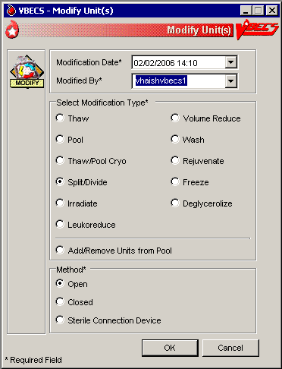

Figure 85: Split/Divide Unit

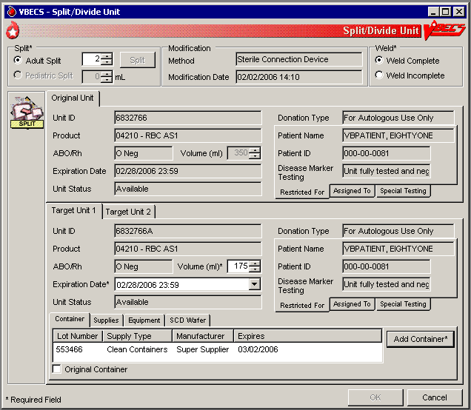

Figure 86: Verify Printed Label

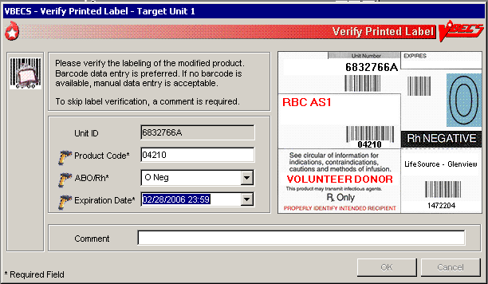

####  Alerts

Table 5: Alerts That May Occur in Modify Units

| **Step** | **Alerts** |
| --- | --- |
| 6 | BR\_26.08 When the unit modification date and time entered are earlier than the date and time the original unit was received in inventory, VBECS warns the user and allows him to reenter the modification date and time. |
| 6 | BR\_26.03, BR\_26.44 VBECS compares the original unit’s expiration date and time to those of the modification to determine whether the selected unit was expired at the time of modification. When the user is a Blood Bank Technologist and the unit selected for modification expired, VBECS emits an audible alert, displays an error message, clears the selected unit, and allows the user to select another unit for modification.   When the user is an Enhanced Technologist and the unit selected for modification is expired, VBECS emits an audible alert, notifies the user, and asks him to verify to continue, or cancel to correct the entry data. **Override** requires a comment and VBECS captures details for inclusion in an Exception Report (exception type: expires unit modified). **Cancel** clears the selected unit and allows the user to select another unit for modification. |
| 6 | BR\_26.07 When ABO/Rh confirmation testing is required but not performed, VBECS notifies the user that testing must be completed before issuing a target unit. The user may continue with the modification. |
| 6 | BR\_26.05 When a unit has an indicator of “quarantined,” VBECS notifies the user that it must be released before processing may continue, clears the selected unit, and allows the user to select another unit.  BR\_26.06  When the user is an Enhanced Technologist and a unit has an indicator of “quarantined,” VBECS notifies the user that it must be released before processing may continue and asks whether the user wishes to release the unit. **Cancel** clears the selected unit and allows the user to select another unit. **Override** releases the unit through Discard or Quarantine. |
| 6 | BR\_26.42 When the selected unit has a positive biohazard Indicator, VBECS emits an audible alert, warns the user, and asks whether the user wishes to continue with the modification. **Cancel** clears the unit and the user may select another unit. **Override** requires a comment and VBECS captures details for inclusion in an Exception Report (exception type: biohazardous unit modified). |
| 8 | BR\_26.46 When a supply item is expired, VBECS emits an audible alert, warns the user, and asks whether the user still wishes to use the item. **Yes** requires a comment and VBECS captures details for inclusion in an Exception Report (exception type: expires supply used in unit modification). **No** requires the user to select another supply lot number. |
| 10 | BR\_26.28 When the user extends the system-recommended expiration date and time, VBECS warns the user, asks him to reenter the unit expiration date, and redisplays the original entry. The user may enter another expiration date and time for the target unit.  BR\_26.21  When an Enhanced Technologist extends the target unit expiration date and time past the system-recommended expiration date and time, VBECS emits an audible alert, warns the user, and asks whether he wishes to continue. **Cancel** restores the expiration date. **Override** allows the user to continue with this date, requires a comment, and captures details for inclusion in an Exception Report (exception type: target product outdate extended). |

### Modify Units: Split a Unit UC\_25

The user selects the unit to be split (divided) for transfusion.

#### Assumptions

* See Modify Units.

#### Outcome

* See Modify Units.

#### Limitations and Restrictions

* BR\_25.21 A unit previously split in VBECS cannot be split again. A unit pooled in VBECS may not be split.
* This option appends alphabetical characters to the Codabar unit ID of split units created from original units. This prevents scanning the unit ID barcode with the split indicator.
* By ISBT 128 convention, split units created from an ISBT 128 original unit will have identical unit ID and five-digit product codes.

#### Additional Information

* BR\_25.17 The user may select blood units from the product types indicated in Appendix B: Table 21: TT\_26.02A Allowable Product Modifications by Original Product Type for splitting.
* To reverse other modifications, remove the “modified” status from each unit through Remove Final Status.

#### User Roles with Access to This Option

All users

#### Modify Units: Split a Unit

The user selects the unit to be split for transfusion. VBECS automatically applies directed and autologous restrictions to aliquots created. The user may or may not maintain patient assignments (usually, these units are crossmatched and available for the patient before the split is made). This section lists only rules unique to the division of a blood unit.

| **User Action** | **VBECS** |
| --- | --- |
| 1. Select **Blood Units** from the main menu.   Select **Modify Units**. | * Displays options for processing blood units. * Displays valid modification types for selection. |
| 1. Click the **Split/Divide** radio button.   Click **OK**. | * Allows the user to search for a unit. |
| 1. Select a unit and click **OK**.   Click **Select** to confirm the unit selected. | * Displays data for the original and target units. |
| 1. Edit the number of adult splits to be created, if required (Figure 85).   Click **Split\*** to verify the number of splits to be created and add the appropriate number of target unit tabs. | * Displays the number of splits to be created (default: 2) for verification. * Requires entry of the number of splits to be created.   **NOTES**  BR\_25.01, BR\_25.16 When Adult Split is selected, the user must indicate the number of split units to be created. The user may split a unit into 2 to 26 subunits until the volume of the original container is consumed. |
| 1. Select or confirm the desired target component type.   For a Sterile Connection Device modification method, click the **Weld Complete** or **Weld Incomplete** radio buttonto indicate the condition of the weld.  Click the **Container**, **Supplies**, **Equipment**, or **SCD Wafer** tab and enter another supply and/or equipment lot or ID number. | * Allows the user to enter lot and ID numbers or select multiple items from the supply and equipment lists.   **NOTES**  BR\_25.04 When multiple target units are created, the user must associate a container lot number with each unit created. “Original container” may serve as the lot number for one of the aliquots created.  The original blood collection facility must keep a record of the original container lot numbers so that, when a lot number is recalled, it is known which patient was exposed to it.  BR\_25.18 The expiration date and time are the same as the original unit for each split unit created using an SCD or a closed method. This applies to all types of splits. |
| 1. Accept or edit the displayed expiration date. | * Displays the expiration date. * Calculates and displays the volume of each split unit.   **NOTES**  BR\_25.19 The expiration date and time for each split created are 24 hours from the date and time of modification (using an open method).  BR\_25.05 The user may edit the default volumes, which must not equal “0” (zero) or be greater than 2,000 mL. VBECS divides the volume of the original unit evenly among the splits and adds the remainder to the first split. |
| 1. Accept or edit the displayed unit volumes. | * Displays the original and target unit data for review.   **NOTES**  The user may not edit original unit data.  BR\_25.11 The product code of target units created is the same as that of the original unit.  BR\_25.12 Target units inherit the original unit data, except for volume: volume is assigned based on the conditions of modification. |
| 1. Review the displayed data for the target units and confirm the modification type. | * Displays the target unit’s ID number.   **NOTES**  BR\_25.06 VBECS assigns the unit ID of the target units based on the labeling of the original unit:   * Codabar: the ID number comprises the original unit ID number and a suffix (A–Z) for the 2 to 26 target units, beginning with A. The five-digit product code remains the same. * BR\_25.07 ISBT 128: the unit ID, five-digit product description code, and sixth-character donation code remain the same. Characters 7 and 8 of the ISBT 128 product code barcode reflect the aliquot level: when a previously undivided unit is split, character 7 of the unique eight-digit ISBT 128 product code is incremented alphabetically in uppercase letters, resulting in characters 7 and 8: A0, B0, C0, D0 … Z0. |
| 1. Click **OK** to save.   Click **Yes** to verify the label. | * Prompts the user to save the data, including patient assignment and restriction information, if any. * Saves aliquots created from the modified unit. * Records the unit ID of the target unit on the record of the original unit. * Saves only the technologist name and the date and time the label was verified. When the user indicates that a new label applied fails to complete the verification process, releases the assignment, quarantines the unit, and captures details for inclusion in an Exception Report (exception type: target product label failed checks). |
| 1. Click **Yes** to save.   Repeat Steps 2–9 to split additional units, or return to Step 1 to use a different modification method on another unit. | * Prompts the user to split or modify another unit. |
| 1. Exit. |  |

### 

### Modify Units: Pool Units UC\_24

The user selects units to be pooled.

#### Assumptions

* See Modify Units.

#### Outcome

* See Modify Units.

#### Limitations and Restrictions DR 4474 removed third bullet

* VBECS allows modification of units only in limited, assigned, crossmatched, and available statuses.
* When a user adds a biohazardous unit to a pool, VBECS does not designate the pool as biohazardous on the Blood Transfusion Record Form (BTRF) or Caution Tag.

#### Additional Information

* BR\_24.16 When autologous or directed units are pooled, the “restricted for” patient must be the same for all units. VBECS assigns the same donation type and applies the “restricted for” patient data to the pool.
* To reverse the pooling of units:
* Inactivate the target through Edit Unit Information.
* Remove the “modified” status from each unit in the pool through Remove Final Status.
* To edit the number of units in an existing pool, use Add/Remove Units from a Pool.

#### User Roles with Access to This Option

All users

#### Modify Units: Pool Units

When the pooling is in process or almost complete, the user records it in VBECS. Data entry may also be completed retrospectively. The user pools units and enters the ID and product code of the original unit and the IDs and product codes for each unit added to the pool.

VBECS records the date and time the units are pooled, uses the date and time to calculate a new expiration date for the pool, and assigns a unit ID and ABO/Rh, as defined by system rules. When an original unit in a pool was previously assigned to a patient, VBECS asks the user whether the entire pool is to be assigned to that patient. VBECS automatically assigns autologous and directed patient restriction data from an individual unit to the pool. VBECS determines the volume of the pool based on the sum of the volumes of the units in the pool.

The new, pooled unit needs a full set of unit properties, some of which were defined by the original units’ properties. VBECS assigns new properties such as volume, date and time created, container lot number, and expiration date to the target.

VBECS uses system rules to check pertinent blood bank requirements associated with pooling and displays appropriate target unit information for review. The user reviews and edits the information, as needed, and completes the transaction. VBECS updates internal records, including the collection of workload and unit statuses, for each unit involved.

The user may now assign the units or print the BTRF and Caution Tag, and notify appropriate personnel that the ordered units are ready for issue.

| **User Action** | **VBECS** |
| --- | --- |
| 1. Select **Blood Units** from the main menu.   Select **Modify Units**. | * Displays options for processing blood units. * Displays valid modification types for selection.   **NOTES**  The  Enhanced Technologist or above is authorized to modify expired blood products. |
| 1. Click the **Pool** or **Thaw/Pool Cryo** radio button.   Click **OK**. | * Allows the user to search for a unit. |
| 1. Scan, enter, or select the ID and product code of the most restricted (e.g., biohazardous, autologous, directed) unit to be pooled. | * Displays current data for the selected unit.   **NOTES**  VBECS applies the restriction of the first unit selected to the pool.   BR\_24.02 Based on the product code, VBECS determines the component class of each selected unit to verify that the component class of the selected unit matches that of the first unit selected for the pool (only units from the same component class may be pooled). When they do not match, VBECS warns the user and clears the entry. The user may enter another unit.  BR\_24.06 VBECS automatically “thaws” frozen components when the user selects Thaw/Pool. |
| 1. Enter the ID and product code of another unit of the same donation type for inclusion in the pool. | * May warn the user and asks whether to release the unit from “restricted for patient.”   **NOTES**  When the donation type of a unit selected for inclusion in a pool is restricted, the user may release the directed unit to the general blood supply, if indicated, and complete the pooling process.   BR\_24.17 When a user selects an autologous unit for inclusion in a pool originally intended to be allogeneic or directed based on previously selected units, VBECS warns the user and clears the screen. The user may select another unit.  BR\_24.11 When the first unit entered in a pool is labeled in Codabar, VBECS determines the unit ID of the pool created from Codabar units using the five-character station identifier, two-number year, and sequential number of the pool event at the division, and displays it for acceptance or edit. The user may enter an alphanumeric combination of six to 13 characters, for example, a station number of 55555, year 2002, and pool number 0520, so the VBECS-determined unit ID number is 5555502520.  BR\_24.12 When the first unit entered for a pool is labeled in ISBT 128, VBECS determines the unit ID of the pool created from ISBT-labeled units using the country and ICCBBA-assigned facility code (division preparing the pool), two-number year, and six-number sequential number of the pool event at the division, and displays it for acceptance only. DR 3668 |
| 1. Click **Yes** to release the unit from its “restricted for patient” status. | * Allows the user to release the directed unit and move it to inventory.   **NOTES**  When needed, VBECS allows the user to select Free Directed Unit For Crossover. |
| 1. Accept the previously selected unit and repeat Step 4 to select another unit to add to the pool. | * Displays all data for all original units.   **NOTES**  BR\_24.03 VBECS tallies the number of units pooled. The user may not edit this number. VBECS calculates the pooled unit’s cost and passes that amount to the patient billing system in U.S. currency.  BR\_24.05 VBECS does not allow a unit to be entered twice in a pool. A split unit created in VBECS may not be pooled. A unit that has a division code (7th/8th characters in the ISBT Product code) present upon receipt in incoming shipment may be pooled. |
| 1. Accept the displayed units’ data for the pool. | * Displays target component types for the modification, conditions selected, and the original unit product type, and allows the user to select a single modification type. |
| 1. Select or confirm the desired target component type.   Click the **Container**, **Supplies**, **Equipment**, or **SCD Wafer** tab and enter another supply and/or equipment lot or ID number. | * Verifies that an active target component was selected. Requires activation, as needed. * Allows the user to enter lot and ID numbers (with auto-completion) or select multiple items from the supply and equipment lists. |
| 1. Accept the displayed expiration date or edit it. | * Calculates and displays the expiration date of the pooled unit based on rules specific to the participant blood product. * Verifies the validity of the expiration date and warns the user, when indicated.   **NOTES**  BR\_24.10 When using the “Thaw/Pool” option to prepare a pool from frozen components, the units are simultaneously thawed and pooled..  BR\_24.13 VBECS calculates an expiration date for the pool based on the product type, the date and time created, and the expiration dates and times of each pool participant. When one or more participants in the pool have an expiration date that is earlier than the calculated expiration date, VBECS uses the earlier date as the default expiration date for the pool.   BR\_24.07 For each unit in the pool that was previously assigned or crossmatched to a patient, VBECS warns the user and asks whether he wishes to assign the entire pool to that patient. **Yes** applies the patient-assigned data to the pool. **No** releases the unit from the patient. |
| 1. Click **OK** to save. | * Calculates the volume, total number of participants, ID, and ABO/Rh for the pool. Applies CMV negative status to the pool, when indicated. * Determines whether any pool participants were previously assigned to a patient and queries the user to maintain the association, when indicated.   **NOTES**  BR\_24.09 When the ABO/Rh of each unit in a pool is identical, VBECS assigns that ABO/Rh to the pool. When the ABO and/or Rh of the units in a pool are not identical, VBECS assigns “mixed” as the ABO and/or Rh group and type.  BR\_24.08 VBECS determines the volume of the pooled unit based on the sum of the individual volumes of the original units included in the pool and displays that as the default. The user may edit this volume (1–2,000 mL).  BR\_24.19 BR\_24.20 VBECS labels the pool as CMV negative, Irradiated, or Leukocyte reduced only when all participant units are CMV negative, Irradiated, or Leukocyte reduced. There is no override. |
| 1. Click **Yes** to verify the label.   Click **OK** to save. | * Saves the new pooled unit. * Updates the status of each participant unit to “modified.” * Records the unit ID of the target unit on the record of the original unit. * Prompts the user to modify another unit. * Saves only the technologist name and the date and time the label was verified. When the user indicates that a new label applied fails to complete the verification process, releases the assignment, quarantines the unit, and captures details for inclusion in an Exception Report (exception type: target product label failed checks). |
| 1. Repeat Steps 2–11 to modify another unit, or exit. |  |

### 

### Add and/or Remove Units from a Pool UC\_26

The user selects a pooled unit to add and/or remove some of the participants.

#### Assumptions

* See Modify Units.

#### Outcome

* See Modify Units.

#### Limitations and Restrictions

* See Modify Units.

#### Additional Information

* Units must be in “available” status for data to be inactivated regardless of historic patient associations.
* To edit the number of units in an existing pool, use Add/Remove Units from a Pool.

#### User Roles with Access to This Option

 Enhanced Technologist (add/remove prior to patient associations)

 Traditional Supervisor (add/remove with patient associations)

#### Add/Remove Units from a Pool

The user adds or deletes units to or from a pool.

| **User Action** | **VBECS** |
| --- | --- |
| 1. Select **Blood Units** from the main menu.   Select **Modify Units**. | * Displays options for processing blood units. * Displays valid modification types and allows the user to select an option. |
| 1. Click the **Add/Remove Units from a Pool** radio button.   Click **OK**. | * Allows the user to search for a pooled unit. |
| 1. Scan, enter, or select the ID and product code for a pooled unit. | * Displays current data for the selected unit.   **NOTES**  BR\_24.21 The user must select a unit that was previously pooled within the user’s division.  BR\_24.30 The user may edit a pooled unit only once.   BR\_70.06 VBECS does not list units (for selection) with a final status. When a user enters a unit with a final status, VBECS alerts the user and clears the screen. The user may select another unit. |
| 1. Review the existing pooled unit data.   Select one or more units to add to the pool.  Clear one or more check boxes to remove units from the pool. | * Allows the user to select one or more units to add to or remove from the pool.   **NOTES**  BR\_24.27 The user may not remove all of the original units.  BR\_24.28 The user may add only units with the same product and donation types as those of the previously pooled unit. |
| 1. Confirm to add the selected units to or remove them from the pool (Figure 87). | * Displays the updated pooled unit data. * Requires the user to confirm to continue. * Requires a comment.   **NOTES**  BR\_24.15 All units in a pool must be of the same restriction type (allogeneic, autologous, directed). The specific donation type within the restriction type of the first unit selected for the pool is assigned to the target.  BR\_24.24 For each individual unit removed from a pool, VBECS compares the unit’s original expiration date and time with the current date and time to determine the status to be assigned to units that are no longer part of the pool.  When the unit’s original expiration date and time is in the future, VBECS assigns units removed from the pool a status of “available.” When the unit’s original expiration date and time is in the past, VBECS assigns units removed from the pool a status of “available.”  BR\_24.25  When the user adds a unit to a pool and the unit expires before the pool expires, VBECS emits an audible alert, warns the user, and asks the user to continue or cancel. **Override** requires a comment and VBECS captures details for inclusion in an Exception Report (exception type: expired unit modified). **Cancel** clears the selected unit data and allows the user to select another unit to modify. |
| 1. Review the entered data and save the updated pool record. | * Saves the modified pooled unit. Updates the status of each added unit to “modified.” Updates the status of each removed unit. Records the unit ID of the target unit on the record of the original unit. |
| 1. Repeat Steps 1–6 to modify another unit or exit. | * Allows the user to modify another unit. |

Figure 87: Add/Remove Units from Pool

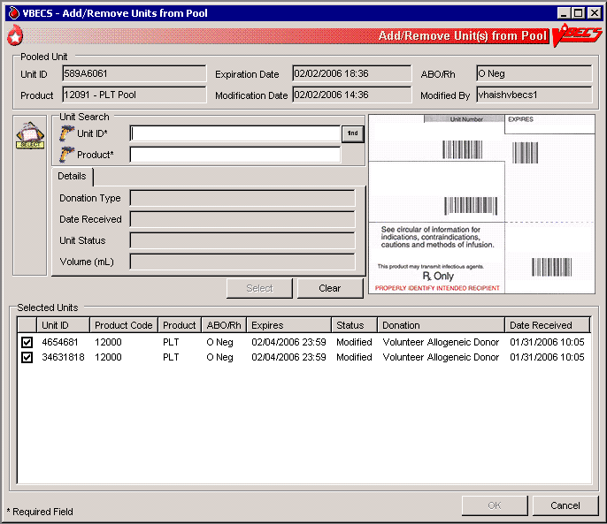

## Maintain Unit Records

### Edit Unit Information UC\_70

The user may inactivate unit tests, correct a data entry error from login, and add information about the unit that was not recorded during login.

#### Assumptions

* The user is logged into the division that contains the unit record.
* The connection to VistA is active.

#### Outcome

* The unit’s new or changed information was saved with its record.

#### Limitations and Restrictions

* The user may correct a limited amount of unit information.
* VBECS does not limit the discarded plasma volume.
* If errors are found in the unit’s product code, division or blood type at login, supplier, or donation type, the user must inactivate the unit and reenter it correctly.
* When a unit does not have a patient association, editable fields are available to an  Enhanced Technologist.
* ABO/Rh confirmation and antigen type testing cannot be inactivated when the unit is in a final unit status.
* A user can change the restricted to patient associated with a split unit when it is not assigned to the patient. DR 2218

#### Additional Information

* Units must be in “available” status to have information inactivated regardless of historic patient associations.
* VBECS does not add corrected unit tests to the Pending Task List (PTL): the user simply repeats the unit test.
* Crossmatches are considered a patient test and are inactivated in Invalidate Test Results.

#### User Roles with Access to This Option

 Enhanced Technologist DR 3,012

#### Edit Unit Information

The user records additional unit information normally recorded during incoming shipment (login), i.e., CMV negative, sickle cell negative, and antigen typing provided by the supplier.

To inactivate a unit, remove the final status, return the unit from issue, and release it from previous assignment. No changes may be made to units in a final status.

| **User Action** | **VBECS** |
| --- | --- |
| 1. Select **Blood Units** from the main menu.   Select **Edit Unit Information**. | * Displays options for processing blood units. * Displays options for selecting and editing a unit. |
| 1. Scan or enter a unit ID and product code. May cancel and select a different unit.   When the unit entered is in a final status, click **Clear** to clear the Unit ID and Product fields and enter another unit. | * Allows the user to scan or enter a unit ID and product code or select a unit. * Displays the editable unit information based on the user‘s security level.   **NOTES**  VBECS does not allow selection of a unit when it:   * BR\_70.03 Is currently assigned to a patient. * BR\_70.06 Has a final unit status. * BR\_70.07 Has a previous patient assignment record and the user is a Lead or Enhanced Technologist. DR 3,012   There is no override. VBECS clears the screen and allows the user to select a new unit. |
| 1. Review and enter or edit the data (Figure 88),   or  Go to Inactivate a Unit. | * Displays tabs to select and edit: * Unit information * Unit ABO/Rh confirmation * Antigen typing * Displays fields to add or inactivate unit information and an option to inactivate a unit based on the condition of the unit and the user’s security level.   **NOTES**  BR\_70.20 The user may add data to a field with no previous entry.  Users may edit unit volume, add special testing and RBC antigens, mark a unit biohazardous, and change the patient restriction. Task 1320  BR\_1.53 When a user enters a blood product code in the RED BLOOD CELLS, WHOLE BLOOD, or APHERESIS RED BLOOD CELLS ICCBBA component classes, VBECS allows the user to enter CMV negative, sickle cell negative and antigen typing.  BR\_1.45 An antigen type may be positive or negative for any antigen listed as a VBECS corresponding antigen in Appendix B: Table 13: TT\_23.01A Antibody and Antigen Table: Irregular Antibodies. An antigen may not be positive and negative for the same unit.  BR\_70.01 Only unit antigen type results originally entered through Incoming Shipment are available for invalidation. The user must invalidate unit antigen type results originally entered through Unit Antigen Typing by selecting Inactivate Unit Testing.  BR\_41.12 VBECS compares the antigen typing interpretation a user enters to previously assigned antigen typings for the same antigen (as assigned during Incoming Shipment, Edit Unit Information, or previous testing). When the previous interpretation was not “inconclusive” and the current interpretation does not match the previously identified antigen type, VBECS warns the user and quarantines the unit. The user may edit the discarded plasma volume only for units with previously reduced volume.  BR\_70.14 VBECS restricts the editing of disease marker testing to autologous units.  BR\_70.16 When the user changes the disease marker testing to “POS” or “NFT (not fully tested),” VBECS enables the biohazard indicator.  BR\_12.13 The user may not clear the biohazard indicator for a unit when:   * The disease marker testing is POS or NFT, * The ISBT 128 Donation Type codes are “X, For Autologous Use Only, Biohazardous” or “3, For Directed Donor Use Only, Biohazardous,” or * The unit is quarantined.   BR\_70.02 When editing the “restricted for” patient name for a unit, the user may change the name of a restricted patient but may not save the transaction without a new patient name for the restriction.  BR\_70.10 When the user restricts a unit to a patient, the patient ID is the primary identifier of the intended recipient. When VBECS searches the VistA PATIENT File (#2) and finds a match, it populates the VBECS database with the selected patient name. When the intended recipient is not in the VistA database, VBECS warns the user, clears the screen, and does not allow the unit to be further processed.  BR\_70.08  The Enhanced Technologist may edit items associated with a unit and add the new data to the unit. VBECS displays only the latest entry for these fields to the Enhanced Technologist before the unit has any patient associations.   The Traditional Supervisor may edit items associated with a unit and add the new data when the unit has a history of patient associations. |
| 1. Select a test for inactivation (Figure 89). | * Displays the previously recorded results for the selected test. * Requires a comment to process the inactivation.   **NOTES**  BR\_94.06 The user may view, not edit, previously entered serologic results and interpretations.  BR\_70.04 When the user selects the unit antigen typing test, VBECS displays antigen typing reagent types and interpretations available for invalidation at the user’s division. Inherited testing is not available for invalidation.  BR\_70.05 When the user selects the ABO/Rh confirmation test, VBECS displays the unit confirmation test interpretations available for invalidation at the user’s division.  BR\_70.21 When a selected unit has current valid tests or XMs, VBECS warns the user and does not allow him to inactivate the unit. There is no override. |
| 1. Verify the test to be inactivated and enter a comment.   Click **OK** to confirm and exit. | * Displays “Test Result Invalidated” in the unit record for the selected test.   **NOTES**  BR\_70.25 When the last ABO/Rh confirmation testing is invalidated, VBECS returns the unit to a limited status and requires an ABO/Rh confirmation test according to the component class setting in Component Classes.  When a unit that requires ABO/Rh confirmation testing no longer has a valid test result in VBECS due to invalidation of previous unit tests, VBECS treats the unit as though no ABO/Rh confirmation testing was performed.  BR\_94.04, BR\_70.09 VBECS flags invalidated test results as “Test Result Invalidated” and captures details for inclusion in an Exception Report.  BR\_70.12 VBECS does not inactivate workload associated with the invalidated test.  Replacement results are entered according to local policy. |
| 1. Return to Step 1 to edit another unit. |  |
| 1. Click **OK** to save. | * Updates and saves the data. |

Figure 88: Edit Unit Information

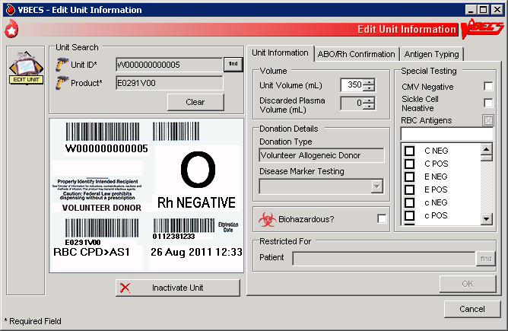

Figure 89: Edit Unit Information Invalidate Test

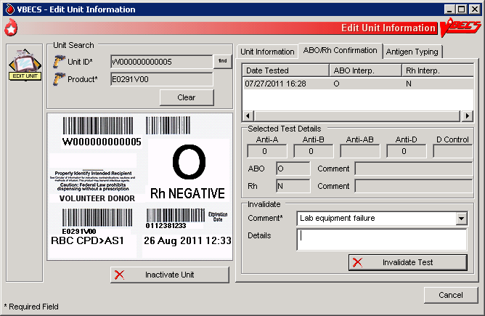

#### Inactivate a Unit

| **User Action** | **VBECS** |
| --- | --- |
| 1. Select **Blood Units** from the main menu.   Select **Edit Unit Information**. | * Displays options for processing blood units. * Displays options for selecting and editing a unit. |
| 1. Scan or enter a unit ID and product code. May cancel and select a different unit. | * Allows the user to scan or enter a unit ID and product code or select a unit. * Displays the editable unit information based on the user‘s security level.   **NOTES**  VBECS does not allow selection of a unit when it:   * BR\_70.03 Is currently assigned to a patient. * BR\_70.06 Has a final unit status. * BR\_70.07 Has a previous patient assignment record and the user is a Lead or Enhanced Technologist. DR 3,012   There is no override. VBECS clears the screen and allows the user to select a new unit. |
| 1. Click **Inactivate Unit,** as desired. | * Displays fields to add or inactivate unit information and an option to inactivate a unit, based on the condition of the unit and the user’s security level. * Displays unit data. * Requires a comment to process the unit inactivation.   **NOTES**  BR\_12.03  When the Traditional Supervisor attempts to inactivate a unit’s record, VBECS warns the user.  BR\_12.05 An inactivated unit is not accessible. The record is available in the Audit Trail and Unit History Reports and in division statistical and informational reports. When VBECS inactivates a unit, it also inactivates costs previously associated with that unit.  BR\_70.11 The user may inactivate the unit with prior but no current patient associations. VBECS requires a comment to explain the inactivation.  Unit inactivation appears on the Audit Trail Report. |
| 1. Enter a comment.   Click **OK** to save. | * Marks the selected unit record “inactive.” * Saves the record. |

### Edit Financial Data UC\_14

The user enters and/or edits charges associated with a unit after it is logged into inventory.

#### Assumptions

* The user is logged into the division containing the unit to be edited.

#### Outcome

* Unit billing information was changed.

#### Limitations and Restrictions

* When a Technologist enters a unit ID and product code for a unit that is not in final status, VBECS does not enable the Special Test Cost field. An Enhanced Technologist or higher access can change the Special Test Cost field in the Edit Financial Data option. DR 5012

#### Additional Information

* None

#### User Roles with Access to This Option

All users

#### Edit Financial Data

The user adds and/or edits a unit charge. The user confirms the unit selection, enters the dollar amount of the charge, and reviews and accepts the charge entered.

| **User Action** | **VBECS** |
| --- | --- |
| 1. Select **Blood Units** from the main menu.   Select **Edit Financial Data**. | * Displays options for processing blood units. * Displays fields for selecting a unit and editing its financial data. |
| 1. Scan or enter a unit ID or product code, or click the **find** button to select a unit from the drop-down list. | * Displays unit data. |
| 1. Edit the Base Cost, Special Test Cost, and/or Return Credit fields (Figure 90). | * Allows the user to edit the fields in the Financial Information area. * Displays the edited data.   **NOTES**   The Enhanced Technologist may edit existing amounts.  BR\_1.46 VBECS allows the user to enter a single special typing cost (the sum of charges from $1.00 to $999.00, other than the base unit cost, added to a unit by the shipper) to associate with a unit.  When no special typing costs are entered through Incoming Shipment, a user may enter them in this option until the unit is in a final status.  BR\_14.02  The Enhanced Technologist may edit a previously entered unit cost (unit base cost, return credit or special testing cost).  BR\_14.01 VBECS displays a return credit in U.S. currency (defined by the return credit percentage multiplied by the base unit cost for the blood product type in Blood Products). A user may enter a return credit amount only when VBECS assigned the return credit percentage through Outgoing Shipment or Discard or Quarantine. Otherwise, VBECS disables the Return Credit field. |
| 1. Review the data, click **OK** to save, and click **OK** again to confirm the save. | * Requests confirmation to update the database. * Saves and updates the unit record. |
| 1. Repeat Steps 2–4, as needed, to update additional unit financial data. |  |
| 1. Click **Cancel** to exit. |  |

Figure 90: Edit Unit Financial Data

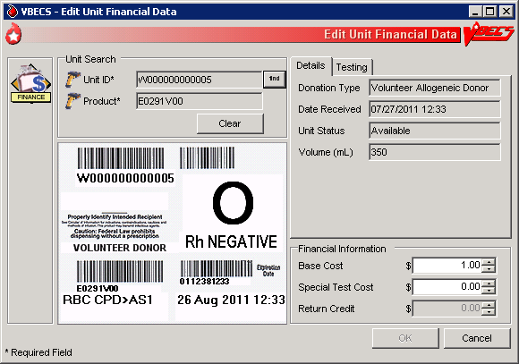

### Free Directed Unit For Crossover UC\_71

The user removes a patient restriction from a directed unit that is eligible for crossover, making that unit available for any patient, according to system rules.

#### Assumptions

* The division is “full service.”
* The unit and the user are in a blood bank in the same division.
* The unit is restricted for a patient.
* The unit is not autologous.
* The unit is not in a final status.

#### Outcome

* The unit has no restrictions.
* VBECS documents the restriction and its removal in the unit record.

#### Limitations and Restrictions

* The unit must not be in a final status to release the restriction.
* This option does not allow the removal of patient restrictions for most of the ISBT donation types that are eligible for crossover.
* This option cannot process multiple directed units simultaneously.

#### Additional Information

* BR\_41.32This option is disabled for transfusion-only facilities.

#### User Roles with Access to This Option

 Enhanced Technologist

#### Free Directed Unit For Crossover

The user releases the restriction on a directed donor unit to make the unit available in general inventory.

| **User Action** | **VBECS** |
| --- | --- |
| 1. Select **Blood Units** from the main menu.   Select **Free Directed Unit For Crossover**. | * Displays options for processing units. * Prompts the user to scan or enter the unit ID and product code. |
| 1. Scan or enter the unit ID and product code for each unit. | * Displays the unit information.   **NOTES**  When a user adds a directed unit to an undirected pool, VBECS queries the user regarding releasing the unit’s restriction.   BR\_71.01 The unit must have a donation type of only Volunteer Directed, Eligible for Crossover. If not, VBECS warns that the unit has an invalid donation type and is in a final status.”  BR\_71.03 The unit must not be assigned to a patient to release the restriction. VBECS warns that the unit is currently assigned and that he must release the assignment before continuing. |
| 1. Enter a date and time and possibly a different user, or accept the defaults (Figure 91).   Enter the required comment. | * Displays the unit information. * BR\_71.04  Emits an audible alert, requires a comment, and captures details for inclusion in an Exception Report (exception type: released patient restriction). |
| 1. Click **OK** to process the unit and add it to available inventory. | * Displays the return time, the editable (past date and time) field (default: current date and time), and the list of users for selection. * Saves the information to the database. * Changes the donation type of the unit to “Voluntary Allogeneic” and removes the restriction associated with the unit. |
| 1. Click **Yes** to confirm the save. |  |

Figure 91: Free Directed Unit For Crossover

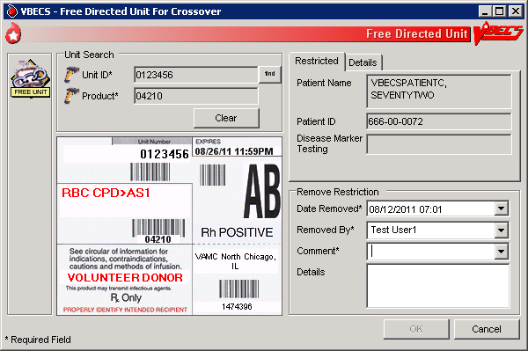

### Discard or Quarantine UC\_27

The user discards, quarantines, or releases from quarantine one or more units of blood.

#### Assumptions

* The unit of blood is in the same division as the user.

#### Outcome

* Discarded units are not available.
* Quarantined units are available for limited processing, not for patient assignment.
* Units released from quarantine are available.

#### Limitations and Restrictions

* When a user retroactively updates a unit status through this option, the Unit History Report displays the updated information, but does not display the date the change was made.

#### Additional Information

* None

#### User Roles with Access to This Option

All users

 Enhanced Technologist (release blood products from quarantine)BR\_27.17

#### Discard or Quarantine

The user changes the status (discard, quarantine, release from quarantine) of one or more units of blood. The user must indicate the ID and product code of the units to be updated. VBECS also allows batch data entry to process all units from an invoice.

A quarantined unit has limited availability for continued processing. Under certain circumstances, VBECS assigns quarantine status automatically; otherwise, the user determines and enters the status. The user must specify whether a discarded unit is for credit or for waste, which determines whether or not a return credit is assigned to the selected unit.

#### Discard or Quarantine Individual Units

| **User Action** | **VBECS** |
| --- | --- |
| 1. Select **Blood Units** from the main menu.   Select **Discard or Quarantine**. | * Displays options for processing blood units. * Displays fields for entering unit information. * Allows the user to discard or quarantine individual units. |
| 1. Enter an ID and product code for a blood unit. | * When a unit is appropriate for processing, displays unit information, including the current status.   **NOTES**  The user may deselect units prior to editing. |
| 1. Click **Select** to add the selected unit to the worklist, or click **Clear** to select another unit. | * Adds the unit to a temporary list of selected units. |
| 1. Repeat Step 3, as needed, to process multiple blood units as a single batch.   Click **OK** to continue. | * Displays selected units. |
| 1. In the Activity area, click the **Discard**, **Quarantine**, or **Release from Quarantine** radio button(Figure 92). | **NOTES**   The Enhanced Technologist may release a unit from quarantine. |
| 1. Select or enter a comment in the Comment field to explain the change in status, when indicated. Enter details, as needed. | * Displays entered data.   **NOTES**  BR\_27.04 When a status of “Discard” is assigned to a unit, the user must enter a comment.  BR\_27.08, BR\_27.02When a blood unit is assigned an indicator of “quarantined,” VBECS emits an audible alert, requires a comment, and captures details for inclusion in an Exception Report (exception type: Quarantine, Discard or Release from Quarantine, depending on the user action).  BR\_27.11  When a unit is released from quarantine, a new status must be assigned. VBECS assigns the previous status as the default status. When the unit expiration date is in the past, VBECS emits an audible alert, warns the user, and asks whether he wishes to continue.  **Yes** accepts the default status, requires a comment, and captures details for inclusion in an Exception Report (exception type: expired unit released from quarantine). **No** stops the process; the unit remains marked as quarantined.  BR\_27.05 When the user assigns a status of “Discard,” he must indicate whether the discard is waste or credit.  BR\_27.06 When VBECS processes a unit as a discard that is waste, it does not apply a return credit to the discarded unit. (There is no refund of monies from the blood shipper.)  BR\_27.07 When VBECS saves a unit as “discard for credit,” it applies a default return credit. A user may edit the default return credit applied to the unit before updating the database.  BR\_27.15 When a unit was assigned, VBECS releases patient assignments. Patient restrictions associated with the unit remain intact.  BR\_27.16 When a user attempts to release a unit from quarantine and the unit was quarantined because of a data conflict, VBECS checks the inconsistency before allowing the unit to be released. VBECS warns the user. There is no override. The user must invalidate the incorrect information or test to resolve the data conflict. |
| 1. Enter the date and time of the status update.   Click the **Waste** or **Credit** radio button. | * DR 3241 VBECS defaults the date and time of the status update to the date and time the user opened the Discard or Quarantine option * Displays entered data.   **NOTES**  The default date and time are the current date and time.  BR\_27.14 When the user updates the status of a unit and enters a date or time in the past, VBECS compares the retrospective date and time with the last record update for the unit. VBECS allows the user to update a unit record with a date and time between the last record update and the current date and time.   When the user attempts to update a unit record prior to the last record update, VBECS emits an audible alert, warns the Enhanced Technologist, and instructs him to check the date and time entered. There is no override.   When the user is a Lead Technologist, VBECS also requires a comment and asks whether the user wishes to continue. **Yes** accepts the date and time entered, requires a comment, and captures details for inclusion in an Exception Report (exception type: retrospective update prior to last record update). **No** allows the user to correct the entry. |
| 1. Review the unit status update information and click **Save** to save. | * Evaluates the unit’s current status to determine whether it is eligible for the selected function. * Displays appropriate error messages when the unit cannot be processed. * Prompts the user to confirm the save. |
| 1. Click **Yes** to confirm the save. | * Saves the data.   **NOTES**  BR\_27.01 During batch data entry of “Discard,” “Quarantine,” and “Release from Quarantine,” VBECS saves transaction details, including user-entered comments, to each blood unit included in the batch. |

Figure 92: Discard or Quarantine Units

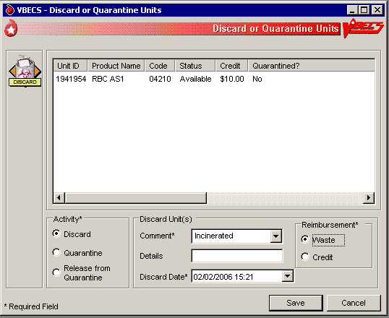

#### Discard or Quarantine Units by Invoice

| **User Action** | **VBECS** |
| --- | --- |
| 1. Select **Shipments** from the main menu.   Select **Discard or Quarantine**.  Select an invoice and click **OK**. | * Displays options for processing blood product shipments. * Displays fields for entering shipment information. * Allows the user to discard or quarantine units by invoice. |
| 1. Click (clear) one or more check boxes to remove units from the invoice.   Click **OK**. | * Allows the user to select individual units. * Displays unit information, including the current status included in the invoice. * Allows the user to deselect units from the batch prior to editing.   **NOTES**  BR\_27.09 For batch processing, the user may select incoming shipment invoices from the previous five days processed in the same division as the user.  BR\_27.12 Only incoming shipment invoices processed within the user’s division may be accessed for batch processing. |
| 1. In the Activity area, click the **Discard**, **Quarantine**, or **Release from Quarantine** radio button. | **NOTES**   The Enhanced Technologist may release a unit from quarantine. |
| 1. Select or enter a comment in the Comment field to explain the change in status, when indicated. Enter details, as needed. | * Displays entered data.   **NOTES**  BR\_27.04 When a status of “Discard” is assigned to a unit, the user must enter a comment.  BR\_27.08, BR\_27.02When a blood unit is assigned an indicator of “quarantined,” VBECS emits an audible alert, requires a comment, and captures details for inclusion in an Exception Report (exception type: Quarantine, Discard or Release from Quarantine, depending on the user action).  BR\_27.11 When a unit is released from quarantine, a new status must be assigned. VBECS assigns the previous status as the default status. When the unit expiration date is in the past, VBECS emits an audible alert, warns the user, and asks whether he wishes to continue.  **Yes** accepts the default status, requires a comment, and captures details for inclusion in an Exception Report (exception type: expired unit released from quarantine). **No** stops the process; the unit remains marked as quarantined.  BR\_27.05 When the user assigns a status of “Discard,” he must indicate whether the discard is waste or credit.  BR\_27.06 When VBECS processes a unit as a discard that is waste, it does not apply a return credit is not applied to the discarded unit. (There is no refund of monies from the blood shipper.)  BR\_27.07 When VBECS saves a unit as “discard for credit,” it applies a default return credit. A user may edit the default return credit applied to the unit before updating the database.  BR\_27.15 When a unit was assigned, VBECS releases patient assignments. Patient restrictions associated with the unit remain intact.  BR\_27.16 When a user attempts to release a unit from quarantine and the unit was quarantined because of a data conflict, VBECS checks the inconsistency before allowing the unit to be released. VBECS warns the user. There is no override. The user must invalidate the incorrect information or test to resolve the data conflict. |
| 1. Enter the date and time of the status update.   Click the **Waste** or **Credit** radio button. | * DR 3241 VBECS defaults the date and time of the status update to the date and time the user opened the Discard or Quarantine option * Displays entered data.   **NOTES**  The default date and time are the current date and time.  BR\_27.14 When the user updates the status of a unit and enters a date or time in the past, VBECS compares the retrospective date and time with the last record update for the unit. VBECS allows the user to update a unit record with a date and time between the last record update and the current date and time.   When the user attempts to update a unit record prior to the last record update, VBECS emits an audible alert, warns the Enhanced Technologist, and instructs him to check the date and time entered. There is no override.   When the user is a Lead Technologist, VBECS also requires a comment and asks whether the user wishes to continue. **Yes** accepts the date and time entered, requires a comment, and captures details for inclusion in an Exception Report (exception type: retrospective update prior to last record update). **No** allows the user to correct the entry. |
| 1. Review the unit status update information and click **Save** to save. | * Evaluates the unit’s current status to determine whether it is eligible for the selected function. * Displays appropriate error messages when the unit cannot be processed. * Prompts the user to confirm the save. |
| 1. Click **Yes** to confirm the save. | * Saves the data.   **NOTES**  BR\_27.01 During batch data entry of “Discard,” “Quarantine,” and “Release from Quarantine,” VBECS saves transaction details, including user-entered comments, to each blood unit included in the batch. |

## Select Units UC\_03

A user selects a patient component order and assigns one or more products to a patient for possible transfusion.

#### Assumptions

* An appropriate current order was accepted through Accept Orders: Accept an Order.
* The division may or may not allow electronic crossmatch (eXM).
* When a division is “transfusion only,” eXM is not available. The user must enter a serologic crossmatch (XM) interpretation.

#### Outcome

* The status of the unit and the associated component order task status are updated.
* VBECS indicates that units are available for issue when units do not require XM or other additional testing.
* VBECS allows the user to print a Blood Transfusion Record Form (BTRF) and a Caution Tag for available blood products.
* When serologic XM is required, VBECS automatically adds units to the XM data entry grid when Patient Testing: Record a Crossmatch is accessed.
* When eXM is enabled for the facility, the patient is eligible for eXM in accordance with system rules (see Table 23: TT\_3.05 Rules for Electronic and Serologic Crossmatch), and the user selects a unit, VBECS assigns the unit to the patient without further testing.

#### Limitations and Restrictions

* Task 1,126When a user checks the “D Pos” or “D Neg” check box to modify a search for blood, VBECS returns no units, regardless of the availability of units.
* DR 2,578 VBECS does not allow a user to select a pool of mixed ABO/Rh units for a patient. Instead, the user must select random units for the patient and pool the mixed ABO/Rh units to allow issue.
* DR 2,808VBECS displays a component order as “filled” when the number of units transfused and the number of units ordered are the same. CPRS displays a component order as “completed” when the number of units ready for issue and the number of units ordered are the same. Therefore, CPRS displays the order as “completed” before VBECS displays the order as “filled.”
* Changing a patient's antigen negative requirement or antibody identified after a unit is crossmatched does not provide an alert at Issue Unit regarding the type of crossmatch (electronic or serologic) performed on a unit available for issue.

#### Additional Information

* BR\_3.03 Active component orders and the user must be in the same division.
* BR\_5.03 The user may select only active units and those not in an inactive or final status.
* Multiple users may select units associated with a component order.
* When a user selects a patient order, VBECS searches for available autologous and directed units regardless of the unit’s current division within a multidivisional database, displays the unit information, and allows the user to assign the unit when it is in the user’s division.
* A user may select units for only one ordered component class at a time.
* An existing specimen and/or order remains available to select additional units until its expiration date.
* The selection of blood units does not complete an order.
* A user must accept or cancel each component task in its entirety.
* BR\_3.38 The user reserves autologous and directed units and all units processed in a “transfusion-only” facility, regardless of donation type, for a specific patient. VBECS displays this information to all divisions in a multidivisional database and accommodates immediate selection of the unit for the patient when the user is in the same division.
* BR\_3.42 When VBECS compares a patient’s current and previous ABO/Rh results, it does not evaluate previously recorded ABO/Rh results marked “Test Result Invalidated.”
* An ABO/Rh confirmation test interpretation must match the unit ABO/Rh at login and when repeat confirmation tests are not invalidated. A user may not select a unit for a patient based on ABO/Rh at login. The unit must have a satisfactory confirmation result before VBECS considers it available for selection.
* BR\_3.53 When a user accepts an order without a specimen, he may associate the specimen when he selects units for XM.
* ABO/Rh confirmation testing is not required for components in the OTHER component class that do not traditionally contain red blood cells. A user may request a XM for these components in accordance with local policy.

#### User Roles with Access to This Option

All users

#### Select Units

A user selects a patient’s component order and assigns one or more products to a patient. The user may then enter individual units or select units from a list of selectable, potentially compatible units for each component order.

| **User Action** | **VBECS** |
| --- | --- |
| 1. Select **Patients** from the main menu and select **Patient Testing**, or   Select **Blood Units** from the main menu and select **Select Units**. | * Displays options for processing patient-related functions. * Displays the Pending Task List (PTL) and PTL search parameters in the Diagnostic Tests tab or in the Component Orders tab. |
| 1. Enter or select PTL search parameters, if appropriate (Figure 93).   Click the check boxes in the PTL to select one to four component orders.  Click **OK** to continue (Figure 94). | * Displays information for each component order. * When the selected order class is RED BLOOD CELLS and the division enabled eXM, evaluates the patient for eXM unit processing.   **NOTES**   See Table 6 for alerts that may occur during this option. |
| 1. DR 4414 **Steps 3 through 8 are optional. If a specimen is already associated with the order, skip to Step 9.** To associate a specimen with an emergency-issued unit requiring XM, select (highlight) an issued unit in the Order Group tree view in the left pane (Figure 95). | * Enables the Associate Specimen check box.   **NOTES**  If eXM is enabled, complete the TAS prior to associating the specimen UID with the emergency-issued units. |
| 1. Click the **Associate with Specimen** check box**.**   Click the **find** button to select a specimen UID (Figure 95). | * Opens the Select Patient Specimen window. |
| 1. Scan or enter the correct specimen UID and click **Search**. | * Displays the selected patient specimen information. |
| 1. Click **OK**. | * Saves the specimen information and returns the user to the Select Units window. * Displays the associated specimen UID in the Specimen UID field. |
| 1. Repeat Steps 3–6 to associate the sample with other emergency-issued units, or click **OK** to save. | * When the user clicks OK, displays a message asking the user if he wishes to complete serologic crossmatch. |
| 1. Click **Yes** to complete the serologic crossmatch.   Click **No** to return to the VBECS desktop. | * Allows the user to enter results in the Serologic Crossmatch (XM) cells in the patient testing grid. |
| 1. Click **Add Units** to add units to the component orders selected. | * Searches the database and displays available restricted autologous and directed units that the user must select before selecting allogeneic units of the same ICCBBA component class. * Displays the unit ID, product type, unit ABO/Rh, unit expiration date, specimen UID, if applicable, of units assigned to the patient in the division’s blood bank on a different specimen or order. The user may release and reassign the units to the current order. * When eXM was configured for the facility, displays the eXM status (eligible or not eligible) for the patient.   **NOTES**   See Table 6 for alerts that may occur during this option.  Units that are selectable with an override do not appear on the list of available units and must be scanned or entered by the user. DR 2819  BR\_3.05 When no valid ABO exists for the patient, the user may select components, including autologous units:   * For RBC or WB order: * Group O, Rh positive or O Rh negative RBC * WHOLE BLOOD is not selectable * For FFP order only, group AB, Rh positive or Rh negative * For PLT, CRYO, or OTHER order, all available units are selectable. |
| 1. Scan, enter or select **\***allogeneic units. Units may be selected from the Order Group tree view or by clicking the **find** button for a list of compatible units.   **\*** when typing in a unit ID and Product Code, use the tab key or mouse to leave the field.  Enter or select a date in the Selection Date field. Each unit may have its own selection date and time.  Click **Add Units** to display the unit selection form.  DR 4414 | * Maintains a list of selected units. The user may deselect selected units. * Evaluates the selected unit: * For the ABO/Rh compatibility of each unit and warns the user. * Against patient Transfusion Requirements (TRs) and warns the user. * For unit antigen negative compatibility and warns the user. * Performs additional checks that include days remaining until the unit’s expiration date, the current status, assignments to other patients, quarantine and biohazard indicators, when applied, and associated special testing.   ***NOTES***  * *See Table 6 for alerts that may occur during this option.  *When the user selects a unit in the tree view, he may accept or edit the current date and time displayed; the date and time must be in the past.*  BR\_3.25, BR\_16.13 Restricted (autologous or directed) unit selection eligibility criteria:   * Restricted For Patient ID: must match * Restricted For Patient Name: must match * Unit expiration date must be in the future. * Component class (transfusion only requires restriction of all units)   BR\_3.19 The criteria for selecting or including an individual unit in a pick list include evaluating a unit for:   * Considered substitutable for the order * Same division as the user * Current location is in the blood bank * Has no quarantine indicator * Is not already assigned or crossmatched to the patient * Is not “restricted” for a different patient * Meets ABO/Rh compatibility requirements specific to the component class * Future expiration date   BR\_3.04 VBECS lists only ABO and Rh compatible units for selection. DR 4414  BR\_3.11 When ABO/Rh results were not created for the specimen associated with the component order and the order is not designated “emergency issue,” VBECS allows the user to select units using historic records, and notifies the user that ABO/Rh testing must be performed at this division on this patient before any selected units can be issued.  BR\_3.55 VBECS displays and allows the user to complete a pending XM associated with a patient order without a final unit status. |
| 1. Repeat Step 10 until all units are selected. DR 4414 | * Requests the user to confirm the list of selected blood units.   **NOTES**  The user may select or deselect additional units. |
| 1. Click **OK** to confirm the selection of units. | * Determines whether the units are available for issue or whether they require additional modification and/or testing based on the component class. * Updates the database, as appropriate. * Sends selected blood units with patient details to the BCE COTS system via an HL7 message.   **NOTES**  BR\_56.31 When the total number of blood units eligible for issue, issued, or transfused is greater or equal to the number of ordered units, VBECS sends and order completion message to CPRS.   See Table 6 for alerts that may occur during this option.  BR\_3.17, BR\_3.27 When eXM is enabled at the division and blood units require XM, VBECS determines whether the patient and units are eligible for eXM. All parameters listed in Appendix B: Table 23: TT\_3.05 Rules for Electronic and Serologic Crossmatch must be met. Units not eligible for eXM must have serologic XM performed.  When eXM is not enabled, the user must enter serologic XM results for red blood cell classes or when a user orders an optional XM for OTHER component classes. VBECS does not change the unit status to “crossmatched,” make units available for issue, or allow the Caution Tag or BTRF to be printed until a user enters a valid XM result, unless an emergency-issued unit is being processed. |
| 1. Select another component order to continue selecting units, or exit. | * Displays orders for the next patient. |

Figure 93: Pending Task List Component Orders

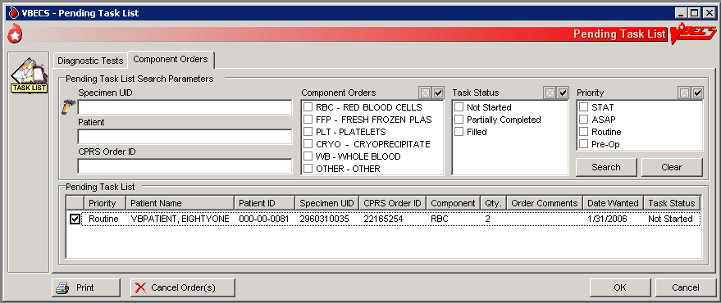

Figure 94: Select Units for a Patient

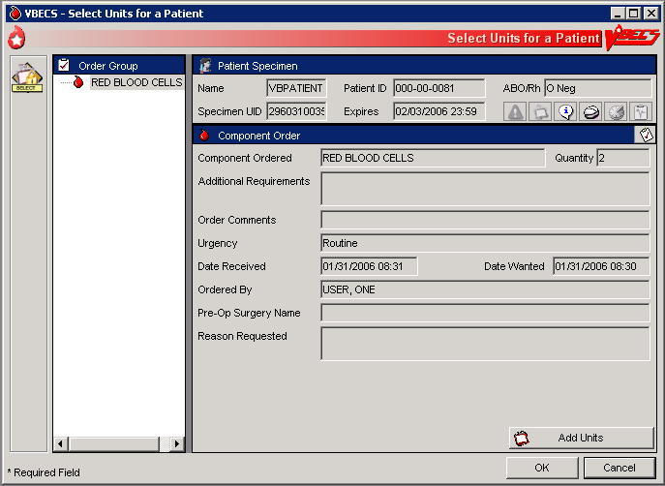

Figure 95: Associate a Specimen with an Emergency-Issued Unit

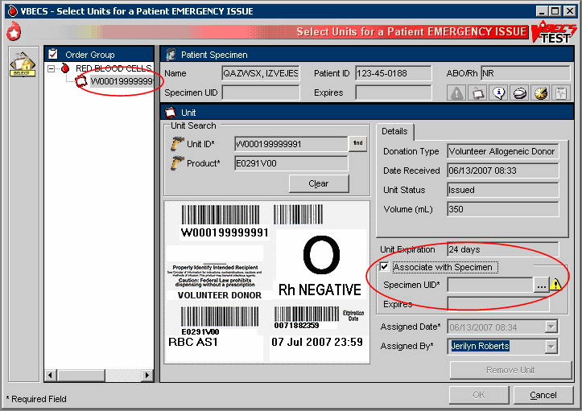

####  Alerts

Table 6: Alerts That May Occur in Select Units

| **Step** | **Alerts** |
| --- | --- |
| 2 | BR\_16.01 VBECS displays small_si_tr and emits an audible alert when there are Special Instructions (SIs) or TRs for the patient. |
| 2 | BR\_3.18 When the user selects blood units that require XM, and eXM is enabled at the division but the current patient is not eligible for eXMs, VBECS displays a warning that includes the reason for the ineligibility. Selected units must have serologic XM performed. The user may not print the Caution Tag or the BTRF. VBECS does not change the unit status to “crossmatched” until the user enters a valid serologic XM result in Patient Testing: Record a Crossmatch. |
| 2 | BR\_3.57 When the user clicked the Emergency Order check box during specimen acceptance and selects blood units requiring crossmatch, VBECS does not allow the user to perform an electronic or serologic crossmatch. |
| 9 | BR\_3.01 When a current specimen is required for the selected component class based on Component Classes and one does not exist for the patient, the user may not select ABO type-specific blood products. VBECS notifies the user that he is selecting units using the emergency issue compatibility rules. |
| 9 | BR\_3.24 When the patient record is marked as having a previous ABO/Rh discrepancy that was justified, a current specimen is required. The user must select units based on the current specimen ABO/Rh. When the current specimen ABO/Rh was not performed, VBECS warns that the patient had a previous ABO/Rh discrepancy and instructs the user to perform ABO/Rh on the current specimen to continue using normal rules and policies or follow emergency issue rules and policies. |
| 9 | BR\_3.30 When there is a current specimen and ABO/Rh testing was performed, VBECS compares the ABO/Rh of the current specimen to the historical ABO/Rh. When there is a discrepancy, the ABO type is inconclusive, and there is no previous justification for the discrepancy on the patient record, VBECS notifies the user that the ABO/Rh on the current specimen does not agree with the historical ABO/Rh and instructs the user to resolve the discrepancy to continue using normal rules and policies, and recommends that the user release previously selected units or follow emergency issue rules and local policies. |
| 9 | BR\_3.40 When a repeat ABO/Rh is performed on the patient specimen and the interpretation does not match the original ABO/Rh interpretation. |
| 9 | BR\_3.10 When a user selects a blood unit that is evaluated as ABO incompatible (based on comparison of the patient's current ABO/Rh entered by the user with the ABO/Rh on record), VBECS emits an audible alert and warns the user that the unit is not ABO compatible for this patient and that the user may not select the unit. There is no override; VBECS clears the screen and allows the user to select another unit. |
| 10 | BR\_3.34 The user may override the selection of restricted units. VBECS warns that more restricted units were not selected for the patient and asks whether the user wishes to continue. The override requires a comment and captures details for inclusion in an Exception Report (exception type: less restrictive unit issued). |
| 10 | BR\_3.52 VBECS warns the user when he selects type-specific plasma products that do not require a specimen, according to the division configuration of component classes, for a patient with a history of justified ABO/Rh change. |
| 10 | BR\_3.49 Once a valid XM interpretation is verified and the unit is compatible, VBECS does not allow a user to select that unit (ID and product code) for the same specimen. The user may select the unit for a XM with the same patient’s new specimen after the unit is released from the current assignment. VBECS warns that the unit has a valid current XM with this patient. The user clears the warning and may continue or enter a new unit number for selection. |
| 10 | BR\_3.28 When a selected unit is currently assigned to another patient, VBECS warns the user and asks whether the user wishes to continue to select for this patient.  **Yes** allows the user to continue. **No** clears the screen and allows the user to select a new unit. |
| 10 | BR\_3.19 When a user is a Technologist and selects an expired unit, VBECS warns him. There is no override.   When the user is an Enhanced Technologist or above, VBECS warns that the unit is expired and asks whether the user wishes to continue to select.  **No** clears the screen. **Yes** requires a comment and captures details for inclusion in an Exception Report (exception type: expired unit selected). |
| 10 | BR\_3.13 When a unit is selected for a patient, VBECS displays a tool tip stating that the unit may not be selected or removed. |
| 10 | When the user selects a unit and these conditions exist, VBECS warns the user. There is no override. VBECS clears the screen and the user may select another unit:   * For XM for the same patient, VBECS warns that the unit was already selected for the patient. * BR\_3.33 That is not substitutable for the order, VBECS warns that the selected unit is not valid for order. * BR\_3.43 That is quarantined, VBECS warns that the unit is quarantined and may not be selected. * BR\_3.45 That is on a pending outgoing shipment list, VBECS warns that the unit is currently included on a pending outgoing shipment invoice and must be removed from the shipment invoice before it can be selected. * BR\_3.44 That is not in the blood bank or is issued to another patient, VBECS warns that the unit is not in the blood bank and may not be selected. * BR\_3.46 That is restricted for a different patient, VBECS warns that the unit is restricted for a different patient and may not be selected. * BR\_3.16 The confirmation is not performed or is incomplete, VBECS emits an audible alert and warns that the unit ABO/Rh confirmation was not performed or is incomplete and that the unit may not be selected. |
| 10 | BR\_3.23 When the selected unit had an incompatible crossmatch result with the current patient in the past, VBECS warns the user. The user may continue with this unit and proceed with electronic or serologic crossmatch testing. |
| 10 | BR\_3.06 When the user selects an antigen positive (or inconclusive for testing) unit and the patient has the corresponding antigen negative requirement, VBECS warns the user and requires action determined by the user’s security level. |
| 10 |  When the user is an Enhanced Technologist or below**,** VBECS emits an audible alert and warns that the patient has a history of an antibody, that the unit does not have a negative test for the corresponding antigen, and that the user does not have the proper security level to select the unit. There is no override. |
| 10 |  When the user is a Lead Technologist or above, VBECS emits an audible alert, warns that the patient has a history of an antibody and that the unit is positive or inconclusive for the corresponding antigen, and asks whether the user wishes to continue to select the unit.  **No** allows the user to continue to select units for the patient. **Yes** requires a comment and captures details for inclusion in an Exception Report (exception type: antigen positive units selected). |
| 10 | BR\_3.15 When a unit was not antigen typed for the corresponding antigen, VBECS emits an audible alert, warns that the unit must be typed and found negative to be available for this patient, and asks whether the user wishes to continue to select this unit. The user may continue to select units for the patient.  **Yes** requires a comment and captures details for inclusion in an Exception Report (exception type: antigen positive units selected).  See Appendix B: Table 13: TT\_23.01A Antibody and Antigen Table: Irregular Antibodies. |
| 10 | BR\_3.08 When an Rh negative patient has an active anti-D antibody or a D antigen negative requirement set in Special Instructions and Transfusion Requirements, VBECS verifies the presence or absence of the corresponding antigen based on the ABO/Rh of the selected blood unit. When a user selects an Rh positive blood unit for a patient with anti-D, VBECS warns the user and requires action based on the user’s security level.  The antigen negative requirement for anti-D is D, not AGwD. AGwD is not a selectable antigen negative requirement in Special Instructions & Transfusion Requirements: Antigen Negative RBCs. |
| 10 | BR\_3.21 For an Rh negative, unknown, or inconclusive patient: when the selection of Rh positive or Rh pooled units from the WHOLE BLOOD, RED BLOOD CELLS, PLATELETS, and OTHER VBECS component classes are individually entered and confirmed as required, VBECS emits an audible alert, warns that the patient is Rh negative and the selected unit is Rh positive, instructs the user to check the patient sex and hospital policy before continuing, and asks whether the user wishes to continue to select the unit.  **No** clears the unit data and allows the user to select a different unit. **Yes** requires additional comment (unit selection canned comment context) and captures details for inclusion in an Exception Report (exception type: Rh positive units selected). |
| 10 | BR\_3.09 When a user selects blood units to fill an OTHER component order, VBECS allows him to order an optional XM. When the user requests an optional XM order, he must specify a specimen UID to associate with the XM. When the selection process is complete and eXM is enabled at the site or added to the serologic XM data grid, VBECS evaluates the units for eXM. See Appendix B: Table 20: TT\_3.07 Enable Crossmatch Option for OTHER Product Types. |
| 10 | BR\_3.14 When a patient has TRs other than CMV negative or Sickle Cell negative, VBECS verifies whether the selected unit satisfies the requirement based on system rules TT\_3.04 Blood Unit Substitution and the Fulfillment of Transfusion Requirements. When the TR is not satisfied, VBECS emits an audible alert, warns that the unit does not satisfy all of the patient’s TRs, and asks whether the user wishes to continue to select the unit.  **No** clears the screen. **Yes** allows the user to continue without comment. |
| 10 | BR\_3.32 When a patient has a TR of CMV negative or Sickle Cell negative, VBECS verifies the selected unit for compliance. When the selected unit does not fit the criteria, VBECS emits an audible alert and warns the user:   *  Enhanced Technologist or below: VBECS warns that the patient requires CMV negative or Sickle Cell negative blood, that the selected unit is not CMV negative or Sickle Cell negative, and that the user does not have the proper security level to select the unit. There is no override. VBECS clears the screen, and the user must select another unit. *  Lead Technologist or above: VBECS warns that the patient requires CMV negative or Sickle Cell negative blood, that the selected unit is not CMV negative or Sickle Cell negative, and asks whether the user wishes to continue to select. **No** clears the screen and the user must select a new blood unit. **Yes** requires a comment and captures details for inclusion in an Exception Report (exception type: Transfusion Requirement incompatible unit selected). |
| 10 | BR\_3.39 When a user selects a unit with a biohazardous indicator for a patient, VBECS emits an audible alert, warns the user, and asks whether the user still wishes to select the unit.  **No** clears the entry and allows the user to select a new unit. **Yes** requires a comment and captures details for inclusion in an Exception Report (exception type: biohazardous unit selected). |
| 10 | BR\_3.12  When the user selects blood components from the frozen product types for a patient, VBECS emits an audible alert and warns that the selected blood unit must be thawed and may require additional processing prior to issue. The unit is not eligible for printing the BTRF or Caution Tag. VBECS updates the blood unit status to “assigned” and the unit is no longer available for issue. |
| 10 | BR\_3.35 When a user selects a unit requiring XM, eXM is enabled, and the patient is eligible, the selected unit ABO/Rh must be compatible with the patient ABO/Rh. VBECS displays a message based on Appendix B: Table 23: TT\_3.05 Rules for Electronic and Serologic Crossmatch. If the user continues to select that unit in which VBECS requires a serologic XM, VBECS does not allow the Caution Tag or BTRF to be printed, and does not update the unit status to “crossmatched”’ under normal system rules and policies. When the selected unit is available for emergency issue to the patient, VBECS allows the Caution Tag and BTRF to be printed. |
| 12 | BR\_3.29 When eXM is enabled and the patient and selected units are eligible, VBECS notifies the user and asks whether he wishes to continue with eXM.  **Yes** assigns a XM result of “Compatible: Electronically Crossmatched.” VBECS updates the database with the XM result, date and time of XM, XM technologist, division, specimen UID, specimen phlebotomist, and specimen expiration date and time. VBECS allows a Caution Tag and BTRF to be printed and the unit is ready for issue and transfusion. VBECS changes the unit status to “crossmatched.”  **No** keeps the unit assigned to the patient and available for data entry of serologic XM. VBECS does not allow the Caution Tag or BTRF to be printed and does not change the unit status to “crossmatched.” When a division is “transfusion only,” the unit remains assigned to the patient and is available for the user to enter the serologic XM interpretation, VBECS does not allow the Caution Tag or BTRF to be printed, and the unit is not crossmatched. |
| 12 | BR\_3.37 When the user selects a unit requiring XM, the division is defined as “full service,” eXM is enabled, and the patient is not eligible for eXM, VBECS warns the user that the selected units require serologic XM and asks whether he wishes to continue.  **Yes** adds the units to the XM data entry grid and transfers the user to Patient Testing: Record Patient Test Results to begin the XM process. **No** records that a serologic XM test is needed. The user may not print a Caution Tag or Blood Transfusion Record Form; the unit status does not change to “crossmatched.” |

## Issue Blood Components UC\_73

The user issues one or more patient-assigned blood units to a transporter for storage in a remote location or for possible transfusion.

#### Assumptions

* The facility has a procedure for the emergency issue of blood products.
* The unit and the user are in the same division.
* The unit is assigned and/or crossmatched for the patient currently selected for issue.
* VistA is available for the user to choose a physician and valid hospital locations.
* All issue-to locations must be valid entries in the VistA HOSPITAL LOCATION (#44), including home transfusion.

#### Outcome

* The unit status was updated to “issued.”
* The unit’s current location was updated to the “issue-to” location.

#### Limitations and Restrictions

* VBECS does not check for restricted units (not assigned to the patient) received between selection and issue.
* All issue-to locations must be valid entries in the VistA hospital location file, including home transfusion.
* If VistA link is not available, the user may proceed with the issue process but the current issue-to hospital location is not recorded. All of the associated report records display “VistALink Down” in the Issue To location field. DR 5073
* ISBT 128 tables include blood product codes labeled as not for manufacturing or transfusion. VBECS does not restrict such products from being entered, issued, or transferred (local policy controls their use) and does not accommodate blood modification for these products.
* When a site has configured subservient VistA institutions to the VBECS division, users can only issue units to locations in the primary VistA. Sites may add locations to VistA to account for the relocations to the subservient VistA institutions.DR 2,880
* BCE information applies ONLY when a BCE COTS product is available for communication and is configured.
* Changing a patient's transfusion requirements (component requirements, antigen negative requirement or antibody identified) after a unit is crossmatched does not provide an alert at Issue Unit regarding the type of crossmatch (electronic or serologic) performed on a unit available for issue.

#### Additional Information

* When no VistA order is available, the user must process the request manually until VistA provides them to VBECS. The user must print blank Caution Tags and Blood Transfusion Record Forms (BTRFs) to accommodate this rare occurrence. When VistA does not provide a pseudonym or associated pseudo-ID for the patient that allows placement of a VistA order, VBECS cannot create a patient order for emergency issue of blood.
* “Issue with Medical Director Approval” components must be approved prior to this option and do not require special handling by VBECS.
* Emergency issue processing accommodates the issue of blood to patients without completed specimen testing, as required.
* Sites may enter the lot number of blood administration sets and leukoreducing filters when they enter the name of the individual picking up the blood product. VBECS retains this information in the unit history record.
* User must date all signature lines on the BTRF dating of the signatures [i.e., Inspected and issued by, Issued to, First Identifier, Second Identifier, Transfusion Data section completed by, Transfusion Reaction Data section completed by (as needed)].

#### User Roles with Access to This Option

All users

To correct issue time and other errors, return the unit from issue and reissue it with the correct information.

#### Issue Blood Components (Routine)

The user issues assigned or crossmatched blood to a transporter for patient transfusion at valid inpatient and outpatient hospital locations, and records issue details, including the transporter’s name or identifier.

| **User Action** | **VBECS** |
| --- | --- |
| 1. Select **Patients** from the main menu.   Select **Issue Blood Components**. | * Displays options for processing patient-related functions. * Displays an option to scan the Caution Tag or enter a patient name or ID.   **NOTES**  BR\_73.22 The user must verify the correct patient selection.  The  Enhanced Technologist or above is authorized to issue expired blood products.  The  Lead Technologist or above is authorized to issue antigen positive and untyped red blood cells. |
| 1. Select a patient. | * Displays patient data, including entries that meet the entered patient criteria, and allows the user to select the correct patient.   **NOTES**   See Table 7 for alerts that may occur during this option.  Not all possible error messages may display when multiple messages may apply to the unit/patient. Correction of any one of the patient/unit problems and subsequent re-attempts to issue the unit to the patient will display another of the possible messages until all errors are corrected. DR 4808 |
| 1. Click **OK** to verify that the correct patient was selected. | * Displays fields for the user to enter data for the issue transaction. |
| 1. Enter the required data in the transporter name, issue-to location, and date and time fields (Figure 96).   Click **OK**. | **NOTES**  BR\_73.01 The user may edit the transfusion-ordering clinician, which does not change the blood-ordering clinician.  BR\_73.18 When the user updates the transfusion-ordering-clinician field, VistALink queries VistA for valid providers only. The user may narrow the search by entering the provider’s name.  BR\_73.08 The user may edit the issue date and time (default: current date and time) to allow retrospective data entry; no future issue date or time is allowed. When the issue time is incorrect, the user must undo the issue and reissue the unit with the correct date and time.  BR\_73.09, BR\_30.02 A remote storage indicator is optional (default: No).The transporter name field allows free text and does not display a selection list. The issue-to location lists current hospital locations provided by VistALink, including the inpatient or outpatient location indicator (VistA refers to this as a “patient class”). This is related to billing reimbursement and is not an enabled field in the issue option.  A user could return the unit from issue and reissue it with a hospital location when VistALink is up again. DR 5073  BR\_73.34 When a remote storage location indicator is checked, the user may select from a list of previously entered locations or enter a new, free-text location. Each location entered and saved is available for future selection as a remote location. |
| 1. Scan the unit ID and product code, or click one or more check boxes to select units for issue to the selected patient (Figure 97). | * Displays the option to select units from the Assigned Units or Emergency Issue Units tabs. * Lists the selected units, allows the user to select additional units or deselect units, and prompts the user to indicate that the selections are complete. * Allows the user to select the unsatisfactory unit and edit its issue selections.   **NOTES**   See Table 7 for alerts that may occur during this option.  BR\_73.35 When the user attempts to issue a unit with an inconclusive crossmatch result, VBECS warns the user that the repeat crossmatch is required before the unit can be issued.  BR\_73.13 When the user attempts to issue a unit that is not assigned or crossmatched to the patient, VBECS warns the user that the unit is not assigned to the patient and allows the user to enter another unit number.  BR\_73.26 When required by the component, the unit must have a satisfactory ABO/Rh confirmation result before it is considered available for issue (emergency or routine) and the Caution Tag and BTRF may be generated.  BR\_3.42 When a current specimen is required, VBECS compares the current and previous ABO/Rh results. It does not evaluate results marked “Test Result Invalidated.”  BR\_73.23 To issue blood components that require a crossmatch, the TAS must be completed and the unit status must be crossmatched to the patient.  Whole blood is not allowed for the emergency issue process. Completed Type and Screen and compatible crossmatch tests are required for whole blood issuance. DR 4811 DR 4854 |
| 1. Click **OK** to save and complete the unit issue. | * Displays entries for review and editing.   **NOTES**  BR\_73.24 When the user selects multiple units for a patient and creates a batch for issue, all units in the batch are issued simultaneously to the same location. VBECS assigns the issue information to all units in the batch. The user may not enter different information, including any override comment, for an individual unit in the batch. |
| 1. Click **Yes** when the unit is satisfactory to save, or **No** when the unit is unsatisfactory. | * Saves the data. * Displays the unit inspection indicator (satisfactory or unsatisfactory) listing each selected unit. * Sends updated patient and blood unit information to the BCE COTS system via an HL7 message. * Sends updated patient and blood unit information to the BCE COTS system via an HL7 message. The message contains the date time when VBECS creates the message and not the date time the user selects the unit for issue. DR 4334   **NOTES**   See Table 7 for alerts that may occur during this option.  Sites using BCE COTS must issue blood components in real-time for BCE COTS to be able to perform transfusion verification.  DR 4334 |
| 1. Exit. |  |

Figure 96: Issue Blood Components (1)

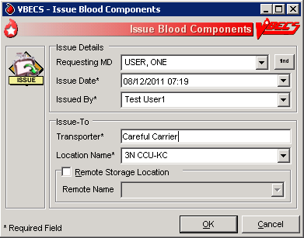

Figure 97: Issue Blood Components (2)

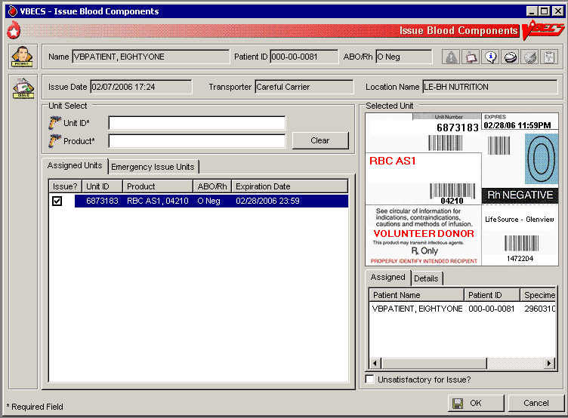

#### Issue Blood Components (Emergency)

The user issues assigned or crossmatched blood to a transporter for patient transfusion that does not meet routine issue conditions at valid inpatient and outpatient hospital locations, and records issue details, including the transporter’s name or identifier.

| **User Action** | **VBECS** |
| --- | --- |
| 1. Select **Patients** from the main menu.   Select **Issue Blood Components**. | * Displays options for processing patient-related functions. * Displays an option to scan the Caution Tag or enter a patient name or ID. |
| 1. Select a patient. | * Displays patient data, including entries that meet the entered patient criteria, and allows the user to select the correct patient.   **NOTES**   See Table 8 for alerts that may occur during this option. |
| 1. Click **OK** to verify that the correct patient was selected. | * Displays fields for the user to enter the data for the issue transaction. |
| 1. Enter the required data. | * Displays the option to select units from the Assigned Units or Emergency Issue Units tabs. |
| 1. Click the **Emergency Issue Units tab**.   Scan or click one or more check boxes to select units for issue to the selected patient (Figure 98).  Click **OK**. | * Lists the selected units, allows the user to select additional units or deselect units, and prompts the user to indicate that the selections are complete. * Allows the user to select the unsatisfactory unit and edit its issue selections.   **NOTES**   See Table 8 for alerts that may occur during this option. |
| 1. Click **OK** to accept the entries and complete the unit issue. | * Displays entries for review and editing. |
| 1. Click **Yes** when the unit is satisfactory or **No** when the unit is unsatisfactory. | * Saves the data. * Displays the unit inspection indicator (satisfactory or unsatisfactory) listing each selected unit. * Sends updated patient and blood unit information to the BCE COTS system via an HL7 message.   **NOTES**   See Table 8 for alerts that may occur during this option. |
| 1. Exit. |  |

Figure 98: Issue Blood Components Emergency Issue Units Tab

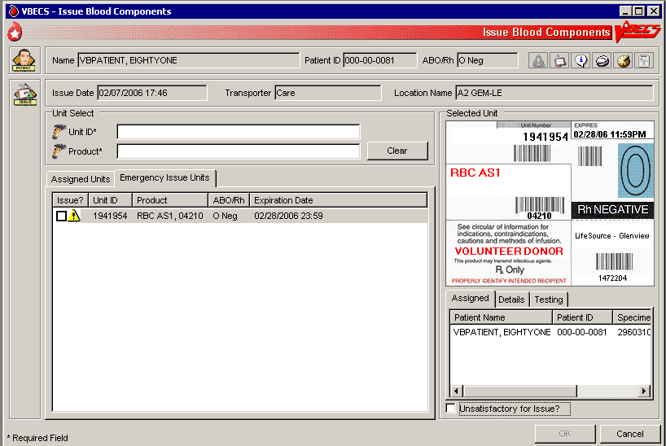

Figure 99: Emergency Issue



####  Alerts

Table 7: Alerts That May Occur in Issue Blood Components (Routine)

| **User Action Step** | **Alerts** |
| --- | --- |
| 2 | BR\_16.01 VBECS displays small_si_tr and emits an audible alert when there are Special Instructions (SIs) or Transfusion Requirements (TRs) for the patient. |
| 2 | BR\_73.21 When no patient is found, VBECS warns the user and does not allow the user to continue. |
| 2 | BR\_73.20 When the patient has nocomponents available for issue, VBECS warns the user and does not allow the user to continue. |
| 2 | BR\_73.31 When required testing is incomplete at issue, VBECS emits an audible alert, warns the user, and asks whether to emergency issue the unit in accordance with hospital policy.  **No** stops the user from issuing the unit and requires selection of another unit. **Yes** creates an Exception Report entry for the issue, indicates on the unit record that the unit was issued emergently, and asks whether the user wishes to print the Caution Tags and Blood Transfusion Record Forms. **No** allows the user to continue with the emergency issue. **Yes** prints a Caution Tag and/or Blood Transfusion Record Form and proceeds with the issue. |
| 5 | BR\_73.17 When the user attempts to issue a unit located in a different division, VBECS warms him that the unit cannot be issued and does not allow him to continue. |
| 5 | BR\_73.25 When autologous or directed, or designated or dedicated blood units of the same component class are available in the same division as the user, VBECS requires blood units to be issued in this order:   1. Autologous units 2. Restricted units 3. Voluntary allogeneic units   When the user attempts to issue a unit out of order, VBECS warns him that more restrictive units are available for issue and asks whether he wishes to continue. **No** allows the user to enter another unit number. **Yes** allows the user to continue and captures transaction details for inclusion in an Exception Report (exception type: less restrictive unit issued). |
| 5 | BR\_73.19 When a user indicates that the inspected unit is unsatisfactory, VBECS does not allow the unit to be issued, releases it from assignment, and warns the user that the unit is unacceptable for transfusion. VBECS allows the user to enter another unit number. |
| 5 | BR\_73.27 When the user attempts to select frozen blood components, VBECS warns the user. Units selected in their frozen state must be thawed before issue. |
| 5 | When the patient has Component Requirements (CRs) and Antigen Negative Requirements, the user attempts to issue (including emergency issue) red blood cells that do not satisfy the requirements, and the user is:   An Enhanced Technologist or below, VBECS emits an audible alert and warns the user that the unit is not selectable and he is not authorized to issue the unit. The unsatisfied requirements are not detailed.  VBECS does not allow an override. |
| 5 | BR\_73.28 When the patient has Component Requirements, the user attempts to issue (including emergency issue) red blood cells that do not satisfy the requirement, and the user is:   *  An Enhanced Technologist or below, VBECS emits an audible alert and warns the user that the patient's component requirement is not satisfied and he is not authorized to issue the unit. VBECS does not allow an override. *  A Lead Technologist or above, VBECS emits an audible alert and warns the user that the patient's component requirement is not satisfied and allows for an override. **No** clears the screen. **Yes** requires a comment and captures details for inclusion in an Exception Report (exception type: unit issued with unsatisfied TR). |
| 5 | BR\_73.15 When a repeat ABO/Rh performed on the patient specimen does not match the original ABO/Rh interpretation and the unit doesn’t qualify for emergency issue, VBECS warns the user and instructs him to resolve the discrepancy before issuing the unit. There is no override. Units that qualify for emergency issue may continue and VBECS will display a message that the ABO/Rh on the current specimen does not agree with the historic ABO/Rh. |
| 5 | BR\_73.29 When a unit is issued for a patient with a specimen expiration date more than three days in the future, VBECS changes the expiration date to three days from the date of issue of the unit. |
| 5 | BR\_73.30 When a unit has a biohazard indicator, VBECS emits an audible alert, warns the user, and asks whether he still wishes to issue the unit. **No** clears the entry and allows the user to select a new unit. **Yes** requires a comment and captures details of the transaction for inclusion in an Exception Report (exception type: biohazardous unit issued). |
| 5 | BR\_73.16 For an Rh negative, unknown, or inconclusive patient: the user may enter and confirm Rh positive or Rh pooled units from the WHOLE BLOOD, RED BLOOD CELLS, PLATELETS, and OTHER VBECS component classes. When VBECS component classes are individually entered and confirmed by the user, VBECS emits an audible alert, warns the user, and asks whether he wishes to issue the unit. **No** clears the unit data and allows the user to select a different unit. **Yes** requires additional comment and captures details for inclusion in an Exception Report (exception type: antigen positive/untested units issued). |
| 5 | BR\_73.03 When a user attempts to issue units assigned and/or crossmatched or that require an ABO/Rh associated with an expired specimen when compared to the issue date and time, VBECS warns the user. There is no override.   When the user is an Enhanced Technologist or above, VBECS emits an audible alert, warns the user, and asks whether he wishes to continue to issue. **No** clears the screen. **Yes** requires a comment and captures details for inclusion in an Exception Report (exception type: unit issued on expired specimen). |
| 5 | BR\_73.04 When the user attempts to issue an expired unit, VBECS warns him. There is no override.   When the user is an Enhanced Technologist or above, VBECS emits an audible alert, warns him, and asks whether he wishes to continue to issue. **No** clears the screen. **Yes** requires a comment and captures details for inclusion in an Exception Report (exception type: issued expired unit). |
| 5 | BR\_73.14 When the user selects units from the WHOLE BLOOD, RED BLOOD CELLS, or APHERESIS RED BLOOD CELLS ICCBBA component classes, VBECS determines when the patient has a calculated or a persistent antigen negative requirement. This does not apply when selecting autologous (ISBT 128 units with an autologous donation type). When the selected unit was antigen typed and is positive for the corresponding antigen or is untested for the antigen, VBECS warns the user and requires action based on his security level.   When the user is an Enhanced Technologist or below, VBECS warns that he does not have the proper security level to issue the unit. There is no override.   When the user is a Lead Technologist or above, VBECS emits an audible alert, warns him, and asks whether he wishes to continue to issue. **No** clears the screen. **Yes** requires a comment and captures details for inclusion in an Exception Report entry (exception type: antigen-positive/untested units issued). |
| 5 | BR\_73.05 VBECS compares the ABO/Rh of the current specimen to the historic ABO/Rh. When there is a discrepancy, there is no previous justification for the discrepancy on the patient record, as described in Justify ABO/Rh Change, and the unit does not qualify for emergency issue, VBECS warns the user and instructs him to resolve the discrepancy before issuing the unit. There is no override. VBECS exits the option, clears the screen, and returns the user to the point of entry. Units that qualify for emergency issue may continue and VBECS will display a message that the ABO/Rh on the current specimen does not agree with the historic ABO/Rh. |
| 5 | BR\_3.05 When no valid ABO exists for the patient, the user may select components, including autologous units:   * For RBC or WB order: group O, Rh positive or O Rh negative RBC. WHOLE BLOOD is not selectable. * For FFP order only: group AB, Rh positive or Rh negative. * For PLT, CRYO, or OTHER order, all available units are selectable. |
| 5 | BR\_73.37 When the division is “transfusion only” and a blood unit is ABO incompatible at issue based on the interpretation of the current patient specimen’s ABO test, VBECS warns the user that the unit is not ABO compatible for the patient’s current specimen and may not be issued. The user must resolve pending ABO discrepancies before issuing the unit. |
| 7 | BR\_73.33 When the division is “full service” and a blood unit is ABO incompatible at issue based on the system interpretation of the current patient specimen’s ABO test result, VBECS emits an audible alert, warns that the unit is not ABO compatible with the patient’s current specimen results, and asks whether he wishes to continue. **No** clears the screen and allows the user to select another unit. **Yes** requires a comment and captures details for inclusion in an Exception Report (exception type: ABO discrepant unit issue). |

Table 8: Alerts That May Occur in Issue Blood Components (Emergency)

| **User Action Step** | **Alerts** |
| --- | --- |
| 2 | BR\_16.01 VBECS displays small_si_tr and emits an audible alert when there are Special Instructions (SIs) or Transfusion Requirements (TRs) for the patient. |
| 2 | BR\_73.21 When no patient is found, VBECS warns the user and does not allow the user to continue. |
| 2 | BR\_73.20 When the patient has nocomponents available for issue, VBECS warns the user and does not allow the user to continue. |
| 2 | BR\_73.31 When required testing is incomplete at issue, VBECS emits an audible alert, warns the user, and asks whether to emergency issue the unit in accordance with hospital policy.  **No** stops the user from issuing the unit and requires selection of another unit. **Yes** creates an Exception Report entry for the issue, indicates on the unit record that the unit was issued emergently, and asks whether the user wishes to print the Caution Tags and Blood Transfusion Record Forms. **No** allows the user to continue with the emergency issue. **Yes** prints a Caution Tag and/or Blood Transfusion Record Form and proceeds with the issue. |
| 5 | BR\_73.17 When the user attempts to issue a unit located in a different division, VBECS warms him that the unit cannot be issued and does not allow him to continue. |
| 5 | BR\_73.19 When a user indicates that the inspected unit is unsatisfactory, VBECS does not allow the unit to be issued, releases it from assignment, and warns the user that the unit is unacceptable for transfusion. VBECS allows the user to enter another unit number. |
| 5 | BR\_73.27 When the user attempts to select frozen blood components, VBECS emits an audible alert and warns the user. Units selected in their frozen state must be thawed before issue. |
| 5 | When the patient has Component Requirements and Antigen Negative Requirements, the user attempts to issue (including emergency issue) red blood cells that do not satisfy the requirements, and the user is:   An Enhanced Technologist or below, VBECS emits an audible alert and warns the user that the unit is not selectable and he is not authorized to issue the unit. The unsatisfied requirements are not detailed.  VBECS does not allow an override. |
| 5 | BR\_73.28 When the patient has Component Requirements, the user attempts to issue (including emergency issue) red blood cells that do not satisfy the TR, and the user is:   *  An Enhanced Technologist or below, VBECS warns the user that he is not authorized to issue untyped red blood cells (for the clinically significant antibodies in the table). VBECS does not allow an override. *  A Lead Technologist or above, VBECS emits an audible alert and warns the user. **No** clears the screen. **Yes** requires a comment and captures details for inclusion in an Exception Report (exception type: unit issued with unsatisfied TR). |
| 5 | BR\_73.15 When a repeat ABO/Rh performed on the patient specimen does not match the original ABO/Rh interpretation and the unit does not qualify for emergency issue, VBECS warns the user and instructs him to resolve the discrepancy before issuing the unit. There is no override. Emergency issue may continue for qualifying units. |
| 5 | BR\_73.29 When a unit is issued for a patient with a specimen expiration date more than three days in the future, VBECS changes the expiration date to three days from the date of issue of the unit. |
| 5 | BR\_73.30 When a unit has a biohazard indicator, VBECS emits an audible alert, warns the user, and asks whether he still wishes to issue the unit. **No** clears the entry and allows the user to select a new unit. **Yes** requires a comment and captures details of the transaction for inclusion in an Exception Report (exception type: biohazardous unit issued). |
| 5 | BR\_73.16 For an Rh negative, unknown, or inconclusive patient, the user may enter and confirm Rh positive and Rh pooled units from the WHOLE BLOOD, RED BLOOD CELLS, PLATELETS, and OTHER VBECS component classes. VBECS emits an audible alert, warns that the patient is Rh negative and the selected unit is Rh positive, instructs the user to check the patient sex and hospital policy before continuing, and asks whether the user wishes to continue to select the unit. **No** clears the unit data and allows the user to select a different unit. **Yes** requires additional comment and captures details for inclusion in an Exception Report (exception type: antigen positive/untested units issued). DR 4508 |
| 5 | BR\_73.04 When the user attempts to issue an expired unit, VBECS emits an audible alert and warns him. There is no override.   When the user is an Enhanced Technologist or above, VBECS emits an audible alert, warns him, and asks whether he wishes to continue to issue. **No** clears the screen. **Yes** requires a comment and captures details for inclusion in an Exception Report (exception type: issued expired unit). |
| 5 | BR\_73.14 When the user selects units from the WHOLE BLOOD, RED BLOOD CELLS, or APHERESIS RED BLOOD CELLS ICCBBA component classes, VBECS determines when the patient has a calculated or a persistent antigen negative requirement. This does not apply when selecting autologous (ISBT 128 units with an autologous donation type). When the selected unit was antigen typed and is positive for the corresponding antigen or is untested for the antigen, VBECS warns the user and requires action based on his security level.   When the user is an Enhanced Technologist or below, VBECS emits an audible alert and warns that he does not have the proper security level to issue the unit. There is no override.   When the user is a Lead Technologist or above, VBECS emits an audible alert, warns him, and asks whether he wishes to continue to issue. **No** clears the screen. **Yes** requires a comment and captures details for inclusion in an Exception Report entry (exception type: antigen-positive/untested units issued). |
| 5 | BR\_73.05 VBECS compares the ABO/Rh of the current specimen to the historic ABO/Rh. When the unit was electronically crossmatched, the current and historic ABO/Rh results must have been recorded in the login user’s division. When there is a discrepancy, there is no previous justification for the discrepancy on the patient record, as described in Justify ABO/Rh Change, and the unit does not qualify for emergency issue, VBECS warns the user and instructs him to resolve the discrepancy before issuing the unit. There is no override. VBECS exits the option, clears the screen, and returns the user to the point of entry. Emergency issue may continue for qualifying units. |
| 5 | BR\_3.05 When no valid ABO exists for the patient, the user may select components, including autologous units:   * For RBC or WB order: group O, Rh positive or O Rh negative RBC. WHOLE BLOOD is not selectable. * For FFP order only: group AB, Rh positive or Rh negative. * For PLT, CRYO, or OTHER order, all available units are selectable. |
| 5 | BR\_3.12  When the user selects blood components from the frozen product types for a patient, VBECS emits an audible alert and warns that the selected blood unit must be thawed and may require additional processing prior to issue. The unit is not eligible for printing the BTRF or Caution Tag. VBECS updates the blood unit status to “assigned” and the unit is no longer available for issue. |
| 5 | BR\_43.04 When a Caution Tag or BTRF is printed for an emergency-issued unit, “Emergency Issue” is included on the form.  The recipient ABO/Rh prints as “Unk” or “Unknown” during emergency issue when no current specimen results are on file; VBECS may not use a historic record blood type (from any source) for the typing printed on the tag/form.   | **Compatibility Interpretation** | **Text on BTRF** | | --- | --- | | Crossmatch | TESTING INCOMPLETE | | Crossmatch Not Required | Not Required |   VBECS prints “Emergency Issue” in the TR section of the form. |
| 5 | BR\_44.05 When blood products are emergency issued (units has an emergency issue” order indicator, or the testing is incomplete or inconclusive on the current specimen), the remarks section of the Blood Transfusion Record Form includes “This unit is issued for transfusion BEFORE the completion of required compatibility testing. The blood bank staff will continue to test the compatibility of the unit using the current patient specimen. If you are alerted to a unit’s incompatibility by the blood bank, stop the transfusion immediately.”  When “\*\*\*” prints for the patient ABO/Rh and crossmatch, the form includes “Specimen testing incomplete at time of issue.” |
| 5 | BR\_56.29 When a unit was emergency issued and a conflicting test result found that indicates a potential unit incompatibility with the patient, such as a patient ABO/Rh discrepancy, the unit XM is incompatible with the patient, the patient ABS is positive, the patient DAT is positive, or the unit is antigen positive where antigen negative is required on the tested specimen, VBECS warns the user and instructs him to notify the physician of this potential problem immediately, according to hospital policy. VBECS warns the user during the execution of the various tests related to the compatibility of a blood unit and captures details for inclusion in an Exception Report (exception type: unit ER issued, testing problem). |
| 7 | BR\_73.33 When the division is “full service” and a blood unit is ABO incompatible at issue based on the system interpretation of the current patient specimen’s ABO test result, VBECS emits an audible alert and warns that the unit is not ABO compatible with the patient’s current specimen results and asks whether he wishes to continue. No clears the screen and allows the user to select another unit. Yes requires a comment and captures details for inclusion in an Exception Report (exception type: ABO discrepant unit issue). |

## Return Issued Units To Blood Bank UC\_59

An issued unit was returned to the blood bank in satisfactory condition after issue to a valid hospital location.

#### Assumptions

* The user is logged into the division that contains the unit.
* The blood unit is in the “issued” status.
* The connection to VistA is active.

#### Outcome

* The unit is returned to a hospital location of a blood bank.
* The unit retains its patient assignment at the time of issue when returned in satisfactory condition.
* The user may mark the unit “unsatisfactory” and quarantine the unit to generate an Exception Report, if needed per hospital policy.

#### Limitations and Restrictions

* None

#### Additional Information

* None

#### User Roles with Access to This Option

All users

#### Return Issued Units To Blood Bank

An issued unit was returned to the blood bank in satisfactory condition after issue to a valid hospital location. The user updates VBECS to reflect the change in location.

| **User Action** | **VBECS** |
| --- | --- |
| 1. Select **Blood Units** or **Patients** from the main menu.   Select **Return Issued Units To Blood Bank**. | * Displays options for processing blood units or for processing patient-related functions. * Displays the return date and time and the name of the user who returned the issued unit.   **NOTES**  The user may edit the return date and time (default: current date and time) to a past date and time.  BR\_59.01 VBECS assigns the same return date and time to all units processed in a batch. |
| 1. Enter or edit the date and time and/or select a user, or click **OK** to accept the default data. |  |
| 1. Enter the patient data. | * Prompts the user to enter the unit ID and product code or enter patient data to retrieve the records for the units issued. * Displays an option to search for or enter a patient or unit based on the original menu option selected. |
| 1. Select a patient or unit. | * Lists the units in “issued” status that are assigned to the patient. |
| 1. Select one or more units to return from issue. | * Displays the units selected for return for review and allows the user to select or deselect additional units. |
| 1. Scan the unit ID and product code, or click one or more check boxes to select units to return from issue. | * Displays the data entered and allows the user to enter additional units and indicate that he completed the entry for this transaction. * Displays data for each unit entered.   **NOTES**  BR\_59.03 When a selected unit is not in “issued” status, VBECS warns the user, clears the unit field, and allows the user to enter a different unit number.  BR\_59.14 VBECS allows the user to select multiple units to create a worklist for simultaneous processing.  BR\_59.06 VBECS requires the user to enter a “returned-from” location (default: “issue-to” location) and allows the user to change this location to a different valid hospital location. To do this, click the **find** button and select a hospital location. |
| 1. Respond to the warnings and messages (Figure 100). | * BR\_59.04 Compares the issue time of each unit with the return time and warns the user when a unit is out of controlled storage for more than 30 minutes (not issued to a remote storage location). * Allows the user to indicate that each unit or batch of units was visually inspected and marked satisfactory or unsatisfactory.   **NOTES**  BR\_59.08 When the user indicates that the unit is unsatisfactory, VBECS emits an audible alert and quarantines the unit, relocates it to the hospital location of the blood bank, and captures details for inclusion in an Exception Report (exception type: unit unsatisfactory upon return from issue). Upon quarantining the unit, VBECS releases it from assignment and requires a comment regarding the return.  BR\_27.15 When a unit was returned and had a quarantine indicator assigned, VBECS releases patient assignments. Patient restrictions associated with the unit remain intact.  BR\_59.11 VBECS places units returned from issue to the blood bank in satisfactory condition in the status they had prior to issue.  BR\_59.12, BR\_59.13 When the unit returned and/or the specimen used for assignment or crossmatch is expired, VBECS warns the user. |
| 1. Click **OK** to accept the entries, and complete the unit return.   Exit. | * Saves the data. * UC\_109 Sends update to the BCE COTS system via an HL7 message to remove the unit from the system.   **NOTES**  BR\_59.10 VBECS returns units to the blood bank location within the division. |

Figure 100: Return Issued Units

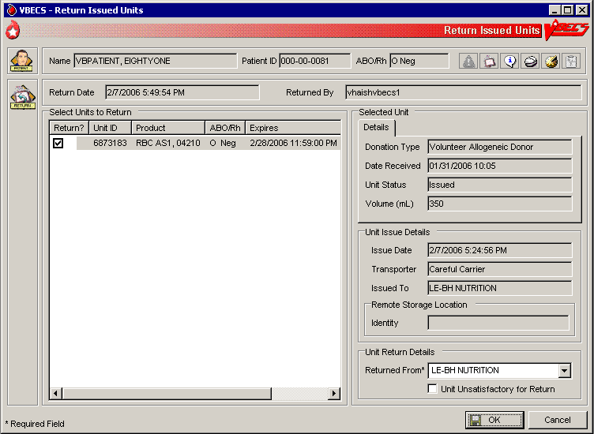

## Release Units From Patient Assignment UC\_47

The user releases crossmatched and assigned blood units not issued after a period determined by regulatory standards and by internal policy.

#### Assumptions

* The blood unit is assigned or crossmatched to at least one patient.

#### Outcome

* Patient restrictions still apply to a unit even after it is released from assignment and made available.

#### Limitations and Restrictions

* This option does not apply to the release of patient restrictions (autologous and directed).
* When a patient, specimen ,or blood unit expires, VBECS does not automatically release an assigned blood unit: a user must release the unit.

#### Additional Information

* A user may release units from assignment as a group or individually from a patient’s list of units.

#### User Roles with Access to This Option

All users

#### Release Units From Patient Assignment

A user may select one or more blood units for release from patient assignment and return to “available” status. A user may release one of multiple patient assignments without affecting other patient assignments on a unit.

| **User Action** | **VBECS** |
| --- | --- |
| 1. To release units by patient, select **Patients** from the main menu.   To release units by unit, select **Blood Units** from the main menu.  Select **Release Units From Patient Assignment**. | * Displays options for processing patient-related functions or for processing units. |
| 1. Scan or enter a unit ID or select a patient to release units from patient assignment and/or crossmatch (XM). | * Allows the user to edit the date and time and the user who released the units. * Lists currently assigned units. * Allows the user to list assigned units by patient, by unit ID, or by unit expiration date.   **NOTES**  BR\_47.03 VBECS indicates which specimens and units are expired.  BR\_47.04 VBECS displays a unit’s donation type only when it is restricted.  BR\_47.01 VBECS displays all currently assigned/crossmatched units located in the blood bank. When the user enters a unit ID that is not currently in the blood bank location, VBECS warns the user, clears the unit ID entry, and allows the user to enter another unit or patient. |
| 1. Indicate which units to release.   Click **OK**.  Indicate a reason for release of units (Figure 101). | * Allows the user to enter a reason for releasing for an individual unit. * Allows the user to review the selections, select additional units, and deselect units before saving.   **NOTES**  BR\_47.06 VBECS allows the user to select no units or one or more units for each patient on the list. |
| 1. Review the entered information and click **OK** to save.   Click **OK** to exit. | * Updates the patient record, the unit record, and the status. * UC\_109 Sends update to the BCE COTS system via an HL7 message to remove the unit from the system.   **NOTES**  BR\_47.07 When a unit has a future expiration date and holds no other assignments, VBECS updates the unit to “available” status. When a unit is assigned to a different patient, it remains assigned to that patient.  VBECS alerts the user when the unit is expired and reminds him to remove additional patient assignments and the unit from the available inventory according to local policies. VBECS instructs the user to release the unit from all assignments and remove it from the available inventory per hospital policy. |

Figure 101: Confirm Release

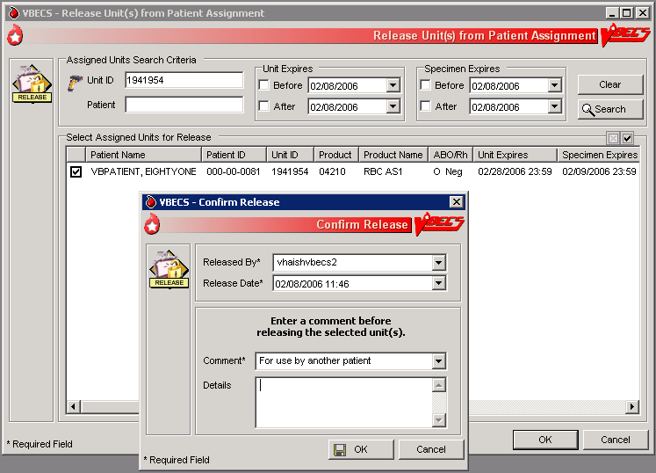

## Print Unit Caution Tag & Transfusion Record Form UC\_43, UC\_44

The user may print a Caution Tag and/or a Blood Transfusion Record Form (BTRF) when crossmatch compatibility, assignment, or emergency issue are completed or as an independent action.

#### Assumptions

* The blood unit, patient order, and user are in the same division.
* There is a current component class or emergency issue order for the patient, and the blood unit printed on the Caution Tag fulfills the patient order requirements.
* When the blood unit belongs to a component class that does not require crossmatch, it has a status of “assigned” (non-emergency issue only).
* For non-emergency issue, the blood unit meets all patient Transfusion Requirements (TRs).

#### Outcome

* The barcode generated on the Caution Tag may be used in bedside verification procedures, in accordance with local policy and procedures.
* A user may reprint a BTRF and Caution Tag.

#### Limitations and Restrictions

* VBECS cannot reprint a Caution Tag on an expired unit or expired patient order.
* VBECS does not print a unit’s biohazardous status on the BTRF or Caution Tag.

#### Additional Information

* BR\_43.10 The informational barcode printed on the Caution Tag includes only the patient and unit IDs and the unit product code.
* A user may print multiple Caution Tags and BTRFs for a blood unit when it is assigned to multiple patients.
* Attach the Caution Tag labels to blood bags in accordance with local policy and procedures.

#### User Roles with Access to This Option

All users

#### Print Backup Caution Tags and Blood Transfusion Record Forms

It is recommended that blank Caution Tags and BTRFs be kept on hand in case the system or printer is not available to generate them.

| **User Action** | **VBECS** |
| --- | --- |
| 1. Select **Tools** from the main menu.   Select **Print Backup Forms**.  Enter or select the number of blank tags or forms to print (Figure 102).  Click **OK** to print and exit. | * Displays options for processing administrative functions. * Prompts the user to enter the number of Caution Tags to be printed. * Prints the blank Caution Tags.   **NOTES**  BR\_43.22 VBECS displays an option to print a Caution Tag or a BTRF when the user selects a unit or a patient.  BR\_43.15, BR\_43.11 The user may print 1 to 99 blank Caution Tags and BTRFs to use in case of downtime.  BR\_43.12 VBECS interrupts or cancels a print job to accommodate the printing of an emergency issue tag. VBECS notifies the user of the number of tags printed and instructs the user to enter a new request to print more tags. |

Figure 102: Print Backup Forms

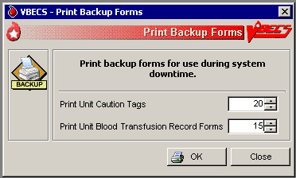

#### Print Unit Caution Tag & Transfusion Record Form

The user may need to generate Caution Tags when they were not printed immediately after unit selection and crossmatch data entry, emergency issue, or when there is a problem with the printed Caution Tag. According to local policy, the user selects a current patient order and one or more units to print from the VBECS-generated list of units eligible for immediate transfusion.

VBECS does not allow a user to print a Caution Tag unless the unit is satisfactory for immediate issue.

| **User Action** | **VBECS** |
| --- | --- |
| 1. Select **Patients** or **Blood Units** from the main menu.   Select **Print Unit Caution Tag & Transfusion Record Form**. | * Displays options for processing patient-related functions or for processing units. * Displays the option to select a patient, if one is not already selected. |
| 1. Enter the patient name or ID and click **Search** to select a patient, or   Click **Search by Unit** (Figure 103).  Enter the unit ID and/or product. | * Requests that the user select a Caution Tag and/or a BTRF to print by unit ID or by patient. * Displays an informational message, when appropriate. |
| 1. Select a patient, or   Select or scan a blood unit. | * Compiles and displays the information associated with the user’s selection. * Displays the patient’s name, ID, date of birth, the unit ID, and the long product name of units to appear on the Caution Tags. * Prompts the user to select the units when selecting by patient. * Allows the user to select and deselect blood units to print. *  See Table 9 for alerts that may occur during this option.   **NOTES**  BR\_43.21 VBECS retrieves the most recent crossmatch result (original or repeat) to determine unit availability and compatibility status to allow printing the Caution Tag and/or BTRF and to allow the unit to be issued.  BR\_43.20 When no valid ABO exists for the patient, the user may select components, including autologous units:   * For RBC order only: Group O, Rh positive or O Rh negative. * For FFP order only: Group AB, Rh positive or Rh negative, or not specified. * For PLT, or Cryo order: All available units are issuable. * For OTHER order: All available units are issuable when the optional crossmatch has not been selected. When the optional crossmatch has been selected, OTHER are handled as RBC. * WHOLE BLOOD IS NOT SELECTABLE.   BR\_43.13 When a user selects a Caution Tag and/or BTRF from the Blood Unit Menu and the units are assigned or have been assigned and/or crossmatched to multiple patients, the selected form may be printed for only one patient during that session. The message will display that the form cannot be printed again for another assigned patient. VBECS must be closed and re-opened to print a tag for one of the other patients. If you need to print tags on the same unit for multiple assigned patients, access the option from the Patient Menu. INC000000997296  BR\_43.01 When VBECS searches for units available for a patient name, it makes available for printing only units considered available for issue (standard processing or emergency issue).  See Appendix B: Table 23: TT\_3.05 Rules for Electronic and Serologic Crossmatchand BR\_5.03. The user may select only active units and those not in an inactive or final status. See Appendix B: Figure 136: TT\_27.01 Unit Status Flowchart. |
| 1. Acknowledge the selected patient and blood units for printing.   Click **Print Unit Caution Tag**, **Print Transfusion Record Form**, or **Print Both**.  Click **OK** to confirm and exit. | * Displays an option to print the Caution Tag and BTRF for units with a patient assignment. * BR\_43.05 Generates a separate Caution Tag and BTRF for each blood unit.   **NOTES**  BR\_43.04 When a Caution Tag or BTRF is printed for an emergency-issued unit, “Emergency Issue” is included on the form.  The recipient ABO/Rh prints as “Unk” or “Unknown” during emergency issue when no current specimen results are on file; VBECS may not use a historic record blood type (from any source) for the typing printed on the tag/form.   | **Compatibility Interpretation** | **Text on BTRF** | | --- | --- | | Crossmatch | TESTING INCOMPLETE | | Crossmatch Not Required | Not Required |   VBECS prints “Emergency Issue” in the TR section of the form.  BR\_43.03 The text that appears in the compatibility section is based on the crossmatch interpretation applied.   | **Compatibility Interpretation** | **Text on BTRF** | | --- | --- | | Crossmatch Compatible | Compatible | | Compatible: Electronically Crossmatched | Compatible | | Crossmatch Not Required | Not Applicable | | Crossmatch Incompatible: Give only with Medical Director Approval | Incompatible: Given with Medical Director Approval | |
| 1. Print and exit. |  |

Figure 103: Print Unit Caution Tag and Transfusion Record Form

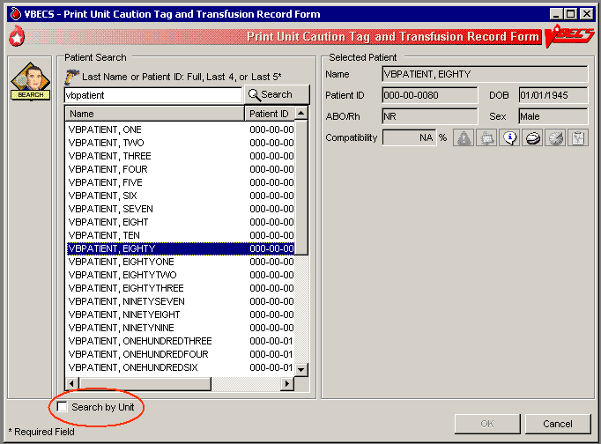

 Alerts

Table 9: Alerts That May Occur in Print Unit Caution Tag & Transfusion Record Form (Step 3)

| **User Action Step 3: When This Condition Exists …** | **…**  **VBECS Emits an Audible Alert and Warns the User:** | **User Role** |
| --- | --- | --- |
| BR\_43.18 VBECS determines whether the patient has a calculated or persistent antigen negative requirement (except when selecting autologous units). The selected unit was antigen typed and is positive for the corresponding antigen or is untested for the antigen. | The patient has a history of a clinically significant antibody, the unit is positive or untested for the corresponding antigen, the user does not have the proper security level. There is no override. | Enhanced Technologist or below |
| The patient has a history of an antibody(s) and the unit ID is positive or untested for the corresponding antigen(s). Continue to print Caution Tag or BTRF? **No** clears the screen. **Yes** requires a comment and captures details for inclusion in an Exception Report (exception type: Caution Tag or BTRF printed for antigen positive or untested unit). | Lead Technologist |
| BR\_43.19 When the patient has TRs, VBECS evaluates the selected unit to see whether a TR was satisfied based on system rulesTT\_3.04, including emergency issue. | The patient has at least one TR that is not satisfied, the user does not have the proper security level to print the Caution Tag or BTRF for this unit. Further processing is needed and must be documented in VBECS. There is no override. | Enhanced Technologist or below |
| The patient has at least one TR that is not satisfied. Continue to print Caution Tag or BTRF? **No** clears the screen. **Yes** requires a comment and captures details for inclusion in an Exception Report (exception type: Caution Tag printed with unsatisfied TR). | Lead Technologist |
| BR\_43.16 The patient specimen is expired. | The patient specimen is expired. There is no override. | Technologist |
| The patient specimen is expired. Continue to print the Caution Tag and/or the BTRF? **No** clears the screen. **Yes** requires a comment and captures details for inclusion in an Exception Report (exception type: Caution Tag printed on expired specimen). | Enhanced Technologist |
| BR\_3.05 The user attempts to print Caution Tags for emergency issue and:   * The current specimen has an “Emergency Issue” order. * The patient has no record of ABO/Rh typing. * The required ABO/Rh specimen testing is incomplete.   The user may select:   * For WB or RBC order only: group O, Rh positive or O Rh negative (WHOLE BLOOD is not available). * For FFP order only: group AB, Rh positive or Rh negative. * For PLT order: all available units are issuable. | The unit does not meet these requirements. Testing is incomplete and this unit is not eligible for emergency issue. The Caution Tag cannot be printed. There is no override. | All users |
| BR\_43.02 VBECS determines whether a blood unit that does require crossmatch (electronic or serologic) is ready for issue based on the following rules:   * Unit is not in a frozen state. * The unit is crossmatched to the patient (eXM, or serologic XM). * TAS Specimen testing is complete and valid (ABO/Rh and ABS results are entered).   One of these crossmatch interpretations was entered:   * Crossmatch Compatible * Compatible: Electronically crossmatched * Crossmatch Incompatible: Give only with Medical Director approval | All of the conditions for the unit are met but an emergency issue order indicator is in place or the testing is incomplete or inconclusive on the current specimen and units were selected. Do you want to print emergency issue tags/forms for the unit/patient? **Yes** prints the emergency issue tags and forms. **No** does not allow the user to continue. | All users |
| BR\_43.07 For blood units that do not require crossmatch when the unit is assigned to the patient and is not in a frozen state, VBECS determines when a blood unit is ready for issue. | All of the conditions for the unit arenot met. The Caution Tag and/or the BTRF cannot be printed at this time and the reason they cannot be printed. Additional patient testing or unit processing must be performed. | All users |

Figure 104: Caution Tag DR 4848

|  |  |  |
| --- | --- | --- |
| Product Code 2D Barcode  Division Name  City, State | | |
|
| Patient Name: | | |
| Patient ID: | | Recipient Blood Type: |
| Unit/Pool ID: | | Donor Blood Type: |
|
| Compatibility Interpretation: | | |
| **CAUTION:** **Before transfusing this blood component, perform bedside verification of the patient’s identity** by matching the patient identification on this tag with the patient wristband and the Blood Transfusion Record Form. | | |
|
|
| Assigned Date/Time: | Assigning Tech/ Crossmatch Tech: | |

Figure 105: Blood Transfusion Record Form

|  |  |  |  |  |  |  |  |
| --- | --- | --- | --- | --- | --- | --- | --- |
| **Blood Transfusion Record Form (revision no.)** | | | | | | | |
| VA Logo  Division Name, City, State | | | | | **Transfusion Requirements** | | |
| <Insert applicable Transfusion Requirements and antigen negative requirements.> | | |
| Patient Name: | | | | |
| Patient ID: | | | | Patient Blood Type: | **Blood Component Information** | | |
| Blood Component:  Component Expiration Date/Time:  Number of Units/Pool: | | |
| Unit/Pool ID: | | | | Unit Blood Type: |
| Compatibility Interpretation: | | | | | **Additional Patient Information** | | |
| Specimen UID:  Location: | | |
| Assigned Date/Time: | | Technologist Initials: | | |
| **Remarks** | | | | | | | |
| This section should contain useful information. Examples:  **Unexpected antibodies. Additional units MAY NOT be available in an emergency!**  **Premedicate patient, per MD orders.**  **Blood warmer required.**  **Patient requires leukocyte-reduced products. Do you have the correct filter?**  **Crossmatch by Transfusion Centers of America.** | | | | | | | |
| **Pretransfusion Data** | | | | | | | |
| Inspected and issued by: | | | | | | | |
| Issued to: | | | | | Issue-to location: | | |
| I have verified and compared, AT THE BEDSIDE, the transfusion recipient’s identity (i.e., wristband), the unit ID tag, the blood component container label, and this form. I verify that all information matches and is consistent ITEM for ITEM. I verify that the intended recipient is the same person named on this form and on the unit ID tag. Furthermore, I verify that there is a current, valid informed consent, and a physician’s order for this transfusion. | | | | | | | |
| Verified informed consent for transfusion. | | | First identifier (signature): | | | Second identifier (signature): | |
| **Transfusion Data** | | | | | | | |
|  | Date/Time | | Temperature | | Pulse | Blood Pressure | Respiration |
| Start |  | |  | |  |  |  |
| 15 minutes |  | |  | |  |  |  |
| Mid (optional) |  | |  | |  |  |  |
| Stop |  | |  | |  |  |  |
| Amount given (mL):  Completed  Interrupted  No reaction  Reaction suspected (Complete Transfusion Reaction Data section.) | | | | | | | |
| Other difficulties (equipment, clots, etc.):  No  Yes (Specify.) | | | | | Transfusion Data section completed by (signature): | | |

|  |
| --- |
| **Transfusion Reaction Data** |
| Patient identity match with unit compatibility tag and this form reverified by (initials): |
| Description of reaction:  Urticaria  Chill  Pain  Fever  Dyspnea  Other (Specify.) |
| Transfusion Reaction Data section completed by (signature): |
| **Suspected Transfusion Reaction: Immediate Response** |
| If a reaction is suspected, **IMMEDIATELY:**   1. Interrupt the transfusion. Give emergency treatment. Keep the intravenous line open. 2. Reverify patient and blood product identification. 3. Notify Physician and Transfusion Service. 4. Follow transfusion reaction procedures. 5. Do **NOT** discard the component. Return the blood component bag, filter set, and attached solutions to Transfusion Service. Collect patient specimens, as required. 6. Order a Transfusion Reaction Workup. |

Blood Transfusion Record

Patient name: Patient ID: Date of birth: Form, Version 1.0

## Invalidate Test Results UC\_94

The user invalidates incorrectly entered patient test results and reenters correct patient test results and interpretations.

#### Assumptions

* A completed patient order exists in VBECS.

#### Outcome

* Test results are invalidated.
* VBECS may assign “correction” status to a task to allow the user to repeat a test and add it to the Pending Task List (PTL).

#### Limitations and Restrictions

* A user may not inactivate a component task in this option.
* This option does not release units from patient assignment. The user must release “assigned” units before invalidating the test results.
* To maintain a clear record and system checks, the user must invalidate both original and repeat ABO/Rh tests.
* Do not invalidate part of the configured test. Doing this will put the specimen into a state where it cannot be processed. Invalidate all tests configured as part of the TAS regardless of which sub test (ABO/Rh, ABS or DAT) is the problem. DR 4685 DR 4854

#### Additional Information

* VBECS invalidates the entire test group during this option. The user must reenter results to replace the invalidated results.
* Workload and billing are inactivated or rescinded from the inactivated testing.
* BR\_94.09 VBECS invalidates transfusion reaction workups (TRWs) in total and crossmatches (XMs) by unit.
* BR\_94.10 Invalidation of an antibody identification (ABID) task invalidates all antibody specificities entered in that task..
* VBECS displays results and interpretations of the tests but not any QC performed with the tests.
* BR\_94.04 VBECS displays “Test Result Invalidated” to indicate invalidated test results.

#### User Roles with Access to This Option

 Enhanced Technologist

#### Invalidate Test Results

The user may invalidate one or more previously entered test results and replace them with corrected results.

| **User Action** | **VBECS** |
| --- | --- |
| 1. Select **Patients** from the main menu.   Select **Invalidate Test Results**. | * Displays options for processing patient-related functions.   **NOTES**  Click the **Component Orders** tab to view its PTL. |
| 1. Enter the patient name and/or specimen UID.   Edit the “expires after” date, if required.  Click **Search**, if needed. | * BR\_94.01 Displays an option to enter a specimen UID or a patient for a specific date or for a range of dates. * BR\_94.02 Displays the complete diagnostic tests associated with the entry. |
| 1. Select a test result from the Specimen Test Results list. | * Displays the original results for the user to review. BR\_94.06   **NOTES**  BR\_94.10 When the user chooses to invalidate an ABID, VBECS warns that the invalidation of the antibody specificity also invalidates the corresponding calculated antigen negative requirements. No user action is required.  BR\_94.12  When the user is a Traditional Supervisor and the selected specimen is the most recent specimen tested for the selected patient, the user may invalidate a previously justified ABO/Rh test result. When the specimen ABO/Rh test associated with a justification is invalidated, VBECS removes the justification information from the patient record.  BR\_94.03 When the user attempts to invalidate a non-XM test for a patient specimen and blood units are currently associated with the specimen (assigned, electronically or serologically crossmatched, issued or transfused), VBECS warns that blood components are associated to this specimen and that the associated units must be removed before testing can be invalidated. The user may not continue to invalidate the test.  When the user attempts to invalidate a XM test for a patient specimen and the associated blood units are currently issued or transfused, VBECS warns the user that the selected test cannot be invalidated because the unit was issued based on the XM result. The user may not continue to invalidate the XM test. |
| 1. Verify the accuracy of the selected patient specimen and patient information (Figure 106).   Click **OK** to accept the results. | * Marks these test results as “invalid” and asks the user whether he needs to replace the invalidated results with new test results. * **Yes** (test result replacement is needed) changes the task status to “correction” to return the task to the PTL for completion. * **No** (test replacement is not needed) marks the erroneous test results as “Test Result Invalidated”; the task status does not change. * When the user selects all the diagnostic tests associated with a specimen, displays an option to mark the specimen unacceptable and invalidate the tests. |
| 1. Select the test to invalidate from the Patient Test Results list.   Click **Invalidate Results** (Figure 107).  Enter a comment.  Click the **Add test to the Pending Task List to allow for replacement results** check box, if appropriate.  Click **OK**. | * Asks the user whether he wishes to change the specimen status to “unacceptable.”   **NOTES**  To maintain a clear record and system checks, invalidate both original and repeat ABO/Rh tests.  BR\_94.05 When the user invalidated all of the diagnostic tests associated with a given specimen, VBECS asks whether the user wishes to change the specimen to “unacceptable.” **No** allows the user to invalidate the test results without making the specimen unacceptable. **Yes** changes the specimen to “unacceptable” and requires a comment. |
| 1. Click **OK** to exit. |  |

Figure 106: Invalidate Patient Test Results

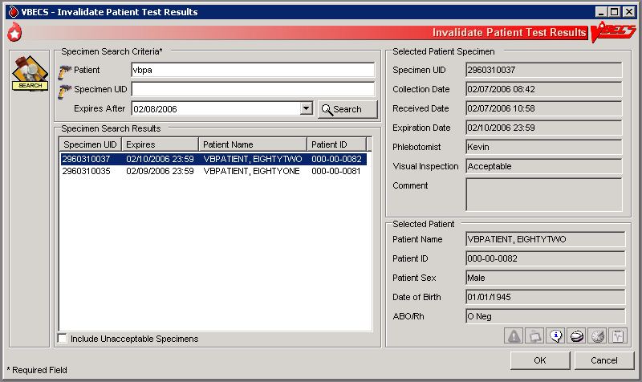

Figure 107: Confirm Invalidation

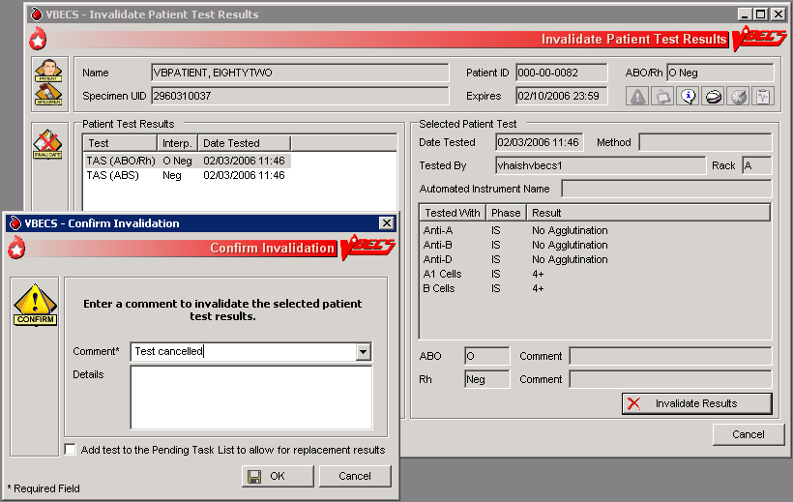

## Remove Final Status UC\_13

The user removes a final status from a unit. All other statuses are manipulated through normal system rules and practices.

#### Assumptions

* The user is logged into the division containing the unit record.
* The unit is in a final (transfused, transferred, modified, discarded) status.
* The user must invalidate the modification status of the split or pooled units, and then the original unit or pool.

#### Outcome

* The new information was saved with the unit’s historic record.
* The unit is in the status immediately prior to the final status.

#### Limitations and Restrictions

* This option applies only to the release of units in final statuses.

#### Additional Information

* This option allows a user to restore a unit to inventory from a final status. It may be used to begin undoing a transfusion episode (step by step in reverse order) or correct a unit modification record.
* “Issued” is not a final unit status.
* This option is not used to add units to or remove them from a pool.

#### User Roles with Access to This Option

 Traditional Supervisor

#### Remove Final Status

The user corrects a clerical error: a unit was processed and moved to a final status in the computer incorrectly.

Removing final status of a unit reported as transfused by the Transfusion Verification application will create a discrepancy between the systems. Changes or updates to a transfusion record must be made in the Transfusion Verification application first. DR 4134

| **User Action** | **VBECS** |
| --- | --- |
| 1. Select **Supervisor** from the main menu.   Select **Remove Final Status**. | * Displays options available to supervisors. * Displays fields for selecting a unit and removing its final status. |
| 1. Scan or enter a unit ID or product code, or click the **find** button to select a unit from the drop-down list. | * Displays unit data, including the previous and current unit statuses. * BR\_13.01 Warns the user to proceed with caution.   **NOTES**  BR\_13.04 VBECS warns the user when the unit does not have a final status or was not modified (other than pool, thaw/pool, and split). The user may select another unit.  BR\_13.05 When the final status is “modified” (pooled, thaw/pooled, or split), VBECS verifies that the target unit is invalidated. When the target unit was not invalidated, the user may not continue. |
| 1. Verify that the unit selected is the desired unit.   Click **OK**.  Enter a comment (Figure 108). | * Asks the user if he would like to remove the final status. * BR\_13.02 Requires the user to enter an explanatory comment.   **NOTES**  BR\_13.03 VBECS updates the unit status to the previous status and maintains restrictions on the original unit. |
| 1. Review the data, click **OK** to save, and click **OK** again to confirm the save. | * Displays the unit data and asks the user to verify the return to the previous status. * Allows the user to review his entries and choices and save the correction to the unit record or exit without saving. * Updates the unit record.   **NOTES**  BR\_13.06 When VBECS removes a final status of “discard” or “transfer,” it also removes return credits previously assigned to the unit. |

Figure 108: Remove Final Unit Status

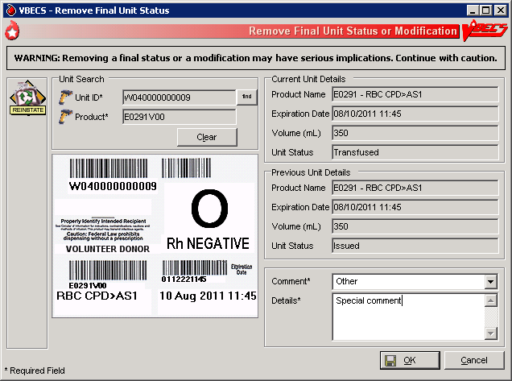

# This page intentionally left blank.

# Processing Orders

## Accept Orders: Accept an Order UC\_16

The user accepts the receipt of an order.

#### Assumptions

* Orders were placed in CPRS for a patient and a VBECS order number was generated.
* When a specimen is required, the user located it.
* Inappropriate Transfusion Request parameters are defined for orderable component classes.
* The connection to VistA is active.

#### Outcome

* Ordered tests may be processed and are available to various worklists.

#### Limitations and Restrictions

* An order for TAS must be accepted before the component order if the user wants to include the component request to the Inappropriate Transfusion Request Report. Accepting the TAS after the component order is marked inappropriate and accepted clears the user’s indication that this is an inappropriate request. Remedy 826766 DR 4854
* When no CPRS order exists, the user processes the specimen offline.
* DR 2,811The user must accept the Type & Screen (TAS) before he accepts other diagnostic tests or component orders.
* The user cannot click small_patientselectedunits (Restricted or Assigned Units) to access information on autologous or directed units that may be restricted to a patient.
* Orders placed for patients with names that exceed the database standard for File #2 (30 characters) or do not have a first or last name in VistA are rejected and do not appear in VBECS. The VBECS System Administrator is notified of each rejection via an email to the address entered in VBECS Administrator “Interface Failure Alert Recipient” field.
* A VBECS order on a Collection List has to be received with a date and time in VistA to make the specimen available in VBECS.

#### Additional Information

* VBECS automatically cancels previously accepted orders the day after they expire. DR 4519
* To maintain a specimen with a TAS and diagnostic test orders, the TAS must be processed first, before any diagnostic test order (see Maintain Specimen). DR 4519
* The user may investigate patient clinical information using VistA and CPRS.
* A facility may capture the phlebotomist's signature and the date and time of specimen collection on a printed order from CPRS. [Local IRM personnel may configure CPRS to print the blood bank order: refer to *Setup Guide* (August 2000) in VistA Document Library, Computerized Patient Record System (CPRS)].

#### User Roles with Access to This Option

All users

#### Accept Orders: Accept an Order

The user reviews the list of pending orders and the specimen, determines that local policy requirements are satisfied, and accepts all or part of a routine order. The user accepts the VBECS order and associates the Laboratory generated specimen UID number with the order.

The user uses the Pending Order List (POL) to view additional details, print outstanding orders, and to select, accept, and add orders to the Pending Task List (PTL).

Changes made in the VBECS Administrator option mapping orders to another VBECS division do not affect delivered orders. Orders delivered to a VBECS division must be completed, rejected, or canceled in that division. Resubmit orders after mapping is completed to send an order to another VBECS division.DR 2,896

| **User Action** | **VBECS** |
| --- | --- |
| 1. Select **Orders** from the main menu.   Select **Accept Orders**. | * Displays options for processing orders. * Displays the POL and POL search criteria. |
| 1. Select an order to accept from the POL (Figure 109), or   In the Pending Order List Search Criteria area, enter the known data, including the date wanted.  Click **Search** to find an order. | * Displays options for selecting, reviewing, and processing patient data and pending orders. * Allows the user to associate a specimen with an order. * Displays the Patient Information Toolbar that allows the user to review.   **NOTES**  Select an order for TAS before selecting a corresponding order for diagnostic tests or components.  BR\_16.01 VBECS emits an audible alert when there are patient Special Instructions or Transfusion Requirements.  BR\_16.02, BR\_88.06 VBECS alerts the user when the component class ordered requires a specimen. The status may be REQ (specimen required) or NRQ (no specimen required). The user may not continue until specimen information is added.  BR\_16.21  When modifiers are included in the physician's component order, VBECS provides visual and audible alerts to remind the user to evaluate the request. VBECS does not monitor subsequent action.  BR\_16.03 VBECS alerts the user when units (autologous, directed, or assigned/crossmatched) with a future expiration date are associated with the patient in any division in the database. (See PT\_1.05 ISBT 128 Donation Types.) |
| 1. Scan or enter the specimen UID in the Specimen UID field. (See Maintain Specimen.) (Figure 110)   BR\_16.23 When the component requires a current specimen and a valid sample is not available, click the **Emergency Order** check box.  Click **Accept** to accept the order without an associated specimen. | * Allows the user to enter new specimen information or correct problems with an existing specimen with the current VBECS order. * Allows the user to process an order without an associated specimen for emergency issue and retroactively associate a specimen with the order.   **NOTES**  Alphabetical characters in specimen UIDs must be capitalized: VBECS recognizes only uppercase letters.  BR\_35.04 Specimens collected for diagnostic tests only are to be used for performing the specifically ordered tests and are not available for processing blood component orders.  BR\_16.19 For all orders requiring a specimen, VBECS queries VistALink to verify that the lab order numbers are consistent with the specimen. If they are not consistent, VBECS notifies the user that the specimen’s lab number does not match the number associated with the order. VBECS does not accept the order until the user identifies a specimen with a matching lab order number.  BR\_16.20 When the order status is “In Blood Bank,” a specimen was associated with the order; when the status is “Specimen Required,” the user must identify a specimen by its UID and enter specimen details according to Maintain Specimen.  BR\_16.06 When an order for a component class requires a specimen (WHOLE BLOOD and RED BLOOD CELLS component classes, and, optionally, based on Setting Component Classes) the user must select this function and replace the existing specimen with a new one. However, when VBECS displays the “emergency issue” order indicator, the user may continue without identifying an associated specimen. VBECS captures details for inclusion in an Exception Report [exception type: Emergency order accepted (no specimen)].  BR\_35.19 Within an order group containing orders for blood components and the Type & Screen (TAS) test, the specimen associated with the TAS test applies to the TAS test and to all blood component orders contained in the order group. |
| 1. Click small_view_order to review order details. | * Displays order details that may not be edited. |
| 1. When the urgency is “Pre-Op,” click small_msbos in the Patient Information Toolbar to review the MSBOS information for the division.   View and/or search entries in the MSBOS for possible matches with the patient surgery. | * Allows the user to review current MSBOS settings. * Lists the current MSBOS site parameters, based on generic surgery types.   **NOTES**  BR\_16.11 When the pre-op indicator is “Yes,” the user may access the MSBOS to determine whether to include details of the order in the Inappropriate Request Report. |
| 1. Based on the review of the MSBOS parameter associated with the surgery type and the details of the current order, click the **Include In Inappropriate Transfusion Request Report** check box, according to local policy. | * Adds the details of the order to the Inappropriate Transfusion Request Report when the user completes Accept Orders: Accept an Order.   **NOTES**  To display a list of available autologous and/or directed units in the system for the selected patient, see Blood Availability.  A user must accept the corresponding TAS order before including a component order in Inappropriate Transfusion Request Report. Remedy 826766 |
| 1. Click small_si_tr in the Patient Information Toolbar to review patient data, Transfusion Requirements and Special Instructions. | * Displays read-only TR and SI patient VBECS data. |
| 1. Click **Accept** or **Reject** for each order. | * For each order accepted, updates the: * Status to “accepted” and adds it to the PTL for further processing. * Existing lab accession number to collect data associated with every order.   **NOTES**  When a user rejects an order, VBECS acknowledges the order and cancels it through Accept Orders: Cancel a Pending Order.  BR\_16.16 When no specimen is required, VBECS assigns an order expiration date to three days in the future at 23:59 (the date of acceptance of the component order acceptance is day “0”).  When a specimen is required, the order expiration date is the same as the associated specimen. VBECS automatically expires the associated component order when the specimen is expired. (See Appendix B: Figure 135: TT\_92.01 Order Status Flowchart.)  BR\_16.14 The user evaluates each diagnostic test and component order separately.  BR\_16.04 When the pre-op indicator is “No,” VBECS compares the Laboratory test values included in the order message from CPRS to the threshold values defined for the ordered component class requirements in Configure ICCBBA Component Classes Inappropriate Request Parameters setting (see Component Classes). When the threshold values were exceeded for one or more ordered component classes, VBECS notifies the user that the Laboratory test value exceeds site parameters for the component class orders and asks whether to add the order to the Inappropriate Transfusion Request report. **Yes** adds the details of the order to the Inappropriate Request Report. **No** requires a comment to be associated with the order.  The user may cancel one or more components of an order through Accept Orders: Cancel a Pending Order to cancel while working in Accept Orders: Accept an Order. When this occurs, VBECS sends a message to CPRS and notifies the VistA Laboratory application that the order was canceled. |
| 1. Repeat Steps 2 through 8 to accept another order, or click **Close** to exit. |  |

Figure 109: Accept Orders

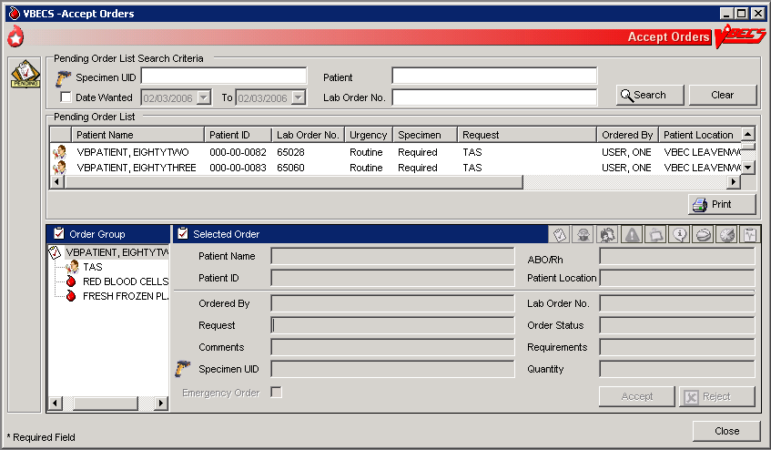

Figure 110: Maintain Specimen

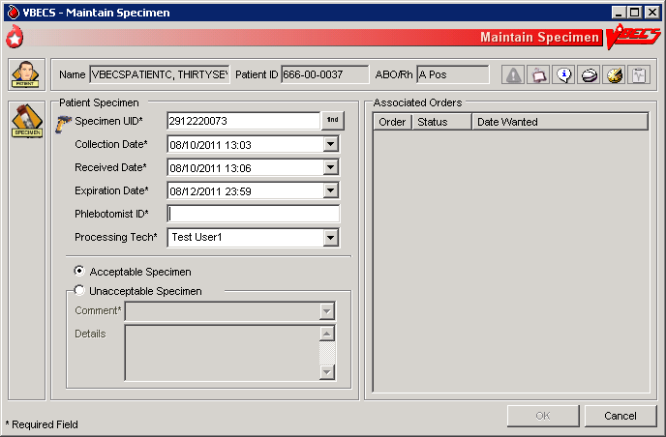

### Accept Orders: Pending Order List UC\_88

The Pending Order List (POL) lists pending blood bank orders.

#### Assumptions

* A CPRS order is acknowledged by VBECS.
* An order is printed or an alert is issued per site parameters.
* The connection to VistA is active.

#### Outcome

* A list of pending orders displays and may be sorted and searched.
* A list of pending orders may be printed in the default sort presentation.

#### Limitations and Restrictions

* Orders placed for patients with names that exceed the database standard for File #2 (30 characters) or do not have a first or last name in VistA are rejected and do not appear in VBECS. The VBECS System Administrator is notified of each rejection via an email to the address entered in VBECS Administrator “Interface Failure Alert Recipient” field.

#### Additional Information

* This option is used for diagnostic and blood component test orders.

#### User Roles with Access to This Option

All users

#### Accept Orders: Pending Order List

VBECS displays the POL with search criteria, which allows the user to limit the number of viewable items. The user may review details of an order without taking action on it.

| **User Action** | **VBECS** |
| --- | --- |
| 1. Select **Orders** from the main menu.   Select **Accept Orders**, or  Click the **Pending Orders alert icon**, if available, in the status bar at the bottom of the screen (Figure 109). | * Displays options for processing orders. * Displays the Pending Order List and Pending Order List search criteria. * Allows the user to search for specific orders. * Provides the criteria to limit the search and subsequent presentation and processing. * Allows acceptance of an order.   **NOTES**  BR\_88.10 VBECS displays orders directed to the division by a user during system configuration.DR 2,889  See Appendix B: Figure 135: TT\_92.01 Order Status Flowchart.  BR\_88.04 When searching for pending orders based on patient name, the system displays all pending and current accepted orders for the patient. A current order is a previously accepted order with a future order/specimen expiration date. |
| 1. Change the selection criteria, as needed, to prepare the list or to accept the default presentation. | * Displays the POL requested by user’s selection(s).   **NOTES**  BR\_88.09 The POL can be sorted by Patient, Procedure, Urgency, Date/time received or date/time wanted.  BR\_88.07 The user may select an entry on the POL to view additional details for the order, including:   * Patient Name * Patient ID * Additional component class or diagnostic tests included in the same order group as the selected order. (These are displayed whether they are “in progress” or still on the POL. There should be some indication to distinguish those that are already in progress.) * Order comments (additional requirements from CPRS) * Quantity (component class orders only) * Patient hospital location * Lab order # * Patient ABO/Rh (if known) * The CPRS Order ID, Group Order ID for all diagnostic tests and component orders placed in one CPRS order is the CPRS Order ID used by VBECS on the Order History Report and the Pending Task Lists. DR 4938 |
| 1. To continue processing the POL, review the displayed list, print the list, or go to Accept Orders: Accept an Order. | * Allows the user to return to Step 1 to change the presentation of the list, review details of pending orders, print the list, or select an order or proceed to Accept Orders: Accept an Order.   **NOTES**  BR\_92.07 When a user requests a POL report and VBECS does not find any information, VBECS notifies the user and asks whether he wishes to continue to print. The user may cancel or print the report, which will include “No pending orders found.” |
| 1. Exit. |  |

small_order_alert Display Order Alerts **UC\_84**

VBECS notifies the user of new and updated patient orders.

#### Assumptions

* VBECS receives a new order or an order update message from VistA for the user’s division.

#### Outcome

* VBECS displays notification icons only to users logged into VBECS.

#### Limitations and Restrictions

* VBECS issues no notifications for order cancellations.

#### Additional Information

* BR\_84.12 The user may set VBECS to automatically print an order alert with limited information on the designated printer when VBECS acknowledges the order.
* The alert displays the individual test’s (child) CPRS ID. The individual test’s (child) CPRS ID is not displayed on the Pending Order List, elsewhere in VBECS or on reports and is not usable in search functions. DR 4938

#### User Roles with Access to This Option

All users

#### Display Order Alerts

VBECS notifies the user that order updates occurred and allows him to accept the new orders.

| **User Action** | **VBECS** |
| --- | --- |
| 1. Hold the mouse over the icon to view a tool tip, or   Click small_order_alert to view a panel showing new or updated orders and hide the icon.  Click small_order_alert again to hide the panel. | * Acknowledges a new or updated patient order. * Displays an order notification icon in the status bar when new orders are received, according to local settings. * Displays information regarding new orders and order updates and allows the user to accept them.   **NOTES**  BR\_84.01, BR\_84.02 When the division is configured to alert the user of orders received by VBECS, VBECS notifies the user of ordered components or ordered tests that were:   * Directed to the user’s division. * Added or updated in VistA.   When the division is configured to alert the user of orders needed in the next specified number of hours, VBECS also notifies the user of ordered components or ordered tests with a required time less than a specified number of hours in the future. |

### patientalert Display Patient Update Alerts UC\_84

VBECS notifies the user of patient update, death, and merge events.

#### Assumptions

* A patient demographic update is received from VistA for the user’s division for a VBECS patient with an active order.

#### Outcome

* The patient demographics are updated in VBECS.

#### Limitations and Restrictions

* VBECS does not notify users of additional VistA patient updates or merges while the icon is displayed. DR 2,525 When a user views an update and there is an unprocessed VistA patient merge, the Patient Alert icon remains on the screen until the Traditional Supervisor updates the patient records and clears the icon.
* Patient updates involving patient’s with names that exceed the database standard for File #2 (30 characters) or do not have a first or last name in VistA are rejected and do not appear in VBECS. The VBECS System Administrator is notified of each rejection via an email to the address entered in VBECS Administrator “Interface Failure Alert Recipient” field.
* Patient update alerts only display when active component or diagnostic test orders are pending or active[[4]](#footnote-4) at the time the update occurs. DR 4323 BR\_68.02

#### Additional Information

* None

#### User Roles with Access to This Option

All users

#### Display Patient Update Alerts

VBECS notifies the user that patient updates occurred and allows him to view additional details.

| **User Action** | **VBECS** |
| --- | --- |
| 1. Hold the mouse over the Patient Alert icon to view a tool tip, or   BR\_84.08 Click patientalert to view a menu and select **Updated Patients**, **Deceased Patients**, or **Patient Merge** to view the updates.  Click patientalert again to hide the menu. | * BR\_84.06 Displays a Patient Alert icon in the status bar when it receives a patient update or death event messageand the patient has active or pending orders in the user’s VBECS division. * Displays a Patient Alert icon in the status bar when it receives a merge event message from VistA.   **NOTES**  The user may also select **Patients** from the main menu, **Patient Updates**, and **Updated Patients**, **Deceased Patients**, or **Patient Merge** to view the updates. |

### patientalert Display Patient Merge Alerts UC\_84

VBECS notifies the user of VistA patient merges.

#### Assumptions

* A patient demographic merge alert is received from VistA for the user’s division for a VBECS patient.

#### Outcome

* VBECS notified the user that patient records were merged in VistA and that the user must take action to match the records in VBECS.

#### Limitations and Restrictions

* VBECS does not notify users of additional VistA patient updates or merges while the icon is displayed. DR 2,525 When a user views an update and there is an unprocessed VistA patient merge, the Patient Alert icon remains on the screen until the Traditional Supervisor updates the patient records and clears the icon.

#### Additional Information

* DR 2,527 VBECS notifies users of VistA patient merges until a Traditional Supervisor clears the Patient Alert icon. See Patient Merge for instructions.
* BR\_84.07 VBECS displays an alert to users for a VistA patient merge event if either the merge-from or merge-to patient exists in the VBECS system when the merge message is received.

#### User Roles with Access to This Option

All users

#### Display Patient Merge Alerts

VBECS notifies the user that patient merges occurred in VistA and allows him to view additional update details.

| **User Action** | **VBECS** |
| --- | --- |
| 1. Hold the mouse over the Patient Alert icon to view a tool tip, or   BR\_84.08 Click patientalert to view a menu and select **Updated Patients**, **Deceased Patients**, or **Patient Merge** to view the updates.  Click patientalert again to hide the menu. | * BR\_84.06 When it receives a patient update or death event message and the patient has active or pending orders in the user’s VBECS division, displays a Patient Alert icon in the status bar. * When it receives a merge event message from VistA, displays a Patient Alert icon in the status bar.   **NOTES**  The user may also select **Patients** from the main menu, **Patient Updates**, and **Patient Merge** to view the updates.  BR\_84.10 VBECS displays a patient update or merge icon alert to all users until all merge events are cleared and all updates, including death notices are viewed.DR 2,525 |

## Maintain Specimen UC\_35

A specimen for testing is received in the blood bank and is processed as part of initial order acceptance, as described in Accept Orders: Accept an Order.

#### Assumptions

* Pending CPRS orders and active orders require an acceptable specimen.
* A specimen was collected and previously accessioned in the VistALaboratory system, which generated the specimen’s universal ID (UID).

#### Outcome

* The user accepted or rejected a specimen.

#### Limitations and Restrictions

* When a search by UID causes VBECS to time out, repeat the search by UID and patient name or by patient name only. (UserDoc Tasks 1089 and 1090)
* Specimen recollection requests must be made offline.
* Designating a specimen as “unacceptable” after accepting a CPRS order closes that order and requires a new CPRS order and sample.

#### Additional Information

* A specimen may be marked unsuitable for use after its acceptance.
* A specimen expiration date may be edited after acceptance.
* A specimen may be recollected without canceling or reordering the VistA order. This practice is dictated by local policy and procedures.
* Specimens marked as originally associated with diagnostic tests only or unacceptable are not considered available specimens when CPRS is queried for specimen availability.

#### User Roles with Access to This Option

All users

#### Maintain Specimen

A specimen for testing is received in the blood bank and is processed as part of initial order acceptance, as described in Accept Orders: Accept an Order.

Information about a previously accepted specimen may be updated. The user may verify whether an active specimen is currently in the blood bank or update the information concerning a previously accepted specimen. After the user checks the physician’s order against the specimen requirement, the user verifies the specimen’s condition, labeling, and accompanying paperwork, according to local policy. The user verifies the specimen information and acceptability and prepares the specimen for testing.

The user may edit specimen information, such as extending the expiration time according to local policy, and marking a specimen as unsatisfactory or expired so that future orders require that a new specimen be collected.

When a specimen is required, the user must find that specimen before acknowledging that order, as described in Accept Orders: Accept an Order.

| **User Action** | **VBECS** |
| --- | --- |
| 1. Select **Orders** from the main menu.   Select **Maintain Specimen**. | * Displays options for processing orders. * Displays fields for entering patient specimen information. |
| 1. Scan or enter the specimen’s UID. | * Displays a field to enter the specimen UID and allows the user to search for existing specimens. * Displays previously entered information for the specimen and accommodates data entry of new specimen information.   **NOTES**  The user may:   * Create and/or maintain a specimen associated with an order from Accept Orders: Accept an Order. * Update specimen information from a previously received specimen.   BR\_35.04 Specimens associated with blood bank diagnostic tests are not available in Maintain Specimen. Specimens collected for diagnostic tests only are to be used for performing the specifically ordered tests and are not available for processing blood component orders.  The orders and associated specimens are maintained for three days before the order or specimen expires: Type & Screen (TAS), component orders (RBC, FFP, CRYO, PLT, WB, OTHER).  The list of orderable and reflex tests below may be added to a specimen maintained for a component order, but may not have a component order added to them: they do not have maintained specimens.  These tests have a specimen drawn and used for their ordered test. The specimens are not maintained for component preparation:   * DAT * ABS * ABO/Rh * Transfusion Reaction Workup (TRW)   BR\_35.22 VBECS allows the user to search all existing patient specimens associated with a specific patient. The user may enter the patient name or a specimen UID to access the list. |
| 1. Enter new specimen information or edit previously entered information (Figure 110). | * Displays uneditable patient demographic information. * Displays an option to edit.   **NOTES**  BR\_35.01 When the user extends the specimen expiration date and time, VBECS calculates the number of days by which the specimen was extended (based on the originally calculated expiration date) and the newly entered expiration date. VBECS compares the difference to the site parameter for the maximum number of extension days allowed for a specimen. When the entered expiration date exceeds the parameter, VBECS warns the user. There is no override.  BR\_35.02 The default expiration date is calculated as three days in the future with the day of the original specimen collection as “0.” For example, a specimen collected on September 16, 2007 (regardless of the time), is day “0” and the calculated expiration date and time are September 19, 2007 @ 23:59 (midnight).  BR\_35.20 When a new or existing specimen is being associated with a pending component order during Accept Orders: Accept an Order, the specimen must be acceptable.  BR\_16.14 When there is a specimen requirement for orders, each order must be evaluated for a valid specimen before it can be accepted.  BR\_35.21 VBECS displays specimen UIDs for selection by CPRS-associated maintainable specimen and then by acceptable and unexpired maintainable specimens, in reverse chronological order.  VBECS allows the user to include expired and unacceptable specimens.  BR\_35.05 When the user attempts to save an expiration date past the default of three days, VBECS checks the patient’s record for evidence of transfusion within the previous three months and the history of antibody identification, regardless of the division. If either is found, VBECS emits an audible alert, warns that the patient has evidence of transfusion within previous three months and/or antibody formation, and instructs the user to enter a comment to extend the specimen expiration date beyond three days. The user must enter a canned comment (with the specimen extension) and/or free-text comment to continue. VBECS captures details for inclusion in an Exception Report (exception type: expiration date extended).  BR\_35.07 When the specimen is deemed unacceptable, the status of the orders associated with the specimen remains “pending” or “active.”  BR\_35.10 When a user attempts to reactivate a previously expired or unacceptable specimen, VBECS emits an audible alert, warns that this is a previously expired or unacceptable specimen, and instructs the user to enter a comment to make it available. A comment is required to continue. VBECS captures details for inclusion in an Exception Report (exception type: unacceptable/expired specimen used).  BR\_35.12 VBECS requires the date and time a specimen was collected and the phlebotomist ID.  BR\_35.14 When a specimen is processed, VBECS displays the details of associated orders (read only).  BR\_35.17 The user must enter a comment when marking a specimen as unacceptable. |
| 1. Enter or verify specimen-related information from Step 3. | * Allows the user to review and edit previously entered information. |
| 1. Review the entered information and click **OK** to save. | * Saves the data for use in further specimen order processing and subsequent retrieval.   **NOTES**  BR\_35.23 When saving or updating an expired specimen, VBECS warns the user and asks whether he wishes to continue. The user may continue without entering a comment.  BR\_35.11, BR\_35.15 The UID initially used to identify the specimen becomes the VBECS specimen number, which VBECS retains and uses to process subsequent orders during the life of the specimen, including CPRS, VBECS, and Laboratory orders, and UIDs associated with the specimen. A historical record lists changes made to the specimen and is available for review.  BR\_35.06 A permanent link remains between an exhausted or unacceptable specimen UID and its order, which allows the user to document the recollection of a new specimen, according to local policy. |
| 1. Click **OK** to exit. |  |

## Patient Testing: Cancel an Active Order UC\_72

The user cancels an accepted order on the Pending Task List (PTL) and adds a comment to justify the cancellation.

#### Assumptions

* The order and the user are in the same division.
* A user accepted an order that originated in CPRS through Accept Orders: Accept an Order, or created a reflex test order through Order Reflex Tests.
* The connection to VistA is active.

#### Outcome

* The order was removed from the PTL.
* An order update message was sent to CPRS.

#### Limitations and Restrictions

* Cancellation of one order does not affect other orders placed with it.
* Before a user may cancel a partially completed task, he must invalidate the results for that task, thereby changing its status to “not started.”

#### Additional Information

* None

#### User Roles with Access to This Option

All users

#### Patient Testing: Cancel an Active Order

The user selects one or more tasks to cancel from the PTL, cancels the accepted order from within VBECS, and adds a comment regarding the cancellation.

| **User Action** | **VBECS** |
| --- | --- |
| 1. Select **Patients** from the main menu.   Select **Patient Testing**. | * Displays options for processing patient-related functions. * Displays the Pending Task List in the Diagnostic Tests tab.   **NOTES**  Click the **Component Orders** tab to view its PTL. |
| 1. BR\_72.01 Click one to four check boxes in the PTL in the Diagnostic Tests tab or the Component Orders tab to select tasks (Figure 111).   Click **OK** to continue, or click **Cancel Order(s)** to cancel the selected tasks.  Select or enter a comment.  Click **OK** to confirm the cancellation. | * BR\_61.01, BR\_61.03, BR\_61.04 Deletes the selected tasks from the PTL and sends a message to CPRS with an order status update.   **NOTES**  BR\_61.02 Select a canned comment and/or free-text comment  BR\_72.02 VBECS allows a user to cancel only tasks that are not started.  See Appendix B: Figure 135: TT\_92.01 Order Status Flowchart. |

Figure 111: Pending Task List Diagnostic Tests

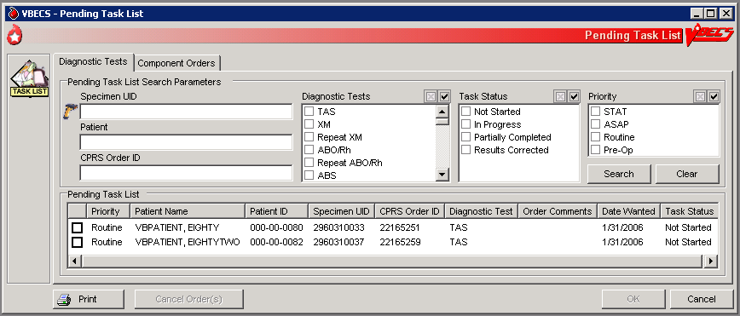

## Patient Testing: Pending Task List UC\_92

The user accesses a Pending Task List (PTL) to select tasks (accepted orders), organize a batch of tests to be performed in a session, process patient component requests, and view and/or print a list of outstanding blood bank tasks.

#### Assumptions

* CPRS orders were accepted or a reflex order was placed within the VBECS division.

#### Outcome

* The task is available for further processing.

#### Limitations and Restrictions

* This option is for diagnostic, blood component, and reflex test orders placed in or directed to the user’s division.
* The PTL does not include daily quality control, equipment maintenance schedules, or pending ABO/Rh confirmation and auxiliary tests on red blood cell units.

#### Additional Information

* This is the main entry point for other testing options.
* The PTL does not display completed diagnostic tests.
* When a specimen is not associated with a component order, partially completed and filled component orders remain on the Pending Task List for 10 days from date of order acceptance. Task 1323 and DR 3604
* When a specimen is associated with a diagnostic test or component order, partially completed diagnostic tests and filled component orders remain on the Pending Task List until the specimen expires. Task 1323 and DR 3604
* VBECS cancels accepted orders (tasks) the day after they expire.
* Multiple users are prohibited from performing the same task on the same unit of blood for the same patient.
* The task may be selected and assigned to a technologist, preventing duplicate selection by another technologist.

#### User Roles with Access to This Option

All users

#### Patient Testing: Pending Task List

The user accesses a list of pending tasks. VBECS displays the PTL with search criteria to allow the user to limit the number of items viewed.

| **User Action** | **VBECS** |
| --- | --- |
| 1. Select **Patients** from the main menu.   Select **Patient Testing** (Figure 111). | * Displays options for processing patient-related functions. * Displays the PTL and PTL search parameters in the Diagnostic Tests tab or in the Component Orders tab. |
| 1. Click the check boxes in the PTL to select one to four tasks for processing and click **OK**, or   Click **Print** to print the list. | * Allows the user to limit the search and display. * Prompts the user to select a task for continued processing, print a task list, or return to Step 1 to change the display of the list.   **NOTES**  Additional information is available in Appendix H: Frequently Asked Questions. DR 3971  The user may click **Cancel Order(s)**, select a comment, and click **OK** to exit.  BR\_92.03, BR\_92.05 The user may select one to four tasks for testing at a time. The tasks may be component class order tasks, diagnostic test tasks, or a combination of both.  VBECS displays “NRQ” (not required) when the task does not require a specimen for processing.  BR\_92.01 For each order, VBECS displays the specific diagnostic test or component order. The default searches for the current date’s tasks, then yesterday’s tasks, and so on until the task status is “completed.” The display includes the task’s status and a user name, when applicable.  BR\_92.10 VBECS alerts the user when he attempts to select multiple tasks of the same type for a patient, and does not allow the selection of two or more tasks of the same type ordered for a patient during a testing session. Tasks are considered to be of the same type when they need to accommodate the use of the same testing grid in Patient Testing: Record Patient Test Results. For example, a user may not select a TAS task and one of its subtests that is ordered in a testing session. VBECS provides for one testing grid display per patient per test, not per specimen UID. If the user selected a TAS and an ABS, VBECS displays only the first one selected for result entry.  BR\_92.02 Task and order statuses and functions that are displayed on the PTL:   * **Not Started:** the order was not selected. * **Partially Completed <user ID>:** allows selection by another user for a diagnostic test to complete, invalidate, or delete the work on this specimen. *Component orders remain in this status until the specimen and order expire.* * **Filled:** This order status is assigned when the total number of units ordered is updated to a unit status of “issued” or “transfused.” DR 2,597 * **Correction:** previous results were invalidated; a corrected entry is required.   Task and order statuses that are not displayed for selection on the PTL:   * **Completed:** applies to diagnostic tests * **Expired:** applies to component orders at expiration of the associated specimen.   See Appendix B: Figure 135: TT\_92.01 Order Status Flowchart for the transmission of orders between CPRS and VBECS.  BR\_92.07 When a user prints a PTL and no pending tasks are found, VBECS asks whether the user wishes to continue to print. The user may cancel or print the report, which states that no pending orders were found. |
| 1. Click **OK** or **Cancel** to exit. |  |

### Accept Orders: Cancel a Pending Order UC\_61

The user cancels an unaccepted order on the Pending Order List (POL).

#### Assumptions

* An order was not accepted by a user.
* The connection to VistA is active.

#### Outcome

* An order update message was sent to CPRS.
* The order was removed from the POL.

#### Limitations and Restrictions

* Cancellation of one order does not affect other orders placed with it.

#### Additional Information

* Each pending order is managed individually.
* VBECS does not automatically clear or cancel pending or unaccepted orders from the POL. Task 1323

#### User Roles with Access to This Option

All users

#### Accept Orders: Cancel a Pending Order

The user selects an unaccepted order for cancellation.

| **User Action** | **VBECS** |
| --- | --- |
| 1. Select **Orders** from the main menu.   Select **Accept Orders**. | * Displays options for processing orders. * Displays the Pending Order List and Pending Order List search criteria. |
| 1. Select an order to cancel from the Pending Order List (Figure 112).   Click **Reject**. | * Requires the user to enter a comment. * Requires the user to confirm the cancellation of the pending order. |
| 1. Enter or select a comment in the Comment field.   Enter details in the Details field, if desired.  Click **OK** and **Close** to confirm the order cancellation. | * Removes the order from the Pending Order List and sends a message to CPRS with an order status update.   **NOTES**  VBECS does not cancel a lab order if the lab order has already been accessioned. See CPRS VBECS Order Details and VBECS Order Cancellation for more information. |

Figure 112: Accept Orders: Reject an Order

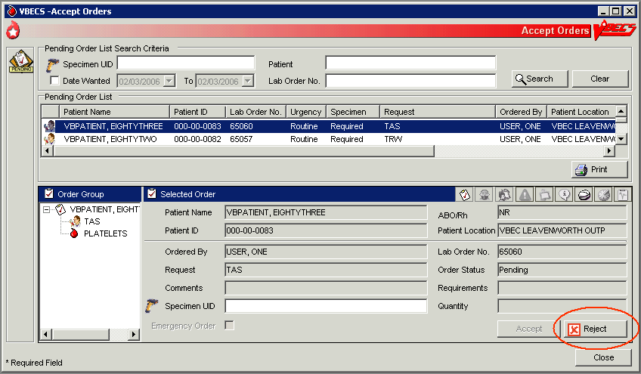

## Order Reflex Tests UC\_45

The user may order additional blood bank tests for a complete or incomplete accepted patient specimen to add to the Pending Task List (PTL). The ordered test or test group limits the type of reflex and repeat test order that may be associated with a specimen.

#### Assumptions

* A patient’s test result requires further investigation or repetition of a diagnostic test.

#### Outcome

* BR\_45.05 One or more reflex orders are in the PTL with a “routine” urgency.

#### Limitations and Restrictions

* BR\_45.10 A crossmatch (XM) and a repeat XM cannot be ordered unless they are associated with a specimen with a future expiration date and a phlebotomist is associated with that specimen.
* BR\_98.02 When a user selects weak D for the antigen typing test and the selected patient is Rh positive, VBECS warns that weak D testing cannot be performed. There is no override and VBECS does not add the test.

#### Additional Information

* Unlimited repeat tests may be ordered and completed, but are not available to CPRS or to billing.

#### User Roles with Access to This Option

All users

#### Order Reflex Tests

The user orders additional blood bank tests for a patient specimen that was already accepted and that may or may not be completed. The ordered reflex test(s) are added to the PTL.

| **User Action** | **VBECS** |
| --- | --- |
| 1. Select **Orders** from the main menu.   Select **Order Reflex Tests**. | * Displays options for processing orders. * Displays specimen search criteria and search results.   **NOTES**  The user may also access Order Reflex Tests by clicking **Order Reflex Tests** when executing Patient Testing or by right-clicking the testing grid that generates the reflexive order. |
| 1. Enter the patient name and/or the specimen UID.   Click **Search**, if necessary. | **NOTES**  BR\_45.08 The user may identify specific specimen for reflex test ordering by scanning or by manual data entry of the UID on the specimen. |
| 1. Select an item from Specimen Search Results.   Review the information in the Selected Patient Specimen area and in the Patient Details and Order Details tabs (Figure 113).  Click **OK** to accept the order.  Respond to messages, as required. | * Displays an option to search for specimens currently available (in-date) for a patient by standard patient search conventions. * Accommodates direct selection of a specimen by scanning or by entering a specimen UID. * BR\_45.02 Displays available (in-date) patient specimens or orders in reverse chronological order within a date range defined by the site parameter. Only one patient specimen may have reflex tests added in one session. The expired and unacceptable specimens will follow. * Displays a message directing the user to complete Patient Testing when the selected test is not completed. User returns to Patient Testing. * Displays a message when a specimen is expired or unacceptable. User may click **Yes** to continue with the order or **No** to select or request another specimen, as appropriate. * BR\_45.03 Displays the date/time/division of the specimen collection when selecting a specimen for ordering reflex tests.   **NOTES**  BR\_45.04 VBECS emits an audible alert, warns that the specimen is expired, and instructs the user to enter a comment to continue. When a user enters or scans an expired specimen. VBECS requires a comment and captures details for inclusion in an Exception Report (exception type: reflex test ordered on an expired specimen).  PT\_45.01 Orderable Reflex Tests |
| 1. When a specimen is already selected, go to Step 5.   Select or enter a patient specimen that requires the additional test. | * Displays all orders associated with a specimen that can be used to request reflex tests for an existing diagnostic test order within an order group. * Automatically associates the reflex test with the order when there is only one order associated with the specimen. |
| 1. Click one or more check boxes to select reflex tests from the Order Reflex Test(s) list. | * Displays the selected tests for review. * Allows the user to select or to deselect reflex tests. |
| 1. Click **OK** to save and exit.   Enter a comment, if required. cancellation. | * Adds the ordered patient reflex tests to the PTL. |

Figure 113: Order Reflex Test(s)

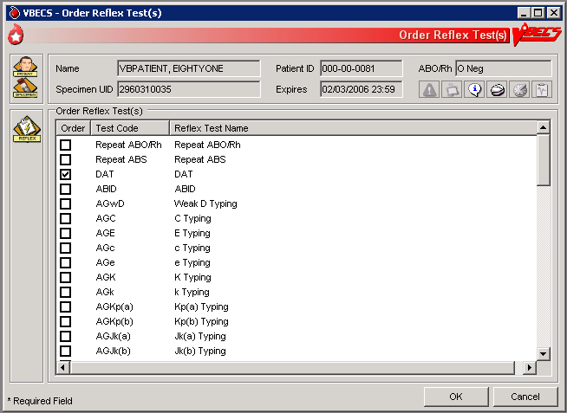

This page intentionally left blank.

# Patient Services

## Patient Search Screen UC\_113

VBECS displays the Patient Search screen to search for a specific patient in VBECS.

#### Assumptions

* The patient record exists in VBECS with the exception of specific searches that return patient information from VistA. For the Edit Unit Information, Incoming Shipment, and Document ABO Incompatible Transfusion options, VBECS searches VistA.

#### Outcome

* VBECS presents the user with a list of patients for selection based on their search input.

#### Limitations and Restrictions

* None.

#### Additional Information

* The Patient Search Screen is used by options throughout VBECS to select patients.
* The Patient Location displayed in Figure 114 is either a representation of the location provided by the subscription to Admit, Discharge and Transfer events or in the event that a patient has been discharged, the location displayed could be the location where a CPRS order was placed for the patient. Once a patient is admitted, the location will be updated with the location at time of admission. If a patient is discharged and no orders are placed for the patient post discharge, no location will be provided. DR 4989

#### User Roles with Access to This Option

All users

#### Patient Search Screen

| **User Action** | **VBECS** |
| --- | --- |
| 1. To access the Patient Search screen, open one of the options listed in Notes. To search for a patient, enter the patient’s full name (last name first) or ID (Figure 114), or   Enter the last four digits of the ID, or the initial of the last name and the last four digits of the ID, and click **Search**. | * Displays the Patient Search screen. * Lists patients that meet the search criteria.   **NOTES**  Options that allow the user to search for a patient:   * **Blood Units** from the main menu. Select **Edit Unit Information** (for restricted units only). * **Patients** from the main menu. Select: * Recent Orders * Blood Availability * Recent Transfusions/Issued Units * Patient Testing Worklist Report * Print Unit Caution Tag & Transfusion Record Form * Issue Blood Components * Post-Transfusion Information * Return Issued Units To Blood Bank and click OK. * Special Instructions & Transfusion Requirements * Transfusion Reaction History * Patient History Report * **Shipments** from the main menu. Select **Incoming Shipment** (for restricted units only). * **Orders** from the main menu. Select **Recent Patient Orders**. * **Reports** from the main menu. Select: * **Blood Availability** (for individual patient only) * **Medication Profile** * **Patient History Report** * **Transfusion Effectiveness Report** (for individual patient report only) * **Supervisor** from the main menu. Select: * Document ABO Incompatible Transfusion * Justify ABO/Rh Change |
| 1. Select a patient from the list. | * Displays patient-associated data. * Displays the Patient Information Toolbar. * Displays Special Instructions (SIs) and Transfusion Requirements (TRs), when appropriate.   **NOTES**  Displays a message when the user selects a patient with a blank first or last name, or the name is too long. The user is instructed to contact the VBECS Administrator for assistance. DR 3444 |

Figure 114: Patient Search

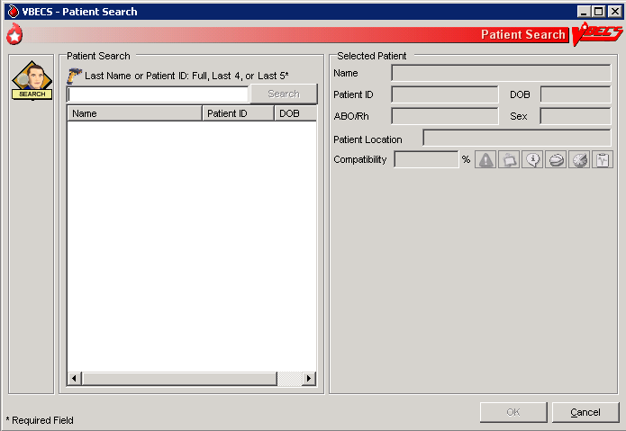

### Patient Merge UC\_68

VBECS notifies the user of VistA patient merges and displays details for his review.

#### Assumptions

* The connection to VistA is active.
* VBECS received the message about a VistA patient merge.
* VBECS accepts merge messages when either or both the merge from or merge to patients exist in VBECS.

#### Outcome

* VBECS notified the user that patient records were merged in VistA.

#### Limitations and Restrictions

* DR 2,527 The Traditional Supervisor or above must update patient records manually.
* VBECS does not notify users of additional VistA patient updates or merges while the icon is displayed. When a user views an update and there is an unprocessed patient merge, the Patient Alert icon remains on the screen until the Traditional Supervisor completes the update and clears the icon.
* Patient merges involving patient’s with names that exceed the database standard for File #2 (30 characters) or do not have a first or last name in VistA are rejected and do not appear in VBECS. The VBECS System Administrator is notified of each rejection via an email to the address entered in VBECS Administrator “Interface Failure Alert Recipient” field.

#### Additional Information

* If more than two records are merged in VistA, VBECS will receive a corresponding number of merge messages.

#### User Roles with Access to This Option

All users

#### Patient Merge

The VBECS user examines records that were merged in VistA and decides whether to update them.

 VBECS does not create links for merged records. Users must update patient information and Special Instructions to show the merged-patient relationship.

 Patient merges that do not change the patient name or social security number (e.g. patient record moved to a new DFN) are displayed to the VBECS user. However, the records displayed in the Merge window will not appear to have any differences. Users are advised to contact customer support if a record merge of this type occurs. DR 4178

| **User Action** | **VBECS** |
| --- | --- |
| 1. Select **Patients** from the main menu.   Select **Patient Updates**.  Select **Patient Merge**, or  Click patientalert in the Patient Information Toolbar. | * Displays patientalert and notifies the user of the VistA patient merge. * Lists the patient records to be updated. * BR\_68.19 Displays limited merge-from and merge-to patient information for evaluation, including: * Patient name * Patient ID, if available * Date and time the merge message was received from VistA   **NOTES**  VBECS displays patientalert at the first instance of a VistA patient update or merge. The icon remains on the screen until the Traditional Supervisor clears the patient merge alert DR 2,2527.  BR\_68.01 The list of patient records is sorted in chronological order: the oldest received updated record appears at the top of the list.  The user may update both patients’ VBECS files in accordance with local policy and procedure. |
| 1. Select a VistA patient merge event from the list and review the data (Figure 115). | * Displays data about merged VistA patient records: * Patient name * Patient ID, if available * Patient sex, if available * Date and time the merge message was received from VistA * Patient ABO/Rh, if available * Patient Transfusion Requirements (TRs) and Special Instructions (SIs), if available * Recent orders and recent transfusion records for the patient (available only by clicking Patient Information Toolbar icons), if available   **NOTES**  “Patient has no VBECS records at the receipt of the merge message” displays when the merge-from or merge-to patient is not found in VBECS. |
| Merge-to Patients   1. Update the merge-to patient record to include SIs and TRs from the merge-from patient record.   Insert a comment in the Special Instruction field to note that a merge occurred. | **NOTES**  A user cannot update SIs or TRs if the merge to patient does not have a VBECS record.  Local policy must define how to handle records when the merge to patient does not exist in VBECS.  The merge-to patient record is the active record in VBECS.  Use Special Instructions & Transfusion Requirements: Enter a Transfusion Requirement, and Special Instructions & Transfusion Requirements: Enter and Remove Special Instructions to enter, update, or delete relevant component requirements, antibodies, or antigen requirements.  Enter an SI comment in the merge-to patient record, for example, “This patient record was merged with <*insert merge-from patient name*> in VistA and is used to process orders after <*insert merge date and time*>. Refer to the records of <*insert merge-from patient name*> for testing and transfusion information prior to the merge event.” |
| 1. Resolve ABO/Rh discrepancies among patients.   Determine which blood type is correct for use. | **NOTES**  Use Justify ABO/Rh Change to finalize blood type changes for the merge-to patient. |
| 1. Complete pending orders for the merge-to patient. |  |
| Merge-from Patients   1. Update the merge-from patient record to include SIs and TRs from the merge-to patient record   Insert a comment in the Special Instruction field to note that a merge occurred. | **NOTES**  A user cannot update SIs or TRs if the merge from patient does not have a VBECS record.  Local policy must define how to handle records when the merge from patient does not exist in VBECS.  The merge-from patient record is the inactive record in VBECS.  Use Special Instructions & Transfusion Requirements: Enter a Transfusion Requirement, and Special Instructions & Transfusion Requirements: Enter and Remove Special Instructions to enter, update, or delete relevant component requirements, antibodies, or antigen requirements.  Enter an SI comment in the merge-from patient record, for example, “This patient record was merged with <*insert merge-to patient name*> in VistA and must not be used to process orders after <*insert merge date and time*>. Refer to the records of <*insert merge-to patient name*> for testing and transfusion information after the merge event.” |
| 1. Cancel pending orders on the merge-from patient. Request replacement orders for the merge-to patient, as appropriate. | **NOTES**  Local policy must define how to handle orders when the merge from patient or merge to patient does not exist in VBECS. |
| 1. To confirm that the merge-from and merge-to patient SIs and TRs match on the Patient Merge display. | **NOTES**  Local policy must define how to handle records when the merge from patient or merge to patient does not exist in VBECS. |
| 1. DR 2,527 Click **Clear Patient Merge Alert**. | * When there are no pending patient updates, clears patientalert (the Patient Alert icon) from the main status bar. * Displays an information message stating that the user viewed the record.   **NOTES**   The Clear Patient Merge Alert function is available only to the Traditional Supervisor and above. |
| 1. Click **OK** to acknowledge the message. | * Clears the icon when the user acknowledges the message. |
| 1. Click **Close** to exit, or return to Step 2. |  |

Figure 115: Patient Merge

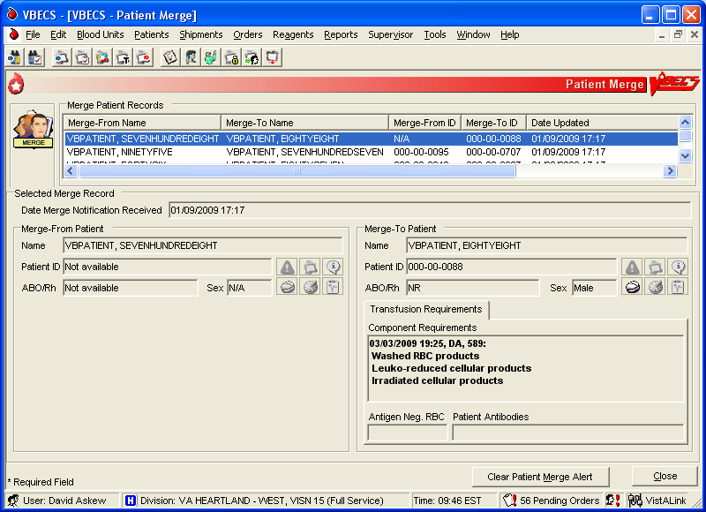

### Updated Patients and Deceased Patients UC\_68

BR\_68.02 The user views patient updates and death events for patients with pending or active orders in VBECS.

#### Assumptions

* The connection to VistA is active.
* The patient record was updated in VistA.
* VBECS received a message from VistA about a patient record update or death.
* The affected patient’s records are in the VBECS database.
* The affected patient has a pending or active order in VBECS for updates and/or death event.

#### Outcome

* The user reviews updated patient records.

#### Limitations and Restrictions

* Demographic and death event updates do not display information for patients without pending or active orders in VBECS. Updates will occur without user input.
* VBECS does not notify users of additional VistA patient updates or merges while the icon is displayed. When a user views an update and there is an unprocessed patient merge, the Patient Alert icon remains on the screen until the Traditional Supervisor completes the update and clears the icon.
* When VBECS notifies a user of an update to a patient’s prefix or suffix, VBECS does not display the updated information: the user must access VistA to view the updated information. DR 2,714

#### Additional Information

* None

#### User Roles with Access to This Option

All users

#### Updated Patients and Deceased Patients

The user views updated patient records.

| **User Action** | **VBECS** |
| --- | --- |
| 1. Select **Patients** from the main menu.   Select **Patient Updates**.  Select **Updated Patient** or **Deceased Patient**, or  Click patientalert in the Patient Information Toolbar, when it is active. | * Displays options for processing patient-related functions. * Lists updated or deceased patients (also lists these data after the update if they changed), including: * Patient name * Patient ID * Patient date of birth * Date and time of the update, or date of death |
| 1. Click **Close** to exit, or return to Step 1 to view another patient’s data. |  |

### 

### Patient Testing: General Instructions UC\_56

The user records a patient’s serologic test results.

#### Assumptions

* The patient specimen and order were processed and found satisfactory for testing.
* The user selected one to four diagnostic and/or component tasks for testing from the Pending Task List (PTL).
* The patient may or may not have a previous blood bank record. Previously saved VBECS data related to this patient are available for comparison with the user’s test results and interpretations.

#### Outcome

* The test record was filed, is unique, and is retrievable for the life of VBECS.
* Partially completed testing is available for completion or invalidation but is not available to the patient record or reports.
* Completed, current specimen test results are available for inclusion in various reports.
* VBECS changes the task status to “completed” and triggers the generation of a message to CPRS that the order is complete.
* The test record includes the details of the verified, completed testing.

#### Limitations and Restrictions

* This test record is not editable after the user completes a test and saves it to the database. When a correction needs to be filed, a corrected report must be generated, as described in Invalidating Patient Test Results.
* User selection of partially completed testing grids with different phases of testing (All Phases or AHG Only) as previously selected creates a testing discrepancy in VBECS.
* Limited batch testing to partially completed orders with the same testing grid selection, either All Phases or AHG Only. DR 4218
* VBECS cannot compare test results for a patient when two users are entering test results for the same patient at the same time. DR 4817

#### Additional Information

* Partially completed tests may be invalidated within the testing option.

#### User Roles with Access to This Option

All users

#### Patient Testing: General Instructions

A user records a patient’s test results: Type & Screen (TAS), ABO/Rh, Antibody Screen Test (ABS), Direct Antiglobulin Test (DAT), and crossmatches (XMs) on units selected for a patient. This option describes the configuration of reflex or repeat testing and patient antigen typing.

| **User Action** | **VBECS** |
| --- | --- |
| 1. Select **Patients** from the main menu.   Select **Patient Testing**. | * Displays options for processing patient-related functions. * Displays the Pending Task List (PTL) in the Diagnostic Tests tab.   **NOTES**  A user may search for specific tasks using search criteria detailed in Pending Task List. |
| 1. Click one to four check boxes in the Pending Task List to select tasks for testing (Figure 111).   Click **OK**. | * Displays patient names and associated task information. |
| 1. Click a check box to select a reagent rack.   In the ABS or XM Testing Phases area, click the **All Phases** or **AHG Only** radio button (Figure 116).  Click **OK** to continue with testing. | * Allows the user to select the All Phases or AHG Only radio buttons only when applicable. * Displays reagent rack names and associated information. * BR\_56.15 Requires the user to select the reagent rack name. The testing grid configuration for serologic testing defaults to the setting selected in the Configure Division option. The user is allowed to indicate whether an automated instrument was used. * Displays the date and time testing was performed. * Displays the testing technologist name.   **NOTES**  BR\_40.04 When the testing method selected is AHG only, VBECS disables the data grid boxes for phases IS, 37, and CC.  Rack configuration of AHG applies only to the antibody screen and crossmatch testing grids.  The user may select another user’s name from the list, as appropriate. The logged on user’s name appears on the Testing Worklist Report as the Processing Tech in addition to the selected user name.  The user may indicate that testing was performed at a past date and time.   See Table 10 for alerts that may occur during this option. |
| 1. Respond to warnings, which may include entering a comment and details, and click **OK** to continue. | *  Displays small_si_tr and emits an audible alert when there are SIs or TRs for the patient. * Prepares a direct data entry (DDE) grid for the user to enter the serologic reaction results for testing associated with the selected tasks. * Displays testing results and entered interpretations until the user saves them. |
| 1. Select a patient to begin entering his serologic reactions (Figure 117).   Repeat this step for each selected patient until all test results and interpretations are entered in the test grid. | * Allows the user to select one patient at a time and enter a test result for that patient. * Allows only valid data entries in the grid reaction result and interpretation cells. * BR\_56.02 Allows a user to save partially completed tests. * When the user enters interpretation data, allows the save with or without warnings and overrides based on the test results entered for the patient and the user’s security level.   **NOTES**  The user may order a reflex test and may update the patient’s TRs and SIs.  BR\_56.02 The ABO and Rh tests are considered one test and must be resulted together before a save is permitted. |
| 1. Respond to warnings for the selected patient and confirm that appropriate test results were entered.   Repeat Steps 5–6 for each patient until all patient work is saved. | * BR\_56.05 When a user enters a valid interpretation and saves it for a test, updates the order status to “completed.” * BR\_56.11 Displays each patient’s data for review before allowing the user to save them. * Saves patient testing results for retrieval from completed tests. * Saves only the patient testing displayed.   **NOTES**  BR\_56.04 The user may save part or all of one patient’s testing results at a time. When all data for a patient are saved, the patient tab is no longer visible.  BR\_56.27 When a user saves a test with a “correction” task status, VBECS saves the results and interpretations and adds a comment to the Testing Worklist Report.  BR\_56.30 VBECS sends an order completion message to CPRS when the user enters and successfully saves all test results and interpretations for a diagnostic test.DR 2,869   May display multiple warning and override messages for the user’s response. |
| 1. When the selected patient testing is complete, click **OK** and **Yes** to confirm changes and continue to the next patient, or exit. |  |

Figure 116: Testing Details

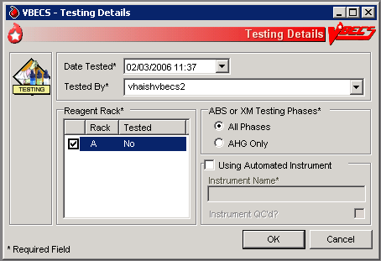

Figure 117: Patient Testing

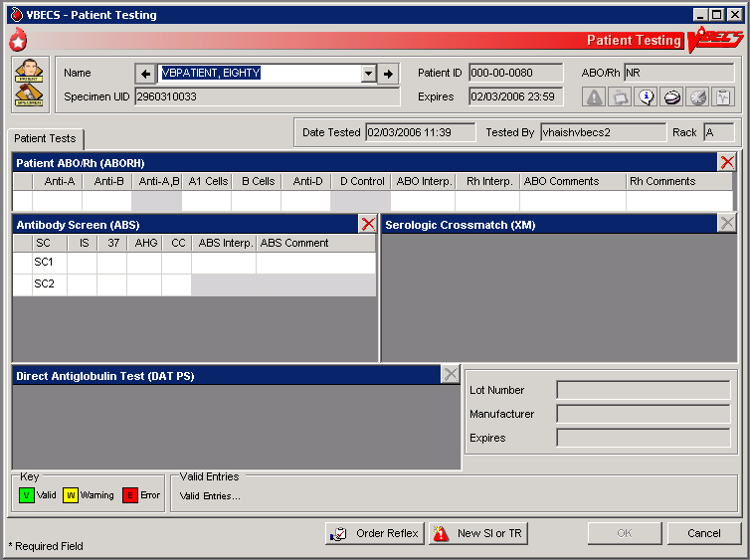

####  Alerts

Table 10: Alerts That May Occur in Patient Testing: General Instructions

| **User Action Step** | **Alerts** |
| --- | --- |
| 4 | BR\_41.04 When the division is configured as “full service” in Configure Division, VBECS displays data fields for the user to select or enter the lot number, and displays the manufacturer and expiration date of each antiserum to be used in this transaction to allow the user to choose the correct antiserum. VBECS displays in-date antisera and allows the user to select outdated antisera, if needed, emits an audible alert, and requires an override. VBECS captures details for inclusion in an Exception Report (exception type: expired antisera used). |
| 5 | BR\_56.03 The user may cancel or delete a partiallycompleted grid. VBECS:   * Emits an audible alert and requires a comment. * Clears previously entered observed results from the data grid and allows the user to enter new data. * Captures details for inclusion in an Exception Report (exception type: previously recorded results invalidated). |
| 6 | BR\_56.01 Warns that the user is saving the first instance of a historic ABO/Rh. |
| 6 | BR\_56.12 When the ABO/Rh interpretation matches observed results, is not inconclusive, and does not match the patient’s historic ABO/Rh (if any, including from database conversion), VBECS emits an audible alert, warns that the current ABO/Rh does not match previous results, and instructs the user to enter a comment to continue, or click **Cancel** to clear the ABO/Rh testing results and interpretation from the screen. VBECS captures details for inclusion in an Exception Report (exception type: ABO/Rh discrepancy). |
| 6 | BR\_56.16, BR\_56.28 When the interpretation of a repeat ABO/Rh does not match the original interpretation, VBECS:   * Verifies the retest results. * Emits an audible alert and warns the user. * Instructs the user to resolve the discrepancy before the specimen may be used. * Asks whether the user wishes to continue to save. **No** clears the ABO/Rh testing results and interpretation from the screen. **Yes** requires a comment and captures details for inclusion in an Exception Report (Exception type: ABO/Rh discrepancy). |
| 6 | BR\_56.19 When a user documents an ABO/Rh discrepancy, VBECS releases units with “assigned” and “crossmatched” statuses associated with this specimen from the patient. |
| 6 | BR\_56.29 When a unit was emergency issued and a conflicting test result found that indicates a potential unit incompatibility with the patient, such as a patient ABO/Rh discrepancy, the unit XM is incompatible with the patient, the patient ABS is positive, the patient DAT is positive, or the unit is antigen positive where antigen negative is required on the tested specimen, VBECS warns the user and instructs him to notify the physician of this potential problem immediately, according to hospital policy. VBECS warns the user during the execution of the various tests related to the compatibility of a blood unit and captures details for inclusion in an Exception Report (exception type: unit ER issued, testing problem). |

### Patient Testing: Record a Patient ABO/Rh UC\_52

The user records observed results when performing ABO/Rh blood typing.

#### Assumptions

* A CPRS order exists that includes an ABO/Rh typing [ABO/Rh Test or Type & Screen (TAS)].
* The user accesses patient ABO/Rh grids through Patient Testing: Record Patient Test Results.

#### Outcome

* The ABO/Rh result is used to determine overall blood component compatibility.
* When ABO/Rh is ordered as a stand-alone test, VBECS changes the task status to “completed” and triggers the generation of a message to CPRS that the order is completed.

#### Limitations and Restrictions

* None

#### Additional Information

* When an ABO/Rh discrepancy exists, VBECS releases assigned and crossmatched units. These units are then available for emergency issue based on system rules.
* VBECS does not enforce local policies that require running a D control for AB positive patients.
* The most recent instance of ABO/Rh testing in the database serves as the historic ABO/Rh record.

#### User Roles with Access to This Option

All users

#### Patient Testing: Record a Patient ABO/Rh

This option describes a test to determine the patient’s ABO/Rh typing from a blood specimen. The user enters the serologic reaction results in the data entry grid using the instructions and rules in this option. The grid is used for the Confirm Patient ABO/Rh reflex test as part of a TAS and crossmatch (XM) test battery. VBECS monitors the user’s entries and interpretations and maintains the records for patient reports.

These steps describe the entry of data for a patient ABO/Rh test when the test is ordered individually or as part of a TAS.

| **User Action** | **VBECS** |
| --- | --- |
| 1. Select **Patients** from the main menu.   Select **Patient Testing**. | * Displays options for processing patient-related functions. * Displays the Pending Task List (PTL) in the Diagnostic Tests tab.   **NOTES**  A user may search for specific tasks using search criteria detailed in Pending Task List. |
| 1. Click one to four check boxes in the Pending Task List to select tasks for testing.   Click **OK**. | * Displays patient names and associated task information. |
| 1. Enter patient ABO/Rh testing results. | * Displays a direct data entry (DDE) grid for entering serologic reaction results for ABO/Rh patient testing.   **NOTES**  BR\_52.09 The user may reenter valid results or delete entries and start over before saving the results. The user may invalidate, but not edit, data in a grid from a previous session by clicking the red “X” in the upper right corner of the testing grid, as described in Invalidate Test Results.  BR\_52.07 VBECS determines the validity of the user-entered patient ABO/Rh interpretation by comparing the reaction results pattern of the row with the truth table and with the previous ABO/Rh entries for the patient. |
| 1. Select a patient to begin entering his serologic reactions. | * Allows the user to select one patient at a time and enter a test result for that patient. * Allows only valid data entries in the grid reaction result and interpretation cells.   **NOTES**  When A,B or D control is not part of the daily QC configuration, VBECS disables it in the ABO/Rh test grid.  When an AB Positive patient requires the performance of a control cell, the user must order a repeat ABO/Rh test.  When A,B is enabled, the user enters a result for Anti-A,B as part of the patient test, it is included in determining the interpretation for that patient test. “X” is an acceptable entry.  A,B and D control are always enabled for the repeat ABO/Rh test grid, regardless of the QC configuration.  BR\_52.10 Reflex testing grid fields are available for data entry regardless of QC rack configuration.  See Table 4: **BR\_2.10** Valid Interpretations.  BR\_52.06 Row validation is established for the interpretation vs. reaction results pattern defined by system rules. |
| 1. Repeat Steps 2–4 until some or all portions of the test grid for the selected patient are entered.   Enter the interpretation for the patient ABO/Rh typing, if appropriate. | * Prompts the user to confirm that all results were reviewed and are acceptable.   **NOTES**  BR\_56.12 When the ABO/Rh interpretation matches observed results, is not inconclusive, and does not match the patient’s historic ABO/Rh (if any, including from database conversion), VBECS emits an audible alert, warns that the current ABO/Rh does not match previous results, and instructs the user to enter a comment to continue, or click **Cancel** to clear the ABO/Rh testing results and interpretation from the screen. VBECS captures details for inclusion in an Exception Report (exception type: ABO/Rh discrepancy).  BR\_52.08, BR\_52.11   VBECS allows the Enhanced Technologist to enter an ABO/Rh interpretation that matches the patient’s previously recorded (historic) ABO/Rh interpretation when the system interpretation is inconclusive. This allows unit selection to continue based on the patient’s ABO/Rh interpretation entered by the user. VBECS requires the user to document the findings of any offline investigation, alerting the reviewer to appropriately follow up, according to local policy.VBECS emits an audible alert and warns the user. VBECS allows an override with comment and captures details for inclusion in an Exception Report (exception type: discrepant ABO/Rh override) that includes all interpretations and historic patient information. |
| 1. When all required fields are complete, click **OK** to save and continue to the next patient, or exit. | * Saves the data. |

### Patient Testing: Record a Patient Antibody Screen UC\_53

The user records the serologic results when performing the Antibody Screen Test (ABS).

#### Assumptions

* The user accesses patient ABO/Rh grids through Patient Testing: Record Patient Test Results.
* A CPRS order exists that includes an ABO/Rh typing [ABO/Rh Test or Type & Screen (TAS)]. An ABS may also be ordered as a reflex patient test.
* Configure Daily QC and Configure Testing are complete.

#### Outcome

* When an ABS is ordered as a stand-alone test, VBECS changes the task status to “completed” and triggers the generation of a message to CPRS that the order is complete.

#### Limitations and Restrictions

* This option is for patient testing only.

#### Additional Information

* The user performs lab tests and enters data simultaneously.

#### User Roles with Access to This Option

All users

#### Patient Testing: Record a Patient Antibody Screen

The user tests the patient’s specimen for the presence of antibodies-to-irregular red cell antigens. The user may perform this test alone or as part of a battery of tests.

The user accesses patient antibody screen grids through Patient Testing: Record Patient Test Results and enters observations of the serologic reactions in the data entry grid during testing. VBECS makes the interpretation available to CPRS and patient reports.

| **User Action** | **VBECS** |
| --- | --- |
| 1. Select **Patients** from the main menu.   Select **Patient Testing**. | * Displays options for processing patient-related functions. * Displays the Pending Task List (PTL) in the Diagnostic Tests tab.   **NOTES**  A user may search for specific tasks using search criteria detailed in Pending Task List. |
| 1. Click one to four check boxes in the Pending Task List to select tasks for testing.   Click **OK**. | * Displays patient names and associated task information. |
| 1. Click a check box to select a reagent rack.   In the ABS or XM Testing Phases area, click the **All Phases** or **AHG Only** radio button.  Click **OK** to continue with testing. | **NOTES**  BR\_40.04 When the testing method selected is AHG only, VBECS disables the data grid boxes for phases IS, 37, and CC. |
| 1. When processing more than one patient, select a name from the drop-down list in the Name field (or click the right or left arrow) to record testing for that patient. | * Allows the user to select a patient and enter a test result for the patient. * Allows only valid data entries in the grid reaction result and interpretation cells.   **NOTES**  BR\_53.02 The logic described in Appendix B: Table 15: TT\_53.02 Antibody Screen Test Interpretation is an integral part of the configuration of the reaction result grid developed for Patient Testing: Record a Patient Antibody Screen.  BR\_53.04 There may be two to five rows of screening cells to be validated as a group (the ABS). The user enters only one interpretation for the combination of cells tested.  BR\_53.03 Valid interpretations of an ABS Test are positive or negative. |
| 1. Repeat Step 4 until results are entered in some or all portions of the test grid for the selected patient. Enter the interpretation for the patient ABS Test, if desired. | * Verifies that appropriate tests are entered. * Prompts the user to confirm that results were reviewed and are acceptable.   **NOTES**  BR\_53.01 When the ABS Test interpretation must be consistent with observed test results based on Table 15: TT\_53.02 Antibody Screen Test Interpretation, discrepancies must be resolved before VBECS verifies the results and adds them to the database. The user may reenter valid results or delete the entries and start over before saving. |
| 1. Enter test results in preparation for updating the database. | * Saves the data. |
| 1. Click **OK** to save, and **OK** to confirm and exit. |  |

### Patient Testing: Record a Direct Antiglobulin Test UC\_54

The user records observed results when performing a Direct Antiglobulin Test (DAT).

#### Assumptions

* A CPRS order exists that includes a DAT, which the user may also order as a reflex patient test.
* The user is testing a patient specimen in Patient Testing: Record Patient Test Results.
* VBECS is configured to accommodate the DAT as part of a Type & Screen (TAS).

#### Outcome

* When a DAT is ordered as a stand-alone test, VBECS changes the task status to “completed” and triggers the generation of a message to CPRS that the order is complete.

#### Limitations and Restrictions

* VBECS does not check whether the lot and vial numbers selected for the positive control cells are different from those of the negative control cells.

#### Additional Information

* BR\_28.11 The site settings determine which reagent types and lot numbers are available.
* VBECS checks the rack for the DAT reagents in use. When the rack testing does not include Poly AHG, Anti-IgG, or anti-complement, VBECS displays additional positive and negative control rows with the test grid for the DAT sera.
* BR\_41.25 The user may select reagent lot numbers for positive and negative control cells: Reverse ABO Typing Cells (Set), A2 cell (vial), Screening Cells (set), Check Cells (vial), Panel (set), and Other (set).

#### User Roles with Access to This Option

All users

#### Patient Testing: Record a Direct Antiglobulin Test

The user performs a DAT on a patient sample.

The DAT may generate additional reflex test orders such as elution and antibody identification. VBECS saves the reactions and interpretation in the database as part of the patient’s record.

| **User Action** | **VBECS** |
| --- | --- |
| 1. Select **Patients** from the main menu.   Select **Patient Testing**. | * Displays options for processing patient-related functions. * Displays the Pending Task List (PTL) in the Diagnostic Tests tab.   **NOTES**  A user may search for specific tasks using search criteria detailed in Pending Task List. |
| 1. Click one to four check boxes in the Pending Task List to select tasks for testing.   Click **OK**. | * Displays patient names and associated task information. |
| 1. When QC was not performed, enter a lot number for the antiserum. | * Displays reaction result grids for DAT tests for each patient. * Lists the AHG antisera related to the test. * Displays information about the lot number, including the manufacturer and expiration date. * Prompts the user to select the correct antisera and possibly the control cell entry.   **NOTES**  BR\_41.25 Reagent lot numbers that are selectable for positive and negative control cells:   * Reverse ABO Typing Cells (set) * A2 cell (vial) * Screening Cells (set) * Check Cells (vial) * Panel (set) * Other (set)   BR\_54.02 VBECS lists the AHG antisera related to the test from previously entered inventory. When VBECS displays multiple DAT tests or the full battery, the user selects each DAT serum separately by repeating this step until all are selected.  BR\_54.06 Each positive and negative control cell requires the user to select a lot number.  BR\_54.04, BR\_54.05 VBECS displays options to select the lot number of the antisera and check cells used for QC of the antiglobulin sera. The user must select complement check cells for Anti-Complement AHG tests.  BR\_28.12 VBECS compares the control cell results entered to those of the previous day for the same rack number and alerts the user when there is a decrease in reactivity of 2 or more within the acceptable limits for each reagent type by lot number. VBECS emits an audible alert, warns that there is a decrease in reagent reactivity of two or more, and asks whether the user wishes to continue to use this vial.  **Yes** allows the user to continue, with comment. VBECS captures details for inclusion in an Exception Report (exception type: QC decrease reagent reactivity ≥ 2).  **No** allows the user to reenter the lot number for this reagent type and allows the approval of this same lot number (different vial) or the entry of a new lot number, returning to the testing worksheet where the user left off. (The user may replace an individual vial that is losing its reactivity with one of the same lot number.)  BR\_28.20, BR\_28.23 When the user-entered test results indicate a satisfactory interpretation, VBECS indicates that testing is satisfactory and allows the user to save the results. VBECS considers the affected QC incomplete until it is retested with satisfactory results. VBECS generates warnings through other options when QC testing is incomplete.  BR\_28.24 VBECS compares the expiration date of the reagent on the selected reagent to the testing date. When the reagent is expired, VBECS emits an audible alert, warns the user and asks whether he still wishes to use this reagent. **Yes** requires a comment and captures details for inclusion in an Exception Report (exception type: expired reagent QC’d).  **No** removes the unsatisfactory reagent and requires the user to enter a new one. Unsatisfactory lot numbers are never displayed. VBECS captures details for inclusion in an Exception Report (exception type: Expired reagent QC’d).  BR\_54.01 When the antisera QC is required, the user verifies the lot numbers, manufacturer name, and expiration date and saves them as part of the QC record for the associated test. |
| 1. Review and accept the selected reagent information. | * Displays the previously entered information for user review. |
| 1. Respond to warnings and continue with DAT testing. | * Displays a direct data entry (DDE) grid for the user to enter serologic reaction results for DAT testing. |
| 1. Enter valid test serologic reactions in the data entry grid. | * Allows the user to enter valid data and test results in the interpretation cells.   **NOTES**  BR\_54.03 Row validation is established for the interpretation vs. reaction results pattern as defined by system rulesTT\_54.01 Direct Antiglobulin Testing. |
| 1. Repeat Step 4 until some or all portions of the test grid for the selected patient are entered. When appropriate, enter the interpretation for the patient DAT testing. | * Prompts the user to confirm that all results were reviewed and are acceptable. |
| 1. Enter test results in preparation for updating the database. |  |
| 1. Click **OK** to exit. |  |

### Patient Testing: Record a Crossmatch UC\_40

The user records observed results and interpretations when performing a serologic crossmatch (XM) between a patient and one or more units of blood.

#### Assumptions

* A CPRS order exists for a blood component that requires a serologic XM. The patient order and the selected units are in the same division as the user.
* A blood unit that contains red blood cells, selected in Select Units, is acceptable for testing, according to the patient’s current or historic records and ABO/Rh.
* A current specimen was accepted and is in process for ABO/Rh and Antibody Screen Test (ABS), or was previously completed and is not expired.

#### Outcome

* When patient Transfusion Requirements (TRs), if any, are fulfilled and a user enters a compatible XM interpretation, VBECS makes units available for generating the Blood Transfusion Record Form (BTRF), for printing the Caution Tag, and for issue to the patient.
* When a user enters an unacceptable XM interpretation, VBECS releases the selected units from the patient.

#### Limitations and Restrictions

* BR\_40.01 The specimen associated with testing must have an expiration date and time that are later than the testing date and time entered in Patient Testing: Record Patient Test Results. When this is not the case, VBECS warns that the patient specimen expired. There is no override.
* This option does not include electronic crossmatch (eXM).

#### Additional Information

* BR\_40.11 When the user saves a partially completed XM testing worklist, VBECS does not clear patient entries without results or release them from the worklist, which VBECS saves for completion later.
* BR\_40.16 When VBECS saves a partially completed XM worksheet, it maintains a status of “assigned” for selected units until the serologic XM is complete. When VBECS saves the XM test. including interpretation, to the database, it assigns “crossmatched” status to the unit. The user may correct verified patient data only through Invalidate Test Results.
* Units that require antigen typing and/or modification to fulfill a component requirement and/or Sickle Cell testing may be crossmatched pending the completion of further processing of the unit.
* VBECS does not allow users in a transfusion-only facility to save partially completed worksheets. The user must enter interpretations for all selected units before VBECS enables the OK button.
* XM compatibility is one aspect of blood unit compatibility. VBECS takes into account the known requirements for compatibility is taken into account when the user prints Caution Tags and BTRFs, and includes such issues as antigen negative requirements and component requirements.

#### User Roles with Access to This Option

All users

#### Patient Testing: Record a Crossmatch

During Select Units, the user selects a blood unit to fill a patient order. If the unit selected contains red blood cells and eXM is not enabled, or the patient or unit does not qualify, VBECS directs the user to enter serologic XM results. (When eXM is enabled, the user may select serologic XM.)

The user performs the serologic XM test and records results in VBECS. VBECS monitors the user’s entries and interpretations to determine (with the user) compatibility for each crossmatched unit.

| **User Action** | **VBECS** |
| --- | --- |
| 1. Select **Patients** from the main menu and select **Patient Testing**, or   Select **Blood Units** from the main menu and select **Select Units**. | * Displays options for processing patient-related functions. * Displays the Pending Task List (PTL) and PTL search parameters in the Diagnostic Tests tab or in the Component Orders tab. |
| 1. Enter or select PTL search parameters, if appropriate.   Click the check boxes in the PTL to select one to four component orders.  Click **OK** to continue. | * Displays information for each component order. * When the selected order class is RED BLOOD CELLS and the division enabled eXM, evaluates the patient for eXM unit processing.   **NOTES**   See Table 11 for alerts that may occur during this option. |
| 1. Click **Add Units** to add units to the component orders selected (Figure 94). | * Searches the database and displays available restricted autologous and directed units that the user must select before selecting allogeneic units of the same ICCBBA component class. * Displays the unit ID, product type, unit ABO/Rh, unit expiration date, specimen UID, if applicable, of units assigned to the patient in the division’s blood bank on a different specimen or order. The user may release and reassign the units to the current order. * When eXM was configured for the facility, displays the eXM status (eligible or not eligible) for the patient.   **NOTES**    See Table 11 for alerts that may occur during this option.  BR\_3.05 When no valid ABO exists for the patient, the user may select components, including autologous units:   * For RBC or WB order: * Group O, Rh positive or O Rh negative RBC * WHOLE BLOOD is not selectable * For FFP order only, group AB, Rh positive or Rh negative, or not specified. * For PLT, CRYO, or OTHER order, all available units are selectable. |
| 1. Scan or enter allogeneic units, select compatible units from the Order Group list, or click the **find** button to select units.   Enter or select a date in the Selection Date field. Each unit may have its own selection date and time.  Click **Add Units** to display the unit selection form.  To change the Assigned Date and Assigned By fields, click a unit in the Order Group list. | * Maintains a list of selected units. The user may deselect selected units. * Evaluates the selected unit: * For the ABO/Rh compatibility of each unit and warns the user. * Against patient Transfusion Requirements (TRs) and warns the user. * For unit antigen negative compatibility and warns the user. * Performs additional checks that include days remaining until the unit’s expiration date, the current status, assignments to other patients, quarantine and biohazard indicators, when applied, and associated special testing.   **NOTES**    See Table 11 for alerts that may occur during this option.  The user may accept or edit the current date and time displayed; the date and time must be in the past.  BR\_3.25, BR\_16.13 Restricted (autologous or directed) unit selection eligibility criteria:   * Restricted For Patient ID: must match * Restricted For Patient Name: must match * Unit expiration date must be in the future. * Component class (transfusion only requires restriction of all units)   BR\_3.19 The criteria for selecting or including an individual unit in a pick list include evaluating a unit for:   * Considered substitutable for the order * Same division as the user * Current location is in the blood bank * Has no quarantine indicator * Is not already assigned or crossmatched to the patient * Is not “restricted” for a different patient * Meets ABO/Rh compatibility requirements specific to the component class * Future expiration date   BR\_3.04 VBECS lists only ABO/Rh compatible units for selection.  BR\_3.11 When ABO/Rh results were not created for the specimen associated with the component order and the order is not designated “emergency issue,” VBECS allows the user to select units using historic records, and notifies the user that ABO/Rh testing must be performed at this division on this patient before any selected units can be issued.  BR\_3.55 VBECS displays and allows the user to complete a pending XM associated with a patient order without a final unit status. |
| 1. Repeat Step 4 until all units are selected. | * Requests the user to confirm the list of selected blood units.   **NOTES**  The user may select or deselect additional units. |
| 1. Click **OK** to confirm the selection of units. | * Determines whether the units are available for issue or whether they require additional modification and/or testing based on the component class. * Updates the database, as appropriate.   **NOTES**   See Table 11 for alerts that may occur during this option.  BR\_3.17, BR\_3.27 When eXM is enabled at the division and blood units require XM, VBECS determines whether the patient and units are eligible for eXM. All parameters listed in Appendix B: Table 23: TT\_3.05 Rules for Electronic and Serologic Crossmatch must be met. Units not eligible for eXM must have serologic XM performed.  When eXM is not enabled, the user must enter serologic XM results for red blood cell classes or when a user orders an optional XM for OTHER component classes. VBECS does not change the unit status to “crossmatched,” make units available for issue, or allow the Caution Tag or BTRF to be printed until a user enters a valid XM result, unless an emergency-issued unit is being processed.BR\_3.17, BR\_3.27 |
| 1. Select another component order to continue selecting units, or exit. | * Displays orders for the next patient. |
| 1. Select a unit to begin entering serologic reactions.   BR\_2.31 Enter valid text, then press the **Enter key** to move to the next data grid comment cell. | * Allows only valid data entries in the grid reaction result and interpretation cells. * Restricts data entry to valid selections for testing results. All testing results and entered interpretations remain on the screen.   **NOTES**  BR\_40.03, BR\_40.12 During XM result data entry within a given row, the IS phase result must be entered first. Once the IS phase has been entered, data entry may progress and an observed result or NT entered in each phase before the XM interpretation is validated by VBECS.  XM interpretations must be consistent with observed test results based on system rules TT\_40.01 Patient Crossmatch Testing for the testing method. Discrepancies must be resolved before VBECS can verify results and add them to the database. The user may reenter valid results or delete entries and start over.  BR\_40.15 If the patient has a history of a clinically significant antibody or a persistent antigen negative requirement, VBECS warns that the patient is not eligible for IS XM and instructs the user to perform the antiglobulin transaction XM on the patient. There is no override. The user must complete all phases of the XM test. |
| 1. Repeat Step 3 until the test grid for the selected patient is complete.   Enter the interpretation for the patient XM test, if desired.  Respond to warnings and enter comments, when indicated. | * Verifies that all appropriate test results have been entered for the patient and the selected unit(s). * Displays various warnings based on rules. * Prompts the user to confirm that results were reviewed and are acceptable.   **NOTES**  BR\_40.18, BR\_40.20 When VBECS emits an audible alert and requires a comment, it captures details for inclusion in an Exception Report (exception type: inconclusive crossmatch).  BR\_40.05 A user may enter a “Compatible” XM interpretation only after entering an observed test result for the IS phase (other phases are NT) when the antibody screen on the current specimen is complete and negative *and* when the patient has no calculated or persistent antigen negative requirement.  BR\_40.09 When observed test result patterns are invalid, VBECS warns that test results are invalid and that the user must repeat tests. VBECS stores these results as documentation and clears the grid for the user to begin again.   VBECS emits an audible alert and requires a comment documenting medical director approval, according to site policy. VBECS captures details for inclusion in an Exception Report (exception type: Crossmatch Incompatible: Give Only with Medical Director Approval). |
| 1. Enter test results in preparation for saving. | * Saves data. * Prompts the user to generate a BTRF and a Caution Tag during Patient Testing: Record Patient Test Results when the crossmatched unit is acceptable for issue. |
| 1. Click **OK** to exit. |  |

#### Crossmatch Interpretations

In all cases, VBECS saves the crossmatch information to the database.

Table 11: BR\_40.14 Crossmatch Interpretations for Print Unit Caution Tag & Transfusion Record Form

| **User Entry** | **Crossmatch Interpretation** | **VBECS Updates the Unit Status to:** | **Is Information Available to CPRS?** | **May User Print the BTRF and Caution Tag?** | **Other** |
| --- | --- | --- | --- | --- | --- |
| C | Crossmatch Compatible | Crossmatched | Yes (unit is available) | Yes |  |
| D | Crossmatch Compatible: Don’t Transfuse | Available | No | No |  |
| G | Crossmatch Incompatible: Give Only with Medical Director Approval | Crossmatched | Yes (unit is available) | Yes |  |
| I | Crossmatch Incompatible | Available | No | No |  |
| V | Inconclusive | Available | No | No |  |

### Patient Testing: Record a Patient Antigen Typing UC\_98

The user records observed results when performing a patient antigen typing test other than the ABO/Rh test.

#### Assumptions

* Patient antigen typing is ordered through Order Reflex Tests.
* The user accesses patient antigen typing grids through Patient Testing: Record Patient Test Results.
* Reagent inventory was entered in Maintain Minimum Levels.

#### Outcome

* BR\_41.06 The testing record includes the patient’s antigen typing and the control cell information.

#### Limitations and Restrictions

* Antigen typing applies only to red blood cell antigens. (This option does not address platelet, HLA, or IgA antigens.)
* VBECS does not check:
* The patient antigen typing with the specificity of any patient’s antibodies entered.
* Whether the lot and vial numbers selected for the positive control cells differ from those of the negative control cells.
* The patient antigen typing result is not available to CPRS.

#### Additional Information

* Clinical significance and availability of typing reagents are not implied when antigens are included in the list of antigen type tests.
* Unit antigen tests may be added through Incoming Shipment and Edit Unit Information.
* The patient antigen typing test is associated with a CPRS patient order.
* The patient’s antigen typing information does not appear as part of the Transfusion Requirements or Special Instructions in the Patient Information Toolbar.
* BR\_28.23 When VBECS displays lot numbers for selection, it checks the inventory for the reagent name and lot numbers in use in a rack. VBECS does not offer reagents with an “unsatisfactory” value in the Inspection field or with a quantity of zero as a selectable reagent. The user may not enter a lot number that VBECS disallowed on the selection list. The user must choose a different reagent.
* BR\_41.30 When a user selects a reagent rack that was never QC’d, VBECS warns the user, clears the selection, and allows the user to select a different rack.
* BR\_41.03 VBECS automatically adds the positive and negative control tests to the selected reagent type worklist if they have not been tested on that calendar date for the selected antisera lot number. DR 3717
* BR\_41.06 VBECS stores the lot number, vial identifier, manufacturer, and expiration date of the positive and negative control cells with the testing record.
* The user may not enter “H” (hemolysis) in antigen typing testing.

#### User Roles with Access to This Option

All users

#### Patient Testing: Record a Patient Antigen Typing

This option describes a test to determine the patient antigen typing from a blood specimen.

| **User Action** | **VBECS** |
| --- | --- |
| 1. Select **Patients** from the main menu.   Select **Patient Testing**. | * Displays options for processing patient-related functions. * Displays the Pending Task List (PTL) in the Diagnostic Tests tab.   **NOTES**  A user may search for specific tasks using search criteria detailed in Pending Task List. |
| 1. Click one to four check boxes in the Pending Task List to select tasks for testing.   Click **OK**. | * Displays patient names and associated task information. * Displays a direct data entry (DDE) grid for entering serologic reaction results for antigen typing testing. This grid may be partially populated from a previous session. * Allows the user to select a unit and enter a test result for the unit. * Displays options for finding and selecting tests to process.   **NOTES**  BR\_41.15 When the user selects a partially completed worksheet, he must verify the lot numbers, manufacturer name, and expiration date of the antiserum and control cells previously selected. These fields may not be edited. (A user who finds a discrepancy must delete the worksheet and start over.) |
| 1. Confirm the selected patient.   When control cells were tested for the antiserum, go to Step 7. | * Displays an option to select a lot number for each of the antiserum types selected.   **NOTES**  VBECS displays grids and quality control cells for each antiserum type. |
| 1. Select a lot number for each antiserum specificity. | * BR\_41.04 Allows the user to select or enter the lot number and displays the manufacturer and expiration date of each antiserum to be used in this transaction so the user can select the correct antiserum. VBECS displays in-date antisera. When the user selects outdated antisera, VBECS emits an audible alert and requires a comment and an override. VBECS captures details for inclusion in an Exception Report (exception type: expired antisera used). * Prompts the user to select the correct antiserum entry for the specificity selected. * Displays the lot number information.   **NOTES**  VBECS requests information about an antigen lot number only the first time it is used on a specific day.  If there are multiple test tabs, VBECS displays a message that may not correspond to the selected tab, but will correspond to information required by one of the requested tests. |
| 1. Verify the antiserum lot number selected (Figure 118). | * Allows the user to select the testing phases for the antiserum specificity by lot number. * Displays a testing grid and disables the phases that are not to be completed. * Stores the antiserum information and checks whether the positive and negative controls are needed.   **NOTES**  BR\_41.02 The user must indicate the phases of reactivity for each antiserum specificity:   * IS * IS/RT * IS/37 * AHG/CC   VBECS enables the Rack Identifier field when the user selects the weak D or AHG/CC phase. VBECS disables the rack identifier field when the user selects other phases.  BR\_41.27 When the user QC’d the antigen typing reagent lot number and performed patient antigen typing on the same date under different testing phases, VBECS enables the QC grid for the antisera in the phases the user selected.  BR\_41.26 When the user attempts to change the phases of reactivity previously recorded for the lot number, VBECS emits an audible alert, warns that the user selected phases that were not used previously for this reagent, and asks whether the user wishes to continue. **No** requires the user to select the correct testing phases. **Yes** requires the user to enter a comment explaining why he is selecting different testing phases. VBECS captures details for inclusion in an Exception Report (exception type: antigen testing phase change). VBECS requires a comment and captures details for inclusion in an Exception Report. Antigen testing phase change |
| 1. Select the lot number for the reagent and the positive and negative control cells. Enter the vial identifiers, if required. Enter “0” when not using panel cells.   Verify the reagent type and the positive and negative control cell lot numbers selected and vial identifiers entered, if required (Figure 119). | * Displays the lot number information, including the vial identifier.   **NOTES**  BR\_41.25 Selectable reagent lot numbers for positive and negative control cells are:   * Reverse ABO Typing Cells * A2 cell * Screening Cells * Check Cells * Panel * Other (set)   The vial identifier, comprising one or two digits, identifies the vial contained in a kit of reagent red blood cells. A vial contains antigen positive or antigen negative blood cells to be used in quality control of the antisera. |
| 1. Respond to warnings and continue with antigen typing. | * Displays a DDE grid for entering serologic reaction results for antigen typing testing. This grid may be partially populated with results from a previous session.   **NOTES**  BR\_41.07 VBECS organizes the worklist for the grids by antiserum types.  BR\_98.06, BR\_41.17 The row title of the data grid specifies the positive and negative control cells; the column title specifies the phases of reactivity that may be used in the test. VBECS fills in this information; the user may not edit it. |
| 1. Select one control cell or patient to begin entering serologic reactions and interpretations. | * Allows the user to select a patient or control cell and enter test results.   **NOTES**  BR\_41.09 Valid observed test results include:   | **Entry** | **VBECS Translation** | | | --- | --- | --- | | 1 | 1+ | Positive | | 2 | 2+ | Positive | | 3 | 3+ | Positive | | 4 | 4+ | Positive | | W | Weak | Positive | | F | Mixed Field | Positive | | M | Microscopic | Positive | | X | Not Tested X (Not Tested) (does not indicate a disabled cell) | Not Tested | | 0 | No Agglutination | Negative | | R | Rouleaux, No Agglutination | Negative |   BR\_41.19System rules establish row validation for the interpretation vs. reaction results pattern [for all user-indicated phase(s) of reactivity] for blood unit and quality control tests.  BR\_41.13 When completing previously saved partially completed testing, the user may not change the antiserum lot number, manufacturer name, or expiration date. The user must invalidate the antiserum testing and start over. |
| 1. Enter results for selected patients and control cells. | * Prompts the user to confirm that results were reviewed and are acceptable.   **NOTES**  BR\_98.01 VBECS searches the current order and the patient’s historical record for previously entered red cell antigen results for each specificity within the user’s division and compares the results to prevent a discrepancy with previous test entries. When a discrepancy is found, VBECS emits an audible alert, notifies the user that the current specimen and a previously entered antigen typing on this patient do not match, and asks whether the user wishes to save the current result.  **No** closes the form and returns to the grid. **Yes** allows the user to update the conflicting results in the database and/or enter a comment explaining why he is accepting this result. VBECS captures details for inclusion in an Exception Report (exception type: discrepant patient antigen typing). |
| 1. Repeat Steps 5–9 for each antiserum type. | * Allows the user to save.   **NOTES**  The positive and/or negative control cell test results on the date of testing must be a valid positive or negative. |
| 1. Respond to warnings and click **OK** to save the data. | * Reconfirms that all appropriate test results are entered, repeats all data validation, and saves the data. |
| 1. Click **OK** to exit. | * Saves the data. |

Figure 118: Patient Testing Antigen Typing (1)

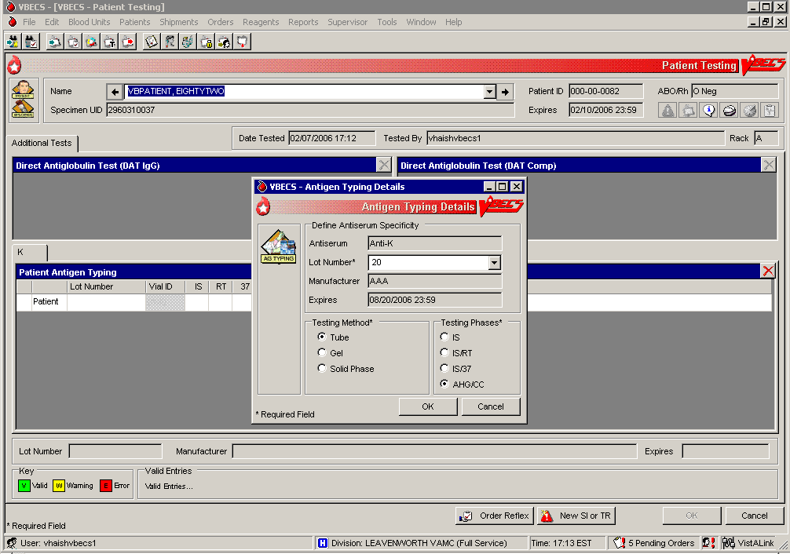

Figure 119: Patient Testing Antigen Typing (2)

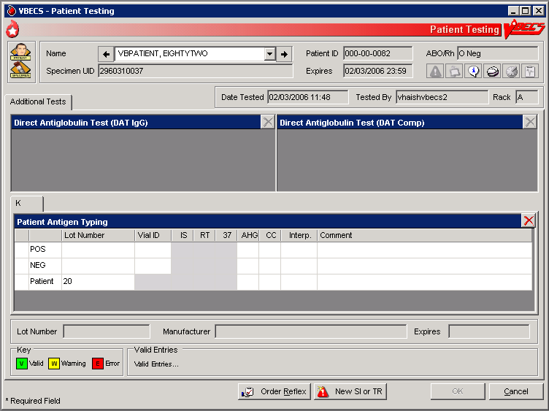

### Patient Testing: Enter Antibody Identification Results UC\_57

The user records results of reflex tests needed to complete a patient blood bank antibody workup.

#### Assumptions

* An order for an antibody identification (ABID) was placed and is opened in the Pending Task List (PTL).

#### Outcome

* VBECS displays the ABID in the patient’s record, which the user may review by clicking an icon in the Patient Information Toolbar.
* Entry of antibody specificity through this option may automatically set an antigen negative requirement [Transfusion Requirement (TR)] based on the division-specific parameters.

#### Limitations and Restrictions

* When an antigen negative requirement is not configured for an antibody, the user may enter the requirement for a patient through Special Instructions & Transfusion Requirements: Enter a Transfusion Requirement.

#### Additional Information

* Correction to verified patient data may be accessed only through Invalidate Test Results.
* Only one technologist at a time can enter test results for a selected PTL task.
* Patient antigen testing is not included in this option.

#### User Roles with Access to This Option

All users

#### Patient Testing: Enter Antibody Identification Results

The user may select workload codes for work performed on-site during the ABID workup. When the ABID is performed off-site, the user enters the associated charges.

| **User Action** | **VBECS** |
| --- | --- |
| 1. Select **Patients** from the main menu.   Select **Patient Testing**. | * Displays options for processing patient-related functions. * Displays the Pending Task List (PTL) in the Diagnostic Tests tab.   **NOTES**  A user may search for specific tasks using search criteria detailed in Pending Task List. |
| 1. Click one to four check boxes in the Pending Task List to select tasks for testing.   Click **OK**. | * Displays patient names and associated task information. |
| 1. Click a check box to select a reagent rack.   Click **OK** to continue with testing. | **NOTES**  No serologic testing is recorded for ABID. |
| 1. Select antibodies.   Enter associated testing details.  Respond to comments and continue.  Verify Patient information.  Click **OK**. | * BR\_57.02 Displays the list of antibodies and allows the user to select from the identified specificities and to add antibodies or to indicate that no antibody was identified.   **NOTES**  BR\_57.03 Multiple workload codes may apply when work is performed on-site. |
| 1. Review the selections displayed. Return to Step 1 to change selections when necessary.   Accept the reviewed entries. | * Displays applicable data fields for the ordered ABID. * Allows the user to indicate the testing site and associated billing from outside sources. |
| 1. Enter the location where testing was performed and cost, when off-site. | * Requires the user to indicate whether the ABID was performed at the division and/or off-site and saves that information with the ABID. * BR\_57.04 Allows the user to enter a charge, but not the workload, when the ABID work was performed off-site. * Allows the user to indicate multiples of any processes when a test was performed on-site. * Allows the user to enter comments. |
| 1. Review the antibody tests entered and comments selected and, when necessary, change them before accepting (Figure 120). | * Displays the requirements for antigen negative blood components, if any, based on the antibody entered. |
| 1. Click **OK** to save the information to the database. | * Saves the data. |
| 1. Click **OK** to exit. |  |

Figure 120: Patient Testing Antibody Identification

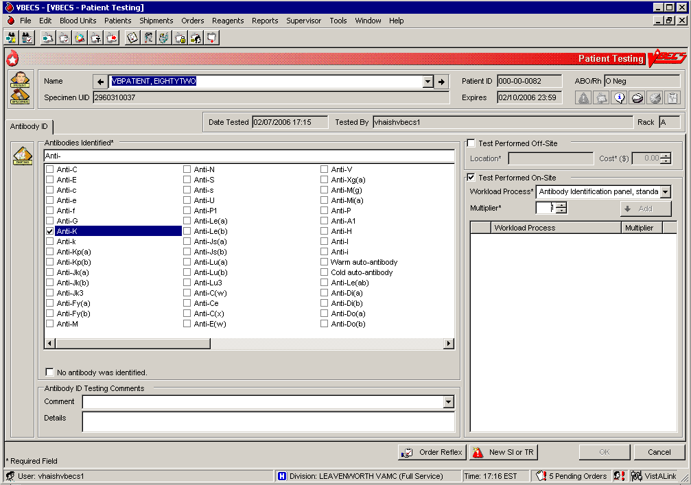

### Patient Testing: Record a Transfusion Reaction Workup UC\_21

The user documents a transfusion reaction workup (TRW).

#### Assumptions

* A TRW is ordered and is “not started” or “in progress” on the Pending Task List (PTL).

#### Outcome

* The user views or prints a preliminary TRW report of findings.
* Preliminary report findings are available for display in CPRS.

#### Limitations and Restrictions

* Adverse reactions to transfusion detected at a later time (disease transmission) are not recorded through this option. Refer to Transfusion Complications Report.

#### Additional Information

* All implicated units are added to data grids.
* Testing is based on local policies.
* BR\_21.30 VBECS allows the user to invalidate previously entered and saved information. When the user invalidates specimen data entered, VBECS invalidates the TRW.
* A delayed hemolytic transfusion reaction is typically identified about 7 to 10 days post-transfusion. It may be addressed in this option or as an antibody identification. (See Patient Testing: Enter Antibody Identification Results.)
* This test record is not editable after the user saves it to the database. When a correction needs to be filed, a corrected report must be generated, as described in Invalidate Test Results.
* See the printed chart copy for the medical director’s signature and TRW interpretation, as described in Finalize/Print TRW.
* A user may order a TRW prior to the completion of a unit’s transfusion record.
* The user must complete the unit’s transfusion record prior to implicating a unit in a TRW.
* These data remain encapsulated as part of the TRW and are not saved, compared to the patient record, or associated with other pre-transfusion grid testing.
* BR\_21.26 TRW ABO/Rh typing results are not saved as historical ABO/Rh typing results. These test records are maintained as part of the TRW only.

#### User Roles with Access to This Option

All users

#### Patient Testing: Record a Transfusion Reaction Workup

The user accepts the TRW order, inspects the sample for hemolysis, and performs implicated clerical checks. The TRW may require entry of patient data, including vital signs and serologic test results. A signed, printed TRW report must be filed with the patient’s chart.

Transfusion reactions may be worked up in stages depending on patient symptoms and serologic findings. The first stage includes the initial clerical and specimen checks. The second stage includes serologic test interpretations, including pre- and post-patient testing, ABO/Rh, ABS, XM, and DAT.

| **User Action** | **VBECS** |
| --- | --- |
| 1. Select **Patients** from the main menu.   Select **Patient Testing**. | * Displays options for processing patient-related functions. * Displays the Pending Task List (PTL) in the Diagnostic Tests tab.   **NOTES**  A user may search for specific tasks using search criteria detailed in Pending Task List. |
| 1. Click a check box in the PTL to select a task.   Click **OK**. | * Displays TRW patient order information and allows the user to indicate which portion of the TRW to perform (initial clerical and specimen checks).   **NOTES**  BR\_21.08 The TRW patient name and patient ID are visible at all times.  BR\_21.09 Initial clerical and specimen checks must be performed before TRW serologic testing is available. |
| 1. Enter the date the transfusion reaction was noted and the date it was investigated. | * Allows the user to document observations about the pre- and post-transfusion specimens. |
| 1. Click a radio button in the Specimen Checks tab to indicate whether pre- and post-transfusion specimens are available (Figure 121).   Scan or enter specimen UIDs in the Specimen UID fields and enter comments, as required.  Select an item from the drop-down menu in the Hemolysis Inspection field. | * Allows the user to enter the date and time the transfusion reaction was noted (provided by the clinician) and the date and time of the investigation (default: current date and time).   **NOTES**  BR\_21.15 When the pre- and/or post-transfusion samples are available to perform the clerical check, VBECS requires the user to indicate whether the clerical check is okay.  BR\_21.17 VBECS allows the user to scan or enter the pre- and post-transfusion specimen UIDs. VBECS compares the patient name and ID associated with each specimen UID to those associated with the TRW workup.  BR\_21.33 When the patient name does not match VBECS data for the TRW patient, VBECS emits an audible alert, warns the user, and instructs him to notify the physician immediately. VBECS allows the user to reenter the specimen UID or verify that the data are correct. VBECS requires a comment when there is no match and captures details for inclusion in an Exception Report (exception type: Transfusion Reaction Workup Specimen).  BR\_21.18 The user may enter “icteric,” “absent,” “1+,” “2+,” “3+,” or “4+” in the Hemolysis Inspection field to identify the presence or absence of hemolysis in the pre- and post-transfusion patient specimens or blood container, when available. |
| 1. Click the **Clerical Check OK** or **Clerical Check Failed** radio button to perform initial clerical and identification checks (Figure 122). |  |
| 1. Click **OK** to save, and **Yes** to confirm the save. | **NOTES**  BR\_21.11 When the user exits and saves the data, VBECS changes the task status of the TRW to “partially completed.”  A partially completed TRW may be corrected only by invalidating and reentering the TRW. |
| 1. Enter the date and time of the transfusion reaction noted by the clinician and the date and time of the reaction investigation. | **NOTES**  BR\_21.01 VBECS allows the user to enter the date and time of the reaction noted by the clinician.  BR\_21.02 When the implicated unit is unknown, VBECS allows the user to continue without identifying a unit or entering implicated unit information.  BR\_21.19 VBECS requires the user to enter the date and time of the TRW investigation (default: current date and time), including a date and time in the past for retrospective data entry. The user may not enter a future date and time.  If the user indicates that implicated units are unknown, he continues at Step 10. |
| 1. In the Implicated Units tab, click the **Implicated Unit(s) Identified** radio button to select an implicated unit.   Scan or enter the unit ID and product code.  Click the **Blood Bag Returned** or **Blood Bank Not Returned** radio button.  Select an item from the drop-down menu in the Hemolysis Inspection field.  Click the **Clerical Check OK** or **Clerical Check Failed** radio button to perform initial clerical and identification checks.  Enter a comment and details, as required (Figure 123).  Click **Add** to add the unit.  or  Click the **No Implicated Units** radio button.  Click **OK** to save, and **Yes** to confirm the save. | * BR\_21.03 Allows the user to: * Enter implicated unit information. * Indicate whether the bag and infusion set were returned. * Review and/or edit the entered information.   **NOTES**  BR\_21.10 When the user indicates that the blood bag was not returned, VBECS disables the hemolysis and clerical checks.  BR\_21.22 All implicated units entered are available for TRW ABO/Rh and TRW crossmatching. Actual data entry of test results for any entries is optional, based on a facility’s local policies and procedures.  The user may enter a free-text comment to document site-specific information such as other solutions or additives, urinary hemoglobin checks, and whether the product was warmed during transfusion. |
| 1. Repeat Step 8 for each implicated unit. | * Allows the user to enter the patient’s symptoms.   **NOTES**  BR\_21.07 VBECS accepts data for multiple implicated units and stores and reports them as part of the clerical check. When the user enters implicated unit data, VBECS adds the unit to TRW serologic testing. |
| 1. In the Symptoms tab, click the **Patient Symptoms Identified** radio button.   Click the check boxes to select one or more patient symptoms (Figure 124),  or  Click the **No Patient Symptoms Identified** radio button.  Click **OK** to save, and **Yes** to confirm the save. | * Allows the user to review and/or edit the entered data before it saves the record. * BR\_21.12 Allows the user to indicate that the TRW is complete. |
| 1. In the Serologic Tests tab, click a check box to select which tests to perform.   Select a rack from the drop-down list in the Rack field.  Click the **Using Automated Instrument** check box, as required.  Enter the name of the instrument in the Name field.  Click the **Instrument QC’d?** check box, as appropriate.  Enter interpretations for TRW testing (Figure 125). | * Allows the user to enter one or more additional TRW test interpretations: * TRW ABO/Rh testing * TRW ABS testing * TRW DAT testing * TRW XM testing * Requires the user to enter the rack name and test method to be applied to the specimens selected in this testing group for serologic testing. The user must also indicate whether an automated instrument was used in testing. * Displays the date and time the testing was performed (default: current date and time), which the user may edit retrospectively. * Displays the testing technologist’s identification (default: current user). Lists valid division users for the user’s selection.   **NOTES**  BR\_21.16, BR\_21.24 When no units were implicated or no pre- or post-transfusion specimens are available, VBECS disables those portions of the grid.  BR\_21.13 VBECS displays the standard TRW tests for the user to select to perform some, none or all. DR 5100  BR\_56.14 When a facility is “full service” and an automated instrument was used for testing, a user must enter the name of the instrument and may indicate that successful quality control testing was done for the testing date.  BR\_21.04, BR\_21.22 For implicated units, the ABO/Rh TRW, ABS TRW, DAT TRW, and Crossmatch TRW testing data grids are pre-populated with pre- and post-specimen data. Data entry of test results is optional, based on a facility’s local policies and procedures. |
| 1. Review the entries.   Click **OK** to save, and **Yes** to confirm the save. | * Stores data for retrieval. * Makes the findings viewable through a CPRS query.   **NOTES**  BR\_21.12 VBECS allows the user to indicate that the TRW is complete, then updates the TRW task status to “complete.”  BR\_21.06 Once the TRW is completed, the summary of results and observations includes the comment, “Final report to follow in hard copy with medical director evaluation of the transfusion reaction workup.”  BR\_21.21 VBECS indicates on the implicated unit’s patient transfusion record that it was implicated in a transfusion reaction and notes the patient’s name and ID and the date and time.  BR\_21.28 VBECS saves the record and one or more clerical checks are marked “failed,” VBECS emits an audible alert, requires a comment, and captures details for inclusion in an Exception Report (exception type: Transfusion Reaction Workup). |
| 1. Click **Finalize/Print TRW** and continue at Finalize/Print TRW to finalize the TRW (Figure 126), or   Click **Cancel** to complete the TRW and exit. | **NOTES**  A completed TRW indicates that serologic testing was completed. A finalized TRW indicates that the medical director reviewed the TRW, classified the reaction, and may make recommendations for future transfusions. |

Figure 121: Transfusion Reaction Workup: Specimen Check

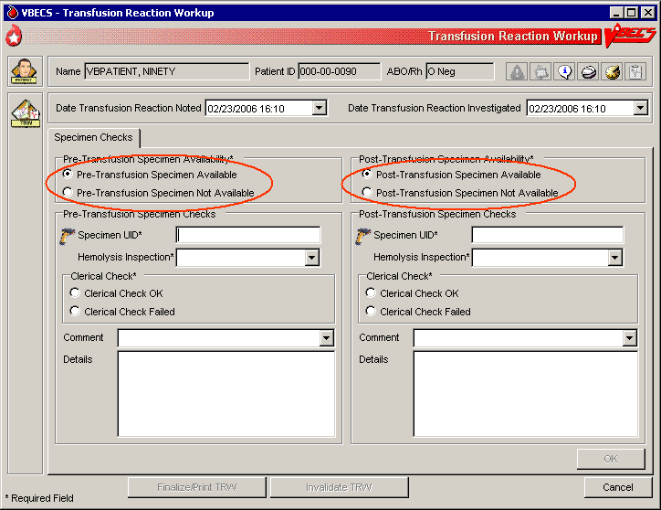

Figure 122: Transfusion Reaction Workup: Clerical Check

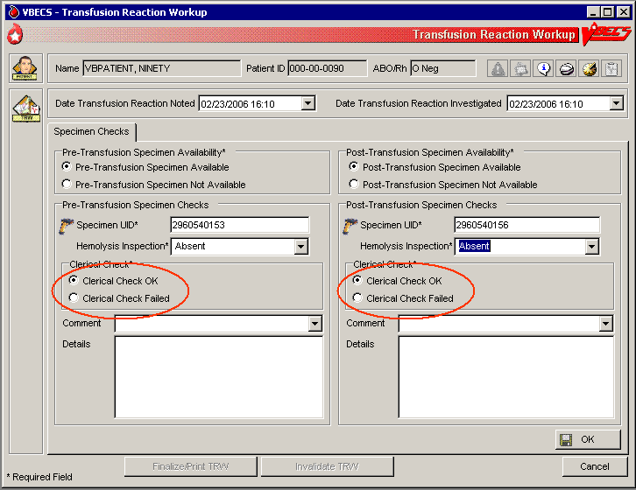

Figure 123: Transfusion Reaction Workup: Implicated Units

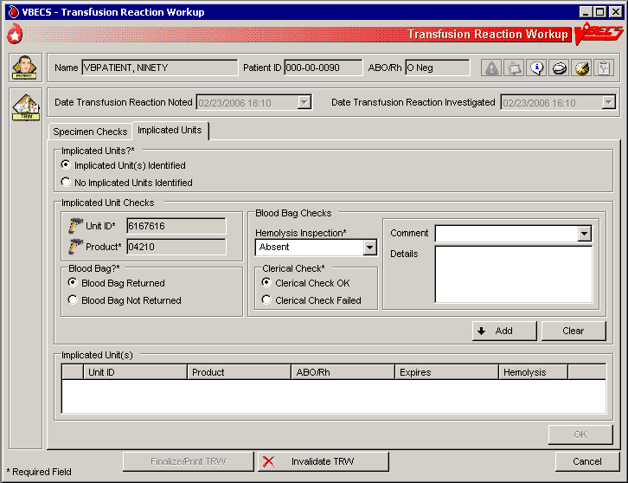

Figure 124: Transfusion Reaction Workup: Symptoms

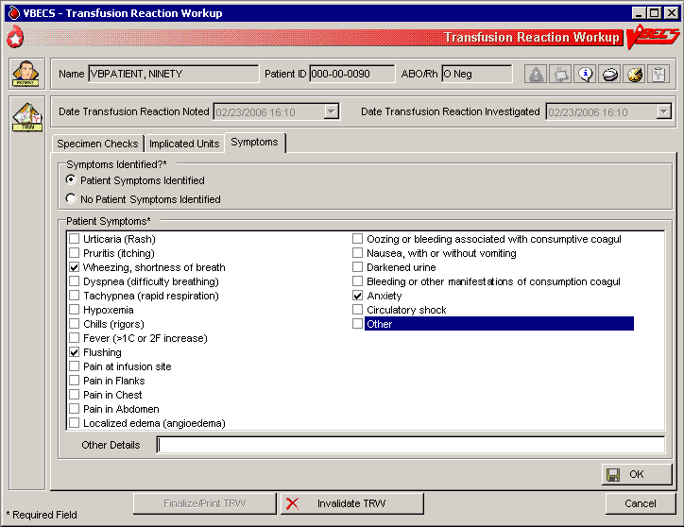

Figure 125: Transfusion Reaction Workup: Serologic Tests

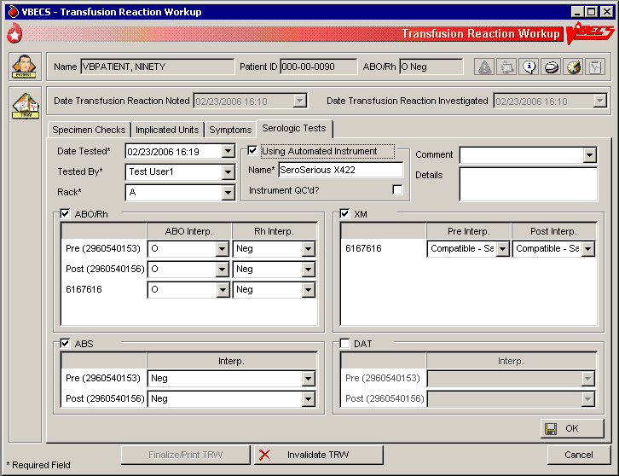

Figure 126: Transfusion Reaction Workup Report

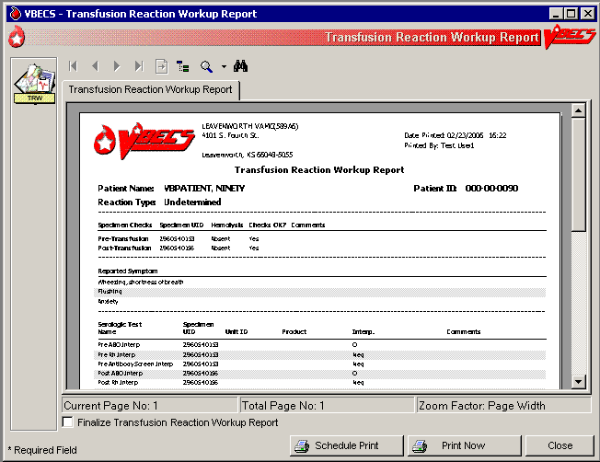

### Finalize/Print TRW UC\_78

The user finalizes and views and/or prints the Transfusion Reaction Workup Report.

#### Assumptions

* Patient Testing: Record a Transfusion Reaction Workup was completed.

#### Outcome

* The Transfusion Reaction Workup Report is available for printing and signing.
* Final report findings are available for display in CPRS.

#### Limitations and Restrictions

* The user cannot invalidate or change a finalized TRW.
* Transfusion reaction reports are not available to clinicians through CPRS: they must be printed and filed with patient charts.
* VBECS displays these default values for transfusion reactions converted from VistA to VBECS. They do not reflect actual interpretations or results: (DR 2,724)

| **Converted Transfusion Reaction** | **Default** |
| --- | --- |
| Pre-Transfusion Specimen Checks, Hemolysis Checks OK? | Yes |
| Post-Transfusion Specimen Checks, Hemolysis Checks OK? | Yes |
| Symptoms | No symptoms identified. |
| Implicated units | No units implicated in reaction. |
| Serologic tests | No serologic tests performed. |

#### Additional Information

* The medical director’s signature is on the patient’s printed chart.
* If a report needs to be replaced, the user may retrieve this report after it is complete. The final report is a printed document with the medical director’s signature.

#### User Roles with Access to This Option

All users

#### Finalize Transfusion Reaction Workup Report

 The Lead Technologist reviews the TRW details, identifies the type of reaction, and adds comments, according to the medical director’s instructions. The user prints a copy for the medical director’s signature and the Lead Technologist finalizes the TRW, generating a preliminary report. The final printed report requires the signature of the medical director.

| **User Action** | **VBECS** |
| --- | --- |
| 1. Select **Reports** from the main menu.   Select **Finalize/Print TRW**.  Click the **Include Non-Finalized TRW Reports** check box (Figure 127).  Select a completed TRW to finalize.  Click **OK**. | * Lists report names. * Lists the completed TRWs for selection.     **NOTES**  BR\_78.04 When the user enters and saves the portion recorded in Patient Testing: Record a Transfusion Reaction Workup, the TRW status is “completed.” When the Transfusion Reaction Workup Report is complete, the TRW status is “finalized.” |
| 1. Click the **Finalize Transfusion Reaction Workup Report** check box. | * Prepares the completed report for review. * Displays the name of the blood bank medical director to sign the final report. * BR\_78.03 VBECS recreates the final report for viewing or printing in the future. |
| 1. Select the Transfusion Reaction Type and complete the Transfusion Reaction Comments required fields (Figure 128). | * Displays the selected Transfusion Reaction Workup Report data. * Requires the user to select a transfusion reaction type listed in Table 12: PT\_78.01 Transfusion Reaction Types. * Allows the user to enter a TRW comment (maximum 1,000 characters). DR 4788 * Allows the user to save the data entered.   **NOTES**  BR\_78.02 The user must indicate one transfusion reaction type. Entry of a comment is optional for all types except O (other), which requires details to be entered. |
| 1. Click **OK** and **Yes** to save. | * Updates the transfusion reaction to “finalized” in the database and prints a report for the medical director’s signature.   **NOTES**  BR\_78.06 VBECS notifies the user when DSS updates cannot be sent because VistALink is not active.  BR\_102.09 VBECS will attempt to resend the DSS information when VistALink is available after any user logs into the VBECS application’s VistALink connection. |
| 1. Select **Schedule Print** or **Print Now** and follow the instructions to print. | * Prints the report on the selected printer. |
| 1. Click **Close** to exit. |  |

Figure 127: Select Transfusion Reaction Workup

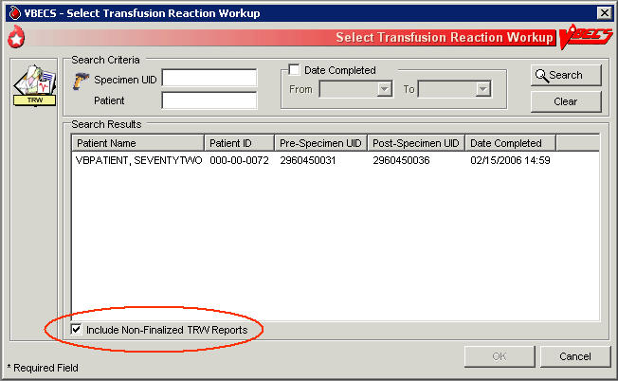

Figure 128: Finalize TRW Report DR 5107

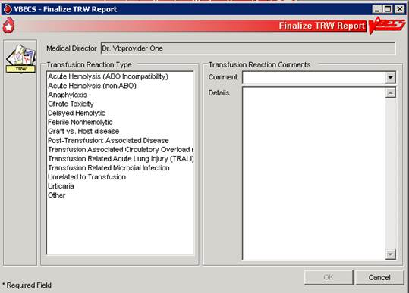

#### View/Print a Finalized Transfusion Reaction Workup Report

The user views and/or prints the finalized Transfusion Reaction Workup Report.

| **User Action** | **VBECS** |
| --- | --- |
| 1. Select **Reports** from the main menu.   Select **Finalize/Print TRW**.  Select a completed TRW (Figure 126). | * Lists report names. * Displays the selected Transfusion Reaction Workup Report data. * Displays an option to view and/or print a finalized TRW by selecting a patient.   **NOTES**  BR\_78.01 The user finalizing the report may not edit previously entered TRW data. |
| 1. Select a patient. | * Compiles the report and displays an option to print the report or exit.   **NOTES**  BR\_78.05 Details included in the finalized TRW report:   * Patient name * Patient ID * Specimen UID * Reported symptoms * Specimen clerical checks (pre-, post-, and unit) * Serologic testing (if performed, interpretations only) * Transfusion reaction type * Comment * Implicated units (include from Patient Testing: Record a Transfusion Reaction Workup ) * TRW report completed by: * Date and time the report was completed * Signature line for the medical director * Line for the date and time the medical director completed the review * Finalized by * Finalized date and time |
| 1. Select **Schedule Print** or **Print Now** and follow the instructions to print. | * Prints the report on the selected printer. |
| 1. Click **Close** to exit. |  |

Table 12: PT\_78.01 Transfusion Reaction Types

| **Transfusion Reaction Type Text** |
| --- |
| Anaphylaxis |
| Citrate Toxicity |
| Delayed Hemolytic |
| Febrile Nonhemolytic |
| Graft vs. Host Disease |
| Acute Hemolysis (non ABO) |
| Acute Hemolysis (ABO Incompatibility) |
| Transfusion Associated Circulatory Overload (TACO) |
| Transfusion Related Acute Lung Injury (TRALI) |
| Transfusion Related Microbial Infection |
| Post-Transfusion: Associated Disease |
| Unrelated to Transfusion |
| Urticaria |
| Other: free-text data required on new entries |

## 

## Maintain Patient Records

### Special Instructions & Transfusion Requirements: Enter a Transfusion Requirement UC\_38

The user enters or inactivates the Transfusion Requirements (TRs) in the patient’s record by division.

#### Assumptions

* The patient exists in the VBECS database.

#### Outcome

* VBECS displays TRs to all divisions within a multidivisional database. The division in which they were entered maintains and controls them.
* VBECS maintains a historic record of changes to the patient’s TRs.

#### Limitations and Restrictions

* Inactivation is defined and restricted by security level.
* VistA Special Instructions (SIs) from database conversion do not become TRs: they remain SIs. SIs are information only and are not enforced unless entered in the Component Requirements tab in Special Instructions & Transfusion Requirements.

#### Additional Information

* No current patient specimen or order is required to access this option.
* When TRs are not met, VBECS prohibits the printing of the Caution Tag and Blood Transfusion Record Form (BTRF) and prevents issue of the blood unit.
* BR\_38.04 User-entered antigen negative requirements are persistent. VBECS enforces them even when they are in conflict with the division’s antibody table settings.
* Patient antibody identifications from VistA are included in the database conversion.
* By default, inactivation of an antibody removes requirements for antigen negative blood derived from the antibody entry.

#### User Roles with Access to This Option

All users

#### Special Instructions & Transfusion Requirements: Enter a Transfusion Requirement

The user assigns patient blood component requirements or indicates the need for antigen negative blood to be applied during blood component selection and issue.

VBECS displays TR data and applies requirements during blood unit selection.

All items in these TR categories indicate the need for pre-transfusion processing of a unit before the unit may be issued to the patient. All users may activate entries.  Only a Traditional Supervisor may inactivate a component requirement for a patient. A patient may have one or more TRs: BR\_38.01

* Irradiate cellular products\*
* Leukoreduce cellular products
* Washed RBC products
* Washed PLT products
* Sickle Cell Negative RBC products
* CMV negative cellular products\*
* Antibodies Identified
* Antigen Negative RBC: A user or VBECS may create an antigen negative requirement.

\*All product types in OTHER are evaluated for the requirement including those that are non-cellular.

| **User Action** | **VBECS** |
| --- | --- |
| 1. Select **Patients** from the main menu.   Select **Special Instructions & Transfusion Requirements**, or  Click small_si_tr in the Patient Information Toolbar, when it is active. | * Displays options for processing patient-related functions. * Displays the option to select a patient, if one is not already selected.   **NOTES**  The user may also click **New SI or TR** in Patient Testing to access this option. |
| 1. Select the **Antigen Negative RBCs**, **Component Requirements**,or **Antibodies Identified** tab (Figure 129). | * Displays the patient’s TRs. * Allows the user to add or inactivate information based on his security level.   **NOTES**  BR\_38.10 When a user accesses antigen negative requirements, VBECS displays and enforces the antigen negative requirement for the patient, regardless of the division setting for the antibody.  When a user accesses the Antibodies Identified tab, VBECS compares the patient’s antibodies with the division’s antibody table setting. When the antibody is set to require antigen negative blood at issue, VBECS displays and enforces the antigen negative requirement. |
| 1. Select a TR from the pick list, or enter an antigen or antibody, as the tab allows.   Click **Add** to move the selection to the patient’s record.  Click **OK** when all TRs are selected to save them to the patient’s record.  Click **Yes** to confirm changes and exit. | * BR\_38.06 Allows multiple selections from the Component Requirements, Antibodies Identified, and Antigen Negative tabs.   **NOTES**  VBECS applies the TR to component classes, as indicated.  BR\_38.16 The user may not add duplicate SIs or TRs in the same session, but may duplicate them in another session.  BR\_38.07 The division code and date of entry are associated with the entered component or antigen negative requirement, or antibody specificity so that other divisions will to know whom to contact for further information, when needed. The original entries may have been made through Patient Testing (associated with an antibody identification) or TRs from any division within a multidivisional database. |
| 1. Select the TR to be inactivated (Figure 130).   Select and/or enter an explanatory comment and click **OK**. | * Allows the user to enter a comment.   **NOTES**  BR\_38.13 When a Transfusion Requirement is inactivated in any division in a multidivisional configuration, a comment (free text or from a canned comment with the context: Transfusion Requirement Inactivation) must be added that will be saved and printed on the audit trail of originating division alerting the originating division of the change to the patient’s TR setting if they were not consulted regarding that change. DR 4598  Note: It is best practice that inactivating a TR in the non-originating division involves a consultation with the originating division and allowing the originating to make the change with any locally required documentation.  For inactivation of an item:   * BR\_38.09, BR\_38.12, BR\_38.14  A Traditional Supervisor from any division may inactivate TRs and persistent antigen negative requirements in a multidivisional database regardless of the source of the TR. * BR\_38.15 When an antibody specificity is inactivated, VBECS inactivates the corresponding calculated (VBECS-generated) antigen negative requirement. * BR\_38.11, BR\_38.03 For antibodies identified, VBECS displays a summary of antibodies currently associated with the patient and identifies their source. Additional antibodies may be added and previously identified antibodies may be inactivated. |
| 1. Return to Step 2 to continue editing the patient’s TRs. |  |
| 1. Accept entries and exit, or   Return to Step 1 to make entries for a different patient. |  |

Figure 129: Enter Patient Special Instructions and Transfusion Requirements

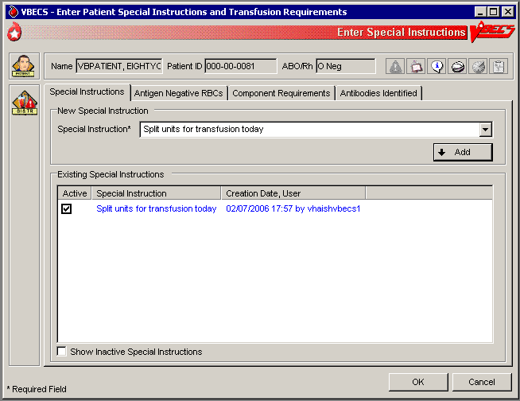

Figure 130: Inactivate Component Requirements

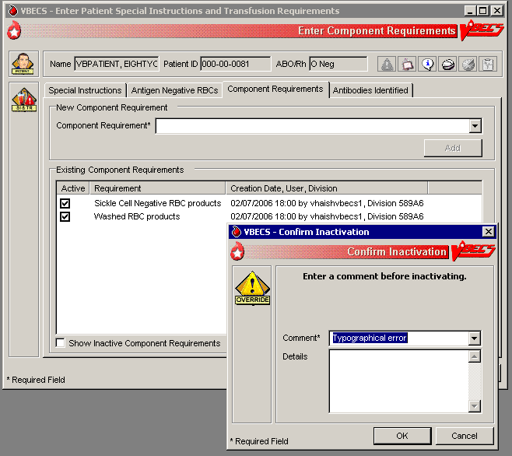

### Special Instructions & Transfusion Requirements: Enter and Remove Special Instructions UC\_37

The user enters comments in a patient’s file that are not enforced by VBECS.

#### Assumptions

* Fields containing Special Instructions (SIs) may be populated during database conversion.

#### Outcome

* When the user searches for a patient or when the Patient Information Toolbar is displayed, VBECS displays small_si_tr to alert the user to view the patient’s SI entries.
* When a user retrieves a patient record and is in a multidivisional setting, he may view SIs created in all divisions within the database.

#### Limitations and Restrictions

* VBECS does not enforce Transfusion Requirements (TRs) or antigen negative requirements entered through this option.
* SIs moved to VBECS during the database conversion may contain information that must be entered as TRs in VBECS. Inactivate the old SI and create a TR and new updated SI: the database conversion software cannot automatically translate the SI from database conversion into a rule-based TR.
* VBECS will truncate SI text from the VistA database conversion.

#### Additional Information

* Inactivation of patient SI entries is allowed only in the division of entry.
* Only currently active SIs at a division will automatically display via the database to all divisions.
* Inactive SIs are not deleted from the VBECS database. They may not be reactivated but may be viewed in the maintenance fields when requested.
* Canned comments in the Special Instructions context must be entered by the division before they can be selected for use.
* BR\_37.03 Previously saved Special Instructions that require editing due to context or spelling errors must be inactivated and reentered in total.
* Database conversion entries are labeled as such. BR\_37.05
* SIs from database conversion may include component or antigen negative requirements that must be entered in TRs so that VBECS can enforce them.

#### User Roles with Access to This Option

All users

#### Special Instructions & Transfusion Requirements: Enter a Special Instruction

A user may add to and inactivate SI comments in a patient’s blood bank record. Users in all divisions in a multidivisional database may view these comments.

|  |  |
| --- | --- |
| **User Action** | **VBECS** |
| 1. Select **Patients** from the main menu.   Select **Special Instructions & Transfusion Requirements**, or  Click small_si_tr in the Patient Information Toolbar, when displayed. | * Displays options for processing patient-related functions. * Displays the option to select a patient, if one is not already selected.   **NOTES**  The user may also click **New SI or TR** in Patient Testing to access this option. |
| 1. Select a patient.   Click **OK**. | * Displays options to select a patient. * Displays the option to enter a new comment or remove an existing comment in the division. * Displays the active SI entries in reverse chronological order with all active SIs first, along with date, division code, and text of the entry.   **NOTES**  The need for SIs is usually temporary and may not be required for all transfusions.  The user may choose to display inactivated SI comments. |
| 1. Select the **Special Instructions** tab (Figure 131).   Click the **Show inactive special instructions** check box to display inactivated SI entries. | * Allows the user to enter or inactivate comments. * Displays inactive Special Instructions but does not allow the user to reactivate them.   **NOTES**  BR\_37.01 A user may add or inactivate a patient-specific comment at any time in the division in which it was entered.  BR\_37.06  A Traditional Supervisor may inactivate SIs from database conversion. |
| 1. Confirm the activation of the entry and enter a comment.   Click **OK**.  Return to Step 2 to add more SIs for this patient.  Select another patient and return to Step 1, if desired.  Exit. | * Saves the entry in the database. |

Figure 131: Enter Patient Special Instructions and Transfusion Requirements

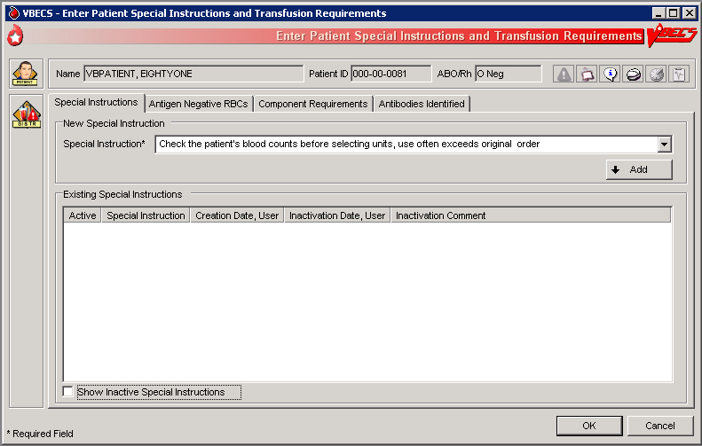

## Post-Transfusion Information UC\_69

The user enters post-transfusion details from the Blood Transfusion Record Form (BTRF) or VBECS saves post-transfusion details received from the Transfusion Verification System.

#### Assumptions

* The BTRF is returned and completed for each unit.
* The unit status is “issued” or “presumed transfused” in VBECS.
* Interface connections to the BCE COTS system are enabled to receive transfusion update messages.

#### Outcome

* The unit status is updated to “transfused.”
* The VBECS patient record includes the blood transfusion information.

#### Limitations and Restrictions

* VBECS cannot update a unit record to presumed transfused when a user has that unit record open (locked) in Enter Post Transfusion Information. VBECS will attempt to update the unit the next time the presumed transfused background routing runs if the unit remains in an issued status. DR 3089
* If post-transfusion information is not transmitted to VBECS by the BCE COTS interface, the user will need to enter that information to update the record from presumed transfused to transfused.
* The transfusion comments and volume transfused entered in the Transfusion Verification application as an update to a completed transfusion are not sent to VBECS. DR 4173
* Transfusion reaction symptoms are not provided to VBECS by the Transfusion Verification application unless a transfusion reaction has also been indicated for that event. DR 4217

#### Additional Information

* A user with the appropriate security level may enter or edit bedside verification information unless it is received from BCE COTS interface.
* BR\_69.09 The user may indicate that a transfusion reaction and symptoms were noted on the BTRF as free text. Noting a transfusion reaction does not create an order for a transfusion reaction workup (TRW).
* Remove a “transfused” status through Remove Final Status unless that unit was transfused by the Transfusion Verification application. See limitations in Remove Final Status.

#### User Roles with Access to This Option

All users

#### Post-Transfusion Information

The user verifies the date and time transfused with a returned BTRF, adds other transfusion details, initiates a system check of the bedside verification information, enters that information, and indicates whether a reaction occurred during or immediately after the transfusion, as documented on the BTRF. VBECS does not require entry of post-transfusion information: once a day, without user input, VBECS moves units 48 hours after issue to “presumed transfused” statusUserDoc Task 1098.

| **User Action** | **VBECS** |
| --- | --- |
| 1. Select **Patients** from the main menu.   Select **Post-Transfusion Information**. | * Displays options for processing patient-related functions. * Displays an option to scan the Caution Tag or enter a patient name or ID. |
| 1. Select a patient and click **OK**. | * BR\_69.02 Lists the units issued to the selected patient. * Displays the issue date and time. * Displays the units one at a time for update in the order in which the user selected them.   **NOTES**  BR\_69.03  VBECS displays an option to obtain a list of transfused (those not received by BCE COTS) units for the patient when the user is a Traditional Supervisor or above.  BR\_69.01 When post-transfusion information is not entered into VBECS within 48 hours from the date/time the unit was recorded as “issued”, VBECS will change the unit status to “transfused” with a presumed indicator after the execution of a scheduled background job. The unit will then be considered transfused by the system regarding report generation. If post-transfusion information is entered later, the presumed indicator is deactivated. |
| 1. Click one or more check boxes to select units (Figure 132).   Click **OK**. | * Allows the user to select units for which to enter post-transfusion information.   **NOTES**   BR\_70.06 VBECS does not list units (for selection) with a final status. When a user enters a unit with a final status, VBECS alerts the user and clears the screen. The user may select another unit. |
| 1. Enter transfusion details for a blood unit.   Verify the unit selection. | * Displays the unit information entered by the bedside verification check and allows the user to enter to edit the information. * Displays an option to enter or edit unit data.   **NOTES**  BR\_69.05  A user with a security setting of Traditional Supervisor may edit user entered bedside verification, transfusion reaction, or post-transfusion detail information.  BR\_69.08 VBECS displays an option to enter information for each unit. This information is available for patient record retrieval. |
| 1. Select one or more units. Enter or edit the bedside verification check information with the proper security level. | * Displays the entries for review, including the comment, until all details are entered. * Displays an option to save the data and exit.   **NOTES**  BR\_69.12 Upon data entry and saving of the post-transfusion information, VBECS assigns a status of “transfused” for the unit of blood assigned to the indicated patient. |
| 1. Enter post-transfusion details, including:  * Transfusion start and end dates and times * Transfusionist ID * Location of transfusion * Whether the transfusion was completed or interrupted * If interrupted, the amount transfused * Whether there was a transfusion reaction * If there was a reaction, symptoms (Figure 133)   Click **OK** to save. | * Displays an option to enter unit data. * Warns the user or allows the user to continue to the next selected unit.   **NOTES**  When a user indicates that a transfusion reaction occurred, VBECS does not automatically order a TRW.  BR\_69.06 VBECS notifies the user when the transfusion end date and time is earlier than the start or issue time. The user may correct the entry.  BR\_69.10 When the unit was not issued to a remote storage location, VBECS compares the date and time the unit was issued to the start transfusion time entered.  When the difference is greater than 30 minutes, VBECS notifies the user that this is a delayed start time and allows the user to edit the transfusion start date and time. **No** allows the user to continue. **Yes** allows the user to edit the date and time the transfusion ended. When the user edits the date and time transfused, VBECS repeats this process until the user stops editing and chooses to continue.  BR\_69.11 When the unit was not issued to a remote storage location, VBECS compares the date and time recorded as the transfusion end time to the start date, calculates the transfusion time in minutes, and compares this period to the maximum transfusion time for the component class. When the calculated transfusion time for this unit exceeds the defined maximum transfusion time for the component class, VBECS notifies the user that this is a prolonged transfusion and allows the user to edit the transfusion end date and time. **No** allows the user to continue. **Yes** allows the user to edit the date and time the transfusion ended. When the user edits the date and time transfused, VBECS repeats this process until the user stops editing and chooses to continue. |
| 1. Respond to warnings or continue to enter data for the next unit. | * Allows the user to repeat for subsequent selected units until all details are entered. * Displays an option to save the data and exit.   **NOTES**  BR\_69.13 VBECS saves all transfusion information for future retrieval and reporting as part of the patient and unit historic records.  BR\_78.06 VBECS notifies the user when DSS updates cannot be sent because VistALink is not active.  BR\_102.09 VBECS will attempt to resend the DSS information when VistALink is available after any user logs into the VBECS application’s VistALink connection |
| 1. Exit. |  |

Figure 132: Post-Transfusion Information

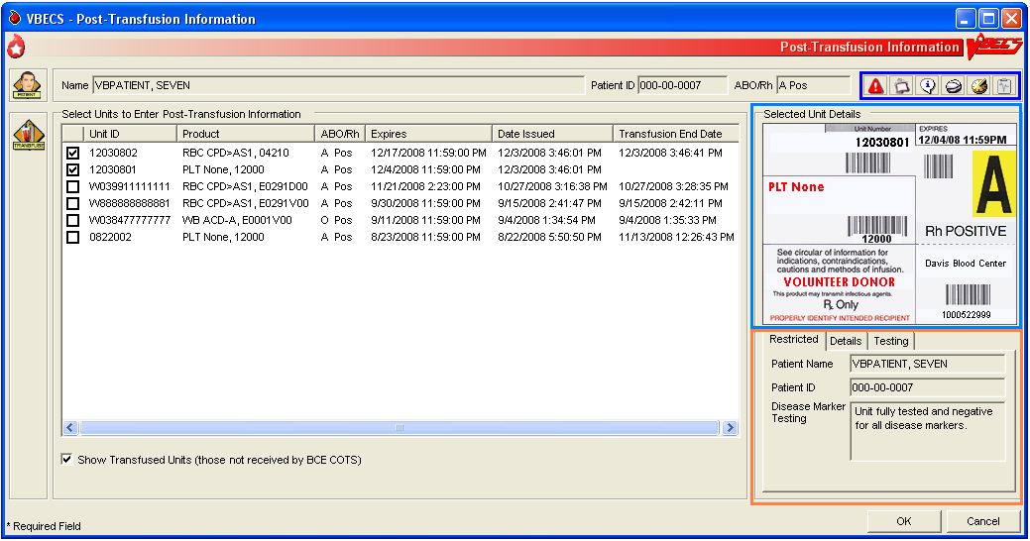

Figure 133: Post-Transfusion Information Details

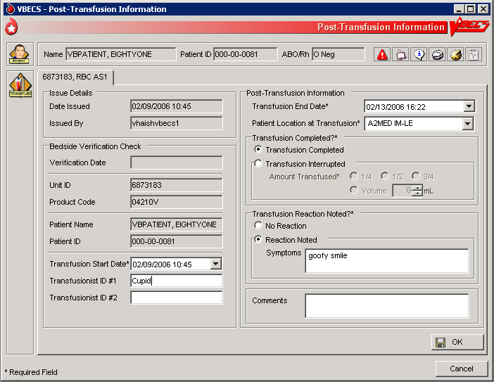

#### Automated Entry of Post-Transfusion Details from BCE COTS Application

VBECS receives and saves the details of a unit transfusion episode as recorded in the BCE COTS system.

| **User Action** | **VBECS** |
| --- | --- |
| 1. BCE COTS system user completes a transfusion for a patient which triggers a HL7 message containing transfusion information to VBECS for a blood unit. | * BR\_69.23 VBECS rejects a BCE COTS HL7 message when data elements are not acceptable per the data entry rules for manual entry.   **NOTES**  Units that are not updated by a BCE COTS message will be marked presumed transfused 48 hours after issue by a VBECS background process.  Transfusion information is available in the Unit History Report. |
| 1. VBECS updates the patient transfusion record with the details received in the successfully acknowledged HL7 message. | * BR\_69.21 VBECS generates an exception report entry: Electronic Transfusion Record Update when a BCE COTS update to a previously saved manually or electronically entered transfusion record is received. * BR\_69.20 When an update to a previously saved transfusion record is made by BCE COTS or a user, VBECS will display the original entry and the updated details in the Patient History and Unit History Reports.   **NOTES**  BR\_69.18 The BCE COTS system delivers these patient and unit specific transfusion data elements to VBECS for update   * Bedside verification date and time * Transfusion verification manual Unit ID entry reason * Transfusion Start date and time * Transfusionist ID #1 * Transfusionist ID #2 (may be blank if so configured in BCE COTS application) * Transfusion End Date and time * Patient location at Transfusion * Transfusion interrupted indicator * Transfused volume, (ml not in fractions by the BCE COTS) * Transfusion Reaction noted * Transfusion Reactions symptoms entered, if any * Transfusion comments, if any |

## Document ABO Incompatible Transfusions UC\_69

The user enters post-transfusion details from the Blood Transfusion Record Form (BTRF) to document ABO incompatible and other inadvertent transfusions.

#### Assumptions

* A unit was transfused to a patient other than the intended recipient.
* The connection to VistA is active.

#### Outcome

* The unit status is updated to “transfused.”
* The patient record includes the blood transfusion information.

#### Limitations and Restrictions

* VBECS does not enforce compatibility checks between the patient and the unit.
* VBECS does not update CPRS component order status when the Document ABO Incompatible Transfusion option is used.

#### Additional Information

* FDA guidances govern when to file blood product deviation reports.
* Follow local policy and procedures for additional reporting requirements.
* VBECS requires a specimen and an order placed through CPRS to process transfusions. When a patient was transfused and no specimen was collected or order placed for blood components, the user may record the transfusion using this option. UserDoc Task 1087

#### User Roles with Access to This Option

 Traditional Supervisor

#### Document ABO Incompatible Transfusions

When a unit is transfused to the incorrect patient, the user enters transfusion details for that unit.

 VBECS does not enforce compatibility checks to allow consistent and accurate online availability of a unit’s final disposition.Use of this option is restricted to supervisory blood bank personnel who have thoroughly investigated the transfusion and documented the inability to use normal VBECS business processes to enter the transfusion documentation.

| **User Action** | **VBECS** |
| --- | --- |
| 1. Select **Supervisor** from the main menu.   Select **Document ABO Incompatible Transfusion**. | * Displays options for processing patient-related functions. * Displays an option to scan the Caution Tag or enter a patient name or ID. |
| 1. Select a patient and click **OK**. | Displays an option to select a patient that may not be available from the VBECS files.  **NOTES**  Displays a message when the user selects a patient with a blank first or last name, or the name is too long. The user is instructed to contact the VBECS Administrator for assistance. DR 3444 |
| 1. Select a unit to document a transfusion that does not follow system rules. | * Displays an option to enter a unit ID and product code or search for one.   **NOTES**  VBECS presents all units in the system for selection when the search button is used. This search will require time to complete as the number of units to display increases. DR 3516  BR\_69.14 VBECS does not enforce compatibility checks in this option.   BR\_70.06 When a user enters a unit with a final status, VBECS alerts the user and clears the screen. The user may select another unit. |
| 1. Enter post-transfusion details and a comment. | * Displays an option to enter or edit unit data. See Post-Transfusion Information. * BR\_69.16 VBECS emits an audible alert, requires a comment, and captures the transaction details for inclusion in an Exception Report (exception type: ABO incompatible unit transfused). * Displays the entries for review, including the comment, until all details are entered. |
| 1. Click **OK** and **Yes** to save. | * Saves the data. * Allows the user to enter comments and details. |
| 1. Enter or select a comment and details, in accordance with local policy and procedures.   Click **OK**. | **NOTES**  BR\_69.13 VBECS saves transfusion information for future retrieval and reporting as part of the patient and unit historic records.  BR\_69.12 Upon data entry and saving of the post-transfusion information, VBECS assigns a status of “transfused” to the unit of blood for the indicated patient.  VBECS captures details of this override in an Exception Report. |
| 1. Exit. |  |

### Justify ABO/Rh Change UC\_100

The user changes a patient’s historical blood type only when there is a clinical change in blood type, not to correct an error. (See Invalidate Test Results.)

#### Assumptions

* The patient has a previous ABO/Rh on record from the user’s current division, from a different division within the database, or from the database conversion.
* The patient has a current specimen test result with an ABO/Rh interpretation that doesnot match the historical record. Both previous and current specimen test results are valid.

#### Outcome

* BR\_100.03 VBECS permanently marks the patient record and the specimen test to indicate that the patient has a justified ABO/Rh change, regardless of the user’s division.
* BR\_100.05 The justified ABO/Rh on the patient record forces the user’s selection to be used as the new historical record, replacing the current test result as the historic record. VBECS does not check for ABO/Rh discrepancies with tests entered for this patient prior to the justified test result.
* VBECS permanently disallows electronic crossmatch (eXM) for this patient.

#### Limitations and Restrictions

* VBECS does not allow the selection or issue of certain blood components that may appear ABO/Rh compatible when discrepant ABO/Rh results are not justified.

#### Additional Information

* BR\_100.07 When the discrepant ABO/Rh tests are on the same specimen, the user may not justify the patient’s ABO/Rh.
* Do not use this option for ABO/Rh discrepancies that occur because the patient had a recent transfusion of a component of a type other than his own.
* ABO/Rh discrepancies that occur because the previously tested or current specimen was tested in error are handled by inactivating the previously recorded test results through Invalidate Test Results.
* Subsequent specimens may need to be justified in the presence of continued discrepant ABO results.
* This option is used in rare clinical situations such as following bone marrow transplant.

#### User Roles with Access to This Option

 Traditional Supervisor

#### Justify ABO/Rh Change

The user determines that the patient’s current ABO/Rh testing results are valid, although they differ from previously recorded results, and that the patient requires a justification indicator on his record.

This option is used only when both the previous specimen testing and the current specimen testing are considered valid. There is a valid explanation for why the ABO/Rh interpretations do not match and invalidation of the test result is not appropriate. Once the current patient ABO/Rh result change is justified, VBECS marks the patient’s record so that special handling for component orders for the patient apply from thispoint forward and remain in effect until the patient record is inactivated by the recording of his death in VBECS or by removing the justification.

| **User Action** | **VBECS** |
| --- | --- |
| 1. Select **Supervisor** from the main menu.   Select **Justify ABO/Rh Change**. | * Displays options available to supervisors. |
| 1. Enter a patient name in the Patient field and click **Search** to select a patient.   Select a patient.  Click **OK**. | * Displays a screen for patient selection. * Disallows the justification or allows the user to continue.   **NOTES**  BR\_100.01 VBECS compares the results of the current ABO/Rh with the previous ABO/Rh results. When there is no discrepancy, VBECS warns that no justification is required. There is no override. VBECS clears the screen and the user may select another patient.  BR\_100.06 VBECS warns the user to use this option only when both the current and previous specimen tests are valid, otherwise, use Invalidate Patient Test Results. |
| 1. Select an ABO/Rh interpretation as the patient’s justified historical record (Figure 134). | * Displays details of the historic and current ABO/Rh testing for comparison and a list of available ABO and Rh types for user selection. * Requires a comment to continue.   **NOTES**  BR\_100.04 The user may select one ABO group and one Rh type for the patient to serve as the justified ABO/Rh typing in the historic record. VBECS displays the current ABO and Rh interpretations as the defaults.  BR\_100.02 VBECS requires a comment to continue. |
| 1. Confirm the update of the database with the justified ABO/Rh.   Exit. | * Updates the patient record. |

Figure 134: Justify ABO/Rh Change

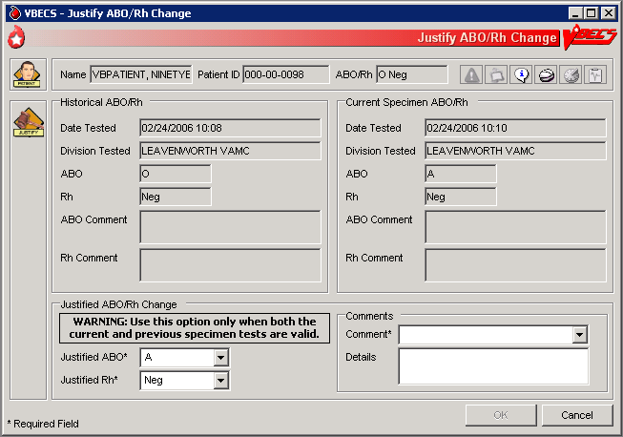

# Reports

The report information that is presented on-screen, not the print preview, can be sorted by clicking on each column header. The sort changes made do not apply to the printed reports. Reports print in a default sort order.

**Note:** Switching to Normal layout view from Print layout view so the user can search the report may cause the error message **“Error. Thread was being aborted.”** to appear for a large report. The report proceeds to load in the different layout view chosen by the user. This is a normal behavior of a report engine and no harm is done. DR 5059

## Administrative Data Report UC\_107

The user views and/or prints the Administrative Data Report.

#### Assumptions

* Data are available for inclusion in the report.

#### Outcome

* The user views and/or prints the report.

#### Limitations and Restrictions

* None

#### Additional Information

* The report is available as a single-division or multidivisional (all divisions) report.

#### User Roles with Access to This Option

All users

#### Administrative Data Report

The user views and/or prints the Administrative Data Report, which includes blood product transactions for a given date range.

| **User Action** | **VBECS** |
| --- | --- |
| 1. Select **Reports** from the main menu.   Select **Administrative Data Report**. | * Lists report names. * Displays report compilation criteria. * Displays a date range for selection. |
| 1. Click the **Current Divisions** or **All Divisions** radio button. | * Allows the user to select one or all divisions.   **NOTES**  For each component class and its subdivisions, VBECS tallies:   * BR\_107.01 Products received * BR\_107.02 Products modified/prepared * BR\_107.03 Units transfused * BR\_107.04 Units shipped * BR\_107.05 Outdated units * BR\_107.06 Discarded credit units * BR\_107.07 Discarded waste units |
| 1. Enter or select start and end dates. |  |
| 1. In the Report Compilation area, click the **Create Report Now** radio button. Click **OK** to view the report, or   Click the **Schedule Print Job** radio button and **OK**, then enter or select a print date and printer name. Click **OK** to view and print the report. | * Compiles and displays the report.   **NOTES**  VBECS prints scheduled reports once an hour. For example: a report is scheduled by the user to print at 1:30PM. VBECS will not print the document at 1:00PM but will print at 2:00PM. DR 4013 |
| 1. Select **Print** to print the report and exit, or click **Close** to exit without printing. | * Prints the report on the selected printer. |

## Audit Trail UC\_77

The user views and/or prints an Audit Trail Report.

#### Assumptions

* Data are available for inclusion in the report.
* The user must be logged into the division in which the report is to be generated.

#### Outcome

* The user views and/or prints the report.

#### Limitations and Restrictions

* VBECS does not accommodate online review (verification, signature) of reports.

#### Additional Information

* Audit trail entries reflect the actual date and time the change was made.

#### User Roles with Access to This Option

All users

#### Audit Trail

The user views and/or prints an Audit Trail Report, which lists changes to specific patient, unit, and division configuration settings. It is a regulatory requirement to maintain documentation proving that these changes were reviewed. Modify local record retention policy to instruct users to print, review, document, and save these reports. The Audit Trail Report contains only data changes generated in the user’s login division.

| **User Action** | **VBECS** |
| --- | --- |
| 1. Select **Reports** from the main menu.   Select **Audit Trail**. | * Lists report names. * Displays report compilation criteria. * Displays a date range for selection. |
| 1. Enter or select start and end dates. | **NOTES**  BR\_77.06 The parameter table and Transfusion Requirements Report sections include changes from no previous entry to an entry and from an entry to no entry.  BR\_77.08 Each entry includes an area for supervisor acknowledgement (signature or initials and date of review) and comment. |
| 1. In the Report Compilation area, click the **Create Report Now** radio button. Click **OK** to view the report, or   Click the **Schedule Print Job** radio button and **OK**, then enter or select a print date and printer name. Click **OK** to view and print the report. | * Compiles and displays the report.   **NOTES**  VBECS prints scheduled reports once an hour. For example: a report is scheduled by the user to print at 1:30PM. VBECS will not print the document at 1:00PM but will print at 2:00PM. DR 4013 |
| 1. Select **Print** to print the report and exit, or click **Close** to exit without printing. | * Prints the report on the selected printer. * See Appendix B: Table 18: TT\_77.01 Details in Audit Trail Report. |

## Blood Availability UC\_49

The user views and/or prints the Blood Availability Report.

#### Assumptions

* A blood unit is logged into a division in the database.

#### Outcome

* VBECS users may view available blood unit data in several formats.

#### Limitations and Restrictions

* None.

#### Additional Information

* VBECS displays the defined reports and allows the user to view an individual Patient Blood Availability Report or to create a custom report.
* The report is available as a single-division or multidivisional (all divisions) report.

#### User Roles with Access to This Option

All users

#### Blood Availability

The user may check the blood availability for a specific patient and view and/or print a variety of Blood Inventory Reports from the user’s and other divisions, as available. Blood Availability Reports include the product’s unit status, indicators, patient information for units in the “assigned” and “issued” statuses, restrictions, and special testing or handling of a unit.

| **User Action** | **VBECS** |
| --- | --- |
| 1. For a non-individual report, select **Reports** from the main menu.   Select **Blood Availability**, or  For a patient-specific report, select **Patients** from the main menu.  Select **Blood Availability**. | * Displays options for generating, viewing, and printing blood reports. * Displays non-individual report type and compilation criteria. * Displays options for generating a patient-specific report.   **NOTES**  BR\_49.08 The “issued to” location for an issued unit, special testing associated with a unit, disease marker testing, and comments are printed in the additional information area of the report. |
| 1. Click a radio button to select a report format:  * **Daily Inventory (All Units)** * **Daily Inventory (Available Units)** * **Antigen Typed Inventory (Available Units)** * **Units with No Disposition (Available Expired)** * **Units with Final Disposition (Not Transfused)** * **Custom Report** * **Individual Patient Blood Availability** | * Displays a print preview of the report.   **NOTES**  The user may click the **Custom Report** radio button and **OK**, and then click the appropriate check boxes in the Component Class, Testing, Donation Type, Unit Status, Date Range, ABO/Rh, Product Attributes, and Division tabs to customize the report.  BR\_49.02 The user may view individual patient Blood Availability Reports, including only blood units currently assigned, crossmatched, or issued for a patient, online only.  BR\_49.22, BR\_49.23, BR\_49.24 When a user selects Units with Final Disposition, the report includes units with a status of “discarded,” “modified,” or “transferred.”  When a user selects Units with No Disposition, the report includes expired units with a status of “limited” or “available.” |
| 1. In the Report Compilation area, click the **Create Report Now** radio button. Click **OK** to view the report, or   Click the **Schedule Print Job** radio button and **OK**, then enter or select a print date and printer name. Click **OK** to view and print the report. | * Compiles and displays the report.   **NOTES**  VBECS prints scheduled reports once an hour. For example: a report is scheduled by the user to print at 1:30PM. VBECS will not print the document at 1:00PM but will print at 2:00PM. DR 4013 |
| 1. Select **Print** to print the report and exit, or click **Close** to exit without printing. | * Prints the report on the selected printer. |

## Cost Accounting Report UC\_75

The user views and/or prints the Cost Accounting Report.

#### Assumptions

* Data for the report were saved in VBECS.

#### Outcome

* The report is viewable or printed.

#### Limitations and Restrictions

* None

#### Additional Information

* The report is for a single division.

#### User Roles with Access to This Option

All users

#### Cost Accounting Report

The user views and/or prints the Cost Accounting Report for a division. The Cost Accounting Report itemizes incoming and outgoing shipments, modifications of blood products, and patient testing costs for a given period. The report includes base cost, special testing, modifications, and return credits for units, as applicable.

| **User Action** | **VBECS** |
| --- | --- |
| 1. Select Reports from the main menu.   Select **Cost Accounting Report**. | * Lists report names. * Displays report compilation criteria. * Displays a date range for selection. |
| 1. Enter or select start and end dates. | * Compiles and displays the report.   **NOTES**  BR\_75.03 Final calculations appear at the end of the report:   * Subtotal of base cost per invoice (Incoming Shipment section only) * Subtotal of special testing cost (Incoming Shipment section only) * Subtotal of return credit for an invoice (Outgoing Shipment section only) * Total base cost of all units * Total return credits of all units * Total special testing cost of all units * Total off-site antibody identification testing cost * Total number of units received * Total number of units transferred * Total number of units modified * Total cost of modifications * Total number of units discarded |
| 1. In the Report Compilation area, click the **Create Report Now** radio button. Click **OK** to view the report, or   Click the **Schedule Print Job** radio button and **OK**, then enter or select a print date and printer name. Click **OK** to view and print the report. | * Compiles and displays the report.   **NOTES**  VBECS prints scheduled reports once an hour. For example: a report is scheduled by the user to print at 1:30PM. VBECS will not print the document at 1:00PM but will print at 2:00PM. DR 4013 |
| 1. Select **Print** to print the report and exit, or click **Close** to exit without printing. | * Prints the report on the selected printer. |

## C:T Ratio Report UC\_104

The user views and/or prints the C:T Ratio Report.

#### Assumptions

* Data for the report are available.

#### Outcome

* The report is viewed or printed.

#### Limitations and Restrictions

* None

#### Additional Information

* This calculation does not include component classes that do not require XMs (FRESH FROZEN PLASMA, PLATELETS, CRYOPRECIPITATE) and component types in the OTHER component class (when no crossmatch is performed).
* The report is available as a single-division or multidivisional (all divisions) report.

#### User Roles with Access to This Option

All users

#### C:T Ratio Report

This option compiles and calculates the crossmatch-to-transfusion ratio. The user may select one of five report formats.

| **User Action** | **VBECS** |
| --- | --- |
| 1. Select **Reports** from the main menu.   Select **C:T Ratio Report**. | * Lists report names. * Displays report type and compilation criteria. * Displays a crossmatched date range for selection. |
| 1. Enter a crossmatched date range. | * Displays an option to compile the report for one or all divisions in the database. |
| 1. Click the **Current Division** or **All Divisions** radio button. | * Allows the user to select a report format.   **NOTES**  BR\_104.08 The user may request the Detailed Report, Physician Summary Report, Treating Specialty Summary Report, Detailed Report with Physician Summary, or Detailed Report with Treating Specialty Summary. |
| 1. Click a radio button to select a report format:  * **Detailed Report** * **Physician Summary Report** * **Treating Specialty Summary Report** * **Detailed Report with Physician Summary** * **Detailed Report with Treating Specialty Summary** | * Compiles the report and displays an option to print the report or exit.   **NOTES**  BR\_104.03 The physician included in this report is the ordering physician.  BR\_104.06 VBECS compiles the C:T ratio report as a summary or detailed report. All versions include a single C:T ratio for the division.  VBECS determines the C:T ratio for a division by dividing the number of units crossmatched (electronically or serologic) during the period selected by the number of units transfused at the division.  This calculation does not include units with a XM result of “Compatible - Don’t Transfuse” or “Incompatible - Unsafe to Transfuse.”  BR\_104.07 The detailed C:T ratio report includes a list of units crossmatched (electronically or serologic) for a patient during the selected date range. The report includes the unit ID, physician name, treating specialty, XM interpretation, date and time the XM was completed, product short name, and an indication as to whether the unit was transfused or presumed transfused.  BR\_104.04 VBECS determines the C:T ratio for a physician by dividing the number of units that were crossmatched (electronically or serologic) during the period selected by the number of transfused units.  BR\_104.05 VBECS determines the C:T ratio for a treating specialty by dividing the number of units crossmatched (electronically or serologic) for all patients listed in that treating specialty by the number of units transfused to all patients listed for that specialty. |
| 1. In the Report Compilation area, click the **Create Report Now** radio button. Click **OK** to view the report, or   Click the **Schedule Print Job** radio button and **OK**, then enter or select a print date and printer name. Click **OK** to view and print the report. | * Compiles and displays the report.   **NOTES**  VBECS prints scheduled reports once an hour. For example: a report is scheduled by the user to print at 1:30PM. VBECS will not print the document at 1:00PM but will print at 2:00PM. DR 4013 |
| 1. Select **Print** to print the report and exit, or click **Close** to exit without printing. | * Prints the report on the selected printer. |

## Division Transfusion Report UC\_74

The user views and/or prints the Division Transfusion Report.

#### Assumptions

* Transfused unit data for the report were saved in VBECS.

#### Outcome

* The user views and/or prints the report.

#### Limitations and Restrictions

* None

#### Additional Information

* BR\_74.01 VBECS compiles data for the report from the user’s login division.

* Appendix B: Table 22: PT\_105.01 National Treating Specialty Table defines the treating specialty.

#### User Roles with Access to This Option

All users

#### Division Transfusion Report

The user views and/or prints a Division Transfusion Report, which lists details of units transfused during a selected period.

| **User Action** | **VBECS** |
| --- | --- |
| 1. Select **Reports** from the main menu.   Select **Division Transfusion Report**. | * Lists report names. * Displays fields for entering a report date range. |
| 1. Enter or select start and end dates.   In the Report Type area, select the **Issuing Physician Report**, **Treating Specialty Report**, or **Issued-To Location Report** radio button. | * BR\_74.05 Allows the user to compile the report by issuing physician, by treating specialty, or by issued-to location. * BR\_74.06 Allows the user to include some or all physicians, treating specialties, or issued-to locations.   **NOTES** |
| 1. In the Report Compilation area, click the **Create Report Now** radio button. Click **OK** to review the report, or   Click the **Schedule Print Job** radio button and **OK**, then enter or select a print date and printer name. Click **OK** to view and print the report. | * Compiles and displays the report.   **NOTES**  BR\_74.03 The report displays tallies of units transfused by component class within the date range, by:   * Physician name * Treating specialty * Issued-to location * Number of units transfused * Number of units presumed transfused * Total number of patients transfused * Total number of units transfused and presumed transfused   BR\_74.04 Reports include:   * Patient name * Patient ID * Unit ID * Product short name * If pooled, number of participants in pool * Date and time Issued * Issued-to location * Physician * Treating specialty * Transfused or presumed transfused indicator, if present * Transfusion comments, if any   VBECS prints scheduled reports once an hour. For example: a report is scheduled by the user to print at 1:30PM. VBECS will not print the document at 1:00PM but will print at 2:00PM. DR 4013 |
| 1. Select **Print** to print the report and exit, or click **Close** to exit without printing. | * Prints the report on the selected printer. |

## Division Workload Report UC\_79

The user views and/or prints a workload report.

#### Assumptions

* VistA workload codes were assigned to VBECS processes through Workload Codes.
* Data for the report were saved in VBECS.

#### Outcome

* The user views and/or prints the report.

#### Limitations and Restrictions

* None

#### Additional Information

* The report is available as a single-division or multidivisional (all divisions) report.

#### User Roles with Access to This Option

All users

#### Division Workload Report

The user views and/or prints a workload report, which includes totals of workload types, for one or all divisions.

| **User Action** | **VBECS** |
| --- | --- |
| 1. Select **Reports** from the main menu.   Select **Division Workload Report**. | * Lists report names. * Displays report division and compilation criteria. * Displays a date range for selection. |
| 1. Click the **Current Divisions** or **All Divisions** radio button. | * Allows the user to select one or all divisions. * Displays a date range for selection. |
| 1. Enter or select start and end dates. | * Compiles and displays the report. * Allows the user to print the report.   **NOTES**  BR\_79.03 A multiple-division workload report includes totals for each type of workload for each division requested in the report.  BR\_79.04 VBECS searches its workload file for entries within the selected date range. |
| 1. In the Report Compilation area, click the **Create Report Now** radio button. Click **OK** to view the report, or   Click the **Schedule Print Job** radio button and **OK**, then enter or select a print date and printer name. Click **OK** to view and print the report. | * Compiles and displays the report.   **NOTES**  VBECS prints scheduled reports once an hour. For example: a report is scheduled by the user to print at 1:30PM. VBECS will not print the document at 1:00PM but will print at 2:00PM. DR 4013 |
| 1. Select **Print** to print the report and exit, or click **Close** to exit without printing. | * Prints the report on the selected printer. |

## Exception Report UC\_82

The user views and/or prints an Exception Report.

#### Assumptions

* Data are available for inclusion in the report.
* The user must be logged into the division in which the report is to be generated.

#### Outcome

* The user views and/or prints the report.

#### Limitations and Restrictions

* VBECS does not accommodate online review (verification, signature) of reports.
* Only the first twenty patient antigens will print on the report when an exception is generated for a unit issued with unsatisfied antigen negative requirements. DR 4820

#### Additional Information

* A supervisor may use a printed report to document the review.
* Exception Report entries reflect the actual date and time an exception occurred.
* Issue Blood Component exceptions that include the Testing Status field displays numeric values 0, 1, 2 or 3. Those numbers represent the unit’s disease marker testing.
  + (0) – N/A for non-autologous units,
  + (1) – NEG – Unit fully tested and negative for all disease markers,
  + (2) – POS – Unit tested and positive for one or more disease markers, Biohazard,
  + (3) – NFT – Unit not fully tested for one or more disease markers, Biohazard. DR 4883

#### User Roles with Access to This Option

All users

#### Exception Report

The user views and/or prints an Exception Report. Exception Reports list details of transactions that involve overrides to warnings and selected transactions of interest to the supervisor (for example, quarantined units).

| .**User Action** | **VBECS** |
| --- | --- |
| 1. Select **Reports** from the main menu.   Select **Exception Report**. | * Lists report names. * Displays report compilation criteria. * Displays a date range for selection. |
| 1. Enter or select start and end dates. | **NOTES**  BR\_82.01 The report is sorted by exception type. Exception types are in chronological order. |
| 1. In the Report Compilation area, click the **Create Report Now** radio button. Click **OK** to view the report, or   Click the **Schedule Print Job** radio button and **OK**, then enter or select a print date and printer name. Click **OK** to view and print the report. | * Compiles and displays the report.   **NOTES**  VBECS prints scheduled reports once an hour. For example: a report is scheduled by the user to print at 1:30PM. VBECS will not print the document at 1:00PM but will print at 2:00PM. DR 4013 |
| 1. Select **Print** to print the report and exit, or click **Close** to exit without printing. | * Prints the report on the selected printer. * See Appendix B: Table 19: TT\_82.01 Details in Exception Report. |

## Finalize/Print TRW UC\_96 (See Patient Services, Finalize/Print TRW)

## Inappropriate Transfusion Request Report UC\_96

The user views and/or prints the Inappropriate Transfusion Request Report.

#### Assumptions

* The order is flagged as an inappropriate transfusion request during Accepting an Order.
* Setting Component Requirements was processed and there are inappropriate test indicators associated with the component classes in the login division.
* Data for the report were saved in VBECS.

#### Outcome

* The user view or prints the report.

#### Limitations and Restrictions

* None

#### Additional Information

* None

#### User Roles with Access to This Option

All users

#### Inappropriate Transfusion Request Report

The user views and/or prints the Inappropriate Transfusion Request Report, which includes inappropriate transfusion orders determined by the division’s configuration of each component class.

| **User Action** | **VBECS** |
| --- | --- |
| 1. Select **Reports** from the main menu.   Select **Inappropriate Transfusion Request Report**. | * Lists report names. * Displays report compilation criteria. * Displays a date range for selection. |
| 1. Enter or select start and end dates. | * Compiles and displays the report.   **NOTES**    See Appendix B: Table 22: PT\_105.01 National Treating Specialty Table. |
| 1. In the Report Compilation area, click the **Create Report Now** radio button. Click **OK** to view the report, or   Click the **Schedule Print Job** radio button and **OK**, then enter or select a print date and printer name. Click **OK** to view and print the report. | * Compiles and displays the report.   **NOTES**  VBECS prints scheduled reports once an hour. For example: a report is scheduled by the user to print at 1:30PM. VBECS will not print the document at 1:00PM but will print at 2:00PM. DR 4013 |
| 1. Select **Print** to print the report and exit, or click **Close** to exit without printing. | * Prints the report on the selected printer. |

## Issued/Returned Unit Report UC\_76

The user views and/or prints the Issued/Returned Unit Report.

#### Assumptions

* Data for the report were saved in the VBECS database.

#### Outcome

* The user views and/or prints the report.

#### Limitations and Restrictions

* None

#### Additional Information

* The report is compiled for one division.
* BR\_76.04 Pooled units include the number of participants in the pool.

#### User Roles with Access to This Option

All users

#### Issued/Returned Unit Report

The user views and/or prints a report of units issued and/or returned to patients within a specified date range for a division.

| **User Action** | **VBECS** |
| --- | --- |
| 1. Select **Reports** from the main menu.   Select **Issued/Returned Report**. | * Lists report names. * Displays fields for entering a report date range. |
| 1. Enter or select start and end dates. | * Allows the user to sort the report by issued date range or by patient name. |
| 1. In the Report Sort Order area, select the **Issue/Return Date** or **Patient Name** radio button. | * BR\_7601 Compiles the report and, for each unit issued and when units are returned, includes return information.   **NOTES**  BR\_76.02 The report includes a unit that is issued or returned within the entered date range. When a unit is identified as issued or returned during the entered date range, the report also includes unit return and issuance data, respectively, even when they fall outside the date range of the report. |
| 1. In the Report Compilation area, click the **Create Report Now** radio button. Click **OK** to view the report, or   Click the **Schedule Print Job** radio button and **OK**, then enter or select a print date and printer name. Click **OK** to view and print the report. | * Compiles and displays the report.   **NOTES**  VBECS prints scheduled reports once an hour. For example: a report is scheduled by the user to print at 1:30PM. VBECS will not print the document at 1:00PM but will print it at 2:00PM. DR 4013 |
| 1. Select **Print** to print the report and exit or click **Close** to exit without printing. | * Prints the report on the selected printer. |

## Medication Profile UC\_46 (See Patient Information Toolbar)

## Order History Report UC\_86

The users views and/or prints a Single-Order History Report or an Order Summary Report.

#### Assumptions

* Data for the report are available.

#### Outcome

* The user may view and/or print a report.

#### Limitations and Restrictions

* VBECS does not display the identity of the CPRS user who discontinues a signed order in CPRS. The CPRS order details option contains all pertinent order information. DR 3766

#### Additional Information

* Test counts and workload information for other VBECS processes are in the Workload Report.

#### User Roles with Access to This Option

All users

#### Order History Report

The user views and/or prints an Order History Report. The user may retrieve a report for a single order or a summary report for all VBECS orders within a date range. The user may sort the Order Summary Report by treating specialty or by patient location.

| **User Action** | **VBECS** |
| --- | --- |
| 1. Select **Reports** from the main menu.   Select **Order History Report**. | * Lists report names. * Displays options for generating, viewing, and printing reports. * Displays report type and compilation criteria. |
| 1. Click the **Order Summary Repor**t or **Single-Order History Report** radio button to select a report type. |  |
| 1. For an Order Summary Report, create a report date range:   Select or edit the dates and times in the Start Date and End Date fields.  In the **Report Sort Order** area, click the **Treating Specialty** or **Ordering Location** radio button and continue at Step 5. | * Displays the option to enter a date range for the report based on the date and time VBECS acknowledged the order. * Displays an option to sort the report by treating specialty or by ordering location. The report tallies orders in a given date range by ordering location and treating specialty. |
| 1. For a Single-Order History Report:   Enter the search criteria and/or click the **find** button to select an order from the list. | * Displays the Select Patient Order window.   **NOTES**  BR\_86.03 The user enters a date or a specimen UID, or selects a patient to locate an order. VBECS displays the following information based on the selected search option:   * When a user enters a date, VBECS displays orders accepted or canceled by VBECS on that date. * When the specimen UID is entered, VBECS displays only orders associated with that specimen. * When a patient name is selected, VBECS displays the patient’s orders listed in reverse chronological order for the last 90 days with an option to display all of the patient’s accepted and canceled orders. |
| 1. In the Report Compilation area, click the **Create Report Now** radio button and **OK** to view the report, or   Click the **Schedule Print Job** radio button and **OK**, then enter or select a print date and printer name, then click **OK** to view and print the report. | * Compiles and displays the report.   **NOTES**  BR\_86.04 The Order Summary Report includes a section for each treating specialty or ordering location, including accepted and canceled VBECS orders and the Diagnostic Test or Component Orders for the selected date range. The report lists individual orders by order type, including the Patient Name, ID, CPRS and Lab Order Numbers, and Date.  BR\_86.01 The Single-Order History Report contains details of an individual order.  VBECS prints scheduled reports once an hour. For example: a report is scheduled by the user to print at 1:30PM. VBECS will not print the document at 1:00PM but will print at 2:00PM. DR 4013 |
| 1. Click **Close** to exit. |  |

## Patient History Report UC\_101

The user views and/or prints the Patient History Report.

#### Assumptions

* VBECS displays the report header even when there is no information in the report.

#### Outcome

* The user views and prints a patient’s VBECS record.

#### Limitations and Restrictions

* When units are restricted for a patient during Incoming Shipment, VBECS does not display them on the Patient History Report.. (UserDoc Task 1039)
* VBECS displays these default values for transfusion reactions converted from VistA to VBECS. They do not reflect actual interpretations or results: (DR 2,724)

| **Converted Transfusion Reaction** | **Default** |
| --- | --- |
| Pre-Transfusion Specimen Checks, Hemolysis Checks OK? | Yes |
| Post-Transfusion Specimen Checks, Hemolysis Checks OK? | Yes |
| Symptoms | No symptoms identified. |
| Implicated units | No units implicated in reaction. |
| Serologic tests | No serologic tests performed. |

#### Additional Information

* The patient record report is divided into sections for report retrieval.
* This report includes:
* Post-transfusion details.
* Data from all divisions within the database.

#### User Roles with Access to This Option

All users

#### Patient History Report

The user views and/or prints the patient’s VBECS record.

| **User Action** | **VBECS** |
| --- | --- |
| 1. Select **Patients** or **Reports** from the main menu.   Select **Patient History Report**. | * Displays options for processing patient-related functions, or for generating, viewing, and printing reports. * Displays report sections and compilation criteria. |
| 1. Enter the patient name and/or ID, or click the **find** button to search for patient data.   Click **OK**. | * Allows the entry or selection of a patient. * Displays the patient report section types for selection: * Patient Demographic History * Transfusion Requirements * Testing Details * Unit Assignment History * Transfusion History * Specimen Details * Special Instructions * Transfusion Reaction Details * Exception Report Entries * Assignments/Releases * Audit Trail Report |
| 1. Select one or more sections to include in the report. |  |
| 1. Click the **Schedule Print Job** radio button and **OK**, then enter or select a print date and printer name. Click **OK** to view and print the report. | * Compiles and displays the report. * Allows the user to print the report.   **NOTES**  BR\_101.04 When the patient has an ABO/Rh as the result of a conversion, VBECS displays a message in the Transfusion History section instructing the user to check the legacy records for additional information.  VBECS prints scheduled reports once an hour. For example: a report is scheduled by the user to print at 1:30PM. VBECS will not print the document at 1:00PM but will print at 2:00PM. DR 4013 |
| 1. Select **Print** to print the report and exit, or click **Close** to exit without printing. | * Prints the report on the selected printer. |

## Prolonged Transfusion Time Report UC\_105

The user views and/or prints the Prolonged Transfusion Time Report.

#### Assumptions

* Data for the report were saved in VBECS.

#### Outcome

* The user views and prints the report.

#### Limitations and Restrictions

* This report does not include presumed transfused units or units issued to a remote storage location.

#### Additional Information

* PT\_105.01 This option uses the Appendix B: Table 22: PT\_105.01 National Treating Specialty Table, not a local list.

#### User Roles with Access to This Option

All users

#### Prolonged Transfusion Time Report

The user views and/or prints the Prolonged Transfusion Time Report, which shows transfusions started more than 30 minutes after issue and units transfused for more than the maximum transfusion time set by each division.

| **User Action** | **VBECS** |
| --- | --- |
| 1. Select **Reports** from the main menu.   Select **Prolonged Transfusion Time Report**. | * Displays options for generating, viewing, and printing reports. * Displays a date range for selection. * Displays report sort order and compilation criteria. |
| 1. Enter a date range.   Click the **Transfusion Date (Reverse Chronological)** or **Issue-To Location** radio button to select a sort order. |  |
| 1. In the Report Compilation area, click the **Create Report Now** radio button. Click **OK** to view the report, or   Click the **Schedule Print Job** radio button and **OK**, then enter or select a print date and printer name. Click **OK** to view and print the report. | * Compiles and displays the report.   **NOTES**  The report includes:   * Issue-to location * Unit ID * Product short name * Issue Date/time * Start Date/time * End Date/time * Number of minutes elapsed between unit issue and start time, when exceeds 30 minutes * Number of minutes elapsed between the unit start and end dates and times, when they exceed the maximum transfusion setting for the component class. * Patient Name * Patient ID * Treating Specialty   BR\_105.02 The report includes instances of a prolonged start time and/or the prolonged transfusion time.  BR\_105.03 A prolonged transfusion time is the number of minutes elapsed between the transfusion start and end times and the maximum transfusion time setting for the component class. When the number of minutes exceeds the maximum transfusion time setting for the component class, the unit and its transfusion data are included in the report.  BR\_105.04 A delayed start of transfusion is the number of minutes elapsed between the issue time and the transfusion start time. When the start time of the unit’s transfusion is greater than 30 minutes from the unit’s issue time, the unit and its transfusion data are included in the report. When no start time is entered, VBECS records the issue time as the start time; it does not calculate a delayed start time.  BR\_105.06 The total transfusion time is the number of minutes elapsed between the issue and end times.  BR\_105.05 The report includes:   * Issue-To Location * Unit ID * Product Short Name * Issue Date/Time * Start Date/Time * End Date/Time * Delayed start interval (the number of minutes elapsed between unit issue and start times, when it exceeds 30 minutes) * Prolonged transfusion interval (the number of minutes elapsed between unit start and end dates and times, when they exceed the maximum transfusion setting for the component class) * Patient Name * Patient ID * Treating Specialty   VBECS prints scheduled reports once an hour. For example: a report is scheduled by the user to print at 1:30PM. VBECS will not print the document at 1:00PM but will print at 2:00PM. DR 4013 |
| 1. Select **Print** to print the report and exit, or click **Close** to exit without printing. | * Prints the report on the selected printer. |

## Patient Testing Worklist and Testing Worklist Reports UC\_48

The user views and/or prints the Patient Testing Worklist and Testing Worklist Reports.

#### Assumptions

* The user must be logged into the division in which the report is to be generated.

#### Outcome

* The user views and/or prints a report, or schedules a report for future compilation and printing.

#### Limitations and Restrictions

* Reports do not include Transfusion Reaction Workup (TRW) test results.
* VBECS does not accommodate online review (verification, signature) of reports.

#### Additional Information

* BR\_48.03 In a transfusion-only facility, VBECS does not populate the test cell or phase results sections.
* VBECS collates complete, incomplete, and invalidated unit test results entered in the user’s division when the date tested falls within the supplied date range for the unit testing, reagent QC, and patient testing sections of the report.
* BR\_48.10 VBECS includes test results on all units, regardless of status, for the unit testing section. CMV and Sickle Cell test results are not included in the report.
* BR\_48.11 VBECS includes the results of the daily rack QC and patient and unit control testing for the reagent QC section.
* BR\_48.06 For the patient testing section:
* VBECS collates as above for the selected patient specimens within a specified date range.
* The report does not include TRW test results.
* BR\_48.08 VBECS includes XMs only in the patient testing section.
* BR\_48.12 VBECS displays individual tests within the TAS and a statement in the Additional Information Column to this effect.
* BR\_48.05 When Antibody Identification (ABID) testing was performed at an outside facility, VBECS prints the name of the outside facility in the Additional Information column.
* If a rack has only been tested offline (never tested within VBECS) and the QC has expired, the message “Rack was never QC’d and cannot be used.” is displayed. DR 4317
* The Testing Worklist Report does not display any information for Rack QC when QC Documentation Offline has been checked for that date. DR 4317

#### User Roles with Access to This Option

All users

#### Patient Testing Worklist and Testing Worklist Reports

The user views and/or prints a Patient Testing Worklist Report for a specific patient or a Testing Worklist Report for a division. The reports contain both partially completed and completed testing data entries on patients, units, and reagents created in the same division as the user generating the report.

| **User Action** | **VBECS** |
| --- | --- |
| 1. For a Patient Testing Worklist Report (for a single patient, select **Patients** from the main menu.   Select **Patient** **Testing Worklist Report**.  For a Testing Worklist Report for a division, go to Step 5. | * Displays options for processing patient-related functions. * Displays patient search criteria. |
| 1. Enter the patient name or identification number.   Click **Search,** as required.  Select a patient and click **OK**. | * Requires the user to select a patient. * Displays specimen search criteria. |
| 1. Select or edit the dates and times in the Specimen Received Start Date and End Date fields.   Click **Search**, as required. | * Allows the user to indicate a date range and patient specimens to include in the report. * Displays specimens with associated testing for the selected patient.   **NOTES**  BR\_48.15 The individual Patient Testing Worklist Report includes VBECS specimen UIDs from the last 90 days, by default. The user may remove one or more specimen UIDs and/or edit the default date range.  BR\_48.04 When the patient record is not found, VBECS notifies the user that no matching patients were found.  BR\_48.01 When the selected patient has no specimen on file within the division, VBECS warns the user and asks the user to select a different patient.  Requires the user to indicate the format of the report:   * Patient Testing * Unit Testing * Daily QC * Miscellaneous Reagent QC |
| 1. Click one or more check boxes to select specimens.   Click **OK**.  Go to Step 8. | * Displays the report. * Allows the user to print the report. |
| 1. For a Testing Worklist Report for a division, select **Reports** from the main menu.   Select **Testing Worklist Report**. | * Lists report names. * Displays the report date range, sections (Patient Testing, Unit Testing, Rack QC, and Miscellaneous Reagent QC), and compilation criteria. |
| 1. Select or edit the dates and times in the **Start Date** and **End Date** fields. | * Displays the option to enter a date range for the report based on the date and time VBECS acknowledged the order. |
| 1. In the Report Compilation area, click the **Create Report Now** radio button. Click **OK** to view the report, or   Click the **Schedule Print Job** radio button and **OK**, then enter or select a print date and printer name. Click **OK** to view and print the report. | * Compiles and displays the report.   **NOTES**  VBECS prints scheduled reports once an hour. For example: a report is scheduled by the user to print at 1:30PM. VBECS will not print the document at 1:00PM but will print at 2:00PM. DR 4013 |
| 1. Select **Print** to print the report and exit, or click **Close** to exit without printing. | * Prints the report on the selected printer. |

## Transfusion Complications Report UC\_90

The user views and/or prints the Transfusion Complications Report.

#### Assumptions

* VistA tests are defined in Transfusion Complications.
* The connection to VistA is active.
* Transfusion Complications was processed and post-transfusion complication tests are defined.
* Units have a status of presumed transfused or transfused for the patient.

#### Outcome

* The user views and/or prints the report.

#### Limitations and Restrictions

* The report does not include units in an issued status.

#### Additional Information

* BR\_90.01 The report searches for evidence of a transfusion in VBECS only. If the user enters a start date that requires a search of VistA records to check back a full 12 months, the report includes a message indicating that only transfusions documented in VBECS are included in the report and that the user needs to run a supplementary report in VistA.
* The report searches for VistA tests defined in Transfusion Complications when the report is requested.
* If threshold values are words, they are case insensitive.
* A patient’s test results and transfusions are not directly linked by date, episode, or admission event.
* Lab test data retrieved for the report are not saved in VBECS.
* The report is not saved in VBECS.

#### User Roles with Access to This Option

All users

#### Transfusion Complications Report

The user views and/or prints the Transfusion Complications Report, which includes patients transfused in his division with a test result that exceeds the threshold set in Transfusion Complications for that test. Tests associated with possible post-transfusion complications are gathered by searching for results in a user-defined date range for the report. The report also includes the documented patient transfusions from 12 months prior to the start date of the report through the end date of the report.

| **User Action** | **VBECS** |
| --- | --- |
| 1. Select **Reports** from the main menu.   Select **Transfusion Complications Report**. | * Lists report names. * Displays fields for entering a report date range. |
| 1. Enter or select start and end dates. | * Compiles and displays the report and allows the user to print it.   **NOTES**  BR\_90.02 VBECS searches the Laboratory files (VistALink) and gathers instances of tests that exceed the threshold result of the tests set in Transfusion Complications within the specified date range. Retrieved test results are then filtered so that the report includes results onlyfor patients who have transfusions documented in VBECS within the last 12 months prior to the start date of the report through the end date.  BR\_90.03 VBECS includes the evaluated tests and their threshold values in the report criteria section.  BR\_90.04 Details of the report include:   * Patient name * Patient ID * Current hospital location * Date of death (in lieu of location if patient died) * Unit ID * Unit short name * End date and time of the unit’s transfusion, if available   From VistA for each patient’s tests:   * Test name * Associated test result * Date and time recorded |
| 1. In the Report Compilation area, click the **Create Report Now** radio button. Click **OK** to view the report, or   Click the **Schedule Print Job** radio button and **OK**, then enter or select a print date and printer name. Click **OK** to view and print the report. | * Compiles and displays the report.   **NOTES**   * VBECS prints scheduled reports once an hour. For example: a report is scheduled by the user to print at 1:30PM. VBECS will not print the document at 1:00PM but will print it at 2:00PM. DR 4013 * This report requires a logged on VistA user to retrieve the lab results. It cannot be scheduled to print. DR 4810 |
| 1. Select **Print** to print the report and exit, or click **Close** to exit without printing. | * Prints the report on the selected printer. |

## Transfusion Effectiveness Report UC\_91

The user views and/or prints a Transfusion Effectiveness Report.

#### Assumptions

* VistA tests are defined in Transfusion Effectiveness.
* The connection to VistA is active.
* Units have a status of presumed transfused or transfused for the patient.
* Data for the report were saved in VBECS and in VistA.

#### Outcome

* The user views and/or prints the report.

#### Limitations and Restrictions

* The report does not include VBECS diagnostic tests.

#### Additional Information

* BR\_91.01 Only verified Laboratory test results are available from VistA.
* Laboratory test data retrieved for the report from VistA are not saved in VBECS.
* BR\_91.03 A new page is started for each patient in the report.
* Test results in the report do not include units of measure or normal ranges.

#### User Roles with Access to This Option

All users

#### Transfusion Effectiveness Report

The user views and/or prints the Transfusion Effectiveness Report, which contains transfusion episodes and Laboratory results for patients for a selected period.

| **User Action** | **VBECS** |
| --- | --- |
| 1. Select **Reports** from the main menu.   Select **Transfusion Effectiveness Report**. | * Lists report names. * Displays report compilation criteria. * Displays a date range for selection. |
| 1. Enter or select start and end dates. |  |
| 1. In the Report Type area, select the **All Patients** radio button, or   Click the **Individual Patient Report** radiobutton and the **find** buttonto search for a patient. | * Compiles and displays the report. |
| 1. In the Report Compilation area, click the **Create Report Now** radio button. Click **OK** to view the report, or   Click the **Schedule Print Job** radio button and **OK**, then enter or select a print date and printer name. Click **OK** to view and print the report. | * Compiles and displays the report.   **NOTES**   * VBECS prints scheduled reports once an hour. For example: a report is scheduled by the user to print at 1:30PM. VBECS will not print the document at 1:00PM but will print at 2:00PM. * This report requires a logged on VistA user to retrieve the lab results. It cannot be scheduled to print. DR 4810   DR 4013 |
| 1. Select **Print** to print the report and exit, or click **Close** to exit without printing. | * Prints the report on the selected printer. |

## Transfusion Reaction Count Report UC\_106

The user views and/or prints a Transfusion Reaction Count Report.

#### Assumptions

* Data for the report were saved in VBECS.

#### Outcome

* The user views and/or prints the report.

#### Limitations and Restrictions

* None

#### Additional Information

* The report is available as a single-division or multidivisional (all divisions) report.

#### User Roles with Access to This Option

All users

#### Transfusion Reaction Count Report

The user views and/or prints the Transfusion Reaction Count Report for a single division or for all divisions in the database.

| **User Action** | **VBECS** |
| --- | --- |
| 1. Select **Reports** from the main menu.   Select **Transfusion Reaction Count Report**. | * Lists report names. * Displays report division, format, and compilation criteria.   **NOTES**  BR\_106.01 The report includes transfusion reactions that are ordered, pending, completed, or finalized, and those indicated during Post-Transfusion Information. |
| 1. Enter or select start and end dates. | * Compiles and displays the report. * Allows the user to print the report. |
| 1. Click the **Current Divisions** or **All Divisions** radio button. | * Allows the user to select one or all divisions. * Displays a date range for selection.   **NOTES**  BR\_106.03 The Transfusion Reaction Count Report by type includes specific patient information indicated by the user. The default report setting excludes patient names. |
| 1. Click the **Detailed Report** or **Summary Report** radio button. | * Displays an option to compile the report as detailed or summary. * Compiles and displays the report. * Allows the user to print the report.   **NOTES**  BR\_106.04 The Transfusion Reaction Count Report prints the implicated unit numbers or “no implicated units,” as appropriate.  BR\_106.06 VBECS reports the total number of patient transfusion reactions in the selected date range. |
| 1. In the Report Compilation area, click the **Create Report Now** radio button. Click **OK** to view the report, or   Click the **Schedule Print Job** radio button and **OK**, then enter or select a print date and printer name. Click **OK** to view and print the report, or click **Close** to exit without printing. | * Compiles and displays the report.   **NOTES**  VBECS prints scheduled reports once an hour. For example: a report is scheduled by the user to print at 1:30PM. VBECS will not print the document at 1:00PM but will print at 2:00PM. DR 4013 |
| 1. Select **Print** to print the report and exit, or click **Close** to exit without printing. | * Prints the report on the selected printer. |

## Transfusion Requirements Report UC\_89

The user views and/or prints a Transfusion Requirements Report.

#### Assumptions

* The database conversion of VistA patient files is complete.
* Data for the report were saved in VBECS.

#### Outcome

* The user views and/or prints the report.

#### Limitations and Restrictions

* BR\_89.01 Deceased patient records do not appear on the report when they are generated after the patient has been marked as deceased in the VBECS database via a VistA Death Notification Update. DR 5086

#### Additional Information

* BR\_89.06 A Transfusion Requirements report is compiled from all VBECS divisions defined in the VBECS database.
* BR\_89.02 VBECS does not allow a report to be printed when no data are available.
* BR\_89.04 When the date range includes a future date and time, VBECS displays “Partial” in the report header on each page of the report.
* BR\_89.05 Each page containing patient information includes the patient name.
* Divisions in a multidivisional database may view each other’s Special Instructions (SI) comments.
* Important transfusion related information for a patient may appear on more than one page. Always check the next page for additional patient information. DR 5125

#### User Roles with Access to This Option

All users

#### Transfusion Requirements Report

The user views and/or prints the Transfusion Requirements Report for a division. This option describes the continuous compilation of the complete file of patients in the VBECS database for historic record checking during downtime.

| **User Action** | **VBECS** |
| --- | --- |
| 1. Select **Reports** from the main menu.   Select **Transfusion Requirements Report**. | * Lists report names. * Displays report compilation criteria. * Displays a date range for selection. |
| 1. In the **Report Type** area, select the **Cumulative Report** radio button, or   Click the **Partial Report** radio button and enter or select start and end dates. | * Compiles and displays the report.   **NOTES**  Patients who do not have a blood type, SI, TR, or Transfusion Reaction in their VBECS record do not display on the Transfusion Requirements Report in either the Cumulative or Partial format. DR 3356  The Cumulative Report displays patients that have a blood type, SI, TR, or Transfusion Reaction.  The Partial Report displays patients that have a change to their VBECS record within the date range of the requested report.  Changes are defined as:   * New order * Record of testing * Patient Update event * New SI entered * New TR entered * New Transfusion Reaction entered |
| 1. In the Report Compilation area, click the **Create Report Now** radio button. Click **OK** to view the report, or   Click the **Schedule Print Job** radio button and **OK**, then enter or select a print date and printer name. Click **OK** to view and print the report. | * Compiles and displays the report.   **NOTES**  VBECS prints scheduled reports once an hour. For example: a report is scheduled by the user to print at 1:30PM. VBECS will not print the document at 1:00PM but will print at 2:00PM. DR 4013 |
| 1. Select **Print** to print the report and exit, or click **Close** to exit without printing. | * Prints the report on the selected printer. |

## Unit History Report UC\_85

The user views and/or prints a Unit History Report.

#### Assumptions

* The unit exists in the user’s division.

#### Outcome

* The user views and/or prints the report.

#### Limitations and Restrictions

* The report is not multidivisional.
* When a user retroactively updates a unit status through Discard or Quarantine, the Unit History Report displays the updated information, but does not display the date the change was made.

#### Additional Information

* There may be multiple instances of the same unit number and product code in the same division. Inactivated unit records may have a unit ID and product code that duplicate an active unit ID and product code.
* VBECS always displays the current unit status when the user selects a blood unit, so there is no need for a separate report option, as is possible in VistA.
* Unit testing details are included in Testing Worklist Report.

#### User Roles with Access to This Option

All users

#### Unit History Report

The user views and/or prints the complete record for a blood unit, from incoming shipment through final status, including unit activities saved in the VBECS database. VBECS compiles data for that unit for one division.

| **User Action** | **VBECS** |
| --- | --- |
| 1. Select **Reports** from the main menu.   Select **Unit History Report**. | * Lists report names. * Allows the user to scan or enter a unit ID and product code. * Displays compilation criteria. |
| 1. Scan or enter the unit ID and product code, or click the **find** button to search for and select a unit. | **NOTES**  BR\_85.01 The user may select any unit (active or inactive) in a division. VBECS marks the units so that the active ones are distinct from the inactive ones. |
| 1. In the **Include Report Sections** area, click one or more check boxes to select report sections. | * BR\_85.02 Displays the unit report section types for selection: * Incoming Shipment * Outgoing Shipment * Unit Quarantine Information * Unit Financials * Patient Associations History * Issue Information * Testing * Crossmatch * Modification * Transfused To * Exception Report |
| 1. In the Report Compilation area, click the **Create Report Now** radio button. Click **OK** to view the report, or   Click the **Schedule Print Job** radio button and **OK**, then enter or select a print date and printer name. Click **OK** to view and print the report. | * BR\_74.01 Compiles and displays the report for the user’s login division.   **NOTES**  BR\_85.03 The page header includes the standard VBECS header, the unit ID, product, donation type, expiration date, restricted for patient, status, ABO/Rh, division, product long name, and user.  BR\_85.04 VBECS displays entries from only the related reports (Audit Trail and Exception Reports) specific to the selected unit or patient.  Audit Trail and Exception Reports that record only unit override information are linked to the unit’s historic record. Those that record only patient override information are linked to the patient’s historic record. Those that record both are accessible in unit and patient historic records.  See Appendix B: Table 18: TT\_77.01 Details in Audit Trail Report and Table 19: TT\_82.01 Details in Exception Report.  BR\_85.05 The report displays the product long name.  BR\_85.08 The report displays “CMV neg” and/or “SC neg” in the “Special Testing” column when a unit qualifies.  BR\_85.09 The report displays the unit’s quarantine indicator in the “Quarantined” column: blank when never quarantined, “Yes” when quarantined, and “No” when released from quarantine.  BR\_85.10 The report displays the unit’s biohazardous indicator in the “Biohazard” column: blank when never marked as biohazardous, “Yes” when biohazardous, and “No” when the biohazard indicator was removed.  VBECS prints scheduled reports once an hour. For example: a report is scheduled by the user to print at 1:30PM. VBECS will not print the document at 1:00PM but will print at 2:00PM. DR 4013 |
| 1. Select **Print** to print the report and exit, or click **Close** to exit without printing. | * Prints the report on the selected printer. |

This page intentionally left blank.

# References

* Association for the Advancement of Medical Instrumentation, Arlington, Virginia. *The Quality System Compendium: GMP Requirements & Industry Practice,* 1998.
* Association for the Advancement of Medical Instrumentation. *Medical device software—Software life cycle processes (ANSI/AAMI SW68:2001), 2001.*
* Brandt, Gwyneth. ClinicalTrialJobs.com. “Preparing for FDA Inspections.” July 18, 2002.
* *Clinical Laboratory Technical Procedure Manuals; Approved Guideline—Fourth Edition*, NCCLS document GP2-A4 (Wayne, PA: National Committee for Clinical Laboratory Standards, 2002).
* CMMI Product Development Team, Carnegie Mellon Software Engineering Institute. *CMMISM-SE/SW, V1.0, Capability Maturity Model®—Integrated for Systems Engineering/Software Engineering, Version 1.0* (Pittsburgh, PA: Carnegie Mellon Software Engineering Institute, August 2000).
* Commission on Laboratory Accreditation, Laboratory Accreditation Program. *Laboratory General Checklist* (Northfield, IL: College of American Pathologists, 2005).
* Commission on Laboratory Accreditation, Laboratory Accreditation Program. *Transfusion Medicine Checklist* (Northfield, IL: College of American Pathologists, 2005).
* *Comprehensive Accreditation Manual for Hospitals: The Official Handbook (CAMH)*. (Oakbrook Terrace, Illinois: Joint Commission on Accreditation of Healthcare Organizations, 2004).
* Joint Commission on Accreditation of Healthcare Organizations. *Comprehensive Accreditation Manual for Hospitals: The Official Handbook (CAMH)*. (Oakbrook Terrace, Illinois: Joint Commission on Accreditation of Healthcare Organizations, 2002).
* Cotliar, William and Larry Bauer. *Complying with FDA Good Manufacturing Practice Requirements: How to Develop Your Quality System Manual.* 5th edition. (Arlington, VA: Association for the Advancement of Medical Instrumentation, 1996).
* Department of Veterans Affairs, Software Engineering Process Group (SEPG) and Software Quality Assurance (SQA), *National Documentation Standards* (October 2005).
* Department of Veterans Affairs, Veterans Health Administration. *VHA Directive 99-053, VistA Blood Bank Software*, November 10, 1999.
* Department of Veterans Affairs, Veterans Health Administration. *VHA Directive 2005-029, Transfusion Verification and Identification Requirements for All Sites*, July 1, 2005.
* Department of Veterans Affairs: Office of Acquisition and Materiel Management. *Veterans Affairs Acquisition Regulation* (Washington, DC: 1997).
* Galloway, Dianne. *Mapping Work Processes*. (Milwaukee, Wisconsin: ASQ Quality Press, 1994).
* *General Principles of Software Validation; Final Guidance for Industry and FDA Staff* (U.S. Department Of Health and Human Services, Food and Drug Administration, Center for Devices and Radiological Health, Center for Biologics Evaluation and Research, January 11, 2002).
* *Guidance for Industry and FDA Premarket and Design Control Reviewers, Medical Device Use-Safety: Incorporating Human Factors Engineering into Risk Management* (U.S. Department of Health and Human Services, Food and Drug Administration, Center for Devices and Radiological Health, Division of Device User Programs and Systems Analysis, Office of Health and Industry Programs, July 18, 2000).
* *Guidance for Industry, FDA Reviewers and Compliance on Off-The-Shelf Software Use in Medical Devices* (U.S. Department Of Health And Human Services, Food and Drug Administration, Center for Devices and Radiological Health, Office of Device Evaluation, September 9, 1999).
* *Guidelines for Implementing the Electronic Crossmatch* (Bethesda, MD: American Association of Blood Banks, 2003).
* *Guidelines for the Labeling of Specimens for Compatibility Testing.* Ed. James P. AuBuchon, MD. (Bethesda, MD: American Association of Blood Banks, 2002).
* *Guidelines for the Laboratory Evaluation of Transfusion Reactions* (Bethesda, MD: American Association of Blood Banks, 2003).
* *IEEE Standard for Software Configuration Management Plans* (IEEE Std 828-1998) (New York: Institute of Electrical and Electronic Engineers, Inc., 1998).
* *ISBT 128 Bar Code Symbology and Application Specification for Labeling of Whole Blood and Blood Components,* Version Number 1.4.0 [York, PA: International Council for Commonality in Blood Banking Automation (ICCBBA), June 2001].
* Jacobson, Ivar, Grady Booch, and James Rumbaugh. *The Unified Software Development Process* (Boston: Addison-Wesley, 1999).
* *Medical Device Reporting—Baseline Report*, Form FDA 3417.
* *Medical devices—Application of risk management to medical devices* (ANSI/AAMI/ISO 14971:2000), 2001. Association for the Advancement of Medical Instrumentation.
* Nevalainen, D. E. and M. F. Callery. *Applying Self-Assessment and Process Analysis to Create a Quality System* (Basel, Switzerland: S. Karger Publishing, 1995).
* Nozick, Robin F. “Demystifying the Information Systems Validation Process,” *AABB News* 7:6 (2005): 50–51.
* *Object-Oriented Analysis and Design Using the UML: Student Manual, Book 1, Version 4.2* (Cupertino, CA: Rational Corporation, 1999).
* *Rational ClearQuest® Introduction. Version: 2002.05.00. Part Number: 800-025123-000. Windows/UNIX.* ©1997–2002 Rational Software Corporation.
* *Reviewer Guidance for a Premarket Notification Submission for Blood Establishment Computer Software* (U.S. Department Of Health and Human Services, Food and Drug Administration, Center for Devices and Radiological Health, Center for Biologics Evaluation and Research, Office of Blood research and Review, Division of Blood Applications (January 13, 1997).
* *Software Documentation Style Standards*, SOP 11.
* *Standards for Blood Banks and Transfusion Services.* Twenty-third edition (Bethesda, MD: American Association of Blood Banks, 2005).
* *Technical Manual. Fifteenth edition* (Bethesda, MD: American Association of Blood Banks, 2005).
* *The Chicago Manual of Style*, 15th ed., (Chicago: The University of Chicago Press, 2003).
* *Title 21 Code of Federal Regulations,* Part 11, Electronic Records; Electronic Signatures.
* *Title 21 Code of Federal Regulations,* Part 803, Medical Device Reporting.
* *Title 21 Code of Federal Regulations,* Part 806, Medical Devices; Reports of Corrections and Removals.
* *Title 21 Code of Federal Regulations,* Part 807, Establishment Registration and Device Listing for Manufacturers and Initial Importers of Devices.
* *Title 21 Code of Federal Regulations*, Part 810, Medical Device Recall Authority.
* *Title 21 Code of Federal Regulations,* Part 820, Quality System Regulation.
* *Title 21 Code of Federal Regulations,* Parts 200 to 299, Food and Drugs.
* *Title 21 Code of Federal Regulations,* Parts 600 to 799, Food and Drugs.
* *Title 21 Code of Federal Regulations,* Parts 800 to 1299, Food and Drugs.
* Trautman, Kimberly A. *The FDA and Worldwide Quality System Requirements Guidebook for Medical Devices* (Milwaukee, Wisconsin: ASQ Quality Press, 1997).
* U.S. Department Of Health and Human Services, Food and Drug Administration, Center for Devices and Radiological Health. *Design Control Guidance for Medical Device Manufacturers*, March 11, 1997.
* U.S. Department Of Health and Human Services, Food and Drug Administration, Center for Devices and Radiological Health. *Inspection of Medical Device Manufacturers, Final Guidance for Industry and FDA*, February 7, 2001.
* U.S. Department Of Health and Human Services, Food and Drug Administration, Center for Devices and Radiological Health. *Medical Device Quality Systems Manual: A Small Entity Compliance Guide*. First edition, December 1996.
* U.S. Department Of Health And Human Services, Food and Drug Administration, Center for Devices and Radiological Health, Office of Device Evaluation. *Guidance for the Content of Premarket Submissions for Software Contained in Medical Devices*, May 29, 1998.
* U.S. Department Of Health And Human Services, Food and Drug Administration, Center for Devices and Radiological Health, Office of Regulatory Affairs. *Glossary of Computerized System and Software Development Terminology*, August 1995.
* U.S. Department Of Health and Human Services, Food and Drug Administration, Center for Devices and Radiological Health. *Premarket Approval Manual*. January 1998.
* U.S. Food and Drug Administration, Office of Regulatory Affairs and the Center for Devices and Radiological Health. *Guide to Inspections of Medical Device Manufacturers*,December 1997.
* U.S. Food and Drug Administration, ORA Inspectional References, Quality Inspection System Technique. *Guide to Inspections of Quality Systems*, August 1999.
* *United States Industry Consensus Standard for the Uniform Labeling of Blood and Blood Components Using ISBT 128, Version 1.2.0*, prepared by the International Council for Commonality in Blood Banking Automation, Inc. (U.S. Department of Health and Human Services, Food and Drug Administration, Center for Biologics Evaluation and Research, November 1999).
* VHA Office of Information, System Design & Development, Software Engineering Process Group, *RequisitePro Requirements Plan*, October 2000.
* *Veterans Health Administration Software Documentation Handbook*.
* VistA Data Systems & Integration Service (VDSI), VHA Office of Information—System Design & Development. *VistA Data Systems & Integration Review Program*. VistA Data Systems & Integration Service (VDSI), VHA Office of Information—System Design & Development, April 2002].
* Wilson, Paul F., Larry D. Dell, and Gaylord F. Anderson. *Root Cause Analysis: A Tool for Total Quality Management* (Milwaukee, Wisconsin: ASQ Quality Press, 1993).
* *ZPL II Programming Guide*,Rev. 1, Customer order # 46530L, Manufacturer part # 46530LB (Zebra Technologies Corporation, 1998).

This page intentionally left blank.

# Glossary

| **Acronym, Term** | **Definition** |
| --- | --- |
| **AABB** | American Association of Blood Banks. |
| **ABID** | Antibody identification. |
| **ABO** | A group for classifying human blood, based on the presence or absence of specific antigens in the blood, which contains four blood types: A, B, AB, and O. The ABO group is the most critical of the human blood systems. It is used to determine general compatibility of donor units to a recipient. |
| **ABS** | Antibody screen, Antibody Screen Test. |
| **Access Code** | A field in the VistA New Person file used to uniquely identify a user on the VistA system. |
| **Accessioned** | Describes an order when a specimen has been collected or has been placed on a current collection list by the VistA Laboratory software. *A mechanism for accessioning orders for blood components that do not require a specimen needs to be designed.* |
| **Active order** | A patient order for blood product(s) that is not completed or expired. Depending on the component class, an accompanying specimen may be required. |
| **Active user** | A user with a setting in VistA that allows him to access VBECS. Inactive users may no longer access VBECS. |
| **Activities** | Business processes that the product supports. |
| **Activity** | An identified verification and validation task. |
| **ADPAC** | Automated Data Processing Application Coordinator. |
| **AHG** | Anti-Human Globulin. |
| **Aliquot** | A sample/portion divided off or separated as a part of a whole. |
| **Allogeneic** | See “Homologous.” |
| **Antibody** | A protein in the serum of some people that will react to a specific antigen on the blood cells. *In the case of a red blood cell transfusion, a patient with a clinically significant (leading to a transfusion reaction and possible patient harm) identified antibody must receive only red cells that are typed and found negative for the associated antigen. Once a clinically significant antibody is identified, antigen-negative cells must always be transfused even if a current specimen no longer shows the presence of the antibody. The antibody table in VBECS addresses the antibodies associated with red cell antigens. Though many antibodies are considered clinically significant, some are more of a nuisance to testing than a problem for transfusion. Many antibodies have documentation that defines their clinical significance; that information is used to define the VBECS table system warnings and overrides.* |
| **Antigen** | A substance on the surface of a red cell that stimulates an immune response (formation of an antibody). |
| **Antigen negative requirement** | A prerequisite that specified blood product categories must not contain stated characteristics. |
| **Antigen typing** | Testing for the presence or absence of an antigen on a red blood cell. |
| **Antiglobulin** | An antibody that combines with a specific protein on a different type of antibody. |
| **Anti-Human Globulin** | A commercial reagent that binds to immunoglobulin molecules attached to the surface of a red blood cell. |
| **Antisera** | Plural of “antiserum.” |
| **Antiserum** | Blood serum (human, animal, monoclonal) containing antibodies that are specific for one or more antigens. |
| **Assigned** | Describes a unit of blood in a state that can be issued for transfusion and assigned to a patient. See “Selected.” |
| **Attribute** | ISBT 128 term that describes a property of a collected blood product. *Examples include “Irradiated” and “Residual Leukocyte Content” (Leukopoor).* |
| **Audit Trail Report** | The report of changes made to previously verified data. *Regulations require that a mechanism be in place to prevent “electronic white-out.” An audit report contains details of the change, before and after data, date, and who made the change.* |
| **Autocontrol** | A test using a patient’s serum (plasma) and cells under the same conditions as the accompanying test. |
| **Autodiscriminate** | Describes the ability of a barcode scanner to identify and interpret more than one barcode symbology without having to adjust any software or hardware parameters. |
| **Autologous** | Describes blood donated in advance for use by the donor in the future, often for elective surgery. *Regulations allow for processing patients with diseases that otherwise would preclude them from donating blood to donate for themselves autologously. It is imperative that software guarantee that such blood is never available for use by anyone other than the intended recipient.* |
| **Automated problem-reporting system (also referred to as the problem-reporting system)** | See “Remedy.” |
| **Barcode scanner** | An electronic device that uses a finely focused beam of light to sense and transmit the data in a barcode image. |
| **BCE** | Bar Code Enhancement. |
| **BCE-PPI** | Bar Code Enhancement – Positive Patient Identification. |
| **Billable** | A characteristic of an LMIP workload code that determines if statistics gathered as a result of that workload code should be included in the monthly report to the Austin Automation Center. |
| **Blood product** | See “Component Type.” |
| **Blood Transfusion Record Form (BTRF)** | A form printed in the blood bank used to record the actual events of a transfusion. *Examples: start/stop time, transfusionists, vitals, reaction information. Formerly “SF 518 equivalent”* (*VistA nomenclature).* |
| **Blood type (blood group)** | The ABO and Rh type of blood determined by testing. |
| **Canned comment** | Defined comments, entered in abbreviated form and displayed as expanded text, used to enter supporting information at a variety of data entry points. |
| **Category type** | When used in relation to the file of canned comments, the category of the comment that determines in which functionality the comment may be selected and associated with other data. |
| **Caution Tag** | A blood bank-generated form attached to a unit of blood when the unit is assigned or crossmatched. |
| **CC** | Check Cell. |
| **Check Cell (CC)** | A type of reagent red cell used in the blood bank to verify the reactivity of antiglobulin antisera when the results of an antiglobulin test are negative. *Also referred to as “Coombs Control cells.”* |
| **Check character** | A character used to check the integrity of a barcode symbol. |
| **Clinically significant antibodies** | If there is a chance of an adverse reaction to a transfusion, the antibodies associated with the antigens in that unit are considered clinically significant. *Only clinically significant antibodies require that the patient receive red cells that have been phenotyped as negative for the associated antigen.* |
| **CMS** | Centers for Medicare and Medicaid Services. The federal agency responsible for administering the Medicare and Medicaid programs as well as certain other healthcare entitlement programs. “CMS” is the new name for HCFA (Health Care Financing Administration) under the Bush administration. |
| **CMV** | Cytomegalovirus. Some patients should receive only blood units that have been tested and found negative for CMV. |
| **COTS** | Commercial-Off-The-Shelf. |
| **Codabar** | Standard symbology used to define the format of barcode labels used to label all blood units. *ISBT 128 will replace Codabar.* |
| **Compatibility testing** | Tests performed in the blood bank to determine the suitability of a unit of blood for a patient. *Depending on the component class, compatibility testing can be as limited as comparing donor and patient ABO/Rh or as complex as requiring crossmatch.* |
| **Completed TRW** | A completed TRW indicates that serologic testing was completed. |
| **Component** | Any raw material, substance, piece, part, software, firmware, labeling, or assembly that is intended to be included as part of the finished, packaged, and labeled device. |
| **Component class** | The general form of a specific product produced by a blood supplier. *Example: Red Blood Cells, Fresh Frozen Plasma, and Platelets. (*Product Type *in VBECS model)* |
| **Coombs test** | See “Anti-Human Globulin.” |
| **CPRS** | Computerized Patient Record System. A VistA software application that provides an integrated patient record system for use by clinicians, managers, quality assurance staff, and researchers. |
| **CPT** | Current Procedural Terminology. A proprietary terminology system owned by the AMA that enumerates medical and surgical services typically provided by physicians. *Although CPT is proprietary, CMS (formerly HCFA) includes it in HCPCS and requires its use for outpatient claims submitted for Medicare and Medicaid beneficiaries.* |
| **Crossmatch** | A procedure that demonstrates ABO compatibility and the absence of clinically significant antibody reactions between a patient and a unit of blood. *Traditionally, a crossmatch consists of a serological test between the patient’s blood and a sample of the blood unit to be transfused. New regulations allow for what is called “computer/electronic crossmatch” in defined circumstances.* |
| **Crossover** | A process by which an autologous or directed donor unit is released from the intended recipient and made available for general transfusion. *VBECS supports only directed unit crossover.* |
| **D** | The major antigen of the Rh system. Also “Rho.” *The presence of this antigen on red blood cells determines if a patient or donor is Rh Pos or Rh Neg. A weak expression of the D antigen, referred to as “Du” or “weak D,” may require additional testing to determine its presence. “D negative” is another term for “Rh negative”; “D control” is another term for “Rh control.” The convention for VBECS GUIs is D control.* |
| **Data entry grid** | A grid that contains observations and interpretations of observations. |
| **Database** | A collection of data arranged for ease and speed of retrieval that may or may not contain data from multiple VBECS divisions. |
| **Day of use** | The calendar date times (0000–2359) a reagent is used. |
| **DDE** | Direct data entry. |
| **Decision support system (DSS)** | A financial/cost tracking system for VA hospitals. |
| **Delete** | Remove a VBECS record from user access and keep it in the database. |
| **Direct Antiglobulin Test (DAT)** | A laboratory test performed in a blood bank in conjunction with pre-transfusion testing or as a diagnostic test. *A positive DAT indicates that an antibody-antigen reaction may have occurred in vivo, which may be related to medications or previous transfusions. “Direct Coombs” and “DAT” are used interchangeably.* |
| **Direct data entry (DDE)** | The process of entering test results in a computer rather than recording them on paper. |
| **Directed** | Blood that is donated in advance to be set aside for a specific patient. *Directed donation units must meet all of the requirements of any regular unit of donated blood (all disease marker testing must be negative). If not needed by the intended recipient, a directed unit may be released for general use.* |
| **Disposition** | The recorded final state of a blood unit. *A blood unit with a disposition is no longer available for routine processing.* |
| **Edit** | To enter or change previously saved information. *VistA overwrites the data and does not create an audit trail. VBECS overlays the data and creates an audit trail.* |
| **Elution** | A procedure performed by a blood bank technologist to investigate a positive DAT. *A positive eluate is further tested to determine the specificity of the antibody, which has been eluted from the patient’s red cells.* |
| **Emergency issue** | The release of blood prior to pre-transfusion testing and crossmatch. |
| **Exception Report** | A report that details a user deviation from a standard process. *Example: a user overrides a warning and is required to enter a justification for continuing.* |
| **eXM** | Electronic crossmatch. |
| **Expiration date** | The last date during which a blood component can be considered safe for transfusion. *If the expiration date does not include a time, the time is assumed to be midnight.* |
| **Eye-readable prefix** | Two non-scannable numbers appended to a Codabar Unit ID label by some collection facilities. *Most Red Cross blood suppliers use eye-readable prefixes; not all private blood suppliers do. Eye-readable prefixes correlate with collection facilities.* |
| **Facility (see “Site”)** | A blood bank laboratory where a blood unit is located. |
| **FDA** | Food and Drug Administration. |
| **File** | Source code, data, and documentation. |
| **Finalized TRW** | A finalized TRW indicates that the medical director reviewed the TRW, classified the reaction, and may make recommendations for future transfusions. |
| **FOIA** | Freedom of Information Act. |
| **HCPCS** | Healthcare Common Procedure Coding System. Codes used to enumerate medical and surgical services and supplies in the outpatient setting. *CMS (formerly HCFA) uses HCPCS for Medicare and Medicaid reimbursement. HCPCS are the required code set for medical and surgical services and supplies for the outpatient setting under the final code set standards for HIPAA. There are three levels of HCPCS codes: level I are CPT codes from AMA; level II are additional codes developed by HCFA for services and supplies not covered by CPT; level III are local codes assigned by individual state Medicare carriers. Level III codes are scheduled to be phased out under HIPAA.* |
| **HIPAA** | Health Insurance Portability and Accountability Act of 1996. |
| **Historical ABO/Rh** | The most recent valid entry entered in the same division as the current order/treatment record, not from the database conversion. |
| **Historical record** | Cumulative, redundant data, referenced continually throughout VBECS. |
| **HL7** | Health Level 7. An international messaging standard used predominantly in the healthcare industry. |
| **HLA (histocompatibility locus antigens)** | Antigens associated with cellular immunity. |
| **Homologous (also “allogeneic”)** | The standard type of blood donation: a volunteer donor reports to a blood collection facility and donates a unit of blood. The blood is tested and released for general use. |
| **ICCBBA** | International Council for Commonality in Blood Banking Automation, Inc. The governing body that developed and maintained the database that governs the ISBT 128 blood labeling system. |
| **IEN** | Internal Entry Number. |
| **IgA (Immunoglobulin A)** | Immune protein usually associated with tissue response (hypersensitivity). |
| **In-date** | Describes the state of a unit of blood when the expiration date/time of the unit is in the future. |
| **Interpretation** | The evaluation of serologic test reactions. |
| **IRM** | Information Resource Management. |
| **Irradiate** | To expose blood products to radiation to damage white cells and avoid graft-versus-host disease. |
| **ISBT** | International Society of Blood Transfusion. |
| **ISBT 128** | New standardized method for labeling blood units. *It includes much more information within the barcodes than is possible with Codabar. Its rules are much more structured than Codabar. It is not backwards compatible with Codabar.* |
| **Leukopoor** | See “leukoreduce.” |
| **Leukoreduce** | To remove white cells from a cellular product through filtration. The resulting product is considered “leukoreduced” or “leukopoor.” |
| **ListServ** | An email distribution list to manage discussion groups. |
| **LMIP** | Laboratory Management Index Program. Coding system used by the College of American Pathologists (CAP) to describe various procedures performed in a clinical laboratory with the purpose of assisting in calculating productivity. |
| **Medical device** | An instrument, apparatus, implement, machine, contrivance, implant, in vitro reagent, or other similar or related article, including a component part, or accessory that is intended for use in the diagnosis of disease or other conditions, or in the cure, mitigation, treatment, or prevention of disease. |
| **Modifier** | An ISBT 128 term that describes a characteristic of a donated unit of blood that distinguishes it from other members of the component class. *The VBECS application is concerned with the modifiers “Washed,” “Thawed,” “Liquid,” “Frozen,” “Rejuvenated,” and “Deglycerolized.”* |
| **Modifier (order)** | Component requirements associated with a specific component order. *Example: a component order where red blood cells must be leukoreduced. When a component order is accompanied by special requirements, units issued for transfusion must meet specific criteria that translate into “Modifiers” or “Attributes” in ISBT 128.* |
| **MSBOS** | Maximum Surgical Blood Ordering Schedule. The appropriate number of specific blood components to be ordered for selected surgeries at a facility. *Preoperative blood component orders are compared with this list and details of orders falling outside of these established criteria are recorded and reportable.* |
| **Multidivisional database** | More than one separate transfusion services share a database. |
| **Negative control** | The negative control cell is known to lack the antigen the antiserum type is to detect. This cell should demonstrate negative serologic reaction, and, therefore, have a valid negative interpretation.  The positive and negative control cells must demonstrate a valid positive or negative set of serologic reactions and interpretations for the test of the unit or patient to be considered valid, regardless of the row validation of the unit test itself. (See “Positive control.” |
| **NFT** | Not fully tested. |
| **NLT** | National Laboratory Test code. Coding schema used by the VistA Laboratory software to assign numeric identifier code to specific tests. Also known as Workload Code (WKLD CODE). |
| **OI NT&EO** | Office of Information National Training and Education Office. |
| **Order** | Request for a service. *The request may specify when the order is to be completed, e.g., immediately (STAT). VBECS acts on the order when it has been “accessioned.”* |
| **Original unit** | A unit before modification. |
| **Outdated** | Describes the state of a unit of blood that has passed the expiration date/time. |
| **Patch** | Software developed and released to correct a defect, or change or enhance existing functionality; usually a modified subset or small addition to existing software. |
| **Patient care encounter (PCE)** | A contact with a patient documented in the patient’s record. |
| **PCE** | Patient care encounter. |
| **Pending Order List (POL)** | A list of orders transmitted from CPRS waiting to be processed. |
| **Pending Task List (PTL)** | A list of tasks to be processed in the blood bank. |
| **Phenotype** | Describes the presence or absence of specific antigens. |
| **Phenotyping** | Testing for the presence or absence of specific antigens. See “Antigen typing.” |
| **Pick list** | A system-generated list that allows a user to select one or more entries. |
| **POL** | Pending Order List. |
| **Pool** | A blood product from many donors stored for later use. |
| **Positive control** | The positive control cell is known to have the antigen that the reagent antiserum type is to detect. This cell should demonstrate positive serologic reaction and, therefore, have a valid positive interpretation.  The positive and negative control cells must demonstrate a valid positive or negative set of serologic reactions and interpretations for the test of the unit or patient to be considered valid, regardless of the row validation of the unit test itself. (See “Negative control.”) |
| **Potential hazard** | An event that compromises the safety of the patient or blood supply. |
| **Pre-transfusion testing** | A group of tests, including ABO/Rh and an antibody screen, that must be performed on a sample of blood prior to crossmatching red cells for transfusion. |
| **Product** | Components, manufacturing materials, in-process devices, finished devices, and returned devices. |
| **Product type** | See “Component class.” |
| **Presumed transfused** | Unit status that VBECS assigns 48 hours after issue of a blood product. |
| **QC** | Quality control. Testing routinely performed to ensure the proper functioning of materials, equipment, and methods. |
| **Quality** | The totality of features and characteristics that affect the ability of a device to satisfy fitness-for-use, including safety and performance. |
| **Reagent rack (also “rack”)** | A group of reagents used in routine blood bank testing. |
| **Reagent red blood cells** | Non-patient testing materials, usually from a commercial source. |
| **Reflex order** | An order for additional testing to be performed resulting from observations of previous testing. |
| **Reflex test** | A laboratory test not ordered by a physician but performed in response to results of other laboratory tests. |
| **Remedy** | A computer application for reporting, logging, and tracking problems associated with the daily operation of computer systems within VistA. |
| **Rh (also “Rh factor”)** | Rhesus factor. The major antigen of the Rh system. Also “D.” *The presence of this antigen on red blood cells determines if a patient or donor is Rh Pos or Rh Neg. A weak expression of the D antigen, referred to as “Du” or “weak D,” may require additional testing to determine its presence.* |
| **SC** | Screening cells. |
| **SCD** | Sterile connection device. |
| **Screening cell (SC)** | Antigenically defined cells used to detect alloantibodies. |
| **Selected** | Status of a unit of red cells when the blood bank technician selects it from available inventory to be crossmatched with a patient specimen. *A unit in “selected” state is not available to be issued for transfusion. By entering a crossmatch result of “compatible,” the state changes from “selected” to “assigned.”* |
| **Serologic crossmatch** | Performance of a laboratory test to predict post-transfusion survival of transfused blood. |
| **Serum** | The liquid portion of blood used to detect antibodies. |
| **Server** | A computer system in a network shared by multiple users. |
| **SF 518 equivalent** | See “Blood Transfusion Reaction Form.” |
| **Site (see also “Facility”)** | A blood bank laboratory where a blood unit is located. |
| **SME** | Subject matter expert. |
| **Software** | Computer programs and associated documentation pertaining to the operation of a system. |
| **Special Instructions (SIs)** | Free-text or canned comments entered by the Blood Bank Technologist to communicate problems, restrictions, and considerations not otherwise documented in a patient’s record. |
| **Status** | The disposition of a unit of blood. |
| **Sterile connection device** | An instrument that connects two plastic tubes while maintaining sterility. |
| **SSRS** | SQL Server Reporting Services. |
| **Target unit** | A unit formed as a result of a pool or split. |
| **TAS** | Type & Screen. |
| **TCP/IP** | Transmission Control Protocol/Internet Protocol. |
| **Test (in general and laboratory contexts)** | A means of examination to determine a property. In the context of the VBECS database, the contents of a single grid entry (test cell). |
| **Test cell** | In the context of the VBECS database: A grid space. In a laboratory: Red cells, in a reagent vial, used in a test. |
| **Testing phase** | 1. The portion of a laboratory test in which an interpretation is recorded. 2. The phase of the development process in which the functionality is available for testing. |
| **TIU** | Text Integration Utility. |
| **Transfusion Requirements (TRs)** | Mandatory blood product attributes applied to every transfusion. |
| **Truth table** | A table, specific to a test or action, listing all possible combinations of user inputs and the corresponding acceptable results and/or interpretations. It allows the system to verify user input based on established parameters. |
| **TRW** | Transfusion reaction workup. |
| **UBS** | United Blood Services. |
| **UID** | Universal ID. An eye-readable and barcode-scannable coded representation of the Accession Number assigned by the laboratory package. *UID is unique to the generating information system where the specimen was received.* |
| **Unit** | A single example of a blood component type. Example: a single unit of red cells, a unit of plasma, a unit of platelets. |
| **Unit ID** | The label identifier, consisting of a string of characters, of the unit of blood, barcoded on the blood bag label and scanned when a blood unit is received in the blood bank in a shipment. |
| **Unit status** | The state of a unit of blood at any given time.   * Available: Required processing is complete. * Crossmatched/Assigned: The unit is immediately available for transfusion. All required compatibility testing, including crossmatch if indicated, is performed. * Discarded: The unit has been destroyed and is no longer available. * Issued: The unit is not currently located in the blood bank. * Limited: Required processing is complete, except for ABO/Rh confirmation. If a limited unit is selected, a warning message is displayed. * Quarantine: The unit cannot be selected. A warning message is displayed. * Selected: The unit is reserved for one or more patients. Additional compatibility testing is required, such as antigen phenotype, crossmatch, and unit ABO/Rh confirmation. * Transferred: The unit has been returned to the original supplier or transferred to a different facility. * Transfused: The unit has been infused into a patient and is no longer available. |
| **Validation** | Establishment by objective evidence that a specific process or device specification conforms to user needs and intended use. |
| **VASD** | VA Service Desk (formerly National Help Desk). |
| **VBECS specimen number** | A blood bank-specific identifier for specimens. |
| **VDL** | VistA Documentation Library. |
| **Verification** | Confirmation by examination and provision of objective evidence that requirements were fulfilled. |
| **Verify Code** | A field in the VistA New Person file used to verify the identity of a user associated with an Access Code. |
| **Vial identifier** | A one- or two-character number that identifies a specific vial contained within a kit of reagents. *A vial contains antigen positive or antigen negative blood cells to be used in quality control of antisera. Also referred to as “cell identifier.”* |
| **VISN** | Veterans Integrated Services Network. |
| **VistA** | Veterans Health Information Systems and Technology Architecture. |
| **VistALink** | A real-time communication link that provides connectivity and utilities for data exchange between VistA and VBECS. |
| **WAN** | Wide Area Network. |
| **Worklist** | A list detailing work to be performed. |
| **Workload** | Statistical data used to calculate productivity. |
| **XM** | Crossmatch. |
| **XML** | Extensible Markup Language. |

# Appendices

## Appendix A: Downtime Forms and Instructions

Each site establishes its own policies, procedures, and processes to address unexpected VBECS downtime issues such as:

* The interface is unavailable. It is recommended that blood bank staff notify clinicians when messaging between CPRS and VBECS fails during order completion: clinicians may need to know that blood units are ready for pickup and transfusion. (ClearQuest Task 386)
* Test order handling and completion when the serologic testing is performed off-site or in a non-VA facility. The CPRS test order must be processed and completed even when testing is done off-site.
* The physical handling of a blood unit when it cannot be logged into inventory because VistALink is down and the patient is not in the VBECS database. The unit does not exist in VBECS until it is logged in, but is physically available. (ClearQuest Task 387)
* Manual blood labeling, verification of labels, and tracking documentation of the downtime labeling. (ClearQuest Task 521)
* Some Special Instructions (SIs) that were moved to VBECS during the database conversion must be entered as Transfusion Requirements (TRs) in VBECS. Inactivate the old SI and create a TR and new updated SI: the database conversion software cannot automatically translate the SI from database conversion into a rule-based TR.
* Creating the Audit Trail, Exception, and Testing Worklist Reports.
* Mitigation of the risk of patient identification conflicts due to patient merge issues (changing patient name or ID). It is recommended that staff submit the patient name and ID in writing to the blood bank when picking up blood products. (ClearQuest Task 395)
* VBECS is unavailable. To ensure accurate entry of information when VBECS is running, users must record the unit number and ID on their downtime form.

It is recommended that each site have available:

* Antibody Workup Forms
* Antigen Typing Forms (for patient)
* Antigen Typing Forms (for unit)
* Blood Transfusion Record Forms
* Caution Tags
* Daily QC Forms
* Emergency Issue Forms: developed by each site to reflect site-specific emergency issue policies and procedures
* Reagent Receipt Log
* Supply Receipt Log
* Transfusion Reaction Forms
* Transfusion Requirements Report: current printed version must be available at all times for users to check patient historic records and Transfusion Requirements. (See Appendix J: Recommended Report Usage: Table 39: Recommended Report Usage.)

Each site may use and modify (included in this appendix):

* Patient Testing Forms
* Unit ABO/Rh Confirmation Forms
* Unit Issue and Inspection Logs
* Unit Modification Forms

The information on these forms matches information to be input in VBECS.

### Patient Testing Form

|  |  |  |  |  |  |  |  |  |  |  |
| --- | --- | --- | --- | --- | --- | --- | --- | --- | --- | --- |
| **Facility Name:** | | | | | | | | | | |
| **Address:** | | | | | | | | | | |
| **City, State, Zip Code:** | | | | | | | | | | |
| **Patient Name** | **Patient Identification Number** | **Location** | **CPRS Order Number** | | **Lab Order Number** | | | **Urgency** | | **Appropriate? (Yes, No)** |
|  |  |  |  | |  | | |  | |  |
| **Specimen UID** | **Date and Time Collected** | **Phlebotomist Name** | | **Date and Time Received** | | | **Processed By:** | | | **Acceptable? (Yes, No)** |
|  |  |  | |  | | |  | | |  |
| **Ordered Tests:** | | | | | | | | | | |
| **Comments:** | | | | | | **Entered By:** | | | **Date and Time:** | |

|  |  |  |  |  |  |  |  |  |  |  |
| --- | --- | --- | --- | --- | --- | --- | --- | --- | --- | --- |
| **Reagent Rack** | | **Date and Time** | | **Tech Name** | | | | | | |
|  | |  | |  | | | | | | |
| **Historic ABO/Rh Check** | **Forward ABO Grouping** | | | | | **Rh Typing** | | **Reverse ABO Grouping** | | **ABO/Rh**  **Interpretation** |
| **Anti-A** | | **Anti-B** | | **Anti-A,B** | **Anti-D** | **Rh Control** | **A1 Cell** | **B Cell** |
|  |  | |  | |  |  |  |  |  |  |
|  |  | |  | |  |  |  |  |  |  |

| **Antibody Screening** | | | | | | | | | | | | | | | | |
| --- | --- | --- | --- | --- | --- | --- | --- | --- | --- | --- | --- | --- | --- | --- | --- | --- |
| **Screen Cell 1** | | | | **Screen Cell 2** | | | | **Screen Cell 3** | | | | **Screen Cell 4** | | | | **Screen Interpretation** |
| **RT/IS[[5]](#footnote-5)** | **37°** | **AHG[[6]](#footnote-6)** | **CC[[7]](#footnote-7)** | **RT/IS** | **37°** | **AHG** | **CC** | **RT/IS** | **37°** | **AHG** | **CC** | **RT/IS** | **37°** | **AHG** | **CC** |
|  |  |  |  |  |  |  |  |  |  |  |  |  |  |  |  |  |
|  |  |  |  |  |  |  |  |  |  |  |  |  |  |  |  |  |
| **Comments:** | | | | | | | | | | | | | | | | |

|  |  |  |  |  |  |  |  |  |  |  |
| --- | --- | --- | --- | --- | --- | --- | --- | --- | --- | --- |
| **Patient Name** | **Patient Identification Number** | | | | | **Location** | | | **Specimen UID** | |
|  |  | | | | |  | | |  | |
| **Compatibility Testing** | | | | | | | | | | |
| **Unit Identification Number** | | **Product Code** | **ABO/Rh** | **RT/IS** | **37°** | **AHG** | **CC** | **Interpretation** | | **Tech Name** |
|  | |  |  |  |  |  |  |  | |  |
|  | |  |  |  |  |  |  |  | |  |
|  | |  |  |  |  |  |  |  | |  |
|  | |  |  |  |  |  |  |  | |  |
|  | |  |  |  |  |  |  |  | |  |
|  | |  |  |  |  |  |  |  | |  |
|  | |  |  |  |  |  |  |  | |  |

| **Direct Antiglobulin Test** | | | | | |
| --- | --- | --- | --- | --- | --- |
| **Reagent Antiserum** | **Lot Number** | **AHG** | **CC** | **Interpretation** | **Tech Name** |
| **Polyspecific** |  |  |  |  |  |
| **Anti-IgG** |  |  |  |  |  |
| **Anti-C3d** |  |  |  |  |  |

| **Direct Antiglobulin QC** | | | | | | | | | |
| --- | --- | --- | --- | --- | --- | --- | --- | --- | --- |
| **Reagent Antiserum** | **Lot Number** | **Expiration Date** | **Reagent Red Cells** | **Lot Number** | **Expiration Date** | **AHG** | **CC** | **Interpretation** | **Tech Name** |
| **Polyspecific** |  |  |  |  |  |  |  |  |  |
| **Anti-IgG** |  |  |  |  |  |  |  |  |  |
| **Anti-C3d** |  |  |  |  |  |  |  |  |  |

Test Results: Positive, Graded = M, F, W, 1+, 2+, 3+, 4+; Negative = 0; NT = Not Tested

### Unit ABO/Rh Confirmation Form

|  |  |  |  |  |
| --- | --- | --- | --- | --- |
| **Facility Name:** | | | | |
| **Address:** | | | | |
| **City, State, Zip Code:** | | | | |
| **Invoice Number** | **Source (Shipper) Name** | **Reagent Rack** | **Date and Time** | **Tech Name** |
|  |  |  |  |  |

| **Unit Identification Number** | **Product Code** | **Unit ABO/Rh** | **Anti-A** | **Anti-B** | **Anti-A,B** | **Anti-D** | **Rh Control** | **ABO/Rh Interpretation** |
| --- | --- | --- | --- | --- | --- | --- | --- | --- |
|  |  |  |  |  |  |  |  |  |
|  |  |  |  |  |  |  |  |  |
|  |  |  |  |  |  |  |  |  |
|  |  |  |  |  |  |  |  |  |
|  |  |  |  |  |  |  |  |  |
|  |  |  |  |  |  |  |  |  |
|  |  |  |  |  |  |  |  |  |
|  |  |  |  |  |  |  |  |  |
|  |  |  |  |  |  |  |  |  |
|  |  |  |  |  |  |  |  |  |
|  |  |  |  |  |  |  |  |  |
|  |  |  |  |  |  |  |  |  |

### Unit Issue and Inspection Log

|  |  |  |  |  |  |  |  |  |  |
| --- | --- | --- | --- | --- | --- | --- | --- | --- | --- |
| **Facility Name:** | | | | | | | | | |
| **Address:** | | | | | | | | | |
| **City, State, Zip Code:** | | | | | | | | | |
| **Patient Last Name, Last Four Digits of SSN** | **Unit Number** | **Product Code** | **Date** | **Time** | | **Unit Satisfactory?**  **(Yes, No)** | **Ward** | **Tech** | **Issued To:** |
| **Issue** | **Return** |
|  |  |  |  |  |  |  |  |  |  |
|  |  |  |  |  |  |  |  |  |  |
|  |  |  |  |  |  |  |  |  |  |
|  |  |  |  |  |  |  |  |  |  |
|  |  |  |  |  |  |  |  |  |  |
|  |  |  |  |  |  |  |  |  |  |
|  |  |  |  |  |  |  |  |  |  |
|  |  |  |  |  |  |  |  |  |  |
|  |  |  |  |  |  |  |  |  |  |
|  |  |  |  |  |  |  |  |  |  |
|  |  |  |  |  |  |  |  |  |  |
|  |  |  |  |  |  |  |  |  |  |
|  |  |  |  |  |  |  |  |  |  |
|  |  |  |  |  |  |  |  |  |  |

### Unit Modification Form

|  |  |  |  |  |  |  |
| --- | --- | --- | --- | --- | --- | --- |
| **Facility Name:** | | | | | | |
| **Address:** | | | | | | |
| **City, State, Zip Code:** | | | | | | |
| **Modification Date and Time** | | **Modification Type** | | **Method (Open, Closed, SCD)** | | **Modified By:** |
|  | |  | |  | |  |
| **Unit Assigned? (Yes, No)** | **Patient Name** | | **Patient Identification Number** | | **Specimen UID** | |
|  |  | |  | |  | |

| **Unit(s) to Be Modified** | | | | |
| --- | --- | --- | --- | --- |
| **Unit Identification Number** | **Product Code** | **ABO/Rh** | **Container Lot Number** | **Expiration Date and Time** |
|  |  |  |  |  |
|  |  |  |  |  |
|  |  |  |  |  |
|  |  |  |  |  |
|  |  |  |  |  |
|  |  |  |  |  |
|  |  |  |  |  |
|  |  |  |  |  |
|  |  |  |  |  |
|  |  |  |  |  |
|  |  |  |  |  |
|  |  |  |  |  |
|  |  |  |  |  |

|  |  |  |  |
| --- | --- | --- | --- |
| **Unit Assigned? (Yes, No)** | **Patient Name** | **Patient Identification Number** | **Specimen UID** |
|  |  |  |  |

| **Modified Unit(s)** | | | | |
| --- | --- | --- | --- | --- |
| **Unit Identification Number** | **Product Code** | **ABO/Rh** | **Container Lot Number** | **Expiration Date and Time** |
|  |  |  |  |  |
|  |  |  |  |  |
|  |  |  |  |  |
|  |  |  |  |  |
|  |  |  |  |  |
|  |  |  |  |  |
|  |  |  |  |  |
|  |  |  |  |  |
|  |  |  |  |  |

This page intentionally left blank.

## Appendix B: Database Table Information

### Table 13 and Table 14: TT\_23.01 Antibody and Antigen Tables

### Table 13: Antibody and Antigen Table: Irregular Antibodies

VBECS creates a division-specific copy in each division in the database. Setting Antibody Parameters allows the division to reset the calculated antigen negative requirement of antibodies to its medical director’s policy. Each orderable test name has a corresponding repeat test.

Clinical significance of antibody specificity is set using the 14th edition of the AABB Technical Manual. A specific instance of an antibody for certain patients or different treatment conditions may behave quite differently, requiring antigen negative or crossmatch-compatible blood for the patient. The user may edit these settings for an individual patient.

The antigen negative required settings apply to all instances of the antibody. Individual hospital policy may indicate that a setting of “OPT” should be made “REQ.” A policy of a global OPT may remain in the event of a specific clinically significant instance of a specificity in a particular patient. The individual patient’s antigen negative requirement may be set for the specificity in Entering and Removing Transfusion Requirements. In the Antigen Negative Requirement column:

* “REQ” sets an antigen negative requirement that is not editable because these are generally considered to require the provision of antigen negative blood for patient transfusion.
* “NO” does not set an antigen negative requirement and is not editable.
* “OPT” in the Antibody sets an antigen negative requirement is editable and may be reset repeatedly on the division’s copy of the table.

Table 13: TT\_23.01A Antibody and Antigen Table: Irregular Antibodies

| **Antibody Name** | | **Clinically Significant?§UserDoc Task 1096** | **Does Antibody Set an Antigen Negative Requirement?** | **Associated Antigen** | | **Antigen Negative Compatibility Percentage** | **VBECS Antigen Typing Orderable Test** |
| --- | --- | --- | --- | --- | --- | --- | --- |
| **VBECS\*** | **VistA†** | **VBECS** | **VistA†** |
| Anti-D | Anti-D | Yes | Yes | D | D | 13 | AGD |
| N/A | N/A | N/A | N/A | N/A | N/A | N/A | AGwD |
| Anti-C | Anti-C | Yes | Yes | C | C | 53 | AGC |
| Anti-E | Anti-E | Yes | Yes | E | E | 75 | AGE |
| Anti-c | Anti-c | Yes | Yes | c | c | 12 | AGc |
| Anti-e | Anti-e | Yes | Yes | e | e | 2 | AGe |
| Anti-f | Anti-f | Yes | Yes | c and e | f | N/A | AGc  AGe |
| Anti-G | Anti-G | Yes | Yes | C and D | G | N/A | AGD  AGC |
| Anti-K | Anti-K | Yes | Yes | K | K | 91 | AGK |
| Anti-k | Anti-k | Yes | Yes | k | k | 1 | AGk |
| Anti-Kp(a) | Anti-Kp(a) | Yes | Optional | Kp(a) | Kp(a) | 98 | AGKp(a) |
| Anti-Kp(b) | Anti-Kp(b) | Yes | Optional | Kp(b) | Kp(b) | 2 | AGKp(b) |
| Anti-Jk(a) | Anti-Jk(a) | Yes | Yes | Jk(a) | Jk(a) | 15 | AGJk(a) |
| Anti-Jk(b) | Anti-Jk(b) | Yes | Yes | Jk(b) | Jk(b) | 42 | AGJk(b) |
| Anti-Jk3 | Anti-Jk(a)Jk(b) | Yes | Yes | Jk(a) and Jk(b) | None | N/A | AGJk(a)  AGJk(b) |
| Anti-Fy(a) | Anti-Fy(a) | Yes | Yes | Fy(a) | Fy(a) | 63 | AGFy(a) |
| Anti-Fy(b) | Anti-Fy(b) | Yes | Yes | Fy(b) | Fy(b) | 47 | AGFy(b) |
| Anti-M | Anti-M | No | Optional | M | M | 26 | AGM |
| Anti-N | Anti-N | No | Optional | N | N | 27 | AGN |
| Anti-S | Anti-S | Yes | Yes | S | S | 58 | AGS |
| Anti-s | Anti-s | Yes | Yes | s | s | 7 | AGs |
| Anti-U | Anti-U | Yes | Optional | U | U | 0 | AGU |
| Anti-P1 | Anti-P1 | No | Optional | P1 | P1 | 21 | AGP1 |
| Anti-Le(a) | Anti-Le(a) | No | Optional | Le(a) | Le(a) | 78 | AGLe(a) |
| Anti-Le(b) | Anti-Le(b) | No | Optional | Le(b) | Le(b) | 37 | AGLe(b) |
| Anti-Js(a) | Anti-Js(a) | Yes | Optional | Js(a) | Js(a) | 90 | AGJs(a) |
| Anti-Js(b) | Anti-Js(b) | Yes | Optional | Js(b) | Js(b) | 10 | AGJs(b) |
| Anti-Lu(a) | Anti-Lu(a) | No | Optional | Lu(a) | Lu(a) | 92 | AGLu(a) |
| Anti-Lu(b) | Anti-Lu(b) | No | Optional | Lu(b) | Lu(b) | 2 | AGLu(b) |
| Anti-Lu3 | Anti-Lu(a)Lu(b) | No | Optional | Lu (a) and Lu(b) | None | N/A | AGLu(a) AGLu(b) |
| Anti-C(w) | Anti-Cw | Yes | Optional | C(w) | Cw | 99 | AGC(w) |
| Anti-Ce | Anti-Ce | Yes | Yes | C and e | Ce | N/A | AGC  AGe |
| Anti-C(x) | Anti-Cx | Yes | Optional | C(x) | Cx | 99 | AGC(x) |
| Anti-E(w) | Anti-E(w) | Yes | Optional | E(w) | E(w) | 99 | AGE(w) |
| Anti-V | Anti-V | Yes | Optional | V | V | 85 | AGV |
| Anti-Xg(a) | Anti-Xg(a) | No | Optional | Xg(a) | Xg(a) | 25 | AGXg(a) |
| Anti-M(g) | Anti-M(g) | No | Optional | M(g) | M(g) | 99 | AGM(g) |
| Anti-Mi(a) | Anti-Mi(a) | No | Optional | Mi(a) | Mi(a) | 99 | AGMi(a) |
| Anti-P | Anti-P | No | Optional | P | P (not otherwise specified) | 25 | AGP |
| Anti-A1 | Anti-A-1 | No | Optional | A1 | A-1 | 10 | AGA1 |
| Anti-H | Anti-H | No | Optional | H | H | 0 | AGH |
| Anti-I | Anti-I | No | No | None | None | 0 | None |
| Anti-i | Anti-i | No | No | None | None | 99 |
| Warm autoantibody | Warm autoantibody | Unknown§ | No | None | None | 0 |
| Cold autoantibody | Cold autoantibody | No | No | None | None | 0 |
| Anti-Le(ab) | Anti-Le(x) | No | Optional | Le(a) and Le(b) | None | N/A | AGLe(a)  AGLe(b) |
| Anti-Di(a) | Anti-Di(a) | No | Optional | Di(a) | Di(a) | 0 | AGDi(a) |
| Anti-Di(b) | Anti-Di(b) | No | Optional | Di(b) | Di(b) | 99 | AGDi(b) |
| Anti-Do(a) | Anti-Do(a) | No | Optional | Do(a) | Do(a) | 33 | AGDo(a) |
| Anti-Do(b) | None | No | Optional | Do(b) | None | 17 | AGDo(b) |
| Anti-Co(a) | None | No | Optional | Co(a) | None | 33 | AGCo(a) |
| Anti-Co(b) | None | No | Optional | Co(b) | None | 17 | AGCo(b) |
| Anti-LW(a) | None | No | Optional | LW(a) | None | 0 | AG LW(a) |
| Anti-LW(b) | None | No | Optional | LW(b) | None | 99 | AG LW(b) |
| Anti-Sc1 | None | No | Optional | Sc1 | None | 0 | AGSc1 |
| Anti-Sc2 | None | No | Optional | Sc2 | None | 99 | AGSc2 |
| Anti-Sd(a) | None | No | Optional | Sd(a) | None | 1 | AGSd(a) |
| Anti-Au(a) | Anti-Au(a) | No | Optional | Au(a) | Au(a) | 20 | AGAu(a) |
| Anti-Au(b) | None | No | Optional | Au(b) | None | 50 | AGAu(b) |
| Anti-Ch | None | No | Optional | Ch | None | 2 | AGCh |
| Anti-Rg | None | No | Optional | Rg | None | 3 | AGRg |
| Anti-Cs(a) | None | No | Optional | Cs(a) | None | 4 | AGCs(a) |
| Anti-Yk(a) | None | No | Optional | Yk(a) | None | 4 | AGYk(a) |
| Anti-Kn(a) | None | No | Optional | Kn(a) | None | 1 | AGKn(a) |
| Anti-McC(a) | None | No | Optional | McC(a) | None | 1 | AGMcC(a) |
| Anti-JMH | None | No | Optional | JMH | None | 1 | AGJMH |
| Anti-Yt(a) | None | No | Optional | Yt(a) | None | 1 | AGYt(a) |
| Anti-Yt(b) | None | No | Optional | Yt(b) | None | 92 | AGYt(b) |
| HTLA (probable) | None | No | No | None | None | 0 | None |
| Antibody, No Specificity  Identified | Antibody (not otherwise specified) | Unknown§ | No | None | None | 0 |
| Antibody to Low-Incidence Antigen | Antibody, private (not otherwise specified) | Unknown§ | No | None | None | 99 |
| Antibody to High-Incidence Antigen | Antibody, public (not otherwise specified) | Unknown§ | No | None | None | 0 |

\*Specificities written as superscript or subscript letters in blood bank literature are shown as letters enclosed in parentheses in VBECS (the GUI cannot display superscript or subscript letters). Specificities written as subscript characters in blood bank literature are shown as numbers or letters not enclosed in parentheses.

†Examples of common VistA antibody and antigen terminology. Individual sites may vary. Refer to division-specific mapping documents.

‡The user will order the tests for each antigen separately; VBECS does not display a duplicate antigen typing for this combination antibody specificity.

§When the clinical significance is unknown, it is displayed as "No" due to the limitations of the system.

### Table 14: Antibody and Antigen Table: Database Conversion TT\_23.01C

Users cannot set antigen negative requirements for these antibodies in VBECS. Clinical significance of antibody specificity is set using the 14th edition of the AABB Technical Manual.

Table 14: TT\_23.01C Antibody and Antigen Table: Database Conversion

| **Antibody Name** | | **Associated Antigen** | |
| --- | --- | --- | --- |
| **VBECS\*** | **VistA†** | **VBECS\*** | **VistA†** |
| Anti-P1+P+P(k) | Anti-PP1 | P1+P+P(k) | PP1 |
| Anti-Pk | Anti-p(k) | P(k) | p(k) |
| Anti -M, other | Anti-M, other | None | None |
| Anti-LW | Anti-LW | None | LW |
| Anti-Lu | Anti-Lu | None | Lu |
| Anti-Le, other | Anti-Le, other | None | None |
| Anti-N, other | Anti-N, other | None | None |
| Anti-I(int) | Anti-I(int) | None | I(int) |
| Anti-rhesus (not otherwise specified) | Anti-rhesus (not otherwise specified) | None | None |

\*Specificities written as superscript or subscript letters in blood bank literature are shown as letters enclosed in parentheses in VBECS (the GUI cannot display superscript or subscript letters). Specificities written as subscript characters in blood bank literature are shown as numbers or letters not enclosed in parentheses.

†Examples of common VistA antibody and antigen terminology. Individual sites may vary. Refer to division-specific mapping documents.

### Table 15: TT\_53.02 Antibody Screen Test Interpretation

For an Antibody Screen Test (ABS) to be correctly interpreted, the system must take the row validation (Table 15) for each screening cell and test method and determine whether the screening in total is positive or negative. This table is the input from the Blood Bank Technologist. Interpreting the ABS: The Blood Bank Technologist does not enter an interpretation for each row/cell of the antibody screen. The technologist enters an interpretation for the combination of screening cells including the autocontrol when tested. The system must correlate the information from the rows in the test, as described in system rules TT\_53.01, to determine the proper interpretation for the ABS. Valid interpretations are positive or negative. A technologist may enter an antibody screen comment with the interpretation.

 SR 1: Valid interpretation. Update database.

 SR 2: Warning message. No override. Do not update database at this time.

 SR 3: Valid interpretation. Update database. Collect comment and exception.

 EM 1: “Interpretation does not match your results.”

 EM 2: “You are attempting to file an invalid antibody screen. This is not allowed.”

Table 15: TT\_53.02 Antibody Screen Test Interpretation

| **Antibody Screen Test Interpretation** | | | | | |
| --- | --- | --- | --- | --- | --- |
| **Antibody Screen Interpretation: includes all cells tested; might be SC 1 and SC 2 only, or SC 1, 2, 3, or SC 1, 2, 3, 4, as indicated by site parameter in Configure Daily QC. Method of Tube, Gel, or Solid Phase** | **SC 1, SC 2, SC 3, SC 4, Autocontrol Interpretation** | **Tech Entry** | **System Interpretation of Screening Cell Test** | **System Response** | **Error Message** |
| System interpretation if all individual row validations are negative. | Negative | Negative (N) | SR 1 | N/A |
| Positive | Negative (N) | SR 2 | EM 1 |
| System interpretation if all individual row validations are negative and indicates that a comment is required. | Negative | Negative (N) | SR 3 | N/A |
| System interpretation if one, several, or all rows are positive (P). | Positive | Positive (P) | SR 1 | N/A |
| Negative | Positive (P) | SR 2 | EM 1 |
| System interpretation if one, several, or all rows are positive (P) and indicates that a comment is required. | Positive | Positive (P) | SR 3 | N/A |
| System interpretation if one, several, or all rows are invalid (I). | Positive or Negative | Invalid (I) | SR 2 | EM2 |

### Table 16: PT\_31.01 Canned Comment Category Types and Text

Canned comments are defined comments that can be inserted in a record during execution of a variety of functions. The canned comments available in a function are restricted to the category type associated with that function. Table 16 lists the category types available when defining canned comments.

Table 16: PT\_31.01 Canned Comment Category Types and Text

|  | | **Category Types** | | | | | | | | | | | | | | | | | | | | | | | | | | | | | | | | | | | | | | |
| --- | --- | --- | --- | --- | --- | --- | --- | --- | --- | --- | --- | --- | --- | --- | --- | --- | --- | --- | --- | --- | --- | --- | --- | --- | --- | --- | --- | --- | --- | --- | --- | --- | --- | --- | --- | --- | --- | --- | --- | --- |
| **Text** | | **ABO Incompatible Issue** | | **Crossmatch** | **Incoming Shipment** | **Justify ABO/Rh Change** | **Justify ABO/Rh Discrepancy** | **Order Cancellation** | **Order Processing** | **Parameter Setting Change** | **Patient Testing** | **Quarantine/Discard** | **Reagent and Supply** | **Release from Quarantine** | **Reason for Release** | **Special Instruction Inactivation** | **Special Instructions** | **Specimen Extension** | **Specimen General** | **Specimen Processing** | **Specimen Unacceptable** | **Transfusion Processing** | **Transfusion Reaction Workup** | **Specimen Required** | **Pre-Transfusion Specimen Checks** | **Post-Transfusion Specimen Checks** | **Implicated Units** | **Symptom Details** | **Transfusion Blood Bag Not Returned** | **Transfusion Clerical Checks Failed** | **Transfusion Requirement Inactivation** | **Unit Inactivation** | **Unit Data Invalidation** | **Unit Issue** | **Unit Modification** | **Unit Return** | **Unit Restriction** | **Unit Selection** | **Unit Status Removal** | **Unit Testing** |
| Other | x | | x | | x | x | X | x | x | x | x | x | x | X | x | x |  | x | x | x | x | x | x | x | x | x | x | x | x | x | x | X | X | x | x | X | x | x | x | x |
| 24 hour post-op |  | |  | |  |  |  |  |  |  |  |  |  |  | x |  |  |  |  |  |  |  |  |  |  |  |  |  |  |  |  |  |  |  |  |  |  |  |  |  |
| ABO inconclusive |  | |  | |  |  | X |  |  |  |  | X |  |  |  |  |  |  |  |  |  |  |  |  |  |  |  |  |  |  |  |  |  |  |  |  |  |  |  |  |
| Biohazardous |  | |  | |  |  |  |  |  |  |  |  |  |  | x |  |  |  |  |  |  |  |  |  |  |  | x |  |  |  |  |  |  |  |  |  |  |  |  |  |
| Blood shortage | X | |  | |  |  |  |  |  |  |  |  |  |  |  |  |  |  |  |  |  |  |  |  |  |  |  |  |  |  |  |  |  | X |  | X |  | x |  |  |
| Broken during processing |  | |  | |  |  |  |  |  |  |  |  |  |  |  |  |  |  |  |  | x |  |  |  |  |  |  |  |  |  |  |  |  |  |  | X |  |  |  |  |
| Broken upon receipt |  | |  | |  |  |  |  |  |  |  |  | x |  |  |  |  |  |  |  |  |  |  |  |  |  |  |  |  |  |  |  |  |  |  | X |  |  |  |  |
| Check the patient’s blood counts before selecting units, use often exceeds original order |  | |  | |  |  |  |  |  |  |  |  |  |  |  |  | x |  |  |  |  |  |  |  |  |  |  |  |  |  |  |  |  |  |  |  |  |  |  |  |
| Clerical error |  | |  | |  |  |  |  |  |  |  |  |  |  |  |  |  |  |  |  |  |  |  |  |  |  |  |  |  |  | x | x | x |  |  |  |  |  |  |  |
| Contaminated |  | |  | |  |  |  |  |  |  |  |  | x |  |  |  |  |  |  |  |  |  |  |  |  |  |  |  |  |  |  |  |  |  | x |  |  |  |  |  |
| Counts or levels exceed transfusion trigger |  | |  | |  |  |  |  |  |  |  |  |  |  | x |  |  |  |  |  |  |  |  |  |  |  |  |  |  |  |  |  |  |  |  |  |  |  |  |  |
| Critical need |  | |  | |  |  |  |  |  |  |  |  |  |  |  |  |  |  |  |  |  |  |  |  |  |  |  |  |  |  |  |  |  | X |  |  |  | x |  |  |
| Disposition for research |  | |  | |  |  |  |  |  |  |  | X |  |  |  |  |  |  |  |  |  |  |  |  |  |  |  |  |  |  |  |  |  |  |  |  |  |  |  |  |
| Expired |  | |  | |  |  |  |  |  |  |  | X |  |  |  |  |  |  |  |  |  |  |  |  |  |  |  |  |  |  |  |  |  |  |  | X |  |  |  |  |
| For use by another patient |  | |  | |  |  |  |  |  |  |  |  |  |  | x |  |  |  |  |  |  |  |  |  |  |  |  |  |  |  |  |  |  |  |  |  |  |  |  |  |
| Improperly stored |  | |  | |  |  |  |  |  |  |  |  | x |  |  |  |  |  |  |  |  |  |  |  |  |  |  |  |  |  |  |  |  |  |  | X |  |  |  |  |
| Inappropriate blood component ordered |  | |  | |  |  |  | x |  |  |  |  |  |  |  |  |  |  |  |  |  |  |  |  |  |  |  |  |  |  |  |  |  |  |  |  |  |  |  |  |
| Inappropriate test ordered |  | |  | |  |  |  | x |  |  |  |  |  |  |  |  |  |  |  |  |  |  |  |  |  |  |  |  |  |  |  |  |  |  |  |  |  |  |  |  |
| Incinerated |  | |  | |  |  |  |  |  |  |  | X |  |  |  |  |  |  |  |  |  |  |  |  |  |  |  |  |  |  |  |  |  |  |  |  |  |  |  |  |
| Incomplete donor screening tests |  | |  | |  |  |  |  |  |  |  | X |  |  |  |  |  |  |  |  |  |  |  |  |  |  |  |  |  |  |  |  |  | X |  |  |  |  |  | X |
| Incomplete label |  | |  | |  |  |  |  |  |  |  |  |  |  |  |  |  |  |  |  | x |  |  |  | x | x |  |  |  |  |  |  |  |  |  |  |  |  |  |  |
| Incomplete or unreadable Phlebotomist ID |  | |  | |  |  |  |  |  |  |  |  |  |  |  |  |  |  |  |  | x |  |  |  |  |  |  |  |  |  |  |  |  |  |  |  |  |  |  |  |
| Incorrectly labeled |  | |  | |  |  |  |  |  |  |  |  |  |  |  |  |  |  |  |  | x |  |  |  | x | x |  |  |  |  |  |  |  |  |  |  |  |  |  |  |
| Issued to ER | X | |  | |  |  |  |  |  |  |  |  |  |  |  |  |  |  |  |  |  |  |  |  |  |  |  |  |  |  |  |  |  | x |  |  |  |  |  |  |
| Lab equipment failure |  | |  | |  |  |  |  |  |  | x |  |  |  |  |  |  |  |  |  |  |  |  |  |  |  |  |  |  |  |  |  |  |  |  |  |  |  |  | x |
| Massive transfusion | X | |  | |  |  | X |  |  |  |  |  |  |  |  |  |  |  |  |  |  |  |  |  |  |  |  |  |  |  |  |  |  | x |  | X |  | x |  |  |
| Max time for active orders exceeded |  | |  | |  |  |  | x |  |  |  |  |  |  |  |  |  |  |  |  |  |  |  |  |  |  |  |  |  |  |  |  |  |  |  |  |  |  |  |  |
| New lot numbers in use |  | |  | |  |  |  |  |  |  | x |  |  |  |  |  |  |  |  |  |  |  |  |  |  |  |  |  |  |  |  |  |  |  |  |  |  |  |  |  |
| New specimen required |  | |  | |  |  |  |  |  |  | x |  |  |  |  |  |  |  |  |  |  |  |  |  |  |  |  |  |  |  |  |  |  |  |  |  |  |  |  |  |
| No longer applied |  | |  | |  |  |  |  |  |  |  |  |  |  |  |  |  |  |  |  |  |  |  |  |  |  |  |  |  |  | x |  |  |  |  |  | x |  |  |  |
| No longer applies |  | |  | |  |  |  |  |  | X |  |  |  |  |  | x |  |  |  |  |  |  |  |  |  |  | x |  |  |  |  |  |  |  |  |  |  |  |  |  |
| No phlebotomist ID |  | |  | |  |  |  |  |  |  |  |  |  |  |  |  |  |  |  |  | x |  |  |  |  |  |  |  |  |  |  |  |  |  |  |  |  |  |  |  |
| Order cancelled |  | |  | |  |  |  |  |  |  |  |  |  |  | x |  |  |  |  |  |  |  |  |  |  |  |  |  |  |  | x |  |  |  |  |  |  |  |  |  |
| Patient deceased |  | |  | |  |  |  | X |  |  |  |  |  |  | x |  |  |  |  |  |  |  |  |  |  |  |  |  |  |  |  |  |  |  |  | X |  |  |  |  |
| Patient discharged or transferred |  | |  | |  |  |  | x |  |  |  |  |  |  | X |  |  |  |  |  |  |  |  |  |  |  |  |  |  |  |  |  |  |  |  | X |  |  |  |  |
| Patient eligible for specimen extension |  | |  | |  |  |  |  |  |  |  |  |  |  |  |  |  |  | x | x |  |  |  |  |  |  |  |  |  |  |  |  |  |  |  |  |  |  |  |  |
| Patient has rouleaux; saline replacement crossmatches are needed |  | |  | |  |  |  |  |  |  |  |  |  |  |  |  | x |  |  |  |  |  |  |  |  |  |  |  |  |  |  |  |  |  |  |  |  |  |  |  |
| Patient refuses treatment |  | |  | |  |  |  | x |  |  |  |  |  |  |  |  |  |  |  |  |  |  |  |  |  |  |  |  |  |  |  |  |  |  |  | X |  |  |  |  |
| Patient unavailable |  | |  | |  |  |  | x |  |  |  |  |  |  |  |  |  |  |  |  |  |  |  |  |  |  |  |  |  |  |  |  |  |  |  | X |  |  |  |  |
| Positive donor screening test(s) |  | |  | |  |  |  |  |  |  |  | X |  |  |  |  |  |  |  |  |  |  |  |  |  |  |  |  |  |  |  |  |  | X |  |  |  |  |  | x |
| Pre-op Workup |  | |  | |  |  |  |  |  |  |  |  |  |  |  |  |  | x |  |  |  |  |  |  |  |  |  |  |  |  |  |  |  |  |  |  |  |  |  |  |
| Product shortage |  | |  | |  |  |  |  |  |  |  |  | X |  |  |  |  |  |  |  |  |  |  |  |  |  |  |  |  |  |  |  |  |  |  |  |  |  |  |  |
| Prolonged storage outside of monitored storage area |  | |  | | X |  |  |  |  |  |  | X |  |  |  |  |  |  |  |  |  |  |  |  |  |  |  |  |  |  |  |  |  |  |  |  |  |  |  |  |
| Punctured |  | |  | |  |  |  |  |  |  |  | X |  |  |  |  |  |  |  |  |  |  |  |  |  |  |  |  |  |  |  |  |  |  | X | X |  |  |  |  |
| QNS (quantity not sufficient) |  | |  | |  |  |  |  |  |  |  |  |  |  |  |  |  |  |  |  | x |  |  |  |  |  |  |  |  |  |  |  |  |  |  |  |  |  |  |  |
| Remote storage cooler A |  | |  | |  |  |  |  |  |  |  |  |  |  |  |  |  |  |  |  |  |  |  |  |  |  |  |  |  |  |  |  |  | x |  |  |  |  |  |  |
| Resetting due to policy change |  | |  | |  |  |  |  |  | X |  |  |  |  |  |  |  |  |  |  |  |  |  |  |  |  |  |  |  |  |  |  |  |  |  |  |  |  |  |  |
| Rh mismatch selection necessary |  | |  | |  |  |  |  |  |  |  |  |  |  |  |  |  |  |  |  |  |  |  |  |  |  |  |  |  |  |  |  |  |  |  |  |  | x |  |  |
| Ruptured during thaw |  | |  | |  |  |  |  |  |  |  | X |  |  |  |  |  |  |  |  |  |  |  |  |  |  |  |  |  |  |  |  |  |  | X | X |  |  |  |  |
| Specimen and paperwork do not match |  | |  | |  |  |  |  |  |  |  |  |  |  |  |  |  |  |  |  | x |  |  | x | x | x |  |  |  |  |  |  |  |  |  |  |  |  |  |  |
| Specimen expired |  | |  | |  |  |  |  |  |  |  |  |  |  | x |  |  |  |  |  |  |  |  |  |  |  |  |  |  |  |  |  |  |  |  |  |  |  |  |  |
| Specimen hemolyzed |  | |  | |  |  |  |  |  |  |  |  |  |  |  |  |  |  |  |  | x |  |  |  |  |  |  |  |  |  |  |  |  |  |  |  |  |  |  |  |
| Specimen misplaced |  | |  | |  |  |  |  |  |  |  |  |  |  |  |  |  |  |  | x | x |  |  |  | x | x |  |  |  |  |  |  |  |  |  |  |  |  |  |  |
| Specimen not received |  | |  | |  |  |  |  |  |  |  |  |  |  |  |  |  |  |  |  | x |  |  |  |  |  |  |  |  |  |  |  |  |  |  |  |  |  |  |  |
| Specimen recollected |  | |  | |  |  |  |  |  |  |  |  |  |  |  |  |  |  | x | x |  |  |  |  |  |  |  |  |  |  |  |  |  |  |  |  |  |  |  |  |
| Specimen ruined during test process |  | |  | |  |  |  |  |  |  | x |  |  |  |  |  |  |  |  |  |  |  |  |  |  |  |  |  |  |  |  |  |  |  |  |  |  |  |  |  |
| Spiked or damaged |  | |  | | x |  |  |  |  |  |  |  |  |  |  |  |  |  |  |  |  |  |  |  |  |  |  |  |  |  |  |  |  |  |  | X |  |  |  |  |
| Spilled |  | |  | |  |  |  |  |  |  |  |  | x |  |  |  |  |  |  |  |  |  |  |  |  |  |  |  |  |  |  |  |  |  |  |  |  |  |  |  |
| Split units for transfusion today |  | |  | |  |  |  |  |  |  |  |  |  |  |  |  | x |  |  |  |  |  |  |  |  |  |  |  |  |  |  |  |  |  |  |  |  |  |  |  |
| Surgery rescheduled |  | |  | |  |  |  |  |  |  |  |  |  |  |  |  |  | x |  |  |  |  |  |  |  |  |  |  |  |  |  |  |  |  |  | X |  |  |  |  |
| Test cancelled |  | |  | |  |  |  |  |  |  | x |  |  |  |  |  |  |  |  |  |  |  |  |  |  |  |  |  |  |  |  |  |  |  |  |  |  |  |  |  |
| Test complete, results inconclusive |  | |  | |  |  |  |  |  |  | x |  |  |  |  |  |  |  |  |  |  |  |  |  |  |  |  |  |  |  |  |  |  |  |  |  |  |  |  |  |
| Test compromised |  | |  | |  |  |  |  |  |  | x |  |  |  |  |  |  |  |  |  |  |  |  |  |  |  |  |  |  |  |  |  |  |  |  |  |  |  |  |  |
| Testing inconclusive |  | |  | |  |  |  |  |  |  | x |  |  |  |  |  |  |  |  |  |  |  |  |  |  |  |  |  |  |  |  |  |  |  |  |  |  |  |  |  |
| Testing interrupted |  | |  | |  |  |  |  |  |  | x |  |  |  |  |  |  |  |  |  |  |  |  |  |  |  |  |  |  |  |  |  |  |  |  |  |  |  |  |  |
| Transfusion reaction |  | |  | |  |  |  |  |  |  |  |  |  |  | x |  |  |  |  |  |  |  |  |  |  |  | x |  |  |  |  |  |  |  |  |  |  |  |  |  |
| Trauma | X | |  | |  |  |  |  |  |  |  |  |  |  |  |  |  |  |  |  |  |  |  |  |  |  |  |  |  |  |  |  |  | X |  | X |  | x |  |  |
| Typographical error |  | |  | |  |  |  |  |  |  |  |  |  |  |  |  |  |  |  |  |  |  |  |  |  |  |  |  |  |  | x | x | x |  |  |  |  |  |  |  |
| Unit expired |  | |  | |  |  |  |  |  |  |  |  |  |  | x |  |  |  |  |  |  |  |  |  |  |  |  |  |  |  |  |  |  |  |  |  |  |  |  |  |
| Unit returned unused |  | |  | | x |  |  |  |  |  |  |  |  |  |  |  |  |  |  |  |  |  |  |  |  |  |  |  |  |  |  |  |  |  |  |  |  |  |  |  |
| Unit test cancelled |  | |  | |  |  |  |  |  |  |  |  |  |  |  |  |  |  |  |  |  |  |  |  |  |  |  |  |  |  |  |  |  |  |  |  |  |  |  | x |
| Unsatisfactory, return to supplier |  | |  | |  |  |  |  |  |  |  |  | x |  |  |  |  |  |  |  |  |  |  |  |  |  |  |  |  |  |  |  |  |  |  | X |  |  |  |  |
| Updated inventory |  | |  | |  |  |  |  |  |  |  |  | x |  |  |  |  |  |  |  |  |  |  |  |  |  |  |  |  |  |  |  |  |  |  |  |  |  |  |  |
| Verbal order |  | |  | |  |  |  |  | x |  |  |  |  |  |  |  |  |  |  |  |  |  |  |  |  |  |  |  |  |  |  |  |  |  |  |  |  |  |  |  |
| Visual inspection unsatisfactory |  | |  | | X |  |  |  |  |  |  | X |  |  |  |  |  |  |  |  |  |  |  |  |  |  |  |  |  |  |  |  |  | X |  |  |  |  |  |  |
| Volume reduce platelet pools over 300 mL |  | |  | |  |  |  |  |  |  |  |  |  |  |  |  | x |  |  |  |  |  |  |  |  |  |  |  |  |  |  |  |  |  |  |  |  |  |  |  |
| Wrong specimen type collected |  | |  | |  |  |  |  |  |  |  |  |  |  |  |  |  |  |  |  | x |  |  |  |  |  |  |  |  |  |  |  |  |  |  |  |  |  |  |  |

### Table 17: PT\_1.06 CPRS Orderable Blood Components (Component Classes) Mapped to ICCBBA Component Classes

Table 17 is used to map the CPRS/VistA orderables available to clinicians to the ICCBBA component classes. DR 4481

Table 17: PT\_1.06 CPRS Orderable Blood Components (Component Classes) Mapped to ICCBBA Component Classes

| **VBECS**  **Component Class** | **Code** | **Short Name** | **Product Type Name (ICCBBA Component Class)** |
| --- | --- | --- | --- |
| RED BLOOD CELLS | E002 | RBC | RED BLOOD CELLS |
| E003 | RBC\_Wash | Washed RED BLOOD CELLS |
| E004 | RBC\_Froz | Frozen RED BLOOD CELLS |
| E005 | RBC\_Froz\_Rej | Frozen Rejuvenated RED BLOOD CELLS |
| E006 | RBC\_Deg | Deglycerolized RED BLOOD CELLS |
| E007 | RBC\_Deg\_Rej | Deglycerolized Rejuvenated RED BLOOD CELLS |
| E008 | RBC\_Rej | Rejuvenated RED BLOOD CELLS |
| E009 | RBC\_AFR | Apheresis RED BLOOD CELLS |
| E049 | RBC\_AFR\_Wash | Washed Apheresis RED BLOOD CELLS |
| E050 | RBC\_AFR\_Froz | Frozen Apheresis RED BLOOD CELLS |
| E051 | RBC\_AFR\_Deg | Deglycerolized Apheresis RED BLOOD CELLS |
| E052 | RBC\_AFR\_Rej | Rejuvenated Apheresis RED BLOOD CELLS |
| E053 | RBC\_AFR\_Froz\_Rej | Frozen Rejuvenated Apheresis RED BLOOD CELLS |
| E054 | RBC\_AFR\_Deg\_Rej | Deglycerolized Rejuvenated Apheresis RED BLOOD CELLS |
| WHOLE BLOOD | E001 | WB | WHOLE BLOOD |
| PLATELETS | E020 | PLT | PLATELETS |
| E021 | PLT\_Wash | Washed PLATELETS |
| E022 | PLT\_Pool | POOLED PLATELETS |
| E023 | PLT\_Pool\_Wash | Washed POOLED PLATELETS |
| E024 | PLT\_AFR | Apheresis PLATELETS |
| E025 | PLT\_AFR\_Froz | Frozen Apheresis PLATELETS |
| E026 | PLT\_AFR\_Thaw | Thawed Apheresis PLATELETS |
| E027 | PLT\_AFR\_Wash | Washed Apheresis PLATELETS |
| E060 | PLT\_Pool\_Froz | Frozen POOLED PLATELETS |
| E061 | Plt\_Pool\_Thaw | Thawed POOLED PLATELETS |
| E064 | PLT\_Pool\_Thaw\_Wash | Washed Thawed POOLED PLATELETS |
| E065 | PLT\_AFR\_Thaw\_Wash | Washed Thawed Apheresis PLATELETS |
| E068 | PLT\_AFR\_Pool\_Wash | Washed Apheresis POOLED PLATELETS |
| E069 | PLT\_Froz | Frozen PLATELETS |
| FRESH FROZEN PLASMA | E010 | FFP | FRESH FROZEN PLASMA |
| E011 | FFP\_Thaw | Thawed FRESH FROZEN PLASMA |
| E012 | FFP\_AFR | Apheresis FRESH FROZEN PLASMA |
| E013 | FFP\_AFR\_Thaw | Thawed Apheresis FRESH FROZEN PLASMA |
| E014 | PLASMA\_AFR | Apheresis PLASMA |
| E015 | PLASMA\_AFR\_Thaw | Thawed Apheresis PLASMA |
| E016 | PLASMA\_Liq | Liquid PLASMA |
| E017 | PLASMA | PLASMA |
| E018 | PLASMA\_Thaw | Thawed PLASMA |
| E041 | PLASMA\_AFR\_Liq | Liquid Apheresis PLASMA |
| E055 | PLASMA\_Pool\_Thaw | Thawed Pooled Plasma |
| E056 | FFP\_Pool\_Thaw | Thawed POOLED FRESH FROZEN PLASMA |
| E058 | PLASMA\_Liq\_Pool | Liquid POOLED PLASMA |
| E059 | FFP\_Pool | POOLED FRESH FROZEN PLASMA |
| E062 | FFP\_Afr\_Pool\_Thaw | Thawed Apheresis POOLED FRESH FROZEN PLASMA |
| E063 | Plasma\_Afr\_Pool\_Thaw | Thawed Apheresis POOLED PLASMA |
| E066 | FFP\_Lyfo | Lyophilized FRESH FROZEN PLASMA |
| E067 | FFP\_Recon | Reconstituted FRESH FROZEN PLASMA |
| CRYOPRECIPITATE | E028 | CRYO | CRYOPRECIPITATE |
| E029 | CRYO\_Thaw | Thawed CRYOPRECIPITATE |
| E030 | CRYO\_Pool | POOLED CRYOPRECIPITATE |
| E031 | CRYO\_Pool\_Thaw | Thawed POOLED CRYOPRECIPITATE |
| E032 | CRYO\_AFR | Apheresis CRYOPRECIPITATE |
| E033 | CRYO\_AFR\_Thaw | Thawed Apheresis CRYOPRECIPITATE |
| OTHER | E019 | PLASMA\_PltRch | PLATELET RICH PLASMA |
| E034 | GRAN | GRANULOCYTES |
| E035 | GRAN\_AFR | Apheresis GRANULOCYTES |
| E036 | GRAN\_Pool | POOLED GRANULOCYTES |
| E037 | GRAN-PLT\_AFR | Apheresis GRANULOCYTES-PLATELETS |
| E038 | LEUK | LEUKOCYTES |
| E039 | LEUK\_AFR | Apheresis LEUKOCYTES |
| E040 | PLASMA\_Pool | POOLED PLASMA |
| E042 | BUFFY\_PltRch | PLATELET RICH BUFFY COAT |
| E043 | BUFFY\_PltRch\_Pool | POOLED PLATELET RICH BUFFY COAT |
| E044 | LYMPH\_AFR | Apheresis LYMPHOCYTES |
| E045\* | MONO\_AFR | Apheresis MONOCYTES |
| E046 | SERUM | SERUM |
| E047\* | SERUM\_Pool | POOLED SERUM |
| E048 | SERUM\_Pool\_Froz | Frozen POOLED SERUM |
| E057 | GRAN\_Wash | Washed GRANULOCYTES |

\*This product type currently has no ICCBBA assigned product codes.

### Table 18: TT\_77.01 Details in Audit Trail Report

Changes include the date and time of the change, ID of the user who made the change, and required comments.

Table 18: TT\_77.01 Details in Audit Trail Report

| **Report Section** | **Generating Options** | **GUI Fields Monitored** | **Accessible in:** | |
| --- | --- | --- | --- | --- |
| **Unit History Report?** | **Patient History Report?** |
| Blood Unit Changes | Modify Units: Pool Units (when a previously pooled unit is edited) | For each pooled unit edited (unit ID, long name, product code):   * Added or Removed Unit IDs and Product Codes * Comment | Yes | No |
| Editing A Unit | For each unit edited (unit ID, long name, product code):   * Unit Antigen Information * Special Testing Information * Discarded Plasma Volume * Unit Volume * Biohazardous Indicator * Unit ABO/Rh Confirmation Test, Invalidation Indicator * Unit Antigen Typing Test, Invalidation Indicator * Unit Record Inactivation Indicator * Restricted For Patient Name and Patient ID * Comment | Yes | No |
| Blood Unit Financial Changes | Edit Financial Data | For each unit edited (unit ID, long name, product code):   * Unit Base Cost * Special Test Cost * Return Credit | Yes | No |
| Patient Testing Changes | Invalidate Test Results | For each patient (name, ID):   * Ordered Test Original Results, Invalidation Indicator * Comment | No | Yes |
| Justify ABO/Rh Change | For each patient (name, ID):   * Patient ABO/Rh * Comment | No | Yes |
| Patient Transfusion Requirements | Special Instructions & Transfusion Requirements: Enter a Transfusion Requirement  Patient Testing: Record Patient Test Results (new TR created from ABID data entry) | For each Transfusion Requirement category or Special Instruction:   * Status Indicator * Comment | No | Yes |
| Maintenance: Local Facilities | Local Facilities | For each facility name and FDA Registration Number:   * Eye-readable prefix * ICCBBA Registration Number * Alpha Characters Indicator * Active Facility Indicator * Collection Facility Indicator * Testing Facility Indicator * Address Line 1 * Address Line2 * Address Line 3 * City * State * Zip * Phone * Fax | No | No |
| Maintenance: Blood Product | Blood Products | For each blood product (name, code):   * HCPCS Code and Text   For each shipper of this product code (name, ID):   * Cost * Return Credit Percentage * Status Indicator | No | No |
| Maintenance: Division Configuration | Configure Division | For each Division (Name and Code):   * Full Service, Transfusion Only Indicator * Facility Name * Active Status * Full-Face-Label Printer Status * Full-Face-Label Printer Port Number * Full-Face-Label Printer IP address * Full-Face-Label Printer COM * Report Printer Name DR 2,882 * Accession Area Name * Lock Inactivity Timeout Setting * Time Zone Setting * Daylight savings time Setting * Daylight savings time start date * Daylight savings time end date   For each Associated Institution (Division Code)   * Status indicator DR 2,723 | No | No |
| Maintenance: Division Configuration | Configure Division | For each division (name, code):   * Electronic Crossmatch Enabled Indicator * ICCBBA Registration Number * Maximum Specimen Expiration Days * Blood Bank MD | No | No |
| Maintenance: Division Configuration | Edit Invoice Text | For each division (name, code):   * Invoice Text | No | No |
| Maintenance: Division Configuration | Configure Testing | For each division (name, code):   * Antibody Screen Indicator * ABS and XM Testing Phases | No | No |
| Maintenance: Division Configuration | Order Alerts | For each division (name, code):   * Login Message | No | No |
| Maintenance: Modifications Configuration | Product Modifications | For each modification type:   * Enabled or Disabled Indicator * Cost | No | No |
| Maintenance: User Role Changes | Update User Roles | For each user:   * User Role Security Setting | No | No |
| Maintenance: User Role Changes | Configure Users MUC\_03 | For each NT user (name, ID):   * VistA DUZ * VistA User Name * Email Address * User Initials * Active VBECS User Indicator * Active Division Indicator | No | No |
| Maintenance: Antibody Configuration | Antibodies | For each antibody specificity:   * Compatibility Percentage * Higher Level Override Required Indicator | No | No |
| Maintenance: Workload Configuration | Workload Codes | For each workload process and for each LMIP procedure and LMIP/NLT code:   * Start Date * Stop Date * Status Indicator | No | No |
| Maintenance: MSBOS Configuration | MSBOS | For each surgery name:   * Surgery Status Indicator   For each MSBOS recommendation:   * TAS Indicator * No Blood Required Indicator   For each selected component class:   * Number of Units * Recommendation Status Indicator | No | No |
| Maintenance: Transfusion Effectiveness Changes | Transfusion Effectiveness | For each Laboratory test name, for each VistA Laboratory test Internal Entry Number (IEN), and for each specimen type:   * Status Indicator | No | No |
| Maintenance: Transfusion Complications Changes | Transfusion Complications | For each Laboratory test name, for each VistA Laboratory test IEN, and for each specimen type:   * Threshold Result * Threshold Setting Status * Status indicator | No | No |
| Maintenance: Component Class | Component Classes | For each component class configured:   * Current ABO/Rh Specimen Results Required Indicator * Maximum Transfusion Time * For each Laboratory Test Name, for each VistA Laboratory Test Internal Entry Number (IEN), and for each Specimen Type: Lab Test Status * Threshold Result | No | No |
| Maintenance: Daily QC Configuration | Configure Daily QC | For each daily QC setup changed:   * Commercial or Non-Commercial QC Indicator * Rack Name Indicator (A through Z or 1 through 26) * Number of Racks to Test * Daily Alert Time * Primary Enhancement Media * Secondary Enhancement Media * Comment   For each reagent type and test with combination:   * Status Indicator * Minimum Reaction Entry | No | No |
| Maintenance: Minimum Reagent Inventory Levels | Maintain Minimum Levels | For each reagent type:   * Minimum Inventory Level | No | No |
| Maintenance: User Alert Configuration | Order Alerts | For each division (name, code):   * Printer Alerts On * Printer Name * (Printer) Order Alert Type * (Printer) Orders Needed In * Icon Alerts On * Refresh Rate * (Icon) Order Alert Type * (Icon) Orders Needed In | No | No |
| Maintenance: Interface Control | Configure Interfaces MUC\_01 | * VistA TCP/IP Address * VistA TCP Port Number * VistA Domain DR 2,790 | No | No |
| Maintenance: Interface Control | Configure Interfaces Define Interface Control Parameters MUC\_04 | For each interface defined:   * Interface IP Address * Interface Domain DR 2,790 * Interface Port Number * Interface Facility ID * VBECS IP Address * VBECS Port Number * VBECS Facility ID * Completed Messages * Messages in Error * Log Events and HL7 Messages to Event Log Indicator * Ack Timeout * Retransmit Attempts * Interface Administrator Email * Interface Status | No | No |

### Table 19: TT\_82.01 Details in Exception Report

Table 19 lists exception types and the reports in which they appear.

Table 19: TT\_82.01 Details in Exception Report

| **Exception Type** | **Available to Role** | **Available in Option** | **Accessible in:** | |
| --- | --- | --- | --- | --- |
| **Unit History Report?** | **Patient History Report?** |
| ABO discrepant unit issue | All | Issue Unit | No | Yes |
| ABO incompatible unit selected | None | Select Unit | No | Yes |
| ABO Incompatible Unit Transfused | > Traditional Supervisor | Document ABO Incompatible Transfusion | No | Yes |
| Antigen positive unit crossmatched | > Lead Tech | Select Unit (when crossmatched) | No | Yes |
| Antigen positive unit selected | > Lead Tech | Select Unit | No | Yes |
| Antigen testing phase change | All | Unit or Patient Antigen typing | Yes (Antigen Typing) | Yes (Patient Testing: Record a Patient Antigen Typing) |
| Antigen-positive/untested units issued | > Lead Tech | Issue Blood | No | Yes |
| Biohazardous unit issued | All | Issue Blood | No | Yes |
| Biohazardous unit modified | All | Modification | Yes | No |
| Biohazardous unit selected | All | Select Unit | No | Yes |
| Caution Tag or Blood Transfusion Record Form printed for antigen positive or untested unit | > Lead Tech |  | No | Yes |
| Caution Tag or Blood Transfusion Record Form printed on expired specimen | > Enhanced Tech |  | No | Yes |
| Caution Tag or Blood Transfusion Record Form printed on expired unit | > Enhanced Tech |  | No | Yes |
| Caution Tag or Blood Transfusion Record Form printed with unsatisfied Transfusion Requirement | > Lead Tech |  | No | Yes |
| Crossmatch incompatible: Give only with MD approval | All |  | No | Yes |
| Deletion of partially completed QC | All | Enter Daily QC | No | No |
| Discrepant ABO/Rh override | > Enhanced Tech | Patient Testing | No | Yes |
| Discrepant patient antigen typing | All | Patient Testing | No | Yes |
| Electronic Transfusion Record Update | BCE COTS system | Post –Transfusion Information | No | No |
| Emergency issue request (no specimen) | All | Accept Order | No | Yes |
| Emergency issue, require testing incomplete | All | Patient Testing | No | Yes |
| Expired antisera used | All | Enter Rack QC, Patient and Unit Antigen typing | Yes (Antigen Typing) | Yes (Patient Testing: Record a Patient Antigen Typing) |
| Expired reagent QC’d | All | Enter Daily QC | No | No |
| Expired supply used in modification | All | Modify Units | No | No |
| Expired task processed | All | Pending Task List | No | Yes |
| Expired unit modified | > Enhanced Tech | Modify Units | Yes | No |
| Expired unit received | All | Incoming Shipment | Yes | No |
| Expired unit released from quarantine | > Enhanced Tech | Release from Quarantine | Yes | No |
| Expired unit selected | > Enhanced Tech | Select Unit | No | Yes |
| Final unit status or modification removed | > Traditional Supervisor | Remove Final Status | Yes | No |
| Inconclusive crossmatch | All | Patient Testing, serologic crossmatch grid | No | Yes |
| Issued expired unit | > Enhanced Tech | Issue Blood | No | Yes |
| Less restrictive unit issued | All | Issue Blood | No | Yes |
| Less restrictive unit selected | All | Select Unit | No | Yes |
| Non-standard test procedure | All | Patient Testing, Antibody screen, serologic crossmatch | No | Yes |
| (Patient) ABO/Rh discrepancy | All | Patient testing, ABO/Rh test | No | Yes |
| Previously recorded results inactivated | All | All testing grids where the red x is used to clear a grid. | No | Yes |
| Previously recorded results invalidated | All | Invalidate Patient Testing | Yes | No |
| QC decrease reagent reactivity ≥2 | All | All testing where Rack is selected | No | No |
| QC not performed on rack used for testing | All | All testing where Rack is selected | No | Yes |
| Reflex test ordered on expired specimen | All | Order Reflex Test | No | Yes |
| Released patient restriction | > Enhanced Tech | Free Directed Donor | No | Yes |
| Retrospective update prior to last record update | > Lead Tech | Discard/Quarantine | Yes | No |
| Rh positive units selected | All | Select Units | No | Yes |
| Specimen expiration date extended | All | Maintain Specimen | No | Yes |
| Target product label failed checks | All | All modification processes | Yes | No |
| Target product outdate extended | > Enhanced Tech | All modification processes | Yes | No |
| Transfusion Reaction Workup | All | Transfusion Reaction Workup | No | Yes |
| Transfusion Requirement incompatible unit selected | > Lead Tech | Select Unit | No | Yes |
| Unacceptable/expired specimen used | All | Patient Testing | No | Yes |
| Unit ABO/Rh confirmation inconclusive, unit quarantined | All | ABO/Rh Confirmation | Yes | No |
| Unit ABO/Rh log-in vs. confirmation do not match, unit quarantined | All | ABO/Rh Confirmation | Yes | No |
| Unit discarded | All | Discard | Yes | No |
| Unit ER issued, testing problem | All | Patient testing, unit antigen typing | No | Yes |
| Unit issued on expired specimen | > Enhanced Tech | Issue Unit | No | Yes |
| Unit issued with unsatisfied Transfusion Requirement | > Lead Tech | Issue Unit | No | Yes |
| Unit out of controlled storage for more than 30 minutes found acceptable | All | Return Issued Unit to Blood Bank | Yes | No |
| Unit quarantined | All | Quarantine | Yes | No |
| Unit released from quarantine | > Enhanced Tech | Release Unit from Quarantine | Yes | No |
| Unit unsatisfactory upon return from issue | All | Return Issued Units to Blood Bank | Yes BR\_59.08 (quarantined) | No |
| Yes BR\_59.09 (quarantined with patient assignment) | Yes |

### Table 20: TT\_3.07 Enable Crossmatch Option for OTHER Product Types

During the execution of Select Units, the user has the option to request a crossmatch test for the OTHER component class. Table 20 indicates which of the OTHER product types must have the crossmatch test enabled.

Table 20: TT\_3.07 Enable Crossmatch Option for OTHER Product Types

| **Component Class** | **ICCBBA Component Class Allowed** | **Allow XM Order, per BR\_3.09** |
| --- | --- | --- |
| OTHER | PLASMA | No |
| OTHER | APHERESIS PLASMA | No |
| OTHER | PLATELET-RICH PLASMA | No |
| OTHER | GRANULOCYTES | Yes |
| OTHER | APHERESIS GRANULOCYTES-PLATELETS | Yes |
| OTHER | LEUKOCYTES | Yes |
| OTHER | POOLED PLASMA | No |
| OTHER | PLATELET-RICH BUFFY COAT | Yes |
| OTHER | APHERESIS LYMPHOCYTES | Yes |
| OTHER | APHERESIS MONOCYTES | Yes |

### Table 21: TT\_26.02A Allowable Product Modifications by Original Product Type

ICCBBA provides a comprehensive database with every known blood product type that includes a five-digit product code, Product Type classification, and the Product Attribute for each blood product. The VBECS Blood Product Table combines this ICCBBA ISBT 128 blood product database and the known Codabar blood products. Each Codabar blood product was assigned a Product Type and the Product Attribute Form column populated with a core condition and some basic attributes.

#### Calculation of the Expiration Date

VBECS calculates the expiration date of the new unit based on system rules specific to the blood product and modification types, and on whether the system is open or closed. The user may accept or edit this expiration date.

Table 21 shows which kind of modifications are allowed for a specific product type. The first column contains product types; the second set of columns contains allowable modifications. Blank cells indicate that a modification type cannot be performed on an original product type. Modifications are not allowed for product types not listed.

Table 21: TT\_26.02A Allowable Product Modifications by Original Product Type

| **Allowable Product Modifications by Original Product Type** | | | | | | | | | | | | |
| --- | --- | --- | --- | --- | --- | --- | --- | --- | --- | --- | --- | --- |
| **This table defines the allowable Modification using the Original/Parent Unit’s ICCBBA Product Type\*** | | | | | | | | | | | | |
| **Product Type Name** | **ICCBBA Product Type\*** | **Split/**  **Divide** | **Thaw** | **Pool** | **Thaw/**  **Pool** | **Irradiate** | **Leuko-reduce** | **Volume Reduce** | **Wash** | **Rejuvenate** | **Freeze** | **Deglycerolize** |
| WHOLE BLOOD | E001 | **X** |  |  |  | **X** | **X** | **X** | **X** | **X** | **X** |  |
| RED BLOOD CELLS | E002 | **X** |  |  |  | **X** | **X** | **X** | **X** | **X** | **X** |  |
| Washed RED BLOOD CELLS | E003 | **X** |  |  |  | **X** | **X** |  |  | **X** | **X** |  |
| Frozen RED BLOOD CELLS | E004 |  |  |  |  |  |  |  |  |  |  | **X** |
| Frozen Rejuvenated RED BLOOD CELLS | E005 |  |  |  |  |  |  |  |  |  |  | **X** |
| Deglycerolized RED BLOOD CELLS | E006 | **X** |  |  |  | **X** | **X** |  |  |  |  |  |
| Deglycerolized Rejuvenated RED BLOOD CELLS | E007 | **X** |  |  |  | **X** | **X** |  |  |  |  |  |
| Rejuvenated RED BLOOD CELLS | E008 | **X** |  |  |  | **X** | **X** |  |  |  | **X** |  |
| APHERESIS RED BLOOD CELLS | E009 | **X** |  |  |  | **X** | **X** |  | **X** | **X** | **X** |  |
| FRESH FROZEN PLASMA | E010 |  | **X** |  |  |  |  |  |  |  |  |  |
| Thawed FRESH FROZEN PLASMA | E011 | **X** |  |  |  | **X** | **X** |  |  |  |  |  |
| APHERESIS FRESH FROZEN PLASMA | E012 |  | **X** |  | **X** |  |  |  |  |  |  |  |
| Thawed APHERESIS FRESH FROZEN PLASMA | E013 | **X** |  | **X** |  | **X** | **X** |  |  |  |  |  |
| APHERESIS PLASMA | E014 |  | **X** |  | **X** |  |  |  |  |  |  |  |
| Thawed APHERESIS PLASMA | E015 | **X** |  | **X** |  | **X** | **X** |  |  |  |  |  |
| Liquid PLASMA | E016 | **X** |  |  |  | **X** | **X** |  |  |  |  |  |
| PLASMA | E017 |  | **X** |  |  |  |  |  |  |  |  |  |
| Thawed PLASMA | E018 | **X** |  |  |  | **X** | **X** |  |  |  |  |  |
| PLATELET-RICH PLASMA | E019 | **X** |  |  |  |  |  |  |  |  |  |  |
| PLATELETS | E020 | **X** |  | **X** |  | **X** | **X** |  | **X** |  |  |  |
| Washed PLATELETS | E021 | **X** |  | **X** |  | **X** | **X** |  |  |  |  |  |
| POOLED PLATELETS | E022 |  |  | **X** |  | **X** | **X** |  | **X** |  |  |  |
| Washed POOLED PLATELETS | E023 |  |  | **X** |  | **X** | **X** |  |  |  |  |  |
| APHERESIS PLATELETS | E024 | **X** |  |  |  | **X** | **X** |  | **X** |  |  |  |
| Frozen APHERESIS PLATELETS | E025 |  | **X** |  |  |  |  |  |  |  |  |  |
| Thawed APHERESIS PLATELETS | E026 | **X** |  |  |  | **X** | **X** |  |  |  |  |  |
| Washed APHERESIS PLATELETS | E027 | **X** |  |  |  | **X** | **X** |  |  |  |  |  |
| CRYOPRECIPITATE | E028 |  | **X** |  | **X** |  |  |  |  |  |  |  |
| Thawed CRYOPRECIPITATE | E029 | **X** |  | **X** |  | **X** |  |  |  |  |  |  |
| POOLED CRYOPRECIPITATE | E030 |  | **X** |  |  |  |  |  |  |  |  |  |
| Thawed POOLED CRYOPRECIPITATE | E031 |  |  | **X** |  | **X** |  |  |  |  |  |  |
| APHERESIS CRYOPRECIPITATE | E032 |  | **X** |  |  |  |  |  |  |  |  |  |
| Thawed APHERESIS CRYOPRECIPITATE | E033 | **X** |  |  |  | **X** |  |  |  |  |  |  |
| GRANULOCYTES | E034 | **X** |  | **X** |  | **X** |  |  |  |  |  |  |
| APHERESIS GRANULOCYTES | E035 | **X** |  |  |  | **X** |  |  |  |  |  |  |
| POOLED GRANULOCYTES | E036 |  |  | **X** |  | **X** |  |  |  |  |  |  |
| APHERESIS GRANULOCYTES – PLATELETS | E037 | **X** |  |  |  | **X** |  |  |  |  |  |  |
| LEUKOCYTES | E038 | **X** |  |  |  | **X** |  |  |  |  |  |  |
| APHERESIS LEUKOCYTES | E039 | **X** |  |  |  | **X** |  |  |  |  |  |  |
| POOLED PLASMA | E040 |  | **X** |  |  | **X** |  |  |  |  |  |  |
| Liquid APHERESIS PLASMA | E041 | **X** |  |  |  | **X** |  |  |  |  |  |  |
| PLATELET - RICH BUFFY COAT | E042 | **X** |  |  |  | **X** |  |  |  |  |  |  |
| POOLED PLATELET - RICH BUFFY COAT | E043 |  |  |  |  | **X** |  |  |  |  |  |  |
| APHERESIS LYMPHOCYTES | E044 | **X** |  |  |  | **X** |  |  |  |  |  |  |
| APHERESIS MONOCYTES\*\* | E045 | **X** |  |  |  | **X** |  |  |  |  |  |  |
| SERUM | E046 |  |  |  |  |  |  |  |  |  |  |  |
| POOLED SERUM\*\* | E047 |  |  |  |  |  |  |  |  |  |  |  |
| Frozen POOLED SERUM | E048 |  |  |  |  |  |  |  |  |  |  |  |
| Washed APHERESIS RED BLOOD CELLS | E049 | **X** |  |  |  | **X** | **X** |  |  | **X** |  |  |
| Frozen APHERESIS RED BLOOD CELLS | E050 |  |  |  |  |  |  |  |  |  |  | **X** |
| Deglycerolized APHERESIS RED BLOOD CELLS | E051 | **X** |  |  |  | **X** | **X** |  |  | **X** |  |  |
| Rejuvenated APHERESIS RED BLOOD CELLS | E052 | **X** |  |  |  | **X** | **X** |  |  |  | **X** |  |
| Frozen Rejuvenated APHERESIS RED BLOOD CELLS | E053 |  |  |  |  |  |  |  |  |  |  | **X** |
| Deglycerolized Rejuvenated APHERESIS RED BLOOD CELLS | E054 | **X** |  |  |  | **X** | **X** |  |  |  |  |  |
| Thawed POOLED PLASMA | E055 |  |  |  |  | **X** | **X** |  |  |  |  |  |
| Thawed POOLED FRESH FROZEN PLASMA | E056 |  |  |  |  | **X** | **X** |  |  |  |  |  |
| Washed GRANULOCYTES | E057 | **X** |  |  |  | **X** |  |  |  |  |  |  |
| Liquid POOLED PLASMA | E058 |  |  |  |  | **X** | **X** |  |  |  |  |  |
| POOLED FRESH FROZEN PLASMA | E059 |  | **X** |  |  |  |  |  |  |  |  |  |
| Frozen POOLED PLATELETS | E060 |  | **X** |  |  |  |  |  |  |  |  |  |
| Thawed POOLED PLATELETS | E061 |  |  |  |  | **X** | **X** |  |  |  |  |  |
| Thawed Apheresis POOLED FRESH FROZEN PLASMA | E062 |  |  |  |  | **X** | **X** |  |  |  |  |  |
| Thawed Apheresis POOLED PLASMA | E063 |  |  |  |  | **X** | **X** |  |  |  |  |  |
| Washed Thawed POOLED PLATELETS | E064 |  |  |  |  |  |  |  |  |  |  |  |
| Washed Thawed Apheresis PLATELETS | E065 |  |  |  |  |  |  |  |  |  |  |  |
| Lyophilized FRESH FROZEN PLASMA | E066 |  | **X** |  |  |  |  |  |  |  |  |  |
| Reconstituted FRESH FROZEN PLASMA | E067 |  |  |  |  |  |  |  |  |  |  |  |
| Washed Apheresis POOLED PLATELETS | E068 |  |  |  |  |  |  |  |  |  |  |  |
| Frozen PLATELETS | E069 |  | **X** |  |  |  |  |  |  |  |  |  |

\*\*This product type has no ICCBBA assigned product codes.

### Table 22: PT\_105.01 National Treating Specialty Table

Table 22: PT\_105.01 National Treating Specialty Table

| **PT\_105.01 National Treating Specialty Table** | |
| --- | --- |
| **Treating Specialty Code** | **Treating Specialty Name** |
| VA1 | ALLERGY |
| VA2 | CARDIOLOGY |
| VA3 | PULMONARY, TUBERCULOSIS |
| VA4 | PULMONARY, NON-TB |
| VA5 | GERONTOLOGY |
| VA6 | DERMATOLOGY |
| VA7 | ENDOCRINOLOGY |
| VA8 | GASTROENTEROLOGY |
| VA9 | HEMATOLOGY/ONCOLOGY |
| VA10 | NEUROLOGY |
| VA11 | EPILEPSY CENTER |
| VA12 | MEDICAL ICU/CCU |
| VA14 | METABOLIC |
| VA15 | GENERAL (ACUTE MEDICINE) |
| VA16 | CARDIAC-STEP DOWN UNIT |
| VA17 | TELEMETRY |
| VA18 | NEUROLOGY OBSERVATION |
| VA19 | STROKE UNIT |
| VA20 | REHABILITATION MEDICINE |
| VA21 | BLIND REHAB |
| VA22 | SPINAL CORD INJURY |
| VA23 | SPINAL CORD INJURY OBSERVATION |
| VA24 | MEDICAL OBSERVATION |
| VA25 | PSYCH RESID REHAB TRMT PROG |
| VA26 | PTSD RESIDENTIAL REHAB PROG |
| VA27 | SUBSTANCE ABUSE RES TRMT PROG |
| VA28 | HOMELESS CWT/TRANS RESID |
| VA29 | SUBST ABUSE CWT/TRANS RESID |
| VA31 | GEM ACUTE MEDICINE |
| VA32 | GEM INTERMEDIATE CARE |
| VA33 | GEM PSYCHIATRIC BEDS |
| VA34 | GEM NEUROLOGY |
| VA35 | GEM REHABILITATION MEDICINE |
| VA36 | BLIND REHAB OBSERVATION |
| VA37 | DOMICILIARY CHV |
| VA38 | PTSD CWT/TR |
| VA39 | GENERAL CWT/TR |
| VA40 | INTERMEDIATE MEDICINE |
| VA41 | REHAB MEDICINE OBSERVATION |
| VA42 | NH LONG STAY DEMENTIA CARE |
| VA43 | NH LONG STAY SKILLED NURSING |
| VA44 | NH LONG STAY MAINTENANCE CARE |
| VA45 | NH LONG STAY PSYCHIATRIC CARE |
| VA46 | NH LONG STAY SPINAL CORD INJ |
| VA47 | NH RESPITE CARE (NHCU) |
| VA50 | GENERAL SURGERY |
| VA51 | GYNECOLOGY |
| VA52 | NEUROSURGERY |
| VA53 | OPHTHALMOLOGY |
| VA54 | ORTHOPEDIC |
| VA55 | OTORHINOLARYNGOLOGY |
| VA56 | PLASTIC SURG, INC HEAD/NECK |
| VA57 | PROCTOLOGY |
| VA58 | THORACIC SURGERY, INC CARDIAC |
| VA59 | UROLOGY |
| VA60 | ORAL SURGERY |
| VA61 | PODIATRY |
| VA62 | PERIPHERAL VASCULAR |
| VA63 | SURGICAL ICU |
| VA64 | NH SHORT STAY REHABILITATION |
| VA65 | SURGICAL OBSERVATION |
| VA66 | NH SHORT STAY RESTORATIVE |
| VA67 | NH SHORT STAY MAINTENANCE |
| VA68 | NH SHORT STAY PSYCHIATRIC CARE |
| VA69 | NH SHORT STAY DEMENTIA CARE |
| VA70 | ACUTE PSYCHIATRY (<45 DAYS) |
| VA71 | LONG-TERM PSYCHIATRY (>45 DAYS) |
| VA72 | ALCOHOL DEPENDENCE TRMT UNIT |
| VA73 | DRUG DEPENDENCE TRMT UNIT |
| VA74 | SUBSTANCE ABUSE TRMT UNIT |
| VA75 | HALFWAY HOUSE |
| VA76 | PSYCHIATRIC MENTALLY INFIRM |
| VA77 | PRRTP |
| VA79 | SIPU (SPEC INPT PTSD UNIT) |
| VA80 | NHCU |
| VA81 | NH GEM NURSING HOME CARE |
| VA83 | RESPITE CARE (MEDICINE) |
| VA84 | SUBSTANCE ABUSE INTERMED CARE |
| VA85 | DOMICILIARY |
| VA86 | DOMICILIARY SUBSTANCE ABUSE |
| VA87 | GEM DOMICILIARY |
| VA88 | DOMICILIARY PTSD |
| VA89 | STAR I, II & III |
| VA90 | SUBST ABUSE STAR I, II & III |
| VA91 | EVAL/BRF TRMT PTSD UNIT(EBTPU) |
| VA92 | GEN INTERMEDIATE PSYCH |
| VA93 | HIGH INTENSITY GEN PSYCH INPAT |
| VA94 | PSYCHIATRIC OBSERVATION |
| VA95 | NH SHORT STAY SKILLED NURSING |
| VA96 | NH HOSPICE |
| VA98 | NON-DOD BEDS IN VA FACILITY |
| VA99 | DOD BEDS IN VA FACILITY |

### Figure 135: TT\_92.01 Order Status Flowchart

Figure 135: TT\_92.01 Order Status Flowchart



### Table 23: TT\_3.05 Rules for Electronic and Serologic Crossmatch

The WHOLE BLOOD, RED BLOOD CELLS, and APHERESIS RED BLOOD CELLS ICCBBA component classes require crossmatch evaluation, serologic or electronic (when enabled). For the OTHER ICCBBA component class, a reflex crossmatch test was ordered based on the technologist’s evaluation of the unit itself. Each collection is different and the technologist must evaluate the red blood cell content of the unit at the time of selection. See BR\_3.09 for additional information.

When electronic crossmatch is enabled at a division and units that require crossmatch (WHOLE BLOOD, RED BLOOD CELLS, and APHERESIS RED BLOOD CELLS ICCBBA component classes or a reflex crossmatch test was ordered) are selected, the system performs a comprehensive set of data validation, which does not include inactivated patient or unit tests. This patient and unit data validation is to ensure that the combination of patient and blood unit testing allows the unit to be eligible for electronic crossmatch. When the combination does not allow for electronic crossmatch, VBECS warns the user that the electronic crossmatch will not be applied.

Table 23 provides the mapping for the actual parameters verified and associated error messages. All parameters must comply in order for the unit to be eligible for electronic crossmatch: there are no exceptions or overrides. The parameters are checked in the order listed and once a parameter fails, VBECS displays the appropriate error message, no further checking occurs, and the selected unit must have serologic crossmatch performed.

 To use the electronic crossmatch function, sites must perform additional validation of electronic crossmatch to meet regulatory requirements. See Guidelines for Implementing the Electronic Crossmatch (Bethesda, MD: American Association of Blood Banks, 2003).

 Changing a patient’s antigen negative requirement or antibody identified after a unit is crossmatched does not provide an alert at Issue Unit regarding the type of crossmatch (electronic or serologic) performed on a unit available for issue.

Table 23: TT\_3.05 Rules for Electronic and Serologic Crossmatch

| **Parameter Checked** | **Error Message When Parameter Fails** |
| --- | --- |
| Current specimen ABO/Rh and Antibody Screen testing must be complete. | Patient not eligible for eXM. Current specimen not fully tested. |
| Current specimen Antibody Screen interpretation must be negative. VBECS checks only the last Antibody Screen entered. | Patient not eligible for eXM due to positive Antibody Screen. |
| Patient must have no history of previously identified antibodies, regardless of clinical significance based on system rules TT\_23.01or division (or from conversion) of the antibody ID. | Patient not eligible for eXM due to previous antibody history. |
| Patient cannot have a persistent antigen negative requirement regardless of the division of the requirement entry. | Patient not eligible for eXM due to transfusion antigen negative requirement. |
| The patient current ABO/Rh must match the historical record when there is a historical record, and there must be no previous justifications. An ABO/Rh marked as “entered in error” is not considered part of the patient’s record. | Patient not eligible for eXM due to ABO/Rh discrepancy from previous record. |
| The patient cannot have a documented instance of current or previous Inconclusive ABO/Rh typing. | Patient not eligible for eXM due to ABO/Rh typing difficulty. |
| There must be at least two valid instances of ABO/Rh typing performed in the same division for the patient. One instance must be a valid ABO/Rh on the current specimen and not “unknown” or “inconclusive”; the other may be from a previous typing episode or a repeat ABO/Rh performed on the current specimen. The patient ABO/Rh interpretations must match in all instances. The user must enter valid forward and reverse typing for the system to use as the second test performed in the division. | Patient not eligible for eXM: he must have two instances of ABO/Rh typing at the division for eXM, including the current specimen. |
| Selected unit must be ABO compatible based on system rulesTT\_3.01 or TT\_3.02. | Unit not eligible for eXM. Unit is ABO incompatible with the patient. |
| Selected Rh negative units must have ABO and Rh confirmation results entered. The ABO and Rh confirmation interpretation must match the unit ABO/Rh at login. | Unit not eligible for eXM. ABO/Rh confirmation not performed. |
| Selected Rh positive units must have ABO confirmation results entered. The ABO confirmation interpretation must match the unit ABO at login. | Unit not eligible for eXM. ABO confirmation not performed. |
| Selected unit was previously serologically crossmatch incompatible with this patient. | Unit not eligible for eXM. Unit was previously serologically crossmatch incompatible with the patient. |

### Figure 136: TT\_27.01 Unit Status Flowchart

#### Types of Unit Statuses

* Temporary: awaiting ABO/Rh confirmation (lime green on the flowchart)
* Adjustable: may move in and out of the status as part of normal processing
* Issued: pending an update to transfusion or return (bright green in the flowchart)
* Final: the unit is no longer available for most processes in the division; the unit record remains active (pink and stop signs in the flowchart)

#### Indicators Associated with Units

* Quarantined: attaches to the unit record and status when the unit is quarantined. Removed by releasing the unit from quarantined.
* Presumed: attaches to the unit record only when the unit is in an issued unit status for more than 48 hours. Remains on the unit record if no transfusion information is entered through Post-Transfusion Information and Document ABO Incompatible Transfusion.

Figure 136: TT\_27.01C Unit Status Flowchart



### Table 24: PT\_32.01 VBECS Maximum Surgical Blood Order Schedule

Table 24: PT\_32.01 VBECS Maximum Surgical Blood Order Schedule (MSBOS)

| **VBECS Maximum Surgical Blood Order Schedule (MSBOS)** | |
| --- | --- |
| Abdominal-Perineal resection | Keratectomy |
| Adrenalectomy | Hernia repair |
| Amputation (A/K, B/K) | Hip Replacement, total |
| Aneurysm, aortic | Hip Replacement, revision |
| Aneurysm, abdominal | Knee Replacement, total |
| Aneurysm, thoracic | Laminectomy, cervical, thoracic, or lumbar |
| Aneurysm, cranial | Laminectomy, disk repair |
| Aorto-Femoral Bypass | Laparotomy, exploratory |
| Appendectomy | Laryngectomy |
| Coronary Bypass Graft (CABG) | Lobectomy, pulmonary |
| Coronary Bypass Graft (CABG), redo | Mandibulectomy |
| Carotid Endarterectomy | Mastectomy, radical |
| Cervical Discectomy | Maxillectomy |
| Cervical Fusion | Nephrectomy |
| Cholecystectomy | Pancreatectomy |
| Cholostomy | Parathyroidectomy |
| Colectomy | Portocaval Shunt |
| Colon Resection | Prostatectomy |
| Craniotomy | Prostatectomy, total |
| Cystectomy | Radical Neck Dissection |
| Cystolithotomy | Renal Transplant |
| Cystoscopy | Skin Flap |
| Embolectomy | Skin Graft |
| Esophogeal Resection | Splenectomy |
| Esophogectomy | Thyroidectomy |
| Femoral-Popiteal Bypass | Tracheostomy |
| Fracture, open reduction | Transurethral Resection (TURP) |
| Fusion, cervical or lumber | Vagotomy |
| Gastrectomy | Valve replacement, aortic or mitral |
| Gastric Bypass | Other\* |
| Glossectomy |  |
| Hematoma Evacuation, sub- or epidural |  |

\*Other surgeries entered in the Surgery Name field during order entry. (Local facilities may add surgeries to this list.) Entries made during order entry will not have MSBOS component order recommendations. VBECS does not display “Other” in MSBOS.

### Table 25: TT\_109.01 BCE COTS Message Updates

Table 25: TT\_109.01 BCE COTS Message Updates

This table identifies the specific subsequent processing of an assigned unit for one patient unit association that may or may not result in a change to the unit status or other quality and how that may or may not trigger an status change that requires update to the BCE COTS product.

**Unit status code legend:**

|  |  |  |  |
| --- | --- | --- | --- |
| **A** | Available | **S** | Assigned |
| **C** | Crossmatched | **T** | Transfused |
| **D** | Discarded | **X** | Transferred |
| **I** | Issued | **DS** | Dispense Unit (Issued) |
| **L** | Limited | **RE** | Release Unit |
| **M** | Modified | **RS** | Reserve Unit |

| **BCE COTS Message Updates** | | | | | |
| --- | --- | --- | --- | --- | --- |
| **Row #** | **Initial Unit Status** | **Processing Option** | **Additional Information About the Processing Option** | **Unit Status Exiting the Option** | **Unit Status Reported to BCE COTS** |
| 1 | A | Select Unit for Patient | Normal flow | S | RS |
| 2 | A | Select Unit for Patient | Emergency issue flow | S | RS |
| 3 | A | Select Unit for Patient | Electronic Crossmatch processed | C | RS |
| 4 | C | Process Outgoing Shipment | Maintain Assignment | X | RE upon confirmation |
| 5 | C | Process Outgoing Shipment | Release Assignment upon confirmation | A (then X when confirmed) | RE sent when release processed |
| 6 | S | Process Outgoing Shipment | Maintain Assignment | X | RE upon confirmation |
| 7 | S | Process Outgoing Shipment | Release Assignment upon confirmation | A (then X when confirmed) | RE sent when release processed |
| 8 | D | Remove Final Unit Status | Unit was previously Crossmatched | C | RS |
| 9 | D | Remove Final Unit Status | Unit was previously Assigned | S | RS |
| 10 | S | Remove Final Unit Status | Remove Modification | A | No message resent |
| 11 | X | Remove Final Unit Status | Unit was previously Crossmatched | C | RS |
| 12 | X | Remove Final Unit Status | Unit was previously Assigned | S | RS |
| 13 | T | Remove Final Unit Status | Normal flow | I | DS |
| 14 | S | Pool Units | Maintain Assignment | M | RE-original |
| 15 | S | Pool Units | Maintain Assignment | S | RS-target |
| 16 | S | Pool Units | Release Assignment | M | RE-original |
| 17 | S | Pool Units | Release Assignment | A | Target, no message sent |
| 18 | C\*\* | Pool Units | Maintain Assignment | M | RE-original(s), may be multiple messages. |
| 19 | C\*\* | Pool Units | Maintain Assignment | C | RS-target |
| 20 | C\*\* | Pool Units | Release Assignment | M | RE-original |
| 21 | C\*\* | Pool Units | Release Assignment | A | Target, no message sent |
| 22 | S | Split Units | Maintain Assignment | M | RE-original |
| 23 | S | Split Units | Maintain Assignment | S | RS-targets, one message for each target created. |
| 24 | S | Split Units | Release Assignment | M | RE-original |
| 25 | S | Split Units | Release Assignment | A | Target, no message sent |
| 26 | C | Split Units | Maintain Assignment | M | RE-original |
| 27 | C | Split Units | Maintain Assignment | C | RS-target |
| 28 | C | Split Units | Release Assignment | M | RE-original |
| 29 | C | Split Units | Release Assignment | A | Target, no message sent |
| 30 | S | Modify Units | Maintain Assignment | M | RE-original(when processing in batch, multiple messages are sent) |
| 31 | S | Modify Units | Maintain Assignment | S | RS-target (when processing in batch, multiple messages are sent) |
| 32 | S | Modify Units | Release Assignment | M | RE-original(when processing in batch, multiple messages are sent) |
| 33 | S | Modify Units | Release Assignment | A | Target, no message sent |
| 34 | C | Modify Units | Maintain Assignment | M | RE-original(when processing in batch, multiple messages are sent) |
| 35 | C | Modify Units | Maintain Assignment | C | RS-target (when processing in batch, multiple messages are sent) |
| 36 | C | Modify Units | Release Assignment | M | RE-original(when processing in batch, multiple messages are sent) |
| 37 | C | Modify Units | Release Assignment | A | Target, no message sent |
| 38 | C | Discard or Quarantine Unit | Discarded or Wasted | D | RE |
| 39 | S | Discard or Quarantine Unit | Discarded or Wasted | D | RE |
| 40 | S | Discard or Quarantine Unit | Quarantine | A | RE |
| 41 | C | Discard or Quarantine Unit | Quarantine | A | RE |
| 42 | S | Record Testing when saving Crossmatch Results | Compatible ( C) | C | No message is sent |
| 43 | S | Record Testing when saving Crossmatch Results | Incompatible (I) | A | RE |
| 44 | S | Record Testing when saving Crossmatch Results | Crossmatch Compatible: Don’t Transfuse (D) | A | RE |
| 45 | S | Record Testing when saving Crossmatch Results | Compatible-Give with MD approval (G) | C | No message is sent |
| 46 | S | Record Phenotype Results | Unit is antigen positive for a patient's antigen negative requirement | S | No message is sent |
| 47 | C | Record Phenotype Results | Unit is antigen positive for a patient's antigen negative requirement | C | No message is sent |
| 48 | S | Record Phenotype Results | Antigen typing result creates a discrepant antigen typing. | A | RE |
| 49 | C | Record Phenotype Results | Antigen typing result creates a discrepant antigen typing. | A | RE |
| 50 | S | Release Unit from Patient Assignment | Normal flow, or any overrides processed | A | RE |
| 51 | C | Release Unit from Patient Assignment | Normal flow, or any overrides processed | A | RE |
| 52 | I | Return Issued Units to Blood Bank | Unit without a crossmatch | S | RS |
| 53 | I | Return Issued Units to Blood Bank | Crossmatched unit | C | RS |
| 54 | I | Return Issued Units to Blood Bank | Unit without a crossmatch, unit is unsatisfactory | A | RE |
| 55 | I | Return Issued Units to Blood Bank | Unit crossmatched, unit is unsatisfactory | A | RE |
| 56 | S | Issue Blood Components | Normal flow with or without overrides | I | DS |
| 57 | C | Issue Blood Components | Normal flow with or without overrides | I | DS |
| 58 | S | Issue Blood Components | Unit is marked as unsatisfactory for issue | A | RE |
| 59 | C | Issue Blood Components | Unit is marked as unsatisfactory for issue | A | RE |
| 60 | C | Invalidate Patient Test Results | Invalidate Crossmatch results for the unit-patient association | S | No message is sent as the unit has not been released from assignment from the patient. |

\*\*Pooling of products that also require crossmatch is not currently possible.

### Table 26: TT\_15.01 Workload Process to Use Case Mapping Table

Table 26: TT\_15.01 Workload Process to Use Case Mapping Table

\*Transaction type: Patient (P), Unit (U), Misc (M), no donor workload types in VBECS at this time.

| **Workload Process to Use Case Mapping Table** | | | | |
| --- | --- | --- | --- | --- |
| **VBECS Process** | **Record Saved in This Use Case** | **Positive or Negative Workload Accrued** | **Transaction Type\*** | **Explanation** |
| ABO Forward and reverse typing (patient) | Transfusion Reaction Workup | Positive | P | An ABO/Rh test for pre or post is enabled and a valid interpretation other than Not Tested is selected. A workload event is accrued separately for Pre and Post entries. |
| Patient Testing: ABO/Rh | Positive | P | Accrue workload when an CPRS ordered ABO/Rh test performed from the ordered test ABO/Rh only (Record Patient ABO-Rh is completed and saved by Record Testing and was not performed as part of the Type & Screen) (when completed and saved via Record Testing) |
| Invalidate Patient Testing: Patient ABO/Rh | **Negative** | P | Accrue workload when a completed ABO/Rh test is invalidated. |
| ABO Forward and reverse typing (patient) Repeat Test | Patient Testing: ABO/Rh | Positive | M | Accrue workload when a reflex or repeat ABO/Rh test is performed, completed and saved via Record Testing.  Note: ABO/Rh ordered in Order Reflex Test from main menu or via use of Order Reflex Test from Record Testing |
| Invalidate Patient Testing: Patient ABO/Rh | **Negative** | M | Accrue workload when a reflex or repeat ABO/Rh test is invalidated. |
| ABO forward typing (unit) | Unit ABO/RH confirmation test | Positive | U | An ABO confirmation test is performed. When multiple units are selected in a batch, each unit in the batch accrues a workload event.  Note: Workload generated when Anti-D testing is not included in the unit’s confirmation test. Workload is **not** accrued when an ABO or Rh discrepancy override is processed and VBECS releases all patient assignments. Workload is **not** accrued when VBECS quarantines the unit due to a discrepancy. No special handling for workload collection for additional confirmation tests on a unit. |
| Invalidate Unit ABO/RH Confirmation test | **Negative** | U | Accrue workload when an ABO confirmation test is invalidated |
| ABO/Rh forward typing (unit) | Unit ABO/RH confirmation test | Positive | U | An ABO/Rh confirmation test is performed. When multiple units are selected in a batch, each unit in the batch accrues a workload event.  Note: Workload generated when Ant-D is part of the unit’s confirmation test. Workload is **not** accrued when an ABO or Rh discrepancy override is processed and VBECS releases all patient assignments. Workload is **not** accrued when VBECS quarantines the unit due to a discrepancy. Any unit successfully confirmed accrues workload. For modification Split: Workload is not inherited by split units. A split unit that requires confirmation accrues confirmation workload at the time of testing. No special handling for workload collection for additional confirmation tests on a unit. |
| Invalidate Unit ABO/RH Confirmation test | **Negative** | U | Accrue workload when an ABO/Rh confirmation test is invalidated |
| Accept Order | Accept Order | Positive | M | Accrue workload when an order is accepted. When a multiple orders are selected, each order accrues workload. |
| Antibody identification Work-Up | ABID Test | Positive | P | User enters additional workload associated with the individual reflex ordered ABID. The selected VBECS multiplier will multiple against the VistA multiplier and display the (multiplication) product on the report in Division Workload Report. |
| Invalidate ABID Test | **Negative** | P | Accrue workload when the ABID is invalidated. All workload processes associated in Enter Reflex Test Results, including the selected VBECS multiplier, are invalidated |
| Antibody Screen (patient) | Transfusion reaction workup | Positive | P | An ABS test for pre or post is enabled and a valid interpretation other than Not Tested is selected. A workload event is accrued separately for Pre and Post entries. |
| Patient Testing ABS test | Positive | P | Accrue workload when an ordered ABS test performed from the CPRS ordered test ABS only (Record Patient Antibody Screen is completed and saved by Record Testing. The workload accrues when the ABS is completed and saved via Record Testing no matter how many cells (rows) are required by the division configuration. |
| Invalidate Patient Testing ABS test | **Negative** | P | Accrue workload when a completed ABS test is invalidated. |
| Antibody Screen (patient) Repeat Test | Patient Testing ABS test | Positive | M | Accrue workload when a reflex or repeat ABS test is performed, completed and saved via Record Testing.  Note: ABS ordered in Order Reflex Test from main menu or via use of Order Reflex Test from Record Testing. |
| Invalidate Patient Testing ABS test | **Negative** | M | Accrue workload when a reflex or repeat ABS test is invalidated. |
| Antigen phenotyping, Single Test phase (QC) | QC for unit or patient antigen typing | Positive | M | Accrue workload when Antiserum QC is included in Record Phenotype Results or Record Patient Antigen Types includes the testing of both the positive and negative control cells, per specificity by lot number, when only one phase of reactivity is chosen for the test grid, IS or AHG. One workload event is collected per completed tab for regular or repeat antigen tests. |
| Antigen phenotyping, Multiple Test phases (QC) | QC for unit or patient antigen typing | Positive | M | Accrue workload when Antiserum QC is included in Record Phenotype Results or Record Patient Antigen Types includes the testing of both the positive and negative control cells, per specificity by lot number, when only multiple phases of reactivity is chosen for the test grid, IS/RT, RT/37 or weak D. One workload event is collected per completed tab for regular or repeat antigen tests.  When weak D is the selected test, QC may not be accrued for the rack selection. QC is accrued when positive and negative cells must be tested for the lot number. |
| Cancel Order | Accept Order, Reject Order | Positive | M | Accrue workload when an order on the pending order list is canceled. When a multiple orders are canceled, each order accrues workload. |
| Cancel Order | Patient Testing List, Cancel order | Positive | M | Accrue workload when an order on the pending task list is canceled. When a multiple orders are canceled, each order accrues workload. |
| Crossmatch unit, electronic | Select Unit | Positive | P | This process is invoked when an individual unit is selected for patient assignment and the unit is electronically crossmatched. When a multiple units are selected, each unit accrues workload. |
| Crossmatch unit, serologic immediate spin | Patient Testing, serologic crossmatch | Positive | P | Accrue workload when an individual unit (row) crossmatch, selected to include only the IS phase, is completed and is saved by Record Testing. When a multiple units are selected, each unit (row) accrues workload. |
| Invalidate Patient Testing, serologic crossmatch | **Negative** | P | Accrue workload when a completed crossmatch test is invalidated. The workload originally saved with the test, serologic immediate spin. |
| Crossmatch unit, serological Coombs | Transfusion Reaction Workup, serologic crossmatch | Positive | P | A crossmatch test for pre or post is enabled and a valid interpretation other than Not Tested is selected. A workload event is accrued separately for Pre and Post entries.  When a multiple units are selected, each unit accrues workload. |
| Patient Testing, serologic crossmatch | Positive | P | Accrue workload when an individual unit (row) crossmatch, selected to include all phases or only AHG phase, is completed and is saved by Record Testing. When a multiple units are selected, each unit (row) accrues workload. |
| Invalidate  Patient Testing, serologic crossmatch | **Negative** | P | Accrue workload when a completed crossmatch test is invalidated. The workload originally saved with the test, serological Coombs. |
| Crossmatch, Repeat Test | Patient Testing, serologic crossmatch | Positive | M | Accrue workload when an individual unit (row) crossmatch, selected to include all phases or IS or only AHG phase, is completed and is saved by Record Testing. When a multiple units are selected, each unit (row) accrues workload.  Note: ordered via Order Reflex Test from main menu or the use of Order Reflex Test by Record Testing. |
| Invalidate  Patient Testing, serologic crossmatch | **Negative** | M | Accrue workload when an individual unit crossmatch is invalidated. |
| Daily Rack Quality Control (QC) | Enter Daily Reagent Rack QC | Positive | M | Accrue workload when Daily QC rack completed for one individual rack includes all rows in configured QC. When multiple racks are tested, each completed and saved tab accrues a workload event. |
| DAT (QC) | Enter Daily Reagent Rack QC or DAT QC | Positive | M | Accrue workload when Reagent QC completed or in Record Patient Direct Antiglobulin Test includes the testing of both the positive and negative control cells, per specificity per lot number, when only one phase of reactivity is chosen for the test grid, IS or AHG. One workload event is collected per completed tab for regular or repeat antiglobulin tests (PS, IgG, Comp) tests. |
| Direct Antiglobulin Test (DAT) | Transfusion Reaction Workup, DAT test | Positive | P | A DAT test for pre or post is enabled and a valid interpretation other than Not Tested is selected. A workload event is accrued separately for Pre and Post entries. |
| Patient Testing, DAT | Positive | P | Accrue workload when a DAT completed and saved (Record Patient Direct Antiglobulin Test is saved by Record Testing as part of a TAS configuration or individual test ordered. This count is used for all antiglobulin tests (PS, IgG, Comp) when ordered from CPRS or Reflex testing. |
| Invalidate Patient Testing, DAT | **Negative** | P | Accrue workload when a completed DAT, PS, IgG, or Comp is invalidated. |
| Direct Antiglobulin Test (DAT) Repeat test | Patient Testing, DAT | Positive | M | Accrue workload when a reflex or repeat DAT test is performed, completed and saved via Record Testing. This applies to all repeat antiglobulin tests (PS, IgG, Comp)  Note: Any DAT ordered in Order Reflex Test from main menu or via use of Order Reflex Test from Record Testing. |
| Invalidate Patient Testing, DAT | **Negative** | M | Accrue workload when a completed Repeat DAT, PS, IgG, or Comp is invalidated. |
| Deglycerolize unit | Modify Unit, Deglycerolize | Positive | U | Accrue workload when an individual blood unit is processed by the modification type: Deglycerolize.  *Note: Workload is not accrued when a patient assignment is processed and VBECS releases all other patient assignments. Workload is not accrued when VBECS is required to quarantine the unit.* |
| Invalidate Unit Status, Deglycerolize | **Negative** | U | An individual blood unit’s status is invalided when the original modification process was Deglycerolize. |
| Discard unit | Discard Unit | Positive | U | Accrue workload when an individual blood unit’s status is invalided. When a batch of units is selected, each unit accrues workload. |
| Invalidate Unit Status, Discard | **Negative** | U | Accrue workload when a unit is discarded for waste or credit. When a batch of units is selected, each unit accrues workload. |
| Freeze unit | Modify Unit, Freeze | Positive | U | Accrue workload when an individual blood unit is processed by the modification type: Freeze.  *Note: Workload is not accrued when a patient assignment is processed and VBECS releases all other patient assignments. Workload is not accrued when VBECS is required to quarantine the unit.* |
| Invalidate Unit Status, Freeze | **Negative** | U | An individual blood unit’s status is invalided when the original modification process was Freeze. |
| Irradiate unit | Modify Unit, Irradiate | Positive | U | Accrue workload when an individual blood unit is processed by the modification type: Irradiate. When a batch of units is irradiated, each unit accrues workload.  *Note: Workload is not accrued when a patient assignment is processed and VBECS releases all other patient assignments. Workload is not accrued when VBECS is required to quarantine the unit.* |
| Invalidate Unit Status, Irradiate | **Negative** | U | An individual blood unit’s status is invalided when the original modification process was Irradiate. |
| Leukoreduce unit | Modify Unit, Leukoreduce | Positive | U | Accrue workload when an individual blood unit is processed by the modification type: Leukoreduce.  *Note: Workload is not accrued when a patient assignment is processed and VBECS releases all other patient assignments. Workload is not accrued when VBECS is required to quarantine the unit.* |
| Invalidate Unit Status, Leukoreduce | **Negative** | U | An individual blood unit’s status is invalided when the original modification process was Leukoreduce. |
| Split unit | Modify Unit, Split | Positive | U | Accrue workload when a unit modification of Split and a single workload event is recorded regardless of the number of units created by the modification.  *Note: Workload is not accrued when a patient assignment is processed and VBECS releases all other patient assignments. Workload is not accrued when VBECS is required to quarantine the unit. Workload accrued by splitting is invalidated in Remove Final Unit Status with the inactivation of the modification* |
| Invalidate Unit Status, Split | **Negative** | U | A Split Unit has its unit status invalidated. A single workload event is recorded regardless of the number of units originally created by the modification. |
| Rejuvenate unit | Modify Unit, Rejuvenate | Positive | U | Accrue workload when an individual blood unit is processed by the modification type: Rejuvenate.  *Note: Workload is not accrued when a patient assignment is processed and VBECS releases all other patient assignments. Workload is not accrued when VBECS is required to quarantine the unit.* |
| Invalidate Unit Status, Rejuvenate | **Negative** | U | An individual blood unit’s status is invalided when the original modification process was Rejuvenate. |
| Thaw | Modify Unit, Thaw | Positive | U | Accrue workload when an individual blood unit is processed by the modification type: Thaw. When a batch of units is thawed, each unit accrues workload. This applies to Thaw FFP and Thaw Cryo.  *Note: Workload is not accrued when a patient assignment is processed and VBECS releases all other patient assignments. Workload is not accrued when VBECS is required to quarantine the unit.* |
| Invalidate Unit Status, Thaw | **Negative** | U | An individual blood unit’s status is invalided when the original modification process was Thaw. This modification type is applicable to Thaw FFP and Thaw Cryo. |
| Wash unit | Modify Unit, Wash | Positive | U | Accrue workload when an individual blood unit is processed by the modification type: Wash.  *Note: Workload is not accrued when a patient assignment is processed and VBECS releases all other patient assignments. Workload is not accrued when VBECS is required to quarantine the unit.* |
| Invalidate Unit Status, Wash | **Negative** | U | An individual blood unit’s status is invalided when the original modification process was Wash. |
| Volume Reduce | Modify Unit, Volume Reduce | Positive | U | Accrue workload when an individual blood unit is processed by the modification type: Volume Reduce.  *Note: Workload is not accrued when a patient assignment is processed and VBECS releases all other patient assignments. Workload is not accrued when VBECS is required to quarantine the unit.* |
| Invalidate Unit Status, Volume Reduce | **Negative** | U | An individual blood unit’s status is invalided when the original modification process was Volume Reduce. |
| Issue unit | Issue Blood Unit | Positive | P | Accrue workload when a unit (row) is issued or is returned from issue to a patient. When a batch of units is processed, each unit invokes one workload process. |
| Justification | Justify ABO/Rh Change | Positive | M | Workload is accrued when a patient’s ABO or Rh typing is justified. One workload event per patient justification. |
| Login Equipment | Equipment, Login | Positive | M | Accrue workload when a lot number of any type of equipment is logged into the system. |
| Login Reagent | Reagent, Login | Positive | M | Accrue workload when a lot number of any type of reagent is logged into the system. When multiple lot numbers are processed in a batch, each lot number’s workload is counted. |
| Login Supply | Supply, Login | Positive | M | Accrue workload when a lot number of any type of supply is logged into the system. When multiple lot numbers are processed in a batch, each lot number’s workload is counted. |
| Maintain Specimen | Maintain Specimen | Positive | M | Accrue workload when a specimen is maintained during order acceptance when a specimen is requirement for the order.  Note: This event is accrued when the specimen is maintained in Maintain Specimen. This is collected in addition to the accept order workload accrued by Accept Order. Marking a specimen unacceptable does not create a negative workload event. |
| Patient antigen phenotype (multiple phases) | Patient Antigen typing | Positive | P | Accrue workload when a patient antigen phenotype test [specificity (tab)] with IS/RT or IS/37 phases is completed and saved (when completed and saved via Record Testing). One workload event is collected per completed tab for repeat or regular antigen tests. |
| Invalidate, Patient Antigen typing | **Negative** | P | Accrue workload when a patient antigen phenotype test as defined by the antiserum specificity tested with any phases is invalidated. |
| Patient antigen phenotype (single phase) | Patient Antigen typing | Positive | P | Accrue workload when a patient antigen phenotype test [specificity (tab)] with AHG or IS phase is completed and saved (when completed and saved via Record Testing). One workload event is collected per completed tab for repeat or regular antigen tests. |
| Invalidate, Patient Antigen typing | **Negative** | P | Accrue workload when a patient antigen phenotype test as defined by the antiserum specificity tested with a single phases is invalidated. |
| Pool unit | Modify, Pool | Positive | U | Accrue workload when a pooled unit is created and a single workload event is recorded regardless of the number of units included in the pooled unit. This applies to modification type: Pool. Add/Remove unit from a pool does not accrue any workload.  *Note: Workload is not accrued when a patient assignment is processed and VBECS releases all other patient assignments. Workload is not accrued when VBECS is required to quarantine the unit.*  *Workload accrued by Pooling is invalidated in Edit Unit Processing Information with the inactivation of the pooled unit.* |
| Edit Unit, Inactive Unit (that was in a Pool) | **Negative** | U | Accrue workload when a unit is inactivated (unit record inactivated) when the pooled unit was created in VBECS. |
| Invalidate unit status, Pool | **None** | N/A | No effect on workload accrual when a unit is removed from a modified status that was included in a pool. |
| Quarantine unit | Discard/Quarantine, Quarantine unit | Positive | U | Accrue workload when a unit is marked for quarantine. When a batch of units is selected, each unit accrues workload. |
| Release directed unit | Free Directed Unit | Positive | U | Accrue workload when an individual blood unit with the restriction type of directed is released for use as an allogeneic unit. |
| Release unit from patient back to inventory | Release Unit from Patient Assignment | Positive | U | Accrue workload when an individual unit is released from patient assignment. When a multiple units are selected, each unit accrues workload. |
| Release unit from Quarantine | Discard/Quarantine, Release Unit from Quarantine | Positive | U | Accrue workload when a unit is released from quarantine. When a batch of units is selected, each unit accrues workload. |
| Return Issued unit | Return Issued unit to Inventory | Positive | U | Accrue workload when a unit is returned from issue status. |
| *See Serologic Crossmatch, Patient ABO/Rh, Patient ABS, Patient DAT, Patient Antigen Typing* | *Patient Testing* | *Positive* | *Various* | *Patient Testing encapsulates Serologic Crossmatch, Patient ABO/Rh, Patient ABS, Patient DAT, Patient Antigen Typing. Patient Testing does not in and of itself accrue workload, but accrues workload for the various testing grids for which it controls the data save. See the various options in this list for more information.* |
| Thaw/pool Cryo | Modify Unit, Thaw/Pool | Positive | U | Accrue workload when an individual unit modification of Thaw/Pool Cryo. A single workload event is recorded regardless of the number of units included in the pooled unit.  *Note: Workload is not accrued when a patient assignment is processed and VBECS releases all other patient assignments. Workload is not accrued when VBECS is required to quarantine the unit.* |
| Edit, Unit, Inactivate Unit (that was in a Thaw/Pool) | **Negative** | U | Accrue workload when a unit is inactivated (unit record inactivated) when the pooled unit was created in VBECS. |
| Invalidate Unit status, Thaw/Pool | **None** | N/A | No effect on workload accrual when a unit is removed from a modified status that was included in a Thaw/pool Cryo pool. |
| Transfuse Unit | Enter Post Transfusion Data | Positive | U | Accrue workload when an individual blood unit’s status is updated to transfused by Enter Post-Transfusion Details basic flow or Alt Flow A. |
| Invalidate Unit Status, Transfused | **Negative** | U | An individual blood unit’s status is invalided when the unit was in a status of transfused. |
| Transfusion Reaction Investigation | Patient Testing, TRW | Positive | P | Accrue workload when a transfusion reaction investigation is saved by Record Transfusion Reaction Workup. *This does* not *include workload accrued by the optional TRW serologic testing.*  Note: The Division Workload Report workload report reports the sum of Workload Events recorded in Record Transfusion Reaction Workup for an individual TRW. |
| Invalidate Patient Testing, TRW | **Negative** | P | Accrue workload when a transfusion reaction investigation previously saved by Record Transfusion Reaction Workup is invalidated. The workload for the transfusion reaction, as well as all of the workload accrued by the optional TRW serologic testing (pre- and post-ABO/Rh, pre- and post-ABS, pre- and post-DAT) are invalidated, as included in selected TRW (Record Transfusion Reaction Workup).  *Note: Any pre- or post-crossmatch tests performed as part of the TRW must be invalidated individually.* |
| Unit Antigen phenotyping, Multiple Test phases | Unit Antigen typing | Positive | U | Accrue workload when a unit antigen phenotype test [specificity (tab)] with IS/RT or IS/37 phases is selected and completed for an individual blood unit (row).  No special handling for workload collection for additional repeat antigen typing tests on a unit. |
| Edit Unit, Invalidate Unit Antigen Typing | **Negative** | U | Accrue workload when a unit antigen phenotype test (specificity) with Multiple Test phases is invalidated for an individual blood unit. |
| Unit Antigen phenotyping, Single Test phase | Unit Antigen typing | Positive | U | A unit (row) antigen phenotype test [specificity (tab)] with AHG or IS phase is selected and completed for an individual blood unit (row).  No special handling for workload collection for additional repeat antigen typing tests on a unit. |
| Edit Unit, Invalidate Unit Antigen Typing | **Negative** | U | Accrue workload when a unit antigen phenotype test (specificity) with Single Test phase is invalidated for an individual blood unit. |
| Unit login | Incoming Shipment | Positive | U | An individual unit record is activated as saved to an incoming shipment invoice. When a multiple units are entered, each unit added to the database accrues workload. |
| Edit Unit, Invalidate Unit Antigen Typing | **Negative** | U | Accrue workload when a unit is inactivated (unit record inactivated) when logged in thru incoming shipment or is a pooled unit created in VBECS. When the unit was created by split modification no workload is invalidated in this option. |
| Unit logout | Outgoing Shipment | Positive | U | An individual unit’s status is updated to *transferred* on a confirmed outgoing shipment invoice. When a multiple units are selected, each unit accrues workload.  Accrue workload upon the confirmation of the invoice, not the addition of a unit to a temporary outgoing shipment invoice as an invoice may be confirmed only once. |
| Invalidate Unit Status, Transferred | **Negative** | U | An individual unit status is invalidated when the unit had a previous unit status of transferred. |
| Update Equipment Record | Equipment, Update | Positive | M | Accrue workload when a lot number of any type of equipment is updated in the system. |
| Update Reagent Inventory | Reagents, Update | Positive | M | Accrue workload when a lot number of any type of reagent is updated in the system. When multiple lot numbers are processed in a batch, each lot number’s workload is counted. |
| Update Supply Inventory | Supplies, Update | Positive | M | Accrue workload when a lot number of any type of supply is updated in the system. When multiple lot numbers are processed in a batch, each lot number’s workload is counted. |

## Appendix C: VBECS Work Flow

Each of the six user roles is associated with a security level (see Table 1). Privileges accumulate as the security level increases. For example, a Lead Technologist’s privileges include those of a Blood Bank Technologist and Enhanced Technologist.

Figure 137: VBECS Work Flow (left)



Figure 138: VBECS Work Flow (right)



This page intentionally left blank.

## Appendix D: Limitations and Restrictions

Limitations and restrictions are listed by the options in which they occur.

Table 27: Limitations and Restrictions

| **Functions Not Supported DR 5105** |
| --- |
| Blood donor collection activities (donor module) |
| Direct data entry of antibody identification |
| Direct data entry of transfusion reaction workups |
| Patient testing, transfusions, and blood components recorded in Legacy VistA are not available in VBECS |
| Pediatric blood product preparation |
| Printing of blood product labels |
| User defined customized queries or reports |
| User editing blood product, antigen, antibody, or transfusion reaction tables |
| Validation record storage |

| **Throughout VBECS** |
| --- |
| After entering a canned or free-text comment in the testing comment field of the testing grid, the user must press **Enter** to store the comment. |
| Although the copy-and-paste function is enabled, do not use it to enter patient identification information. It is highly recommended that the user scan this information when possible; otherwise, enter it (DR 2,519). |
| Data retrieval from VBECS is available only by approved database integration agreement. |
| Information may not be transferred from one window to another without refreshing the screen. When a window is partially displayed or freezes; or when you move from one window to another, enter information, return to the original window, and the entered information is not available, minimize then maximize the window to refresh it. UserDoc Task 1086 |
| Initial blood orders must be placed in CPRS. Tests and products may be added to existing orders in VBECS. |
| Maximize option windows to display safety-critical information in full. |
| The date and time displayed in VBECS depend on the date and time set on the server. Sites are not notified when an administrator changes the date or time on the server. Users must contact their System Administrator when the date or time is incorrect. |
| Users may perform testing for no more than four patients in one VBECS session. |
| VBECS depends on a connection to VistA and CPRS to retrieve patient information and orders, respectively. |
| When a message window requires a user response and VBECS displays it behind the active window, the user must minimize the active window or click and drag dialog boxes to expose the message window. |
| When the default screen resolution is changed, division or VistALink information may not be entirely visible. |
| When the user does not enter a full or partial unit ID and clicks the **find** button in the Unit Search Screen, response time will vary based on the size of the database. |

| **ABO/Rh Confirmation** |
| --- |
| BR\_2.04 When the user builds a custom worklist or a worklist by invoice number, VBECS includes only units not previously tested or confirmed, and those not selected on another worklist. |
| BR\_27.09 For batch processing, the user can select incoming shipment invoices from his division, processed within the previous five days. |
| VBECS does not display product codes associated with unit IDs in ABO/Rh Confirmation. Therefore, do not create ABO/Rh confirmation worklists containing units with the same unit ID. |

| **Accept Orders: Accept an Order** |
| --- |
| An order for TAS must be accepted before the component order if the user wants to include the component request to the Inappropriate Transfusion Request Report. Accepting the TAS after the component order is marked inappropriate and accepted clears the user’s indication that this is an inappropriate request. DR 4854 |
| When no CPRS order exists, the user must process the specimen offline. |
| DR 2,811The user must accept the Type & Screen (TAS) before he accepts other diagnostic tests or component orders. |
| The user cannot click small_patientselectedunits (Restricted or Assigned Units) to access information on autologous or directed units that may be restricted to a patient. |
| Orders placed for patients with names that exceed the database standard for File #2 (30 characters) or do not have a first or last name in VistA are rejected and do not appear in VBECS. The VBECS System Administrator is notified of each rejection via an email to the address entered in VBECS Administrator “Interface Failure Alert Recipient” field. |
| A VBECS order on a Collection List has to be received with a date and time in VistA to make the specimen available in VBECS. |

| **Accept Orders: Cancel a Pending Order** |
| --- |
| Cancellation of one order does not affect other orders placed with it. |

|  |
| --- |
| **Accept Orders: Pending Order List** |
| Orders placed for patient’s with names that exceed the database standard for File #2 (30 characters) or do not have a first or last name in VistA are rejected and do not appear in VBECS. The VBECS System Administrator is notified of each rejection via an email to the address entered in VBECS Administrator “Interface Failure Alert Recipient” field. |

| **Add/Remove Units from a Pool** |
| --- |
| See Modify Units. |

| **Audit Trail** |
| --- |
| VBECS does not accommodate online review (verification, signature) of reports. |

| **Blood Products** |
| --- |
| Blood product records distributed through VBECS are national standards. |
| The division must have activated the valid target blood products for modification. |

| **Canned Comments** |
| --- |
| The user may not edit comments provided with VBECS, but may create additional comments. |
| Site personnel must enter comments in accordance with local policy and procedures. |

| **Component Classes** |
| --- |
| The user may not change the specimen requirement for a component class when there are incomplete orders for that component class. |
| There is no retrospective data entry or user selection for this option. |

| **Configure Daily QC** |
| --- |
| This option pertains only to routine reagents. |
| When there are partially or currently QC’d racks in the system, the user may not change the QC template. |

| **Configure Division** |
| --- |
| Changes made to the division setting are not applied to a user until they re-connect to VBECS after the change is made. It is highly recommended that all users log off VBECS prior to any configuration setting change. DR 4136 |

| **Discard or Quarantine** |
| --- |
| When a user retroactively updates a unit status through this option, the Unit History Report displays the updated information, but does not display the date the change was made. |

| **Display Order Alerts** |
| --- |
| VBECS issues no notifications for order cancellations. |

| **Display Patient Merge Alerts** |
| --- |
| VBECS does not notify users of additional VistA patient updates or merges while the icon is displayed. DR 2,525 When a user views an update and there is an unprocessed VistA patient merge, the Patient Alert icon remains on the screen until the Traditional Supervisor updates the patient records and clears the icon. |

| **Display Patient Update Alerts** |
| --- |
| VBECS does not notify users of additional VistA patient updates or merges while the icon is displayed. DR 2,525 When a user views an update and there is an unprocessed VistA patient merge, the Patient Alert icon remains on the screen until the Traditional Supervisor updates the patient records and clears the icon. |
| Patient updates involving patient’s with names that exceed the database standard for File #2 (30 characters) or do not have a first or last name in VistA are rejected and do not appear in VBECS. The VBECS System Administrator is notified of each rejection via an email to the address entered in VBECS Administrator “Interface Failure Alert Recipient” field. |

| **Document ABO Incompatible Transfusions** |
| --- |
| VBECS does not enforce compatibility checks between the patient and the unit. |

| **Edit Financial Data** |
| --- |
| When a Technologist enters a unit ID and product code for a unit that is not in final status, VBECS does not enable the Special Test Cost field. An Enhanced Technologist or higher access can change the Special Test Cost field in the Edit Financial Data option. DR 5012 |

| **Edit Unit Information** |
| --- |
| The user may correct a limited amount of unit information. |
| VBECS does not limit the discarded plasma volume. |
| If errors are found in the unit’s product code, division or blood type at login, supplier, or donation type, the user must inactivate the unit and reenter it correctly. |
| When a unit does not have a patient association, editable fields are available to an  Enhanced Technologist. |
| ABO/Rh confirmation and antigen type testing cannot be inactivated when the unit is in a final unit status. |

| **Enter Daily QC Results** |
| --- |
| Additional user-defined reagent types not available in Configure Daily QC or Enter Daily QC Results are not part of a reagent rack’s daily QC testing. |

| **Equipment** |
| --- |
| VBECS does not check for duplicate entries of equipment names and identifiers. |
| There is no retrospective data entry or user selection for this option. |

| **Exception Report** |
| --- |
| VBECS does not accommodate online review (verification, signature) of reports. |

| **Finalize/Print TRW** | | | |
| --- | --- | --- | --- |
| The user cannot invalidate or change a finalized TRW. | | | |
| Transfusion reaction reports are not available to clinicians through CPRS: they must be printed and filed with patient charts. | | | |
| VBECS displays these default values for transfusion reactions converted from VistA to VBECS. They do not reflect actual interpretations or results: (DR 2,724) | | | |
|  | **Converted Transfusion Reaction** | **Default** |  |
| Pre-Transfusion Specimen Checks, Hemolysis Checks OK? | Yes |
| Post-Transfusion Specimen Checks, Hemolysis Checks OK? | Yes |
| Symptoms | No symptoms identified. |
| Implicated units | No units implicated in reaction. |
| Serologic tests | No serologic tests performed. |

| **Free Directed Unit For Crossover** |
| --- |
| The unit must not be in a final status to release the restriction. |
| This option does not allow the removal of patient restrictions for most of the ISBT donation types that are eligible for crossover. |
| This option cannot process multiple directed units simultaneously. |

| **Functions Not Supported DR 5105** |
| --- |
| Blood donor collection activities (donor module) |
| Direct data entry of antibody identification |
| Direct data entry of transfusion reaction workups |
| Patient testing, transfusions, and blood components recorded in Legacy VistA are not available in VBECS |
| Pediatric blood product preparation |
| Printing of blood product labels |
| User defined customized queries or reports |
| User editing blood product, antigen, antibody, or transfusion reaction tables |
| Validation record storage |

| **Incoming Shipment** |
| --- |
| VBECS does not compare the ABO/Rh of an autologous unit or display a message when the ABO/Rh is incompatible with the restricted for patient. |
| When a product type, code, orlocal code is not in VBECS or a blood supplier creates a product code, contact the Help Desk. See Customer Support for contact information. |
| The unit expiration [Maximum Storage Time (MST)] is set to the longest possible storage time based on product type, core condition, attributes, and available references as a guide. The MST is set at a higher level than an individual collection product code. VBECS does not know the specific collection details. It is the responsibility of each user to accurately enter and process any one blood unit based on its expiration date/time as labeled by the collection facility. Task 1280 |
| The user must enter the donation type for Codabar-labeled units. |
| When a user inadvertently enters a unit ID that is longer than seven characters for a Codabar unit, or 13 characters for an ISBT 128 unit, VBECS accepts the entry but will not associate it with the scanned unit ID. DR 2,671 |
| The display of Special Testing for a unit is limited to 253 characters in Incoming Shipment. All of the special testing is saved in VBECS and is available on reports. DR 3781 |
| The display label that is built when logging a blood product into VBECS does not change from volunteer donor to autologous when the donation type is changed. DR 3041 |
| When blood products intended for quarantine are scanned, VBECS does not automatically quarantine them: the user must do so. |
| VBECS does not accept scanned information for some modified ISBT 128 blood units. VBECS accepts entered information in these instances.UserDoc Task 1085, based on CR 1594 (deferred) UserDoc Task 1091, based on DR 1922 |
| The user may not scan labels for para-Bombay or Bombay ISBT units. |
| VBECS does not check whether blood products with the same unit ID and different product codes are the same blood type. |
| A site may receive duplicate unit IDs. VBECS cannot ensure that these IDs represent products from the same donor. |
| VBECS reads Codabar prefixes and translates them into digits. When this results in identical Codabar unit IDs, keep the original unit and return the other unit to the supplier. DR 2,540 |
| When a user scans a product code or expiration date barcode in the Unit ID field, VBECS does not display the entered information or an error icon. |
| When a user scans an ISBT product ID with “0” as the donation type (sixth character), VBECS indicates that the donation type is not specified. When the user selects a donation type from the drop-down menu, VBECS replaces “0” with a recognizable character in the product code text box and stores it as such. When the user rescans the product ID, he must manually replace “0” or search using the unit ID alone, or the unit ID and the first five characters of the product ID. |
| Blood product code entries in the blood product table include those from ICCBBA for ISBT 128 and from the AABB Codabar table. Product codes created after the release of VBECS cannot be entered until the updated tables are incorporated through patches to VBECS. Refuse acceptance of the unit, if possible. Users may not edit the blood product table. |
| ISBT 128 tables include blood product codes labeled as not for manufacturing or transfusion. VBECS does not restrict such products from being entered, issued, or transferred (local policy controls their use) and does not accommodate blood modification for these products. |

| **Invalidate Test Results** |
| --- |
| A user may not inactivate a component task in this option. |
| This option does not release units from patient assignment. The user must release “assigned” units before invalidating the test results. |
| To maintain a clear record and system checks, the user must invalidate both original and repeat ABO/Rh tests. |
| Do not invalidate part of the configured test. Doing this will put the specimen into a state where it cannot be processed; invalidate all tests configured as part of the TAS regardless of which sub test (ABO/Rh, ABS or DAT) is the problem. DR 4854 |

| **Issue Blood Components** |
| --- |
| VBECS does not check for restricted units (not assigned to the patient) received between selection and issue. |
| All issue-to locations must be valid entries in the VistA hospital location file, including home transfusion. |
| If VistA link is not available, the user may proceed with the issue process but the current issue-to hospital location is not recorded. All of the associated report records display “VistALink Down” in the Issue To location field. DR 5073 |
| ISBT 128 tables include blood product codes labeled as not for manufacturing or transfusion. VBECS does not restrict such products from being entered, issued, or transferred (local policy controls their use), but does not accommodate blood modification for these products. |
| When a site has configured subservient VistA institutions to the VBECS division, users can only issue units to locations in the primary VistA. Sites may add locations to VistA to account for the relocations to the subservient VistA institutions. |
| BCE information applies ONLY when a BCE COTS product is available for communication and is configured. |
| Changing a patient's transfusion requirements (component requirements, antigen negative requirement or antibody identified) after a unit is crossmatched does not provide an alert at Issue Unit regarding the type of crossmatch (electronic or serologic) performed on a unit available for issue. |

| **Justify ABO/Rh Change** |
| --- |
| VBECS does not allow the selection or issue of certain blood components that may appear ABO/Rh compatible when discrepant ABO/Rh results are not justified. |

| **Local Facilities** |
| --- |
| A user may:   * Activate and edit collection facility records distributed with VBECS. * Add and locally edit active collection facilities. * Activate and/or deactivate local collection facilities. * Edit a division name, which may result in a mismatch between VistA and VBECS division names. (DR 2,113) * The Local Facility Address maximum length is 45 characters including spaces to allow the address to display on VBECS reports. The third line of the facility address is not displayed on VBECS reports. DR 4980 |

| **Log In Reagents, Update Inventory, View/Print Inventory, Maintain Minimum Levels** |
| --- |
| VBECS does not display a reagent report by invoice number. (UserDoc Task 1083) |
| The unsatisfactory portion of a shipment must be recorded individually. |
| There is no retrospective data entry or user selection for these options. |
| Each site must set a standard for recording quantity: it may use the number of cases or the number of units within the cases. |
| When a user enters a lot number in the Lot # field and clicks the **magnifying glass**, VBECS displays only the first instance of a duplicate lot number. |

| **Log Into VBECS and VistA** |
| --- |
| VBECS automatically logs a BR\_18.05 user with access to only one division into that division. |

| **Maintain Specimen** |
| --- |
| When a search by UID causes VBECS to time out, repeat the search by UID and patient name or by patient name only. (UserDoc Tasks 1089 and 1090) |
| Specimen recollection requests must be made offline. |
| Designating a specimen as “unacceptable” after accepting a CPRS order closes that order and requires a new CPRS order and sample. |

| **Modify Units** |
| --- |
| VBECS allows modification of units only in limited, assigned, crossmatched, and available statuses. |
| VBECS presents the conservative expiration date for target units. VBECS does not know the specific collection details. It is the responsibility of each user to accurately enter and process any one blood unit based on its expiration date/time as labeled by the collection facility. Task 1324 |

| **Modify Units: Pool Units** |
| --- |
| VBECS allows modification of units only in limited, assigned, crossmatched, and available statuses. |
| When a user adds a biohazardous unit to a pool, VBECS does not designate the pool as biohazardous on the Blood Transfusion Record Form (BTRF) or Caution Tag. |

| **Modify Units: Split a Unit** |
| --- |
| BR\_25.21 A unit previously split in VBECS cannot be split again. A unit pooled in VBECS may not be split. |
| This option appends alphabetical characters to the Codabar unit ID of split units created from original units. This prevents scanning the unit ID barcode with the split indicator. |
| By ISBT 128 convention, split units created from an ISBT 128 original unit will have identical unit ID and five-digit product codes. |

| **Order Alerts** |
| --- |
| This option does not create a mechanism to accept or reject orders or specimens or define reports for viewing orders. |
| The user may select the option to display printer alerts only when the designated printer is configured and available. |
| The printer must be configured by the System Administrator. |

| **Order Reflex Tests** |
| --- |
| BR\_45.10 A crossmatch (XM) and a repeat XM cannot be ordered unless they are associated with a specimen with a future expiration date and a phlebotomist is associated with that specimen.BR\_98.02 |
| When a user selects weak D for the antigen typing test and the selected patient is Rh positive, VBECS warns that weak D testing cannot be performed. There is no override and VBECS does not add the test. |

| **Outgoing Shipment** |
| --- |
| A user may edit only unconfirmed invoices. |
| The number of tests displayed on an invoice is limited to 8,000 characters per unit. |
| When the user creates an invoice and cancels before saving it, VBECS excludes the invoice number from use. |

| **Patient History Report** | | | |
| --- | --- | --- | --- |
| When units are restricted for a patient during Incoming Shipment, VBECS does not display them on the Patient History Report. | | | |
| VBECS displays these default values for transfusion reactions converted from VistA to VBECS. They do not reflect actual interpretations or results: (DR 2,724) | | | |
|  | **Converted Transfusion Reaction** | **Default** |  |
| Pre-Transfusion Specimen Checks, Hemolysis Checks OK? | Yes |
| Post-Transfusion Specimen Checks, Hemolysis Checks OK? | Yes |
| Symptoms | No symptoms identified. |
| Implicated units | No units implicated in reaction. |
| Serologic tests | No serologic tests performed. |

| **Order History Report** |
| --- |
| VBECS does not display the identity of the CPRS user who discontinues a signed order in CPRS. DR 3766 |

| **Patient Merge** |
| --- |
| DR 2,527 The Traditional Supervisor or above must update patient records manually. |
| VBECS does not notify users of additional VistA patient updates or merges while the icon is displayed. When a user views an update and there is an unprocessed patient merge, the Patient Alert icon remains on the screen until the Traditional Supervisor completes the update and clears the icon. |
| Patient merges involving patient’s with names that exceed the database standard for File #2 (30 characters) or do not have a first or last name in VistA are rejected and do not appear in VBECS. The VBECS System Administrator is notified of each rejection via an email to the address entered in VBECS Administrator “Interface Failure Alert Recipient” field. |

| **Patient Testing: Cancel an Active Order** |
| --- |
| Cancellation of one order does not affect other orders placed with it. |
| Before a user may cancel a partially completed task, he must invalidate the results for that task, thereby changing its status to “not started.” |

| **Patient Testing: Enter Antibody Identification Results** |
| --- |
| When an antigen negative requirement is not configured for an antibody, the user may enter the requirement for a patient through Special Instructions & Transfusion Requirements: Enter a Transfusion Requirement. |

| **Patient Testing: General Instructions** |
| --- |
| This test record is not editable after the user completes a test and saves it to the database. When a correction needs to be filed, a corrected report must be generated, as described in Invalidating Patient Test Results. |
| User selection of partially completed testing grids with different phases of testing creates a testing discrepancy in VBECS. Batch testing is limited to testing at the same phases. DR 4218 |

| **Patient Testing: Pending Task List** |
| --- |
| This option is for diagnostic, blood component, and reflex test orders placed in or directed to the user’s division. |
| The PTL does not include daily quality control, equipment maintenance schedules, or pending ABO/Rh confirmation and auxiliary tests on red blood cell units. |

| **Patient Testing: Record a Crossmatch** |
| --- |
| BR\_40.01 The specimen associated with testing must have an expiration date and time that are later than the testing date and time entered in Patient Testing: Record Patient Test Results. When this is not the case, VBECS warns that the patient specimen expired. There is no override. |
| This option does not include electronic crossmatch (eXM). |

| **Patient Testing: Record a Direct Antiglobulin Test** |
| --- |
| VBECS does not check whether the lot and vial numbers selected for the positive control cells are different from those of the negative control cells. |

| **Patient Testing: Record a Patient Antibody Screen** |
| --- |
| This option is for patient testing only. |

| Patient Testing: Record a Patient Antigen Typing |
| --- |
| Antigen typing applies only to red blood cell antigens. [This option does not address platelet, histocompatibility locus antigen (HLA), or Immunoglobulin A (IgA) antigens.] |
| VBECS does not check:   * The patient antigen typing with the specificity of any patient’s antibodies entered. * Whether the lot and vial numbers selected for the positive control cells differ from those of the negative control cells. |
| The patient antigen typing result is not available to CPRS. |

| **Patient Testing: Record a Transfusion Reaction Workup** |
| --- |
| Adverse reactions to transfusion detected at a later time (disease transmission) are not recorded through this option. Refer to Transfusion Complications Report. |

| **Patient Testing Worklist and Testing Worklist Reports** |
| --- |
| Reports do not include Transfusion Reaction Workup (TRW) test results. |
| VBECS does not accommodate online review (verification, signature) of reports. |

| **Post-Transfusion Information** |
| --- |
| VBECS cannot update a unit record to presumed transfused when a user has that unit record open (locked) in Enter Post Transfusion Information. VBECS will attempt to update the unit the next time the presumed transfused background routing runs if the unit remains in an issued status. DR 3089 |
| If post-transfusion information is not transmitted to VBECS, the user will need to enter that information to update the record from presumed transfused to transfused. |
| The transfusion comments and volume transfused entered in the Transfusion Verification application as an update to a completed transfusion are not sent to VBECS. DR 4173 |
| Transfusion reaction symptoms are not sent to VBECS by the Transfusion Verification application unless a transfusion reaction has also been indicated for that event. DR 4217 |

| **Print Unit Caution Tag & Transfusion Record Form** |
| --- |
| VBECS cannot reprint a Caution Tag on an expired unit or expired patient order. |
| VBECS does not print a unit’s biohazardous status on the BTRF or Caution Tag. |

| **Prolonged Transfusion Time Report** |
| --- |
| This report does not include presumed transfused units or units issued to a remote storage location. |

| **Reagents** |
| --- |
| VBECS does not display a reagent report by invoice number. |
| The unsatisfactory portion of a shipment must be recorded individually. |
| There is no retrospective data entry or user selection for these options. |
| Each site must set a standard for recording quantity: it may use the number of cases or the number of units within the cases. |
| When a user enters a lot number in the Lot # field and clicks the magnifying glass, VBECS displays only the first instance of a duplicate lot number. (UserDoc Task 1083) |
| Free text details can be added only when “Other” is selected as the canned comment. DR 2218 |

| **Release Units From Patient Assignment** |
| --- |
| This option does not apply to the release of patient restrictions (autologous and directed). |
| When a patient, specimen, or blood unit expires, VBECS does not automatically release an assigned blood unit: a user must release the unit. |

| **Remove Final Status** |
| --- |
| This option applies only to the release of units in final statuses. |

| **Screen Settings** |
| --- |
| VBECS was designed to operate with the settings described in this section to display complete screens. Failure to maintain these settings may result in partial display of safety-critical information. |

| **Select Units** |
| --- |
| Task 1,126When a user checks the “D Pos” or “D Neg” check box to modify a search for blood, VBECS returns no units, regardless of the availability of units. |
| DR 2,578 VBECS does not allow a user to select a pool of mixed ABO/Rh units for a patient. Instead, the user must select random units for the patient and pool the mixed ABO/Rh units to allow issue. |
| DR 2,808VBECS displays a component order as “filled” when the number of units transfused and the number of units ordered are the same. CPRS displays a component order as “completed” when the number of units ready for issue and the number of units ordered are the same. Therefore, CPRS displays the order as “completed” before VBECS displays the order as “filled.” |

| **Special Instructions & Transfusion Requirements: Enter a Transfusion Requirement** |
| --- |
| Inactivation is defined and restricted by security level. |
| VistA Special Instructions (SIs) from database conversion do not become Transfusion Requirements (TRs): they remain SIs. SIs are information only and are not enforced unless entered in the Component Requirements tab in Special Instructions & Transfusion Requirements. |

| **Special Instructions & Transfusion Requirements: Enter and Remove Special Instructions** |
| --- |
| VBECS does not enforce Transfusion Requirements (TRs) or antigen negative requirements entered through this option. |
| SIs moved to VBECS during the database conversion may contain information that must be entered as TRs in VBECS. Inactivate the old SI and create a TR and new updated SI: the database conversion software cannot automatically translate the SI from database conversion into a rule-based TR. |
| VBECS will truncate SI text longer than 255 characters from the VistA database conversion. |

| **Supplies** |
| --- |
| The division’s modification processes may allow or require the user to select previously entered supplies for association with a blood unit’s modification. An inventory of containers (transfer bags) and sterile connection device (SCD) wafers is *required* for various modification processes. |
| There is no retrospective data entry or user selection for this option. |
| The unsatisfactory portion of a shipment must be recorded individually. |
| Each site must set a standard for recording quantity: it may use the number of cases or the number of units within the cases. |

| **Transfusion Complications Report** |
| --- |
| The report does not include units in an issued status. |

| **Transfusion Effectiveness Report** |
| --- |
| The report does not include VBECS diagnostic tests. |

| **Transfusion Requirements Report** |
| --- |
| Deceased patient records do not appear on the report when they are generated after the patient has been marked as deceased in the VBECS database via a VistA Death Notification Update. |

| **Unit Antigen Typing** |
| --- |
| Antigen typing applies only to blood products that contain red blood cells. This option does not address platelet, HLAs, or IgA antigenicity. |
| VBECS does not check whether the lot and vial numbers selected for the positive control cells differ from those of the negative control cells. |
| D antigen typing must not be combined in batch testing of Rh positive units. |

| **Unit History Report** |
| --- |
| The report is not multidivisional. |
| When a user retroactively updates a unit status through Discard or Quarantine, the Unit History Report displays the updated information, but does not display the date the change was made. |

| **Update User Roles** |
| --- |
| BR\_19.01, BR\_19.03 One role at a time may be assigned to a user at a division. The role may be reset. |
| VBECS does not allow users BR\_19.06 to edit or delete the sole Administrator/Supervisor. |

| **Updated Patients and Deceased Patients** |
| --- |
| Demographic and death event updates do not display information for patients without pending or active orders in VBECS. Updates will occur without user input. |
| VBECS does not notify users of additional VistA patient updates or merges while the icon is displayed. When a user views an update and there is an unprocessed patient merge, the Patient Alert icon remains on the screen until the Traditional Supervisor completes the update and clears the icon. |
| When VBECS notifies a user of an update to a patient’s prefix or suffix, VBECS does not display the updated information: the user must access VistA to view the updated information. DR 2,714 |

| **Workload Codes** |
| --- |
| Transfusion-only sites must not map workload codes to processes such as ABO/Rh testing not performed on site. |

This page intentionally left blank.

## Appendix E: Known Defects and Anomalies

Copies of *Known Defects and Anomalies* may be obtained from the VA Software Document Library Web site.

This page intentionally left blank.

## Appendix F: System Validation

### Introduction

Each facility is responsible for validating the VBECS installation, operation, and performance before using VBECS in a live (production) environment. This includes evaluating local intended uses of the software and changing settings to conform to the facility’s procedures, processes, and policies. Use internal operating procedures and policies to validate that the software performs in accordance with your site’s parameters. Determine the level of validation required for changes to hardware and software.

This section describes only basic system validation. Sample test scripts are available from the National Training & Education Office (NT&EO).

### Validation Plan

Write a validation plan with clearly stated goals and strategies to demonstrate that the system hardware, application, new features, and software patches function as expected in your facility’s environment. Include descriptions of documents, hardware and software Verification & Validation (V&V) tools, techniques, methods, and operating and test environments to be used. Determine and document when an option is not applicable to your facility and does not require testing.

You may separate this plan into three major sections:

#### Installation Qualification

The Installation Qualification (IQ) section includes system identification, definition of physical properties, interfaces and peripheral devices, and general functionality. Determine what types of testing must be done. Create test cases in accordance with your internal procedures and intended use.

Apply review, analysis, and testing techniques to determine whether VBECS hardware and peripheral components comply with requirements, including functionality and attributes such as consistency, safety, and security.

#### Operational Qualification

The Operational Qualification (OQ) section includes testing the software (the primary validation activity). Use your OQ to challenge VBECS and the connection to VistA. Base the number and types of tests on the criticality of the software function. The focus of this validation is to test the limits of what the system allows you to do, not how the system will be used. Each facility will have a different level of validation based on local practices.

Analyze risks to ensure that the scope and degree of validation are appropriate. (A system error that may result in direct and severe patient harm requires more detailed and rigorous testing than one that may have minor consequences.)

Create a testing environment as much like the production environment as possible. Design test cases to:

* Address critical software functions.
* Detect failures and flaws.
* Verify and challenge system functions and limitations, and user documentation.

Verify data from VistA displayed in VBECS and data from VBECS displayed in VistA. (Results will vary based on your VBECS settings.) Evaluate the output of the testing and determine whether the test passed or failed.

Maintain evidence of software testing, as part of the validation record, in accordance with standards established by accrediting agencies associated with the blood bank and laboratory. Include, at minimum, your inputs, outputs, and evidence that tests performed were satisfactory or unsatisfactory. (You may record input manually, make copies of unit labels or patient information, capture screen shots[[8]](#footnote-8) from VistA and VBECS, print various reports, etc.)

#### Performance Qualification

The Performance Qualification (PQ) section focuses on the integration of the application and processes into your facility. This begins with the revision of Standard Operation Procedures (SOPs) and policies to include the proper use of the new system. Once the SOPs are in place and validated, train the users. Ensure that training materials and records are complete before allowing users to operate the system. Document the validation, including:

* Personnel participating in validation activities
* Hardware and software change controls
* Testing results
* SOP reviews, training plans, installation and implementation
* Evaluation and acceptance
* Review and approval authority and dates

### Prerequisites

Perform these tasks for test and production environments in VBECS before you test the application:

* Install required patches in your VistA test and production environments.
* Install VBECS.
* Complete the database conversion.
* Record system settings.

### Record System Settings

These sections describe how to capture system settings in preparation for validation.

### Configure Division

A user defines site parameters that affect how VBECS behaves at a specific division. VBECS may be configured to function differently at each division within a consolidated database. Site parameters may be redefined.

#### User Roles with Access to This Option

 Administrator/Supervisor

#### Preparation for Testing

1. Select **Configure Division**.
2. Record:

* ICCBBA registration number:
* Blood Bank Medical Director’s name as you want it to appear on reports:
* Latest expiration date (default: three days) for specimens, in accordance with local policies and procedures:

1. Is your division full service (FS) or transfusion only (TO)?
2. If your site does not perform on-site testing, continue at Order Alerts.
3. If your division is full service, do you want to enable electronic crossmatch?
4. Print, sign, date, and save an Audit Trail Report for your validation record.

### Configure Testing: Full Service

The user sets testing preferences in accordance with a division’s medical policies.

#### User Roles with Access to This Option

 Administrator/Supervisor

#### Preparation for Testing

1. Set testing preferences.
2. Capture and save a screen shot of each piece of information.
3. Print, sign, date, and save an Audit Trail Report for your validation record.

### Product Modifications: Full Service

The user enables the types of modifications made at a division.

#### User Roles with Access to This Option

 Administrator/Supervisor

#### Preparation for Testing

Modification processes are disabled by default. You must activate modification types performed at your facility. You may select none, some, or all. Enter a processing cost for each modification type, as applicable. You may update these settings later.

Table 28: Modification Types and Costs

| **Modification Type** | **Modification Processes** | | **Processing Cost** |
| --- | --- | --- | --- |
| **Enabled** | **Disabled** |
| Thaw |  |  |  |
| Pool |  |  |  |
| Thaw/Pool Cryo |  |  |  |
| Split/Divide |  |  |  |
| Irradiate |  |  |  |
| Leukoreduce |  |  |  |
| Volume Reduce |  |  |  |
| Wash |  |  |  |
| Rejuvenate |  |  |  |
| Freeze |  |  |  |
| Deglycerolize |  |  |  |

1. Capture and save a screen shot of each piece of information.
2. Print, sign, date, and save an Audit Trail Report for your validation record.

### Order Alerts

The user configures diagnostic test or component order alerts that appear at login, and turns them on or off. The alerts notify users when new orders are entered, updated, or canceled in VistA.

#### User Roles with Access to This Option

 Administrator/Supervisor

#### Preparation for Testing

1. Capture and save a screen shot of each piece of information.
2. Print, sign, date, and save an Audit Trail Report for your validation record.

### Configure Daily QC: Full Service

The user sets up the routine reagent racks and QC template for the division before performing daily reagent QC.

#### User Roles with Access to This Option

 Enhanced Supervisor

#### Preparation for Testing

1. If you perform daily reagent rack quality control using a commercial kit, select the commercial kit template. If not, select the non-commercial kit template. Template selected:
2. Daily alert time at which users will be prompted to perform QC:
3. Do you want to use letters or numbers as rack names?
4. Maximum number of reagent racks for daily use:
5. Primary enhancement medium:
6. Secondary enhancement medium:

The template contains the minimum number of tests required to test the reagents. Select additional tests that are part of your daily reagent rack QC, in accordance with local policies and procedures.

1. Capture and save a screen shot of each piece of information.
2. Print, sign, date, and save an Audit Trail Report for your validation record.

### Maintain Minimum Levels: Full Service

The user sets minimum stock levels for reagent types used in the division.

#### User Roles with Access to This Option

 Traditional Supervisor

#### Preparation for Testing

You may enter the minimum number of vials for each reagent type that your blood bank stocks to alert staff when it reaches a critical level.

1. Capture and save a screen shot of each piece of information.
2. Print, sign, date, and save an Audit Trail Report for your validation record.

### Log In Reagents: Full Service

A user records the receipt of specific reagents by type. The reagent record includes the date the shipment was received, reagent name, lot number, expiration date, manufacturer, and number of vials received in a shipment.

#### User Roles with Access to This Option

All users

#### Preparation for Testing

1. Enter reagent types and quantities used. (For QC validation, enter a lot number that was received and found unsatisfactory, and a lot number that expires at 23:59 on the day that you test the reagent rack QC.)
2. Capture and save a screen shot of all entries.
3. Print, sign, date, and save the View/Print Inventory (Reagent) Report for your validation record.

### Blood Products

The user activates, deactivates, and edits a limited number of variables for an existing blood product site parameter. VBECS provides a Codabar and an ISBT 128 Blood Product reference table to facilitate these and other actions.

#### User Roles with Access to This Option

All users

#### Preparation for Testing

Activate blood products here or during incoming shipment. It may be helpful to set up your most common products before entering blood inventory in the system.

Healthcare Common Procedure Coding System (HCPCS) codes are provided by your hospital’s VistA file. Select the code that is associated with the blood product.

1. Use the sample worksheet to record information.
2. Capture and save a screen shot of each piece of information before continuing.
3. Print, sign, date, and save an Audit Trail Report for your validation record.

Table 29: Sample Blood Products Worksheet

| **Blood Product** | | **HCPCS** | | | **Product Shippers** | | | |
| --- | --- | --- | --- | --- | --- | --- | --- | --- |
| **Product  Code** | **Short Product Name** | | **HCPCS Code** | **Shipper Name** | | **FDA Reg. #** | **Cost ($)** | **Return Credit %** |
| 04020 | RBC ACD-A | | P2028 | Abington Memorial Hospital | | 2577690 | $150.00 | 0 |

Table 30: Blood Products Worksheet

| **Blood Product** | | **HCPCS** | | | **Product Shippers** | | | |
| --- | --- | --- | --- | --- | --- | --- | --- | --- |
| **Product  Code** | **Short Product Name** | | **HCPCS Code** | **Shipper Name** | | **FDA Reg. #** | **Cost ($)** | **Return Credit %** |
|  |  | |  |  | |  |  |  |
|  |  | |  |  | |  |  |  |
|  |  | |  |  | |  |  |  |
|  |  | |  |  | |  |  |  |
|  |  | |  |  | |  |  |  |
|  |  | |  |  | |  |  |  |
|  |  | |  |  | |  |  |  |

### Local Facilities

The user customizes collection facility information.

#### User Roles with Access to This Option

All users (activate a facility)

 Enhanced Supervisor (add a facility)

#### Preparation for Testing

1. Use the sample worksheet to record information.
2. Capture and save a screen shot of each piece of information.
3. Print, sign, date, and save an Audit Trail Report for your validation record.

Table 31: Sample Local Facilities Worksheet

| **FDA Reg. No.** | **Facility Name** | **ICCBBA Reg. No.** | **Facility Type** | | **Active Facility?** |
| --- | --- | --- | --- | --- | --- |
| **Collection Facility?** | **Testing Facility?** |
| 2577690 | Abington Memorial Hospital | W0002 | ✓ |  | ✓ |

Table 32: Local Facilities Worksheet

| **FDA Reg. No.** | **Facility Name** | **ICCBBA Reg. No.** | **Facility Type** | | **Active Facility?** |
| --- | --- | --- | --- | --- | --- |
| **Collection Facility?** | **Testing Facility?** |
|  |  |  |  |  |  |
|  |  |  |  |  |  |
|  |  |  |  |  |  |
|  |  |  |  |  |  |
|  |  |  |  |  |  |
|  |  |  |  |  |  |
|  |  |  |  |  |  |

### Component Classes

The user configures the component class parameters for the selected division.

#### User Roles with Access to This Option

 Enhanced Supervisor

#### Preparation for Testing

1. Use the sample worksheet to record information.
2. Capture and save a screen shot of each piece of information.
3. Print, sign, date, and save an Audit Trail Report for your validation record.

Table 33: Component Class Requirements Worksheet

| **Component Class** | **Require Current Specimen ABO/Rh Results?** | **Maximum Transfusion Time[[9]](#footnote-9)** | **Laboratory Test Name** | **Specimen Type** | **Threshold Result** |
| --- | --- | --- | --- | --- | --- |
| RED BLOOD CELLS | ✓ (uneditable) |  |  |  |  |
| FRESH FROZEN PLASMA |  |  |  |  |  |
| PLATELETS |  |  |  |  |  |
| CRYOPRECIPITATE |  |  |  |  |  |
| WHOLE BLOOD | ✓ (uneditable) |  |  |  |  |
| OTHER |  |  |  |  |  |

### 

### Transfusion Complications

The user defines Laboratory tests and threshold values used to generate a report listing patients transfused within a specified period who may have developed a transfusion-associated disease.

#### User Roles with Access to This Option

 Enhanced Supervisor

#### Preparation for Testing

1. Use the sample worksheet to record information.
2. Capture and save a screen shot of all entries.
3. Print, sign, date, and save an Audit Trail Report for your validation record.

Table 34: Transfusion Complications Worksheet

| **Laboratory Test Name** | **Specimen Type** | **Threshold Result** |
| --- | --- | --- |
|  |  |  |
|  |  |  |
|  |  |  |
|  |  |  |
|  |  |  |
|  |  |  |

### Transfusion Effectiveness

The user defines Laboratory tests to monitor the effectiveness of transfusions.

#### User Roles with Access to This Option

 Enhanced Supervisor

#### Preparation for Testing

1. Use the sample worksheet to record information.
2. Capture and save a screen shot of all entries.
3. Print, sign, date, and save an Audit Trail Report for your validation record.

Table 35: Transfusion Effectiveness Worksheet

| **Laboratory Test Name** | **Specimen Type** | **Threshold Result** |
| --- | --- | --- |
|  |  |  |
|  |  |  |
|  |  |  |
|  |  |  |
|  |  |  |
|  |  |  |

### Workload Codes

The user assigns workload Laboratory Management Index Program/National Laboratory Test (LMIP/NLT) tests to processes performed through VBECS. VBECS test names are associated with VistA workload codes, used when compiling and storing data to provide workload-related reports to VistA.

#### User Roles with Access to This Option

 Administrator/Supervisor

#### Preparation for Testing

Print, sign, date, and save an Audit Trail Report for your validation record.

### Canned Comments

The user defines canned comments, by category, for a division.

#### User Roles with Access to This Option

 Enhanced Supervisor

#### Preparation for Testing

Print, sign, date, and save an Audit Trail Report for your validation record.

### MSBOS

The user defines parameters for comparing blood component orders placed by a clinician with the Maximum Surgical Blood Ordering Schedule (MSBOS).

#### User Roles with Access to This Option

 Enhanced Supervisor

#### Preparation for Testing

Print, sign, date, and save an Audit Trail Report for your validation record.

### Edit Invoice Text

The user may edit the explanatory text above the signature on the last page of a shipping invoice.

#### User Roles with Access to This Option

 Enhanced Supervisor

#### Preparation for Testing

Print, sign, date, and save an Audit Trail Report for your validation record.

### Antibodies

The user may edit certain fields in the supplied antibody table (Table 13). Use Table 36 (extracted from Table 13) to document local decisions on antigen-negative settings. (DR 2,617)

Table 36: User-Defined Antigen Negative Requirements

| **Antibody Name** | | **Clinically Significant?** | **VBECS Antigen Negative Setting Default** | **Local comments and decisions on antigen-negative settings.** |
| --- | --- | --- | --- | --- |
| **VBECS** | **VistA** |
| Anti-Kp(a) | Anti-Kp(a) | Yes | No |  |
| Anti-Kp(b) | Anti-Kp(b) | Yes | No |  |
| Anti-M | Anti-M | No | No |  |
| Anti-N | Anti-N | No | No |  |
| Anti-U | Anti-U | Yes | No |  |
| Anti-P1 | Anti-P1 | No | No |  |
| Anti-Le(a) | Anti-Le(a) | No | No |  |
| Anti-Le(b) | Anti-Le(b) | No | No |  |
| Anti-Js(a) | Anti-Js(a) | Yes | No |  |
| Anti-Js(b) | Anti-Js(b) | Yes | No |  |
| Anti-Lu(a) | Anti-Lu(a) | No | No |  |
| Anti-Lu(b) | Anti-Lu(b) | No | No |  |
| Anti-Lu3 | Anti-Lu(a)Lu(b) | No | No |  |
| Anti-C(w) | Anti-Cw | Yes | No |  |
| Anti-C(x) | Anti-Cx | Yes | No |  |
| Anti-E(w) | Anti-E(w) | Yes | No |  |
| Anti-V | Anti-V | Yes | No |  |
| Anti-Xg(a) | Anti-Xg(a) | No | No |  |
| Anti-M(g) | Anti-M(g) | No | No |  |
| Anti-Mi(a) | Anti-Mi(a) | No | No |  |
| Anti-P | Anti-P | No | No |  |
| Anti-A1 | Anti-A-1 | No | No |  |
| Anti-H | Anti-H | No | No |  |
| Anti-Le(ab) | Anti-Le(x) | No | No |  |
| Anti-Di(a) | Anti-Di(a) | No | No |  |
| Anti-Di(b) | Anti-Di(b) | No | No |  |
| Anti-Do(a) | Anti-Do(a) | No | No |  |
| Anti-Do(b) | None | No | No |  |
| Anti-Co(a) | None | No | No |  |
| Anti-Co(b) | None | No | No |  |
| Anti-LW(a) | None | No | No |  |
| Anti-LW(b) | None | No | No |  |
| Anti-Sc1 | None | No | No |  |
| Anti-Sc2 | None | No | No |  |
| Anti-Sd(a) | None | No | No |  |
| Anti-Au(a) | Anti-Au(a) | No | No |  |
| Anti-Au(b) | None | No | No |  |
| Anti-Ch | None | No | No |  |
| Anti-Rg | None | No | No |  |
| Anti-Cs(a) | None | No | No |  |
| Anti-Yk(a) | None | No | No |  |
| Anti-Kn(a) | None | No | No |  |
| Anti-McC(a) | None | No | No |  |
| Anti-JMH | None | No | No |  |
| Anti-Yt(a) | None | No | No |  |
| Anti-Yt(b) | None | No | No |  |

#### User Roles with Access to This Option

 Enhanced Supervisor

#### Preparation for Testing

1. Change the antigen negative requirement setting on those currently not invoked. Change the percent compatible for your donor population.
2. Print, sign, date, and save an Audit Trail Report for your validation record.

### Update User Roles

The user reviews and changes the user roles and associated security levels that determine which options and functions are available to a user in the division.

#### User Roles with Access to This Option

 Administrator/Supervisor (change user roles)

 Lead Technologist (view user roles)

#### Preparation for Testing

1. It is recommended to assign one Lead Technologist on each shift to respond to system overrides.
2. Print, sign, date, and save an Audit Trail Report for your validation record.

### Testing

Sample test scripts will be provided during the implementation of VBECS. Each site must evaluate the intended uses of the software and make appropriate changes (additions or deletions) to the facility’s procedures, processes, policies, and test scripts.

You are required to validate your process and how you use the software. You must also validate the software itself. Training users is an integral part of the validation process.

### VBECS Forms and Reports

Print and review these reports and forms at the end of validation testing.

Administrative Data

Audit Trail

Blood Availability

Cost Accounting

C:T Ratio

Division Transfusion

Division Workload

Exception

Finalize/Print TRW

Inappropriate Transfusion Request

Issued/Returned

Maintain Equipment (Print)

Order History

Patient History

Print Unit Caution Tag & Transfusion Record Form

Prolonged Transfusion Time

Testing Worklist

Transfusion Complications

Transfusion Effectiveness

Transfusion Reaction Count

Transfusion Requirements

Unit History

View/Print Equipment Inventory

View/Print Inventory (Reagent)

View/Print Supply Inventory

This page intentionally left blank.

## Appendix G: Work Process Flowcharts

### Configure Division Settings: Full-Service Divisions



### Configure Division Settings: Transfusion-Only Divisions



### Maintain Reagents and Daily QC: Full-Service Divisions



### Process Incoming Shipment: Full-Service Divisions



### Process Incoming Shipment: Transfusion-Only Divisions



### Modify Units



### Issue, Return, or Transfuse Units: Full-Service Divisions



### Issue, Return, or Transfuse: Transfusion-Only Divisions



### Process a Patient Order



### Patient Testing



## Appendix H: Frequently Asked Questions Appendix added for DR 3971

Frequently Asked Questions (FAQs) are released as standalone documents. Topics are explained in a question and answer format. FAQs are available at the following SharePoint site:

<http://vaww.oed.portal.va.gov/projects/vbecs/VBECS%20FAQs/Forms/AllItems.aspx>

This page intentionally left blank.

## Appendix I: Common Error Corrections

Appendix added for DR 3,673 and DR 3638

### Correct Patient Test Results

**Define the problem:**

Specifically what data needs correction?

Is it a patient test?

Are any units assigned to the specimen UID associated with this patient order?

The path to transfusion is linear and follows the path from assignment to issue to transfusion. VBECS requires the unit-patient connection to be severed in order to change patient testing used to evaluate compatibility.

**All the units must be released from assignment, no matter when the error occurred and needs correction.** VBECS requires undoing all of the unit associations so the computer can re-evaluate the corrected information entered and present any warnings or overrides based on that new information.

Information to gather before you start trying to correct any test results:

* Actual dates/times of processing for retrospective data entry
  + Testing Worklist Report: Test result entry information details from the testing grids, reaction results, tech who did the work, any comments they entered
  + Unit History Report: Unit modification, Issue and Transfusion details
  + Patient History Report: Other patient information
  + Order History report: See the search option only for the CPRS Order Number if you have to retrieve an expired order. You do not need to actually open the report.
  + Any offline results that may need to be entered.
  + VBECS CR, HD (Remedy Ticket) and/or CPRS CQ numbers from the Known Anomalies and Defects document related to this problem. Have the user enter this number in the comment details field for all overrides processed.
  + Any local incident number that they may need to enter as a comment.

### Invalidate Test Results

**Important nuances about invalidating tests:**

* When a Type and Screen (TAS) test needs to be invalidated, all the tests in the TAS test configuration must be invalidated to be able to select a test on the Pending Task List (PTL) (It is a loop of a partially completed test).
* When an Antibody Identification (ABID) test is invalidated:
  + The antibody specificities will be removed from the Special Instructions/Transfusion requirements Antibodies Identified at the same time.  This also clears any antigen negative requirements that are created by the antibody identified.
  + If separate antigen negative requirements for each of these were entered in SI/TR, they will require update separately.
  + **If you need to enter corrected results for the ABID, be sure you check the box to add the order for the PTL.  If not, you will have to reorder the reflex test.**

A finalized Transfusion Reaction Workup (TRW) cannot be invalidated. Invalidation requires a Remedy ticket to have the development team intervene and make that correction. A TRW that has not been finalized can be invalidated and re-entered as any other VBECS test.

**Where to start...**

1. **Are the units transfused?**

Go to Supervisor, Remove Final Status to get the unit back to an issued status.

1. **Are the units issued?**

Go to Return Unit from Issue by either the patient or blood unit menu.

Return the unit from issue at the current date and time.

1. **Are the units selected for a patient?**

Go to Release Units from Assignment by either the patient or blood unit menu.

When the units are no longer assigned to the patient, go into Invalidate Patient Testing by the Patient Menu and invalidate the patient test.

**STOP and make sure the user checks the box in the lower left corner if they want the test to appear on the PTL for correction.**

### UN-Pooling a Pooled Unit (in the computer only)

This may happen when a pool is created in the computer and the physical pool was not created after all.

If there is a patient assignment, issue or transfusion, that must be removed first as described above in the **Where to start** section.

1. Go to Blood Unit, Edit Unit Information and INACTIVATE the Pooled Unit.
2. Go to Supervisor, Remove Final Status, select each original unit removing the MODIFIED status and making each available.
3. Repeat Step 2 for each original unit included in the pool.

### UN-Modifying a Unit

Go to Supervisor, Remove Final Status.

If there is a patient assignment, issue or transfusion, that must be removed first as described above in the **Where to start** section.

## Appendix J: Recommended Report Usage

Table 39 lists reports, how often to run them, and how to use them. These are recommendations for meeting regulatory requirements. Reports, including the non-individual Blood Availability Report, are available through the Reports menu item. The patient-specific Blood Availability Report is available through the Patients menu item.

Table 37: Recommended Report Usage

| **Run This Report:** | **Report Option** | **Purpose** | **To Meet Regulatory Requirements:** |
| --- | --- | --- | --- |
| Daily | Audit Trail | Quality assurance (QA) report details data changes in system. | Print, review, sign, date, and save hard copy. |
| Blood Availability | Inventory report | This report may not be needed by transfusion-only or other sites. |
| Exception Report | QA report details overrides of system rules processed by users. | Print, review, sign, date, and save hard copy. |
| Testing Worklist Report | QA report displays all testing within a division. | Print Patient Testing, Unit testing, Rack QC and miscellaneous reagent QC. Print, review, sign, date, and save hard copy. |
| Daily or Weekly | Issued/Returned Report | QA report displays all relocation transactions. | Review for anomalies and take corrective action. |
| Daily, Weekly, and Monthly | Transfusion Requirements Report | A compendium of patient blood types, SIs, and TRs are printed for use during downtime. | * Days 1–6: print report daily. * Day 7: print report for previous week; discard daily reports. * Start of month: print report for previous month; discard weekly reports. * Start of year: print report for previous year; discard monthly reports.   Generate cumulative reports starting with the date of first data entry through the current date to include all patient records. Store reports so that they are easily accessible. |
| Weekly | Prolonged Transfusion Time Report | Details units that were not infused within the required time frame. | Generate these reports for blood utilization committee and other quality management activities. |
| Transfusion Effectiveness Report | Compares transfusions with user-configured lab data indicators to monitor appropriate blood usage. |
| Weekly or Monthly | C:T Ratio Report | Details crossmatch-to-transfusion ratio by physician or treating specialty. |
| Transfusion Complications Report | Compares transfusions with user configured lab data indicators to monitor adverse affects from transfusion. |
| Inappropriate Transfusion Request Report | Details requests for blood products that did not meet the facility’s transfusion criteria. |
| Monthly | Administrative Data Report | Management report details products received, transfused, and returned. | Generate these reports for administrative purposes. |
| Cost Accounting Report | Management report of expenditure by invoice number. |
| Division Transfusion Report | Details of units transfused during a selected period. |
| Division Workload Report | Totals workload types for one or all divisions. |
| Transfusion Reaction Count Report | Details transfusion reactions that are ordered, pending, completed, or finalized for one or all divisions. | Generate this report for blood utilization committee and other quality management activities. |
| As needed | Finalize/Print TRW | Patient Transfusion Reaction Report details a transfusion reaction episode. | Print, review, sign, date, and save hard copy. |

## Appendix K: Barcode Scanner Configuration and Troubleshooting

Make sure the cord is plugged into the scanner and the computer. Point the scanner at a piece of white paper and squeeze the trigger to verify that the laser works.

For correct barcode scanning results, the Caps Lock key must not be engaged.(DR 2,733)

 Never look directly at the laser. Never direct the laser beam toward yourself or another person. Avoid mirror-like surfaces such as glass, metal, watches, jewelry, and other highly reflective materials when directing the laser beam.

To configure a barcode scanner, scan the barcode in Figure 140. Repeat this process if scanned data are incorrectly displayed on the terminal. Consult the product reference guide or call the VA Service Desk for further assistance.

If your site uses barcode symbology for specimens not covered in these instructions, use the configuration barcodes in the manual included with the scanner.

Figure 139: Barcode Scanner Configuration



This page intentionally left blank.

## Appendix L: United Blood Services (UBS) Facility Barcodes

The FDA Registration Number barcode on blood unit bags is specific to Scottsdale. When a facility receives blood units from a UBS blood center other than Scottsdale, scan the corresponding barcode in the FDA Registration Number field to record the appropriate information.

Albuquerque (1671462)



Billings (1771461)



Bismarck (1776389)



El Paso (1671451)



Cheyenne (1771470)



Ft. Smith (2371453)



Lafayette (2371456)



Las Vegas (2971457)



Lubbock (1671458)



McAllen (1671454)



Meridian (1071460)



Rapid City (1771468)



Reno (2971465)



Tupelo (1044534)



Ventura (2077574)



## Appendix M: System Responses to Active Transfusion Requirements in Select Unit and Issue Blood Component DR 4501

The following series of tables, Figures 141 through 152, detail VBECS response to an active transfusion requirement, component class of the unit selected and the user’s VBECS role at unit selection and blood component issue.

Figure 140: Irradiate Cellular Products Only and Select Blood Unit

Figure 141: Irradiate Cellular Products Only and Issue Blood Component

Figure 142: Leuko-reduce Cellular Products and Select Blood Unit

Figure 143: Leuko-reduce Cellular Products and Issue Blood Component

Figure 144: Washed Red Blood Cell (RBC) Products and Select Blood Unit

Figure 145: Washed Red Blood Cell (RBC) Products and Issue Blood Component

Figure 146: Washed PLATELET (PLT) Products and Select Blood Unit

Figure 147: Washed PLATELET (PLT) Products and Issue Blood Component

Figure 148: Sickle Cell Negative RBC Products and Select Blood Unit

Figure 149: Sickle Cell Negative RBC Products and Issue Blood Component

Figure 150: CMV Negative Cellular Products\* and Select Blood Unit

Figure 151: CMV Negative Cellular Products\* and Issue Blood Component

Figure 140: Irradiate Cellular Products Only and Select Blood Unit

| **Select Unit: IRRADIATED** | | | | |
| --- | --- | --- | --- | --- |
| **Patient Active Transfusion Requirement** | **Ordered Component Class\*** | **Selected Unit is** | **User Role** | **VBECS Response** |
| **Irradiate**  **Cellular  Products**  **Only** | RED BLOOD CELLS  WHOLE BLOOD  PLATELETS  OTHER | Irradiated | **ALL VBECS Users** | No warning message will display. |
| RED BLOOD CELLS  WHOLE BLOOD  PLATELETS  OTHER | **Not Irradiated** | **ALL VBECS Users** | The Transfusion Requirement is not satisfied; the system emits an audible alert and displays a warning message: *This unit does not currently satisfy all of the patient’s Transfusion Requirements. Further processing is needed. Continue to select this unit?*  If the user clicks “No,” the screen is cleared.  If the user clicks “Yes,” selection can continue to select the unit. |

Figure 141: Irradiate Cellular Products Only and Issue Blood Component

| **Issue Blood Component: IRRADIATED** | | | | |
| --- | --- | --- | --- | --- |
| **Patient Active Transfusion Requirement** | **Ordered Component Class\*** | **Selected Unit is** | **User Role** | **VBECS Response** |
| **Irradiate**  **Cellular  Products**  **Only** | RED BLOOD CELLS  WHOLE BLOOD  PLATELETS  OTHER | Irradiated | ALL VBECS Users | No warning message will display. |
| RED BLOOD CELLS  WHOLE BLOOD  PLATELETS  OTHER | **Not Irradiated** | Technologist  Enhanced Technologist | The system displays the warning message: *Patient’s Transfusion Requirement is not satisfied.* *You do not have the proper security to issue this unit. Further processing is needed and must be documented in VBECS.*  The tech may not issue this unit in the computer. |
| RED BLOOD CELLS  WHOLE BLOOD  PLATELETS  OTHER | **Not Irradiated** | Lead Technologist  Traditional Supervisor  Enhanced Supervisor  Administrator/Supervisor | The system displays the warning message: *Patient’s Irradiate Cellular Products Only Transfusion Requirement is not satisfied* and prompts the user whether to proceed.  If the user responds “No”, the system will clear the selected unit.  If the user responds “Yes”, the system will require a comment (free text or canned, “unit issue” context) and capture the transaction details for inclusion in an Exception Report entry: *Unit issued with unsatisfied Transfusion Requirement*. |

Figure 142: Leuko-reduce Cellular Products and Select Blood Unit

| **Select Unit: Leuko-reduce Cellular Products** | | | | |
| --- | --- | --- | --- | --- |
| **Patient Active Transfusion Requirement** | **Ordered Component Class\*** | **Selected Unit is** | **User Role** | **VBECS Response** |
| **Leuko-reduce Cellular Products** | RED BLOOD CELLS  WHOLE BLOOD  PLATELETS | Leuko-reduced | ALL VBECS Users | No warning message will display. |
| RED BLOOD CELLS  WHOLE BLOOD  PLATELETS | **Not Leuko-reduced** | ALL VBECS Users | The Transfusion Requirement is not satisfied; the system emits an audible alert and displays a warning message: *This unit does not currently satisfy all of the patient’s Transfusion Requirements. Further processing is needed. Continue to select this unit?*  If the user clicks “No,” the screen is cleared.  If the user clicks “Yes,” selection can continue to select the unit. |

Figure 143: Leuko-reduce Cellular Products and Issue Blood Component

| **Issue Blood Component: Leuko-reduce Cellular Products** | | | | |
| --- | --- | --- | --- | --- |
| **Patient Active Transfusion Requirement** | **Ordered Component Class\*** | **Selected Unit is** | **Selected User Role** | **Expected System Response** |
| **Leuko-reduce Cellular Products** | RED BLOOD CELLS  WHOLE BLOOD  PLATELETS  OTHER | Leuko-reduced | ALL VBECS Users | No warning message will display. |
| RED BLOOD CELLS  WHOLE BLOOD  PLATELETS | **Not Leuko-reduced** | Technologist  Enhanced Technologist | The system displays the warning message: *Patient’s Transfusion Requirement is not satisfied.* *You do not have the proper security to issue this unit. Further processing is needed and must be documented in VBECS.*  The tech may not issue this unit in the computer. |
| RED BLOOD CELLS  WHOLE BLOOD  PLATELETS | **Not Leuko-reduced** | Lead Technologist  Traditional Supervisor  Enhanced Supervisor  Administrator/Supervisor | The system displays the warning message: *Patient’s Leuko-reduce Cellular Products Transfusion Requirement is not satisfied* and prompts the user whether to proceed.  If the user responds “No”, the system will clear the selected unit.  If the user responds “Yes”, the system will require a comment (free text or canned, “unit issue” context) and capture the transaction details for inclusion in an Exception Report entry: *Unit issued with unsatisfied Transfusion Requirement* . |

Figure 144: Washed Red Blood Cell (RBC) Products and Select Blood Unit

| **Select Unit: Washed Red Blood Cell (RBC) products** | | | | |
| --- | --- | --- | --- | --- |
| **Patient Active Transfusion Requirement** | **Ordered Component Class\*** | **Selected Unit is** | **User Role** | **VBECS Response** |
| **Washed RBC products** | RED BLOOD CELLS  WHOLE BLOOD | Washed | ALL VBECS Users | No warning message will display. |
| RED BLOOD CELLS  WHOLE BLOOD | **Not Washed** | ALL VBECS Users | The Transfusion Requirement is not satisfied; the system emits an audible alert and displays a warning message: *This unit does not currently satisfy all of the patient’s Transfusion Requirements. Further processing is needed. Continue to select this unit?*  If the user clicks “No,” the screen is cleared.  If the user clicks “Yes,” selection can continue to select the unit. |

Figure 145: Washed Red Blood Cell (RBC) Products and Issue Blood Component

| **Issue Blood Component: Washed RBC products** | | | | |
| --- | --- | --- | --- | --- |
| **Patient Active Transfusion Requirement** | **Ordered Component Class\*** | **Selected Unit is** | **Selected User Role** | **Expected System Response** |
| Washed RBC products | RED BLOOD CELLS  WHOLE BLOOD | Washed | ALL VBECS Users | No warning message will display. |
| RED BLOOD CELLS  WHOLE BLOOD | **Not Washed** | Technologist  Enhanced Technologist | The system displays the warning message: *Patient’s Transfusion Requirement is not satisfied.* *You do not have the proper security to issue this unit. Further processing is needed and must be documented in VBECS.*  The tech may not issue this unit in the computer. |
| RED BLOOD CELLS  WHOLE BLOOD | **Not Washed** | Lead Technologist  Traditional Supervisor  Enhanced Supervisor  Administrator/Supervisor | The system displays the warning message: *Patient’s Washed RBC Products Transfusion Requirement is not satisfied* and prompts the user whether to proceed.  If the user responds “No”, the system will clear the selected unit.  If the user responds “Yes”, the system will require a comment (free text or canned, “unit issue” context) and capture the transaction details for inclusion in an Exception Report entry: *Unit issued with unsatisfied Transfusion Requirement* . |

Figure 146: Washed PLATELET (PLT) Products and Select Blood Unit

| **Select Unit: Washed PLT products** | | | | |
| --- | --- | --- | --- | --- |
| **Patient Active Transfusion Requirement** | **Ordered Component Class\*** | **Selected Unit is** | **User Role** | **VBECS Response** |
| **Washed PLT products** | RED BLOOD CELLS  WHOLE BLOOD  PLATELETS  OTHER | Washed | ALL VBECS Users | No warning message will display. |
| RED BLOOD CELLS  WHOLE BLOOD  PLATELETS  OTHER | **Not Washed** | ALL VBECS Users | The Transfusion Requirement is not satisfied; the system emits an audible alert and displays a warning message: *This unit does not currently satisfy all of the patient’s Transfusion Requirements. Further processing is needed. Continue to select this unit?*  If the user clicks “No,” the screen is cleared.  If the user clicks “Yes,” selection can continue to select the unit. |

Figure 147: Washed PLATELET (PLT) Products and Issue Blood Component

| **Issue Blood Component: Washed PLT products** | | | | |
| --- | --- | --- | --- | --- |
| **Patient Active Transfusion Requirement** | **Ordered Component Class\*** | **Selected Platelet Unit is** | **Selected User Role** | **Expected System Response** |
| **Washed PLT products** | PLATELETS | Washed | ALL VBECS Users | No warning message will display. |
| PLATELETS | **Not Washed** | Technologist  Enhanced Technologist | The system displays the warning message: *Patient’s Transfusion Requirement is not satisfied.* *You do not have the proper security to issue this unit. Further processing is needed and must be documented in VBECS.*  The tech may not issue this unit in the computer. |
| PLATELETS | **Not Washed** | Lead Technologist  Traditional Supervisor  Enhanced Supervisor  Administrator/Supervisor | The system displays the warning message: *Patient’s Washed PLT products Transfusion Requirement is not satisfied* and prompts the user whether to proceed.  If the user responds “No”, the system will clear the selected unit.  If the user responds “Yes”, the system will require a comment (free text or canned, “unit issue” context) and capture the transaction details for inclusion in an Exception Report entry: *Unit issued with unsatisfied Transfusion Requirement* . |

Figure 148: Sickle Cell Negative RBC Products and Select Blood Unit

| **Select Unit: Sickle Cell Negative RBC products** | | | | |
| --- | --- | --- | --- | --- |
| **Patient Active Transfusion Requirement** | **Ordered Component Class\*** | **Selected Unit is** | **User Role** | **VBECS Response** |
| **Sickle Cell Negative RBC products** | RED BLOOD CELLS  WHOLE BLOOD | Sickle Cell Negative | ALL VBECS Users | No warning message will display. |
| RED BLOOD CELLS  WHOLE BLOOD | **Not Sickle Cell Negative** | Technologist  Enhanced Technologist | The Transfusion Requirement is not satisfied; the system emits an audible alert and displays a warning message: *This unit does not currently satisfy all of the patient’s Transfusion Requirements. Further processing is needed. Continue to select this unit?*  If the user clicks “No,” the screen is cleared.  If the user clicks “Yes,” selection can continue to select the unit. |
| RED BLOOD CELLS  WHOLE BLOOD | **Not Sickle Cell Negative** | Lead Technologist  Traditional Supervisor  Enhanced Supervisor  Administrator/Supervisor | The following warning(s) is informational: *This unit does not currently satisfy the patient’s Sickle Cell Negative Transfusion Requirements. Further processing is needed. Continue to select this unit?*  *Do you wish to proceed with the selection of unit <insert unit ID number>:?*  If “No,” is selected, the screen is cleared and a new blood unit must be selected.  If “Yes,” is selected, a comment is required and the details of the transaction are captured for later inclusion in an exception report entry: *Transfusion Requirement incompatible unit selected.* |

Figure 149: Sickle Cell Negative RBC Products and Issue Blood Component

| **Issue Blood Component: Sickle Cell Negative RBC Products** | | | | |
| --- | --- | --- | --- | --- |
| **Patient Active Transfusion Requirement** | **Ordered Component Class\*** | **Selected Unit is** | **Selected User Role** | **Expected System Response** |
| **Sickle Cell Negative RBC products** | RED BLOOD CELLS  WHOLE BLOOD | Sickle Cell negative | ALL VBECS Users | No warning message will display. |
| RED BLOOD CELLS  WHOLE BLOOD | **NOT**  **Sickle Cell Negative** | Technologist  Enhanced Technologist | The system displays the warning message: *Patient’s Transfusion Requirement is not satisfied.* *You do not have the proper security to issue this unit. Further processing is needed and must be documented in VBECS.*  The tech may not issue this unit in the computer. |
| RED BLOOD CELLS  WHOLE BLOOD | **NOT**  **Sickle Cell Negative** | Lead Technologist  Traditional Supervisor  Enhanced Supervisor  Administrator/Supervisor | The system displays the warning message: *Patient’s Sickle Cell Negative RBC products Transfusion Requirement is not satisfied* and prompts the user whether to proceed.  If the user responds “No”, the system will clear the selected unit.  If the user responds “Yes”, the system will require a comment (free text or canned, “unit issue” context) and capture the transaction details for inclusion in an Exception Report entry: *Unit issued with unsatisfied Transfusion Requirement* . |

Figure 150: CMV Negative Cellular Products\* and Select Blood Unit

| **Select Unit: CMV Negative Cellular Products** | | | | |
| --- | --- | --- | --- | --- |
| **Patient Active Transfusion Requirement** | **Ordered Component Class\*** | **Selected Unit is** | **User Role** | **VBECS Response** |
| **CMV negative cellular products\*** | RED BLOOD CELLS  WHOLE BLOOD  PLATELETS  OTHER | CMV Negative**\*** | ALL VBECS Users | No warning message will display. |
| RED BLOOD CELLS  WHOLE BLOOD  PLATELETS    OTHER\* | **Not**  **CMV negative** | Technologist  Enhanced Technologist | The Transfusion Requirement is not satisfied; the system emits an audible alert and displays a warning message: *This unit does not currently satisfy all of the patient’s Transfusion Requirements. Further processing is needed. Continue to select this unit?*  If the user clicks “No,” the screen is cleared.  If the user clicks “Yes,” selection can continue to select the unit. |
| RED BLOOD CELLS  WHOLE BLOOD  PLATELETS    OTHER\* | **Not**  **CMV negative** | Lead Technologist  Traditional Supervisor  Enhanced Supervisor  Administrator/Supervisor | The system displays the warning message: *Patient’s CMV Negative cellular products Transfusion Requirement is not satisfied* and prompts the user whether to proceed.  If the user responds “No”, the system will clear the selected unit.  If the user responds “Yes”, the system will require a comment (free text or canned, “unit issue” context) and capture the transaction details for inclusion in an Exception Report entry: *Unit issued with unsatisfied Transfusion Requirement.* |

\*VistA test results are not evaluated by VBECS. CMV Negative status is recorded during receipt at Incoming Shipment or added to the unit record in Edit Unit Information. All product types in OTHER are evaluated for the requirement including those that are non-cellular.

Figure 151: CMV Negative Cellular Products\* and Issue Blood Component

| **Issue Blood Component: CMV Negative Cellular Products** | | | | |
| --- | --- | --- | --- | --- |
| **Patient Active Transfusion Requirement** | **Ordered Component Class\*** | **Selected Unit is** | **Selected User Role** | **Expected System Response** |
| **CMV negative cellular products\*** | RED BLOOD CELLS  WHOLE BLOOD  PLATELETS  OTHER | CMV Negative\* | ALL VBECS Users | No warning message will display. |
| RED BLOOD CELLS    WHOLE BLOOD  PLATELETS  OTHER\* | **Not**  **CMV negative** | Technologist  Enhanced Technologist | The system displays the warning message: *Patient’s Transfusion Requirement is not satisfied.* *You do not have the proper security to issue this unit. Further processing is needed and must be documented in VBECS.*  The tech may not issue this unit in the computer. |
| RED BLOOD CELLS  WHOLE BLOOD  PLATELETS  OTHER\* | **Not**  **CMV negative** | Lead Technologist  Traditional Supervisor  Enhanced Supervisor  Administrator/Supervisor | The system displays the warning message: *Patient’s* CMV Negative Cellular Products *Transfusion Requirement is not satisfied* and prompts the user whether to proceed.  If the user responds “No”, the system will clear the selected unit.  If the user responds “Yes”, the system will require a comment (free text or canned, “unit issue” context) and capture the transaction details for inclusion in an Exception Report entry: *Unit issued with unsatisfied Transfusion Requirement* . |

\*VistA test results are not evaluated by VBECS. CMV Negative status is recorded during receipt at Incoming Shipment or added to the unit record in Edit Unit Information. All product types in OTHER are evaluated for the requirement including those that are non-cellular.

This page intentionally left blank.

## Appendix N: Workload Process Mapping to Application Option Table DR 4679

Table 41associates record saves with workload processes. The data fields identified for transmission at the completion of a Workload Event are based on current VistA workload-related files and fields. VBECS will transmit information to a new flat file. There are no donor workload types in VBECS.

Table 38: Workload Process Mapping to Application Option

| **Record Save Option** | **VBECS Process** | **Transaction Type [P (Patient), U (Unit), M (Miscellaneous)]** | **Explanation** |
| --- | --- | --- | --- |
| Record a Transfusion Reaction Workup | ABO Forward and reverse typing (patient) | P | An ABO/Rh test for “pre” or “post” is enabled and a valid interpretation other than Not Tested is selected. A workload event is accrued separately for “Pre” and “Post” entries. |
| Record Patient ABO/Rh | P | Accrue workload when a CPRS-ordered ABO/Rh test is performed. |
| Invalidate Patient Test Results\* | P | Accrue workload when a completed ABO/Rh test is invalidated. |
| Record Patient ABO/Rh | ABO Forward and reverse typing (patient) Repeat Test | M | Accrue workload when a reflex or repeat ABO/Rh test is performed, completed, and saved. |
| Invalidate Patient Test Results\* | M | Accrue workload when a reflex or repeat ABO/Rh test is invalidated. |
| ABO/Rh Confirmation | ABO forward typing (unit) | U | An ABO confirmation test is performed. When multiple units are selected in a batch, each unit in the batch accrues a workload event. Note: Workload generated during Anti-D testing is not included in the unit’s confirmation test. Workload is not accrued when an ABO or Rh discrepancy override is processed and VBECS releases all patient assignments. Workload is not accrued when VBECS quarantines the unit due to a discrepancy. There is no special handling for workload collection for additional confirmation tests on a unit. |
| Edit Unit Information\* | U | Accrue workload when an ABO confirmation test is invalidated. |
| ABO/Rh Confirmation | ABO/Rh forward typing (unit) | U | An ABO/Rh confirmation test is performed. When multiple units are selected in a batch, each unit in the batch accrues a workload event. Note: Workload generated during Anti-D is part of the unit’s confirmation test. Workload is not accrued when an ABO or Rh discrepancy override is processed and VBECS releases all patient assignments. Workload is not accrued when VBECS quarantines the unit due to a discrepancy. Any unit successfully confirmed accrues workload. For split modifications: workload is not inherited by split units. A split unit that requires confirmation accrues confirmation workload at the time of testing. There is no special handling for workload collection for additional confirmation tests on a unit. |
| Edit Unit Information\* | U | Accrue workload when an ABO/Rh confirmation test is invalidated. |
| Accept Order | Accept Order | M | Accrue workload when an order is accepted. When a multiple orders are selected, each order accrues workload. |
| Enter Antibody Identification Results | Antibody identification Work-Up | P | User enters additional workload associated with the individual reflex-ordered ABID. The selected VBECS multiplier will multiply against the VistA multiplier and display the (multiplication) product on the Division Workload Report. |
| Invalidate Patient Test Results\* | P | Accrue workload when the ABID is invalidated. |
| Record a Transfusion Reaction Workup | Antibody Screen (patient) | P | An ABS test for “pre” or “post” is enabled and a valid interpretation other than Not Tested is selected. A workload event is accrued separately for “Pre” and “Post” entries. |
| Record Patient Antibody Screen | P | Accrue workload when an ordered ABS test is performed. |
| Invalidate Patient Test Results\* | P | Accrue workload when a completed ABS test is invalidated. |
| Record Patient Antibody Screen | Antibody Screen (patient) Repeat Test | M | Accrue workload when a reflex or repeat ABS test is performed, completed, and saved. |
| Invalidate Patient Test Results\* | M | Accrue workload when a reflex or repeat ABS test is invalidated. |
| Unit Antigen Typing / Patient Antigen Typing | Antigen phenotyping, Single Test phase (QC) | M | Accrue workload when Antiserum QC in Unit or Patient Antigen Typing includes the testing of both the positive and negative control cells, per specificity by lot number, when only one phase of reactivity is chosen for the test grid (IS or AHG). One workload event is collected per completed tab for regular or repeat antigen tests. |
| Unit Antigen Typing / Patient Antigen Typing | Antigen phenotyping, Multiple Test phases (QC) | M | Accrue workload when Antiserum QC in Unit or Patient Antigen Typing includes the testing of both the positive and negative control cells, per specificity by lot number, when only multiple phases of reactivity are chosen for the test grid, IS/RT, RT/37, or weak D. One workload event is collected per completed tab for regular or repeat antigen tests. When weak D is the selected test, QC may not be accrued for the rack selection. QC is accrued when positive and negative cells must be tested for the lot number. |
| Cancel Pending Order | Cancel Order | M | Accrue workload when an order on the pending order list is canceled. When multiple orders are canceled, each order accrues workload. |
| Cancel Active Order | Cancel Order | M | Accrue workload when an order on the pending task list is canceled. When multiple orders are canceled, each order accrues workload. |
| Select Units for Crossmatch | Crossmatch unit, electronic | P | This process is invoked when an individual unit is selected for patient assignment and the unit is electronically crossmatched. When multiple units are selected, each unit accrues workload. |
| Enter Crossmatch Results | Crossmatch unit, serologic immediate spin | P | Accrue workload when an individual unit crossmatch is selected to include only the IS phase, is completed, and is saved. When multiple units are selected, each unit accrues workload. |
| Invalidate Patient Test Results\* | P | Accrue workload when a completed crossmatch test is invalidated. This applies to the workload originally saved with the serologic immediate spin test. |
| Record a Transfusion Reaction Workup | Crossmatch unit, serological Coombs | P | A crossmatch test for “pre” or “post” is enabled and a valid interpretation other than Not Tested is selected. A workload event is accrued separately for “Pre” and “Post” entries. When multiple units are selected, each unit accrues workload. |
| Enter Crossmatch Results | P | Accrue workload when an individual unit crossmatch is selected to include all phases or only the AHG phase, is completed, and is saved. When multiple units are selected, each unit accrues workload. |
| Invalidate Patient Test Results\* | P | Accrue workload when a completed crossmatch test is invalidated. This applies to the workload originally saved with the test, serological Coombs. |
| Enter Crossmatch Results | Crossmatch, Repeat Test | M | Accrue workload when an individual unit crossmatch is selected to include all phases or IS or only the AHG phase, is completed, and is saved. When multiple units are selected, each unit accrues workload. |
| Invalidate Patient Test Results\* | M | Accrue workload when an individual unit crossmatch is invalidated. |
| Enter Daily QC Results | Daily Rack Quality Control (QC) | M | Accrue workload when Daily QC rack completed for one individual rack includes all rows in configured QC. When multiple racks are tested, each completed and saved tab accrues a workload event. |
| Record Patient Direct Antiglobulin Test | DAT (QC) | M | Accrue workload when Reagent QC completed in Patient DAT testing includes the testing of both the positive and negative control cells, per specificity per lot number, when only one phase of reactivity is chosen for the test grid (IS or AHG). One workload event is collected per completed tab for regular or repeat antiglobulin tests (PS, IgG, Comp). |
| Record a Transfusion Reaction Workup | Direct Antiglobulin Test (DAT) | P | A DAT test for “pre” or “post” is enabled and a valid interpretation other than Not Tested is selected. A workload event is accrued separately for “Pre” and “Post “entries. |
| Record Patient Direct Antiglobulin Test | P | Accrue workload when a DAT is completed and saved. This count is used for all antiglobulin tests (PS, IgG, Comp) when ordered from CPRS or Reflex testing. |
| Invalidate Patient Test Results\* | P | Accrue workload when a completed DAT, PS, IgG, or Comp is invalidated. |
| Record Patient Direct Antiglobulin Test | Direct Antiglobulin Test (DAT) Repeat test | M | Accrue workload when a reflex or repeat DAT test is performed, completed, and saved. This applies to all repeat antiglobulin tests (PS, IgG, Comp). |
| Invalidate Patient Test Results\* | M | Accrue workload when a completed Repeat DAT, PS, IgG, or Comp is invalidated. |
| Modify Units | Deglycerolize unit | U | Accrue workload when an individual blood unit is processed by the Deglycerolize modification type. Note: Workload is not accrued when a patient assignment is processed and VBECS releases all other patient assignments. Workload is not accrued when VBECS is required to quarantine the unit. |
| Remove Final Status\* | U | An individual blood unit’s status is invalidated when the original modification process was “Deglycerolize.” |
| Discard or Quarantine Unit | Discard unit | U | Accrue workload when an individual blood unit’s status is invalidated. When a batch of units is selected, each unit accrues workload. |
| Remove Final Status\* | U | Accrue workload when a unit is discarded for waste or credit. When a batch of units is selected, each unit accrues workload. |
| Modify Units | Freeze unit | U | Accrue workload when an individual blood unit is processed by the Freeze modification type. Note: Workload is not accrued when a patient assignment is processed and VBECS releases all other patient assignments. Workload is not accrued when VBECS is required to quarantine the unit. |
| Remove Final Status\* | U | An individual blood unit’s status is invalidated when the original modification process was “Freeze.” |
| Modify Units | Irradiate unit | U | Accrue workload when an individual blood unit is processed by the Irradiate modification type. When a batch of units is irradiated, each unit accrues workload. Note: Workload is not accrued when a patient assignment is processed and VBECS releases all other patient assignments. Workload is not accrued when VBECS is required to quarantine the unit. |
| Remove Final Status\* | U | An individual blood unit’s status is invalidated when the original modification process was “Irradiate.” |
| Modify Units | Leukoreduce unit | U | Accrue workload when an individual blood unit is processed by the Leukoreduce modification type. Note: Workload is not accrued when a patient assignment is processed and VBECS releases all other patient assignments. Workload is not accrued when VBECS is required to quarantine the unit. |
| Remove Final Status\* | U | An individual blood unit’s status is invalidated when the original modification process was “Leukoreduce.” |
| Split a Unit | Split unit | U | Accrue workload when a unit modification of Split and a single workload event is recorded regardless of the number of units created by the modification.Note: Workload is not accrued when a patient assignment is processed and VBECS releases all other patient assignments. Workload is not accrued when VBECS is required to quarantine the unit. |
| Remove Final Status\* | U | A Split Unit has its unit status invalidated. A single workload event is recorded regardless of the number of units originally created by the modification. |
| Modify Units | Rejuvenate unit | U | Accrue workload when an individual blood unit is processed by the Rejuvenate modification type.  Note: Workload is not accrued when a patient assignment is processed and VBECS releases all other patient assignments. Workload is not accrued when VBECS is required to quarantine the unit. |
| Remove Final Status\* | U | An individual blood unit’s status is invalidated when the original modification process was “Rejuvenate. “ |
| Modify Units | Thaw | U | Accrue workload when an individual blood unit is processed by the Thaw modification type. When a batch of units is thawed, each unit accrues workload. This applies to Thaw FFP and Thaw Cryo. Note: Workload is not accrued when a patient assignment is processed and VBECS releases all other patient assignments. Workload is not accrued when VBECS is required to quarantine the unit. |
| Remove Final Status\* | U | An individual blood unit’s status is invalidated when the original modification process was “Thaw.” This modification type is applicable to Thaw FFP and Thaw Cryo. |
| Modify Units | Wash unit | U | Accrue workload when an individual blood unit is processed by the Wash modification type. Note: Workload is not accrued when a patient assignment is processed and VBECS releases all other patient assignments. Workload is not accrued when VBECS is required to quarantine the unit. |
| Remove Final Status\* | U | An individual blood unit’s status is invalidated when the original modification process was “Wash.” |
| Modify Units | Volume Reduce | U | Accrue workload when an individual blood unit is processed by the Volume Reduce modification type. Note: Workload is not accrued when a patient assignment is processed and VBECS releases all other patient assignments. Workload is not accrued when VBECS is required to quarantine the unit. |
| Remove Final Status\* | U | An individual blood unit’s status is invalidated when the original modification process was Volume Reduce. |
| Issue Blood Components | Issue unit | P | Accrue workload when a unit is issued to a patient. When a batch of units is processed, each unit invokes one workload process. |
| Justify Patient ABO/Rh Change | Justification | M | Workload is accrued when a patient’s ABO or Rh typing is justified. One workload event is accrued per patient justification. |
| Login Equipment | Login Equipment | M | Accrue workload when a lot number of any type of equipment is logged into the system. When multiple lot numbers are processed in a batch, each lot number’s workload is counted. |
| Login Reagent | Login Reagent | M | Accrue workload when a lot number of any type of reagent is logged into the system. When multiple lot numbers are processed in a batch, each lot number’s workload is counted. |
| Login Supply | Login Supply | M | Accrue workload when a lot number of any type of supply is logged into the system. When multiple lot numbers are processed in a batch, each lot number’s workload is counted. |
| Maintain Specimen | Maintain Specimen | M | Accrue workload when a specimen is maintained during order acceptance and is required for acceptance of the order. Note: This is collected in addition to the accept order workload accrued by accepting an order. Marking a specimen unacceptable does not create a negative workload event. |
| Patient antigen phenotype | Patient antigen phenotype (multiple phases) | P | Accrue workload when a patient antigen phenotype test with IS/RT or IS/37 phases is completed and saved. One workload event is collected per completed tab for repeat or regular antigen tests. |
| Invalidate Patient Test Results\* | P | Accrue workload when a patient antigen phenotype test as defined by the antiserum specificity tested with any phases is invalidated. |
| Patient antigen phenotype | Patient antigen phenotype (single phase) | P | Accrue workload when a patient antigen phenotype test with AHG or IS phase is completed and saved. One workload event is collected per completed tab for repeat or regular antigen tests. |
| Invalidate Patient Test Results\* | P | Accrue workload when a patient antigen phenotype test as defined by the antiserum specificity tested with a single phases is invalidated. |
| Pool Units | Pool unit | U | Accrue workload when a pooled unit is created and a single workload event is recorded regardless of the number of units included in the pooled unit. This applies to the Pool modification type. Add/Remove unit from a pool does not accrue any workload. Note: Workload is not accrued when a patient assignment is processed and VBECS releases all other patient assignments. Workload is not accrued when VBECS is required to quarantine the unit. |
| Edit Unit Information\* | U | Accrue workload when a unit is inactivated if the pooled unit was created in VBECS. |
| Remove Final Status | N/A | No effect on workload accrual when a unit is removed from a modified status that was included in a pool. |
| Discard or Quarantine Unit | Quarantine unit | U | Accrue workload when a unit is marked for quarantine. When a batch of units is selected, each unit accrues workload. |
| Free Directed Unit For Crossover | Release directed unit | U | Accrue workload when an individual blood unit with the restriction type of “directed” is released for use as an allogeneic unit. |
| Release Unit from Patient Assignment | Release unit from patient back to inventory | U | Accrue workload when an individual unit is released from patient assignment. When multiple units are selected, each unit accrues workload. |
| Discard or Quarantine Unit | Release unit from Quarantine | U | Accrue workload when a unit is released from quarantine. When a batch of units is selected, each unit accrues workload. |
| Return Issued Unit | Return Issued unit | U | Accrue workload when a unit is returned from issue status. |
| Modify Units | Thaw/pool Cryo | U | Accrue workload when an individual unit has a modification of Thaw/Pool Cryo. A single workload event is recorded regardless of the number of units included in the pooled unit. Note: Workload is not accrued when a patient assignment is processed and VBECS releases all other patient assignments. Workload is not accrued when VBECS is required to quarantine the unit. |
| Edit Unit Information\* | U | Accrue workload when a unit is inactivated (unit record inactivated) when the pooled unit was created in VBECS. |
| Remove Final Status | N/A | There is no effect on workload accrual when a unit is removed from a modified status that was included in a Thaw/pool Cryo pool. |
| Enter Post-Transfusion Details | Transfuse Unit | U | Accrue workload when an individual blood unit’s status is updated to “transfused.“ |
| Remove Final Status\* | U | An individual blood unit’s status is invalidated when the unit was in a status of “transfused.” |
| Record a Transfusion Reaction Workup | Transfusion Reaction Investigation | P | Accrue workload when a transfusion reaction investigation is saved. This does not include workload accrued by the optional TRW serologic testing. |
| Invalidate Patient Test Results\* | P | Accrue workload when a transfusion reaction investigation previously saved is invalidated. |
| Unit Antigen Typing | Unit Antigen phenotyping, Multiple Test phases | U | Accrue workload when a unit antigen phenotype test with IS/RT or IS/37 phases is selected and completed for an individual blood unit. There is no special handling for workload collection for additional repeat antigen typing tests on a unit. |
| Edit Unit Information\* | U | Accrue workload when a unit antigen phenotype test with Multiple Test phases is invalidated for an individual blood unit. |
| Unit Antigen Typing | Unit Antigen phenotyping, Single Test phase | U | A unit antigen phenotype test with AHG or IS phase is selected and completed for an individual blood unit. There is no special handling for workload collection for additional repeat antigen typing tests on a unit. |
| Edit Unit Information\* | U | Accrue workload when a unit antigen phenotype test with Single Test phase is invalidated for an individual blood unit. |
| Incoming Shipment | Unit login | U | An individual unit record is activated as “saved” to an incoming shipment invoice. When multiple units are entered, each unit added to the database accrues workload. |
| Edit Unit Information\* | U | Accrue workload when a unit is inactivated and logged in through incoming shipment or is a pooled unit created in VBECS. When the unit was created by split modification, no workload is invalidated in this option. |
| Outgoing Shipment | Unit logout | U | An individual unit’s status is updated to “transferred” on a confirmed outgoing shipment invoice. When multiple units are selected, each unit accrues workload. Accrue workload on confirmation of the invoice, not the addition of a unit to a temporary outgoing shipment invoice: an invoice may be confirmed only once. |
| Remove Final Status\* | U | An individual unit status is invalidated when the unit had a previous unit status of “transferred.” |
| Update Equipment Record | Update Equipment Record | M | Accrue workload when a lot number of any type of equipment is updated in the system. |
| Update Reagent Inventory | Update Reagent Inventory | M | Accrue workload when a lot number of any type of reagent is updated in the system. When multiple lot numbers are processed in a batch, each lot number’s workload is counted. |
| Update Supply Inventory | Update Supply Inventory | M | Accrue workload when a lot number of any type of supply is updated in the system. When multiple lot numbers are processed in a batch, each lot number’s workload is counted. |

\*Accumulates negative workload when it is associated with inactivation of a unit or removal of a final status.

# Index

A

Accept Orders: Accept an Order 225

Accessing the System 35

Administrative Data Report 313

Appendices 4

Application Architecture 6

Assumptions 147

Audit Trail 315

Automated Entry of Post-Transfusion Details from BCE COTS Application 307

B

Background and Basic Knowledge 3

Barcode Scanner Configuration and Troubleshooting 481

Blood Availability 317

C

C:T Ratio Report 321

check character 116

Collecting Workload 55

Common Error Corrections 477

Commonly Used System Rules 12

Component Processing 115

Configure Division 65

Configuring Site Parameters 57

Contents Tab 28

Cost Accounting Report 319

Creating and Viewing Reports 16

Crossmatch Interpretations 273

Customer Support 10

D

Database Table Information 377

Date and Time 12

Discard or Quarantine Individual Units 177

Discard or Quarantine Units by Invoice 180

Display Order Alerts 232

Display Patient Merge Alerts 234

Display Patient Update Alerts 233

Division Transfusion Report 323

Division Workload Report 325

Document ABO Incompatible Transfusions 308

Downtime Forms and Instructions 367

Drop-Down Menus 47

E

Enter Daily QC Results 92

Equipment 109

Equipment: Log In Equipment 110

Equipment: Maintain Equipment 111

Exception Report 327

F

Figures

Barcode Scanner Configuration 481

Blood Transfusion Record Form 215

Caution Tag 214

Order Status Flowchart 407

System Schematic 9

Unit Status Flowchart 409

VBECS Work Flow 427

Figures and Tables 3

Finalize Transfusion Reaction Workup Report 291

Finalize/Print TRW 291

Forms

Patient Testing Form 369

Unit ABO/Rh Confirmation Form 372

Unit Issue and Inspection Log 373

Unit Modification Form 374

Freeware Disclaimer 1

Frequently Asked Questions 475

G

Glossary 357

Glossary Tab 31

H

Hardware and Infrastructure Architecture 6

How This User Guide Is Organized 3

I

Icons and Buttons 48

Inactivate a Unit 171

Inappropriate Transfusion Request Report 329

Index Tab 29

Introduction 1

Issue Blood Components 192

Issue Blood Components (Emergency) 196

Issue Blood Components (Routine) 193

Issued/Returned Unit Report 331

J

Justify ABO/Rh Change 310

K

Keyboard Shortcuts for Windows 46

Known Defects and Anomalies 445

L

Limitations and Restrictions 431

Local Facilities 75

Local Machine Screen Resolution 39

Locking and Time-Outs 12

Log in Reagents 99

Log in Supplies 105

Login Message 73

M

Main Status Bar 55

Main Toolbar 48

Maintain Minimum Levels 103

Maintain Patient Records 295

Maintain Specimen 235

Maintain Unit Records 167

Medication Profile 50

Modify Component 147

MSBOS 88

O

Online Help F1 42

Options 3

Order Alerts 71

Order History Report 333

Order Reflex Tests 245

Orientation 3

Other VBECS Functions 55

Outgoing Shipment 123

P

Patient Blood Availability 49

Patient History Report 335

Patient Information Toolbar 49

Patient Merge 251

Patient Search Screen 249

Patient Services 249

Patient Testing Form 369

Patient Testing Worklist and Testing Worklist Reports 339

Patient Testing: Cancel an Active Order 239

Patient Testing: Enter Antibody Identification Results 280

Patient Testing: General Instructions 256

Patient Testing: Pending Task List 241

Patient Testing: Record a Crossmatch 269

Patient Testing: Record a Direct Antiglobulin Test 266

Patient Testing: Record a Patient ABO/Rh 261

Patient Testing: Record a Patient Antibody Screen 264

Patient Testing: Record a Patient Antigen Typing 274

Patient Testing: Record a Transfusion Reaction Workup 283

Post-Transfusion Information 303

Print Backup Caution Tags and Blood Transfusion Record Forms 209

Problems? 10

Processing Orders 225

Product Modifications 69

Prolonged Transfusion Time Report 337

Q

Quick K Calculator 116

R

Reagents 99

Reagents and Supplies 92

Recommended Report Usage 479

References 353

Related Manuals and Materials 2

Remote Desktop Connections Screen Size 40

Restore VistA Connection 38

S

Screen Display 42

Screen Settings 39

Search Tab 30

Searching the Database 13

Security 4

Setting Transfusion Parameters 85

Shipments 115

Software Basics 10

Sound 43

Special Instructions & Transfusion Requirements: Enter and Remove Special Instructions 300

Supplemental Information 4

Supplies 105

System Responses to Active Transfusion Requirements in Select Unit and Issue Blood Component 485

System Validation

Antibodies 461

Blood Products 455

Canned Comments 460

Component Classes 457

Configure Daily QC: Full Service 452

Configure Division 449

Configure Testing: Full Service 449

Edit Invoice Text 460

Installation Qualification 447

Introduction 447

Local Facilities 456

Log In Reagents: Full Service 454

Maintain Minimum Levels: Full Service 453

MSBOS 460

Operational Qualification 447

Order Alerts 451

Performance Qualification 448

Prerequisites 448

Product Modifications: Full Service 450

Record System Settings 449

Testing 462

Transfusion Complications 458

Transfusion Effectiveness 459

Update User Roles 462

Validation Plan 447

VBECS Forms and Reports 463

Workload Codes 460

System Validation 447

T

Tables

Alerts That May Occur in Issue Blood Components (Emergency) 201

Alerts That May Occur in Issue Blood Components (Routine) 199

Alerts That May Occur in Modify Units 156

Alerts That May Occur in Patient Testing

General Instructions 259

Alerts That May Occur in Print Unit Caution Tag & Transfusion Record Form 213

Alerts That May Occur in Select Units 188

Allowable Product Modifications by Original Product Type 399

Antibody and Antigen Table, Database Conversion 380

Antibody and Antigen Table, Irregular Antibodies 377

Antibody Screen Test Interpretation 381

BCE COTS Message Updates 412

Blood Products Worksheet 455

Canned Comment Category Types and Text 382

Component Class Requirements Worksheet 457

CPRS Orderable Blood Components (Component Classes) Mapped to ICCBBA Component Classes 390

Crossmatch Interpretations for Print Unit Caution Tag & Transfusion Record Form 273

Details in Audit Trail Report 391

Details in Exception Report 396

Enable Crossmatch Option for OTHER Product Types 398

Local Facilities Worksheet 456

Modification Types and Costs 450

National Treating Specialty Table 404

Rules for Electronic and Serologic Crossmatch 408

Sample Blood Products Worksheet 455

Sample Local Facilities Worksheet 456

Transfusion Complications Worksheet 458

Transfusion Effectiveness Worksheet 459

Transfusion Reaction Types 294

User Roles and Functions 4

Valid Interpretations 137

Valid Observed Test Results Entries 14

VBECS Maximum Surgical Blood Order Schedule (MSBOS) 411

Terms 3

Test Units 136

Testing 14

Throughout VBECS 55

Tool Tips 47

Toolbars 48

Transfusion Complications Report 342

Transfusion Effectiveness 86

Transfusion Effectiveness Report 344

Transfusion Reaction Count Report 346

Transfusion Requirements Report 348

U

Unit ABO/Rh Confirmation Form 372

Unit History Report 350

Unit Issue and Inspection Log 373

Unit Modification Form 374

Unit Search Screen 134

United Blood Services (UBS) Facility Barcodes 483

Update Reagent Inventory 100

Update Supply Inventory 107

Updated Patients and Deceased Patients 255

Using Online Help 26

Using the Software 10

Using VBECS 25

V

**VA Service Desk** 10

VBECS User Report 58

VBECS Work Flow 427

View/Print a Finalized Transfusion Reaction Workup Report 293

View/Print Reagent Inventory 102

View/Print Supply Inventory 108

Viewing the VBECS Version Number 32

VistA Records in VBECS 34

Volume 45

W

Work Process Flowcharts 465

Configure Division Settings: Full-Service Divisions 465

Configure Division Settings: Transfusion-Only Divisions 466

Issue, Return, or Transfuse Units: Full-Service Divisions 471

Issue, Return, or Transfuse: Transfusion-Only Divisions 472

Maintain Reagents and Daily QC: Full-Service Divisions 467

Modify Units 470

Patient Testing 474

Process a Patient Order 473

Process Incoming Shipment: Full-Service Divisions 468

Process Incoming Shipment: Transfusion-Only Divisions 469

Working with Data 12

Workload Codes 90

Workload Process Mapping to Application Option Table 495

Workload Process to Use Case Mapping Table 416

This is the last page of *VistA Blood Establishment Computer Software (VBECS) 2.0.0 User Guide*.

1. VBECS recognizes the WHOLE BLOOD, E001; RED BLOOD CELLS, E002, E003, E004, E005, E006, E007, E008; and APHERESIS RED BLOOD CELLS, E009, E049, E050, E051, E052, E053, E054 ICCBBA component classes. [↑](#footnote-ref-1)
2. There is a slight difference in terminology between VistA and VBECS: VistA uses “log on” and “logon,” and VBECS uses “log in” and “login.” Therefore, both terms are used throughout this guide. “Log in” and “login” are used generically when referring to both systems at one time. [↑](#footnote-ref-2)
3. Larger versions of these icons appear throughout VBECS in the corresponding option windows. They cannot be used to access options. [↑](#footnote-ref-3)
4. Active: VBECS order that is not rejected, canceled or completed. When the patient update is received and the order is ‘active’, the update is displayed regardless of order cancelation until it is viewed by a VBECS user. [↑](#footnote-ref-4)
5. Room Temperature/Immediate Spin [↑](#footnote-ref-5)
6. Anti-Human Globulin [↑](#footnote-ref-6)
7. Coated cell [↑](#footnote-ref-7)
8. * To make a copy of the active window, press **Alt+Print Screen**. To copy the entire screen as it appears on your monitor, press **Print Screen**. To paste the image into a file in an Office program, open the file you want to paste the image into, click **Edit**, and then click **Paste**.

   [↑](#footnote-ref-8)
9. Default is 270 minutes (4 hours, 30 minutes). [↑](#footnote-ref-9)